The Will to Express the Primordial:
An examination of the artistic relationship between
Arnold Schönberg and Wassily Kandinsky

Cynthia Lewis
LIB 200B
Professor Craft
13 May 2003

“Painting is like a thundering collision of different worlds that are destined in and through conflict to create that new world called the work. Technically, every work of art comes into being in the same way as the cosmos – by means of catastrophes, which ultimately create out of the cacophony of the various instruments that symphony we call the music of the spheres, the creation of the work of art is the creation of the world.” (Wassily Kandinsky, Reminiscences)

On January 1, 1911, Kandinsky attended a concert in Munich during which he heard Schönberg’s Second String Quartet, Op. 10 (1907-8), and Three Piano Pieces, Op. 11 (1909). Kandinsky was so electrified with what he heard that two weeks later he sent a letter of introduction to Schönberg. “You do not know me … ," Kandinsky wrote, "however, what we are striving for and our whole manner of thought and feeling have so much in common that I feel completely justified in expressing my empathy." This letter marks the beginning of an intensely important and symbiotic relationship between two artists who were both striving to get past the impediments of artistic tradition in order to discover the elemental origin of art. Kandinsky and Schönberg revolutionized the world of modern artistic expression. Just as the conventions of figurative painting were radically transformed by the abstract art of Kandinsky, so too were the fundamental forms of music by the atonality and twelve-tone system of composition developed by Schönberg. Through an analysis of their simultaneously published theoretical works, Concerning the Spiritual in Art by Kandinsky and Theory of Harmony by Schönberg and their correspondence which led to their collaboration on Der Blaue Reiter project, we can see the profound impact that these two artists have had on the development of Modern artistic expression.
Wassily Kandinsky was born to an aristocratic family in Russia in the year 1866. He was blessed with both musical and artistic talent, as well as a family that was able to financially support his interest in the fine arts. At almost thirty years of age, having already completed his university studies, Kandinsky abandoned his homeland and the security of an academic career in law to begin studying art in Munich with Anton Azbe. The motivation for this life-altering change of course is due in part to his encounter with the work of the French Impressionists. While at an art exhibition in Moscow in 1895, Kandinsky saw Monet’s Haystack. He has been quoted as saying, “I had the impression that here painting itself comes into the foreground; I wondered if it would not be possible to go further in this direction.” Although this comment may seem like an understatement of his interest in the art of painting, it does contain the underlying essence that is unique to all of Kandinsky’s work: his neverending examination of every aspect of what it means to paint.
Kandinsky’s most important theoretical writing, Concerning the Spiritual in Art, was published in 1911. This text outlines the struggles from which Kandinsky was trying to create a new means of artistic expression. Kandinsky writes, “Every work of art is the child of its age and, in many cases, the mother of our emotion. It follows that each period of culture produces an art of its own which can never be repeated. Efforts to revive the art-principles of the past will at best produce an art that is still-born.” Kandinsky begins his book this way to establish his intention of transforming painting into a means of expressing the inner worlds of the current psychological landscapes of his time, rather than relying upon the traditional structures of figurative representation.
He goes on to say, “Our minds, which are even now only just awakening after years of materialism, are infected with the despair of unbelief, of lack of purpose and ideal.” Kandinsky hoped to radicalize art in order to uncover the underlying layers of human consciousness. Much of his book is based upon theories that were common in modern artistic circles around the turn of the century. “His works are built upon the assumptions that there is a qualitative hierarchy in human experience that works of art are united by their possession of an essential expressive value and that this value is a function of art’s autonomy with respect to naturalistic appearances.” Essentially, Concerning the Spiritual in Art seeks to rally the artists of the day to do away with the tradition-based regurgitation of the style of the old masters, the trend-following, the excessively materialistic or representational and most importantly, art in which formal invention is not matched by emotional power. In an age where a godless faith in science had resulted in a soulless culture, Kandinsky used the pages of his book to cry out for a re-infusion of spirituality into the creation of art.
Of great importance to understanding Kandinsky’s paintings is his explanation of movement as explained in Concerning the Spiritual in Art. Kandinsky believed that spiritual life could be best represented by a triangle. This triangle moves slowly forward and upward, so that “where the highest point is today; the next division is tomorrow, i.e. what is today comprehensible only to the topmost segment of the triangle and to the rest of the triangle is gibberish, becomes tomorrow the sensible and emotional content of the life of the second segment.” This triangle was then divided into unequal parts, with the smallest portion occupying the very top. Kandinsky writes, “In every division of the triangle one can find artists. Every one of them who is able to see beyond the frontiers of his own segment is the prophet of his environment, and helps the forward movement of the obstinate cartload of humanity.” Kandinsky took this stratification of society as fact. He placed at the very apex of the triangle a sole artist-prophet whose vision led the way towards spiritual enlightenment for the masses beneath him. It is clear that Kandinsky saw himself atop this triangle as a spiritual and aesthetic pioneer.
Two key aspects of Kandinsky’s theories that lie behind all of his works are the effects of colors as vibrations of the soul and the connection between form and color. It is essential to understand these theories before one can understand the intention behind his art. According to Kandinsky, colors are basically arranged warm-cold / light-dark. Each color is assigned a spiritual expressive quality, which he illustrates with musical examples; “the sound of colors is so definite that it would be hard to find anyone who would try to express bright yellow in the bass notes, or dark blue in the treble.”
While Kandinsky was working on Concerning the Spiritual in Art, Arnold Schönberg was working on his own theoretical magnum opus, Theory of Harmony. Schönberg was born in Vienna to a poor Jewish family in 1874. He was mostly self-taught in music with the exception of counterpoint lessons from Alexander Zemlinksy (1871-1942) in 1894. Both Schönberg and Kandinsky shared the unyielding drive to create. As Schönberg said in an essay entitled “Problems in Teaching Art” (1911), “I believe art is born of ‘I must’, not of ‘I can’.” This is exactly the place of origin of Schönberg’s compositions and his theoretical work, Theory of Harmony. More than just an instruction manual, this work is an entrance into the mystical side of Schönberg’s theory of harmony.
In the chapter titled, “Consonance and Dissonance,” Schönberg sets forth an argument in favor of breaking away from mere artistic reproduction of the natural world. He begins the chapter with the statement, “Art in its most primitive state is a simple imitation of nature.” Schönberg’s theory is realized in his later statement, “In its most advanced state, art is exclusively concerned with the representation of inner nature.” This sentiment mirrors Kandinsky’s notion, as seen in Concerning the Spiritual in Art, that the true purpose of art is found in its ability to bring to life the inner world of the spirit rather than just imitate the outer world.
Theory of Harmony also puts forth arguments for the development of music using a much more “liberal” notion of consonance which could include a much wider range of notes. In addition, Schönberg sets forth very explicit guidelines for the composer, as seen in his sections on “Concerning Root Progression,” “Use of the Chords,” and “Voice Leading.” In these sections Schönberg instructs the reader to “not go too far in the effort to introduce great variety; for it is not his task to write melodiously, to produce effects – he could not succeed at such. The aim here is more to avoid what is unmelodious than to write compelling melody.” However, Schönberg’s most radical ideas are found in his discussion of tone-color melodies in relation to tonality.
Tonality has traditionally provided the composer with a structure in which a certain amount of comprehensibility can be assured. Once this framework is abandoned, the composer has to create his own structure for assuring order in a musical piece. In traditional tonal music, the actual sound of the music is created through the pitch structures and the final orchestration of the music. On the contrary, Schönberg finds that,
“Pitch is nothing else but tone color measured in one direction. Now, if it is possible to create patterns out of tone colors that are differentiated according to pitch, patterns we call ‘melodies’, progressions, whose coherence evokes an effect analogous to thought processes, then it must also be possible to make such progressions out of the tone colors of the other dimension, out of that which we call simple ‘tone color’, progressions whose relations with one another work with a kind of logic entirely equivalent to that logic which satisfies us in the melody of pitches.”

Therefore pitch is nothing but timbre reduced to a one-dimensional instantaneous value. In this way, the tonal system is dependent and capable of producing only a single type of timbre, which is the natural harmonic timbre. In Schönberg’s theory, pitch has become a secondary issue, and therefore one is still capable of communicating a musical idea without any dependency on it. “Tone-color melodies (Klangfarbenmelodie)! How acute the senses that would be able to perceive them! How high the development of spirit that could find pleasure in such subtle things! In such a domain, who dares ask for theory!”
At the same time Schönberg was exploring the idea of these tone-color melodies in his work, Kandinsky was also moving towards abstraction in his painting. Kandinsky’s encounter with Schönberg’s work and their subsequent friendship could not have happened at a more opportune time in the historical context of the lives of these two artists. After Kandinsky’s letter of introduction to Schönberg in January of 1911, the two men began a correspondence devoted to their shared theories of art that blossomed into a deep friendship. This friendship began with the exchange of their artistic works and developed into a beneficial artistic relationship where each artist was able to benefit from the theories of the other. In a letter dated 24 January 1911, Schönberg replies to Kandinsky with,
“our work has much in common … every formal procedure which aspires to traditional effects is not completely free from conscious motivation. But art belongs to the unconscious! One must express oneself! Express oneself directly! Not one’s taste, or one’s upbringing, or one’s intelligence, knowledge or skill. Not all these acquired characteristics, but that which is inborn, instinctive.”

Kandinsky did not know this at the time of his introduction but Schönberg also shared his passion for painting. In the above-cited letter Schönberg states, “Perhaps you do not know that I also paint. But color is so important to me (not ‘beautiful’ color, but color which is expressive in its relationship)”. Thus the exchange of ideas, essays, and works began between Schönberg and Kandinsky. Kandinsky was tremendously impressed with Schönberg’s theoretical writings, his musical compositions, and his paintings; so much so that he asked Schönberg if he could include some in an upcoming exhibition he had planned to organize.
This first exhibition of Der Blaue Reiter group took place in Munich in December of 1911. It was organized by Kandinsky and his friend Franz Marc and was unique in its aim in relation to other contemporary exhibitions. As stated in the exhibition catalogue, “In this small exhibition, we do not seek to propagate any one precise and special form; rather, we aim to show by means of the variety of forms represented how the inner wishes of the artist are embodied in manifold ways.” Included in this exhibition were paintings by Henri Rousseau, Albert Bloch, the Burliuk brothers, Heinrich Campendonck, Robert Delaunay, Elizabeth Epstein, Eugen Kahler, August Macke, Gabriele Munter (Kandinsky’s lover), Jean Niestle, and Arnold Schönberg. At this exhibition Kandinsky showed his Composition V (figure 1), Improvisation No. 22, and the now lost Impression “Moscow,” as well as three paintings on glass. Schönberg showed four paintings, Self-Portrait 1911, Visions (Eyes) 1910 (figure 2), Critic I, and Art Patron. Kandinsky’s Composition V and Schönberg’s Visions (Eyes) 1910 are both works of art that are highly indicative of their creator’s artist’s aspirations and abilities.
Composition V is said to be the first truly abstract painting. Important not only because of its place in art history but also because it served as the motivating factor in Kandinsky’s decision to organize Der Blaue Reiter exhibition. Before forming Der Blaue Reiter, Kandinsky and Marc had been exhibiting their works with the Munich New Artists’ Association. However, when Composition V was rejected for an exhibition with this group, Kandinsky was driven to organize his own group in which he and like-minded artists could exhibit their works.
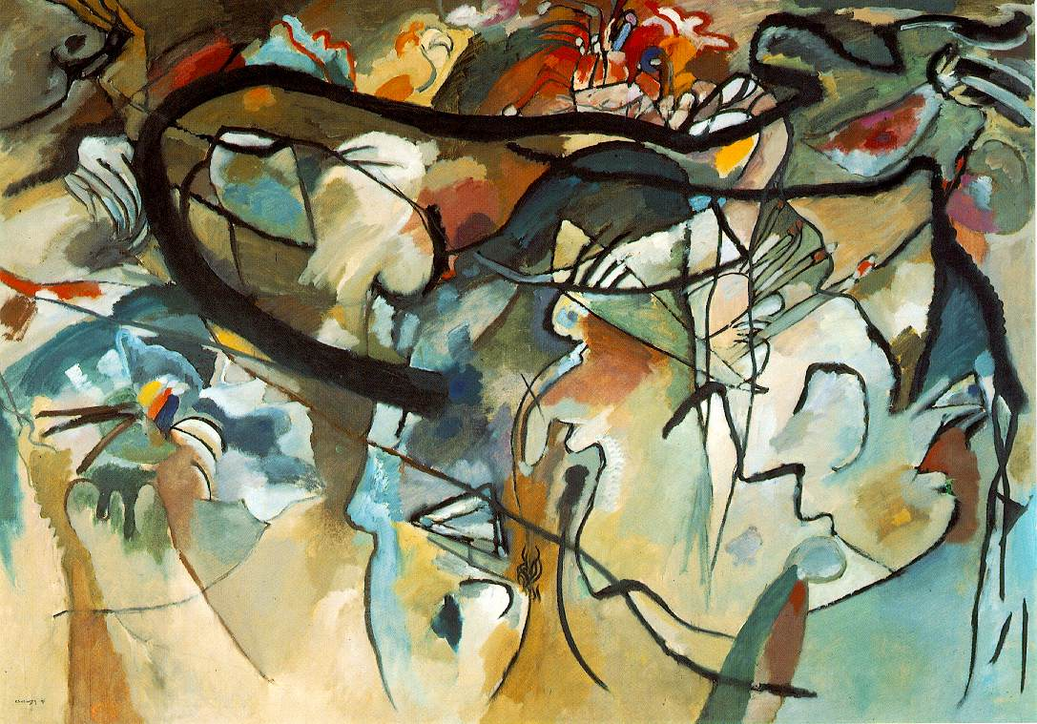

Figure 1; Composition V. 1911, oil on canvas, Private Collection
Iconographically, Compositions V incorporates many themes found in Kandinsky’s previous works as well as theories found in his text Concerning the Spiritual in Art. This painting, with its dramatic encounters between lines, colors, textures, and planes, results in the predominant sensation of abstract eroticism in its use of softly curving black lines, geometric shapes, and subtle pastel approximations of the feminine anatomy. Color is used exclusively to express emotion and sensation rather than realistic representation. The figures and shapes blend into each other almost in a jumbled dream-like manner; as if the artist had simply poured out the contents of his subconscious onto the canvas and let things fall as they may. Expression is the key element in this work. Not expression of some outer reality but an expression of the artist’s inner reality.
While Kandinsky’s Composition V succeeded in breaking out of the bounds of traditionally representational art, the works shown by Schönberg were more a reflection of his own personal search for an identity as an artist and as a human. We can see in his painting entitled Visions (Eyes) 1910 that Schönberg was struggling to find himself in his practice of painting.
In this painting we see two eyes, one in the upper left corner, that is almost shut, drooping downward and thus made blind. In the bottom right corner we see another eye that is wide open, with pupil constricted, looking straight out of the canvas. These two opposites create a tension within the painting that is expressive of Schönberg’s own internal struggles with art and composition. If one looks closely at the painting there appears to be a grayish figure rising up in between the two eyes. Does this figure represent Schönberg’s inner being? His soul trapped within the limitations of his body? This is an intensely dramatic and communicative painting that allows the viewer to gain a unique insight into the mind of the composer.
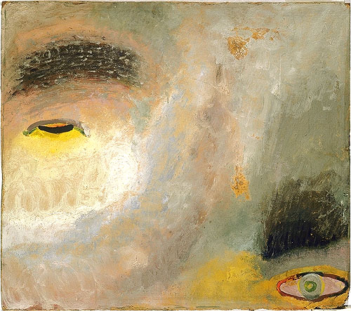
Figure 2; Visions (Eyes) 1910, oil on cardboard, Arnold Schönberg Center, Austria

In an essay on Schönberg’s painting Kandinsky states, “He paints in order to give expression to those motions of his spirit that are not couched in musical form.” He goes on to state, “Schönberg’s pictorial works enable us to recognize, beneath the stamp of his own form, his spiritual complex.
In May 1912, following the first and second exhibition of Der Blaue Reiter, an almanac was published that contained more than 140 reproductions of some of the exhibited paintings, essays on art, theater, and music, and a musical supplement with facsimiles of short song settings by Schönberg and two of his pupils, Alban Berg and Anton von Webern. In addition, it presented dozens of images, including: a Bavarian mirror painting of St. Martin, an anonymous German woodblock from the fifteenth century, a Chinese painting of two cats, a Japanese woodcut of an old man and a monkey, paintings by Arp, Picasso, Delaunay, Van Gogh, Gauguin, Cézanne, and Matisse, two still-life drawings by children, four portraits by amateur painters, a wood sculpture of a male warrior from South Borneo, a mosaic from the Cathedral of San Marco in Venice, an image of St. John by El Greco, examples of Russian folk-art, as well as artifacts from Brazil, the Easter Islands, Cameroon, Mexico, New Caledonia, Guatemala and Alaska. In the foreword to the second edition Kandinsky makes clear his reasoning behind such diverse works of art. “One of our aims – in my eyes, the principle aim … was to demonstrate, by means of examples, practical juxtapositions, and theoretical proofs, that the question of form in art is of secondary importance, that the question of art is above all a question of content.”
Both Kandinsky and Schulenburg’s essays printed in the almanac share a common theme of idealism, a rebellion against form, and external expression of the inner world. Kandinsky contributed three major texts to the Blaue Reiter Almanac. These were his articles “On the Question of Form” and “On Stage Composition,” and his play Yellow Sound. In addition to his musical pieces, Schönberg contributed an essay “The Relationship to the Text” to the almanac. In Kandinsky’s essay “On the Question of Form” he states, “Thus one should not make an idol out of form. And one should not battle over form for any longer than it can serve as the means of expression for this inner sound. One should not, therefore, seek one’s salvation in any one form.” Schoenberg echoes this abandonment of the reliance on form for form’s sake in the essay. He states, “Its [music] meaning becomes perverted to the opposite; one tries to recognize events and feelings in music as if they must be there. The violence of the First World War was mostly to blame for the dissolution of Der Blaue Reiter. Franz Marc lost his life in the war, as well as many other members of Der Blaue Reiter’s inner circle.
Schönberg and Kandinsky continued to have a lively correspondence even after their work together with Der Blaue Reiter was complete. They made many visits to each other’s homes and continued inspiring each other’s works. However, the First World War and the subsequent anti-Semitic mood in Germany eventually took its toll on their friendship and their relationship dwindled down to an occasional correspondence. It must not be overlooked that one of the most profound statements ever made of Jewish identity was written by Schönberg in a letter to Kandinsky, dated 19 April 1923. Schönberg writes, “For I have at last learnt the lesson that has been forced upon me during this year, and I shall not ever forget it. It is that I am not a German, not a European, indeed perhaps scarcely even a human being (at least, the Europeans prefer the worst of their race to me), but I am a Jew.” It is far beyond the scope of this paper to analyze the anti-Semitic environment that Kandinsky as an Aryan, and Schönberg as a Jew, shared as artists. However, despite their differences they were able to come together some years later and renew their friendship.
Fortunately, Schönberg escaped from Germany to America in 1933 where he was able to continue his life and his work. Kandinsky emigrated to France where he was able to continue exploring the Modern style of painting. However, much of his original work was lost during the Entartete Kunst “Degenerate Art” raids of the Third Reich. In fact, 57 of Kandinsky’s works from German museums were seized as ‘degenerate’ and subsequently sold. In the midst of the turmoil of the Second World War, Kandinsky died on December 13th, 1944 in Neuilly-sur-Seine, France. Schönberg, although never truly appreciated in his own lifetime, managed a teaching career at UCLA until he was forced to retire. On July 13th, 1951, Schönberg died in Los Angeles, California.
Although these artists came from very different backgrounds and worked in predominantly different mediums, each shared a passion for the unity of the arts. Kandinsky’s desire to purify his art through the dissolution of form, while at the same time resisting against simple ornamentalism, has a strong parallel in Schönberg’s own struggle against formulaic music and his own distaste for the ornamental. Furthermore, both artists felt that abstraction was the best means available to them for depicting an unseen realm of existence. The simultaneous discovery of atonal music for Schönberg and abstract art for Kandinsky is revealed in the friendship between these two men. We can only begin to understand the importance of these discoveries as we gain insight and distance through time.

Bibliography

Becks-Malorny, Ulrike. Kandinsky. Los Angeles: Taschen, 2003.

Boehmer, Kinrad, ed. Schoenberg and Kandinsky. Amsterdam: Hardwood Academic Publishers, 1997.

Hahl-Koch, Jelena, ed. Schoenberg-Kandinsky: Letters, Pictures and Documents. Trans. John C. Crawford. Boston: Faber and Faber, 1984.

Harrison, Charles, and Paul Wood, eds. Art in Theory 1900-2000. New York: Blackwell Publishing, 2003.

Kandinsky, Wassily. Complete Writings on Art. Eds. Kenneth C. Lindsay and Peter Vergo. New York: Da Capo, 1994.

Kandinsky, Wassily. Concerning the Spiritual in Art. Trans. M.T.H. Sadler. New York: Dover Publications, Inc., 1977.

Kandinsky, Wassily. Point and Line to Plane. Trans. Howard Dearstyne and Hilla Rebay. New York: Dover Publications, Inc., 1979.

Messer, Thomas M. Kandinsky. New York: Harry N. Abrams, Inc. Publishers, 1997.

Schoenberg, Arnold. String Quartets Nos. 1 and 2. New York: Dover Publications Inc., 1997.

Schoenberg, Arnold. Style and Idea. Ed. Leonard Stein. Trans. Leo Black. Berkeley: Univ. of California Press, 1984.

Schoenberg, Arnold. Theory of Harmony. Trans. Roy E. Carter. Berkeley: Univ. of California Press, 1983.

Schoenberg, Arnold. Verklarte nacht and Pierrot Lunaire. New York: Dover Publications Inc., 1994.

Shawn, Allen. Arnold Schulenburg’s Journey. New York: Farrar, Straus and Giroux, 2002.

Jelena Hahl-Koch, ed., Schoenberg-Kandinsky: Letters, Pictures and Documents. trans. John C. Crawford (Boston: Faber and Faber, 1984), 21.
Wassily Kandinsky, Concerning the Spiritual in Art , trans. M.T.H Sadler (New York: Dover, 1977) iii.
Kandinsky, 1.
Kandinsky, 2.
Charles Harrison and Paul Wood, Art in Theory 1900-2000, (New York: Blackwell Publishing) 82-83.
Kandinsky, 6.
Kandinsky, 7.
Kandinsky, 25.
Schoenberg, Style and Idea. (Berkeley: Univ. of California Press, 1984) 365.
Schoenberg, Theory of Harmony. (Berkeley: Univ. of California Press, 1984) 18.
Schoenberg, 18.
Schönberg, 123.
Schoenberg, 421.
Schoenberg, 422.
Hahl-Koch, ed. 23.
Hahl-Koch, ed, 23.
Kandinsky Complete Writings on Art (New York: De Capo, 1994), 113.
Kandinsky, 110
Thomas M. Messer, Kandinsky (New York: Harry N. Abrams, Inc. Publishers, 1997), 78.
Hahl-Koch, 125.
Kandinsky, Complete Writing, 230.
Kandinsky, 285.
Kandinsky, 237.
Schoenberg, Style and Idea, 142.
Hahl-Koch, 76.
Hahl-Koch, 18.

