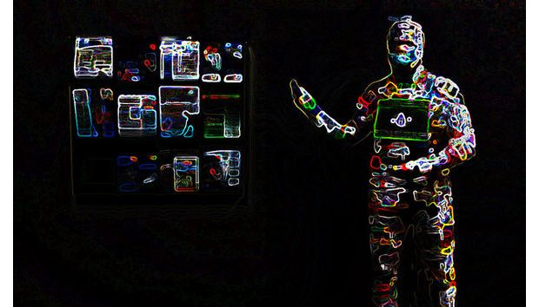

INDUSTRY ANALYSIS: WEARABLE TECHNOLOGY

Professor Hatton
May 16, 2014

Presented By:
Valerie Emperador, Kristine Gasparyan, Heather Hile, Marissa Jestice, & Amporn Teeple

TABLE OF CONTENTS

Introduction and Background 2
Wearable Technology History 2
Dominant Economic Characteristics 3
Market Share Size, Volume and CAGR 3
Expected Growth in the Industry from 2013 to 2018 5
Essential Analysis 6
Technology and Competition 6
Wearable Band Growth 7
Companies in the “Band” Industry 7
Fitbit 8
Jawbone 8
Samsung 9
Apple 9
Wearable Technologies and Competitive Rivalry 10
Google 10
Adidas 10
Under Armour and Zephyr Technology 11
Technology and Innovation 11
Trends 15
Customer Demographics 15
Apple Vertical Integration 16
Industry Profitability 17
Six Forces of Competition 18
Threat of New Entrants 19
Rivalry among existing firms (competition) 20
Threat of substitute products or services 20
Bargaining power of end users/buyers 21
Relative power of Other Stakeholders 22
Six Forces Effect on Wearable Technology Market Segmentation by Application 23
Industrial and Military 23
Healthcare and Medical 24
Infotainment 25
Fitness and Wellness 26
Competitive Position of Major Companies and Competitor Analysis 27
Key Success Factors 33
Fitness and Wellness: 37
Infotainment: 37
Healthcare and Medical: 37
Industrial and Military: 38
Industry Prospects and Overall Attractiveness 40
TRENDS 40
Enterprise 40
Healthcare 42
Futuristic Fashion Wear 43
Security 44
Potential Threats 45
Fad or Future? 45
Lack Innovation: Infographic 47
Power 48
Connectivity 49
Conclusion 49
Appendix 54

Introduction and Background

Wearable Technology History
Wearable computing has a history that goes back longer than most people expect. In the 1960s various militaries around the world began developing headgear with displays for aviators in combat. Then in the 1970s some of the first wearables were created for predicting roulette-wheel speeds. In 1979 Sony invented the Walkman, considered by many as an early wearable computer. In the early 1980s Steve Mann, one of the pioneers of wearable computing, created a backpack-mounted computer to control photographic equipment, and in 1994 he created a headset that transmitted images to the web. By the late 1990s we could find IBM experimenting with wearable computers based on the ThinkPad, and by 2001 it had introduced a prototype of a wristwatch computer known then as the WatchPad. Some of the leading companies in the early development of wearables have had a difficult time commercializing the technology. Xybernaut, CDI and VIA Technologies have been some of the first, and most have had to go through bankruptcy filings at least once. Large consumer-technology manufacturers including Sony and Panasonic have attempted to commercialize wearable devices in the past, but these have yet to reach any form of sustainable success. Wearable technologies are not as straightforward as many other mobile technologies, due to issues such as heat and battery power, local storage, privacy and security. And in the context of wearable fabrics it has been an even longer road to both functional technologies and cultural adoption.
According to marketsandmarkets.com (2013), “The term ‘Wearable technology’ refers to any electronic device or product which can be worn by a person to integrate computing in his [or her] daily activity or work and use technology to [benefit] advanced features & characteristics” (n.p.). For over twenty years, there have been concerted efforts by both people in the industry and people in academia that have resulted in many complex, smart products and devices being launched in the market. Industry potential can be measured by the fact that there are both large, established companies (like Nike) and small start-up companies (like Pebble) that are putting substantial time and investment into the wearable technology market.
Experts are expecting the wearable technology market to grow from the $2.7 billion revenue made in 2012 to an estimated $8.3 billion in 2018. That translates into an estimated compound annual growth rate (CAGR) is 17.71% from 2013 to 2018. During these years, the U.S. is expected to continue to account for more than 80.00% of the market and dominate the industry. Though North America is expected to continue its dominance, Asia–Pacific (China most specifically) is likely to grow at the highest CAGR during the same period. The opinion of industry experts is that wearable technology will be the next big thing after smartphones.

Dominant Economic Characteristics

Market Share Size, Volume and CAGR
The wearable technology market was worth $2.7 billion in revenue in 2012 and is expected to reach $8.3 billion by 2018, with an estimated Compound Annual Growth Rate (CAGR) of 17.7% (Wearable electronics, 2012). More recent research shows the expected growth could rise as high as $18 billion by 2018 (Zeiler, 2014). The wearable technology, also known as wearable computers, is worn by the user to track daily activity and enable computing and wireless networking. Wearable can be in forms of watches, glasses, smart fabrics, contact lenses, small screens, rings and bracelets, hearing aid like devices, smart badges, wrist computers and even smart tattoos on the skin. The wearable technology reaches to health and fitness gaming, aging, transportation, fashion, mobile money, education, disabilities and even music industries. The industry includes both the application sector and product sector as follows:
Product Market Share | Application Market Share
Wrist - Wear - $876.70 Million | Consumer Application - $2,367.99 Million
Neck wear – Smallest Market Share | Industrial and Enterprise Application - $73.04 Million

The industrial and enterprise application has the highest potential for growth with a 21.14% CAGR during the forecast period from 2013 to 2018. Both the big and established players and small start-up companies have great return potential on their investments in this market. The industry experts predict that the wearable technology is the next big market opportunity after smartphones. Everything from smart textiles, skin patches to sophisticated gadgets; the market is expected to boom exponentially. The smart textile material market (smart fabric) is also expected to reach over $2 billion by 2018 with an estimated CAGR of 21.54%.

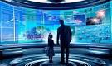
Currently, the U.S accounts for more than 80% of the market and is expected to continue to dominate as the need for healthy living and activity tracking becomes more apparent. Asia-Pacific and China however, are likely to grow at the highest CAGR. Wearable technology will make tomorrow’s world today, all across the planet.

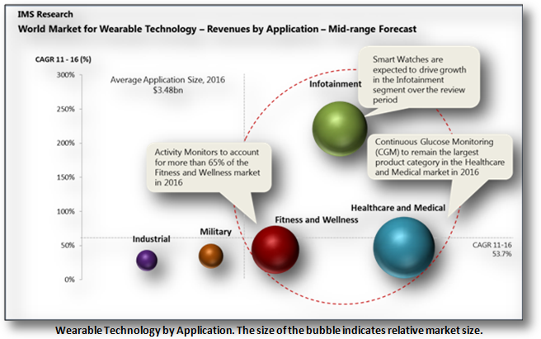

Expected Growth in the Industry from 2013 to 2018
- The global market’s volume is expected to reach 134.27 million units by 2018, growing at a CAGR of 30.36%.
- The wearable technology ecosystem market revenue was $4.3 billion as of 2012 and is expected to reach to $14.0 billion by 2018, growing at an estimated CAGR of 18.93 %
- The global smart, intelligent, digital & interactive fabrics market revenue was $708.31 million as of 2012 and is expected to reach to $2.03 billion by 2018, growing at an estimated CAGR of 17.7 %
- Components accounted for the largest percentage share of the overall revenue of global wearable technology, i.e. 66.2% in 2012 ($1.83 billion) in 2012 and is expected to account for 73.0% of the total market in 2018.
- Product shipments are likely to experience the highest growth at a CAGR of 53.07% from 2013 to 2018, reaching a volume of 2.7 billion units in 2018.

Essential Analysis
- Market statistics with detailed classifications and splits by revenue and volume
- The key trends related to the product technology, prices, and the applications that shape and influence market
- Analysis of the global market with special focus on high growth application in each vertical and fast growing application market segments
- Impact analysis of the market dynamics with factors currently driving and restraining the growth of the market, along with their impact in the short, medium, and long term landscapes
- Detailed Porter's analysis, market life cycle analysis of wearable technology, and its respective markets
- Detailed segmentation of global market by product and component with a focus on cross segment markets like application and industry verticals
- Illustrative segmentation, analysis, and forecast of the major geographical markets to give an overall view of the global market
- The future of the global market & industry from both - technical and market-oriented perspectives with techno-market oriented roadmaps till 2018
- Detailed competitive landscape with identification of the key players with respect to each type of market, in-depth market share analysis with individual revenue, market shares, and market share rankings
- Competitive intelligence from the company profiles, key player strategies, game-changing developments such as product launches, and acquisitions (Wearable electronics, 2012).

Technology and Competition
As mentioned earlier, the wearable technology includes a wide-range of different products and application devices. In this section, we will cover different segments of the wearable technology industry, innovation and competition, and growth potential.

Wearable Band Growth
There are two different types of wearable bands, the “basic” wearable band and the “smart” wearable band. The basic band tracks activities while the smart band has more software knowledge. Wearable band research shows that over 1.6 million bands that track fitness were shipped during the second half 2013 while there were only 200,000 smart bands shipped in the first half of the year representing a 700% growth in the market. The wearable bands are expected to grow as follows:
2014 | 2015 | 2017
8 Million Units Shipped | 23 Million Units Shipped | 45 Million Units Shipped
17 Million Units Including Basic Bands

Companies in the “Band” Industry
The wearable band market as discussed previously is divided up in to two segments, the “basic” wearable bands and the “Smart” wearable bands. The following two graphs illustrate key players in these markets (Lomas, 2014):
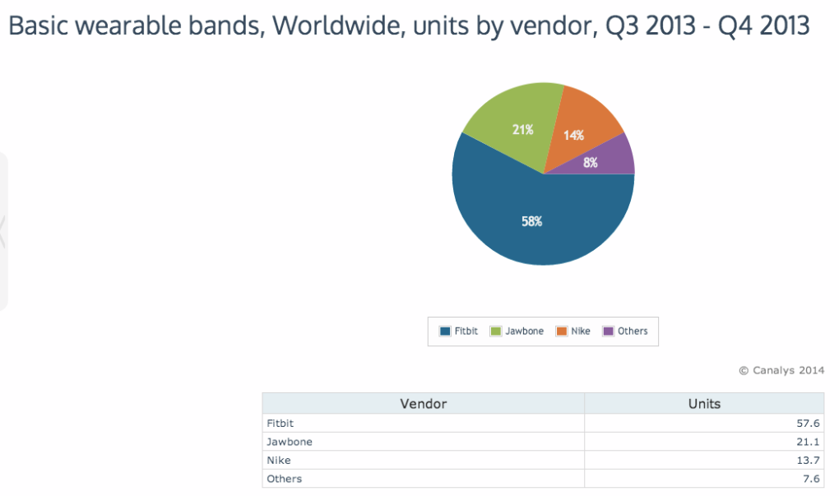

Fitbit
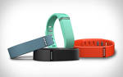
After the launch of of its “affordable” Flex and Force Fitbit became the leader in wearable bands. The Fitbit Flex can track calories, distance, and number of steps, sleep quality, and wakes the user silently in the morning. With over 50% market share in the second half of 2013, Fitbit dominates the basic band market with Flex.

Jawbone
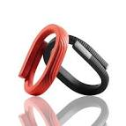
As a result of increased demand, Jawbone has secured $100 Million in a combination of debt and equity financing through the acquisition of Massive Health and BodyMedia, Gigaom. Jawbone Up fitness-tracking wristband and Jambox wireless speaker has increased sales and demand so much that the company never anticipated nor was prepared for such growth (Rossler, 2013).

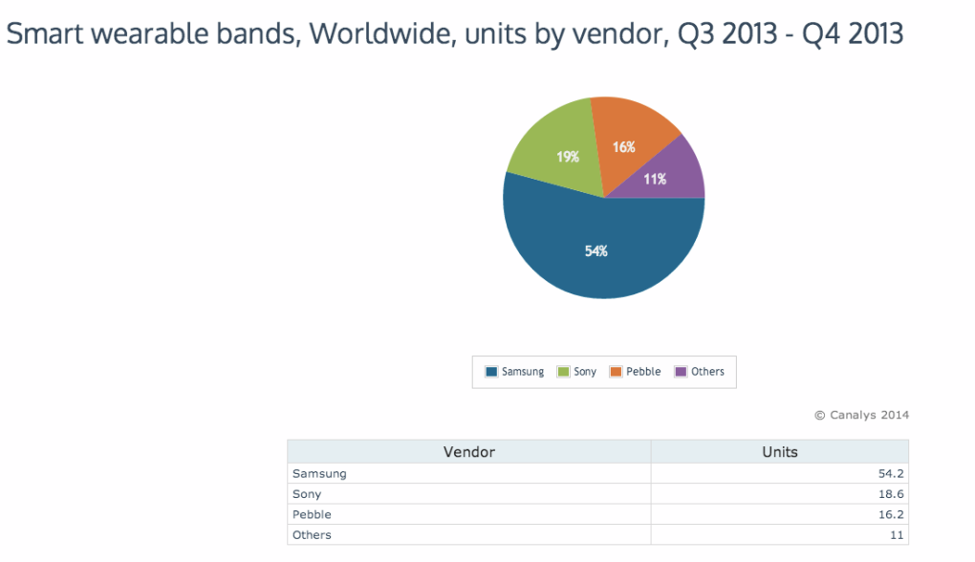 Samsung
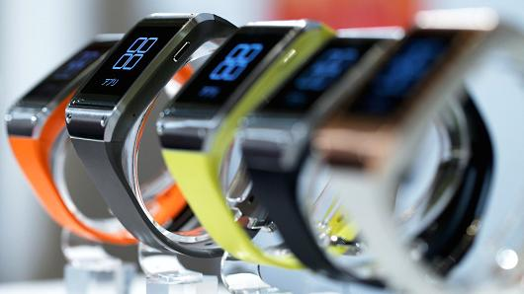
Samsung’s new Smartwatch is at the forefront of this growth in wearable smart bands. With strong promotional push Samsung was able to grab 54% of the market share in 2013. However according to analyst, Daniel Matte due to high $299 price per unit and low battery life, size and weight the product will be “shunned” by the public. However Samsung is optimistic that with the right promotional push they can gain significance with the client base.

Apple
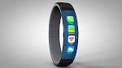
Although the wearable basic bands such as Fitbit Flex have greater wearable expertise and have shipped a great number to date, the smart band such as the Smartwatch is already growing faster. Apple is ready to jump on the bandwagon with a new product – the iWatch later this year (Clinch, 2014).

Wearable Technologies and Competitive Rivalry
As technology continues to evolve, companies such as Apple, Google, Adidas and others will create one product after another to gain market share in the wearable technology industry. Differentiation strategy and innovation will become the source of survival for each of these companies. Entering the wearable technology market seems easy since the industry is in the innovation and growth stage of the product life-cycle. Additionally, the market is booming and is expected to grow exponentially; therefore new entrants may have a chance to take a piece of the pie if they play their cards right. New entrants will need to offer a competitive edge in the marketplace, offer a competitive price and newer, better and innovative technology. However each entrant has to keep in mind who some of the key players in the current market are, i.e. Google – which analysts believe will eventually dominate the industry – Microsoft, Intel, Apple, and the existing companies which have established credibility in the market, i.e. Fitbit, Jawbone and Samsung. The following products are an example of the current competitive rivalry:

Google
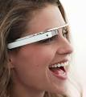
Google is also in the midst of joining the wearable computer market. The Project Glass is expected to reach market in 2014. Project Glass is armed with an LCD or AMOLED display and contains location awareness, illustrates the ability for wearable computing technologies to tap into apps and enable the user to access information (email, directions and other data) in real time through a stream to the user’s glasses. The Project Glass is anticipated to be sold at a price of $1,500 per unit (Ranck, 2012).

Adidas

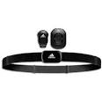
The Adidas miCoach was developed to monitor athletic performance with sensors that measure speed, pace, distance and heart-rate monitor which measures cardio performance. The adiSTAR Fusion, which is mostly used in soccer, is software that connects to sport bras and shirts which tracks acceleration, distance and space.

Under Armour and Zephyr Technology
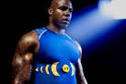
Sports clothing company Under Armour with the help of Zephyr technology has developed the E39 shirt, which is embedded with integrated sensors, an accelerometer and 2 gigabyte of storage that monitors heart rate, breathing rate, skin surface temperature and acceleration. Zephyr is one of the more advanced companies in biometric monitoring systems for wearable technologies (Rank, 2012).

Technology and Innovation
Wearable technologies will continue to evolve in terms of capabilities, robustness and applications. Products and applications will include direct or indirect skin contact which will track, monitor, and report health and fitness activities, body movements, and more. Due to issues such as heat and battery power, local storage, privacy and security, companies will continue to spend millions of dollars in R&D to provide safe and quality products to end user. The context of wearable fabrics has taken a longer road to functional technologies and cultural adoption; however the following table shows examples of companies/universities that have started successful implementations in adopting these technologies into culture, fashion and many other markets. These companies and products have impacted and will continue to have a major economic impact in terms of millions of dollars invested for Research and Development and innovation. As discussed earlier the expected increase of market growth in terms of consumer demand and sales will bring health and fitness, military, disabilities – applications for the deaf, blind, paralyzed and elderly, - fashion trends, gaming and other industries to a new era of economies. Some examples of these changes are also discussed in the table below (Rank, 2012):
Company | Product | Details
Northeastern University | Electromyography-Sensor-Based Shirt | - Tracks the electrical activity of muscles during workouts  - Monitors activity and sends the data to an Android-based program.  - Expected to be available in 2-3 years
Utope Project | Supaheroe Cycle Jacket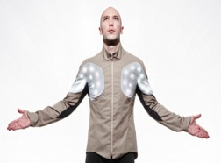 | - Fitness with fashion cycling jacket that has LED displays  - Accelerometer and 3D gyroscope  - Alerts users of incoming telephone calls  - Tracks users movement
SmartLife Tech | HealthVest  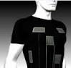 | - Contains ECG electrodes  - Respiratory Sensors and platform for data cleaning and collection  - Target Market includes:  - Cardiac Care  - Military  - Dangerous Environments  - Fitness
Brenig | Sleeve Compass | - Easy to access directly on clothing
Microsoft | Smart Fabrics | - Microsoft is focusing on manipulating smart fabrics to control phones and other devices.  - Through fabrics, user will be able to see a call coming in, dismiss the call or have simple message sent through pressure-sensitive buttons on the clothing.
Innovega – US Department of Defense | iOptik - Contact Lenses  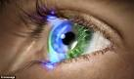 | - Augmented-reality contact lens  - Help to overcome limitations of traditional heads-up-display technologies.  - Enables near and far focused attention simultaneously.  - Expected to release this technology for civilian applications by 2014.
University of Washington | Contact Lenses  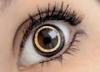 | - Prosthetic device for the sight-impaired that uses LED.  - Monitor glucose levels for diabetics  - Helps self-manage diabetic condition in less invasive manner.
TapTap | TapTap Scarfs – a haptic device | - Allows the transmission of tactile information  - Used for emotional therapy with children and adults  - Haptic message therapy uses heat sensors to trigger haptic information to be sent to an area of the body for stimulation.  - Sense movement of the body of an athlete to determine improper form.  - Reminds a rower, for example, to adopt correct positioning.
Nokia | Magnetic/Vibrating Tattoos  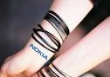 | - Can alert the user when there’s an incoming call  - Warning alert for a dead battery from mobile phone
University of Illinois and Mc10 | Smart Tattoos  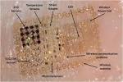 | - Monitoring of Vital Signs  - Integrates sensing, diagnostics and communications on an ultrathin patch attached directly to the skin.  - An actual platform that has wide range of technologies that can be used.  - Planning to add Wi-Fi capabilities
Sano Intelligence | Wearable Patch  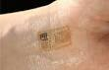 | - Continually monitors glucose levels, kidney function and metabolite levels.
Victoria and Albert Museum in London & UK Design Council | Hear Ware | - Embedding jewelry with technology to enhance social functioning for those disabilities.  - Hearing aids are cumbersome, unattractive and not very effective.  - Market for hearing devices in Europe over $5 billion with only 30% using the device.  - Innovation of patches that help communicate wirelessly to an earbud in the hearing-impaired person’s ear  - Innovation of jewelry – when noise levels are high enough to damage the ear, will vibrate on the cervical vertebrae and warn user to move to safer location.  - Glasses with hearing aids – attach to sensors at a table in a bar that could help the user block out noise and hear only relevant conversation.  - Over-the-counter hearing aids – different strengths and types of hearing loss
Design Research Lab | The Mobile Lorm Glove  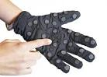 | - Designed for deaf-blind that enables them to use the glove to send text messages.  - Lorm – the language used by deaf-blind, uses touch to sign language on the palm of the hand.  - Enables a user to translate messages composed on the palm of the glove into text messages that can be sent to another user wearing the same glove.
Point Locus | Tactile way-finding Vest  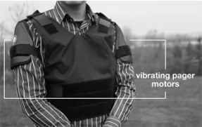 | - Used for the blind to communicate directions via vibrations on the user’s triceps  - Serves as a replacement for the standard GPS device
Orpyx | SurroSense RX  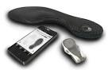 | - Self – monitoring device for diabetics with neuropathy who cannot feel pain.  - Pain may result in ulceration and even amputation of the feet.  - SurroSense collects pressure data, detect when damage is being done and send a signal to user to change behaviors
Grathio Labs | Tacit Glove  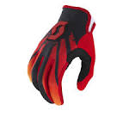 | - Sonar for the blind that uses haptic technology to measure distance to things  - Translates into vibrations or tactile responses on the back of the user’s hand.
Founders Fund and Khosla Ventures | Misfit Wearables  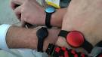 | - $7.6 million Investment  - Fashion and health not trade-offs but critical to future success
Electicfoxy | The Move Garment | - Uses gentle signals to lead the user to adopt the right movements in anything from Yoga and Pilates to dance performance or physical therapy.  - Pulse and heart rate monitored via a ring connected to smartphone app to stay in right target zone for workouts
Philips | Emotions Jacket  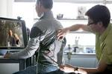 | - Explores the connection between emotions and touch  - Used with a DVD of a movie to create linkages between the user of the jacket and emotional content of the movie  - Viewer experiences part of what the character on –screen is feeling.  - Jacket being developed for entertainment sector only, to create a real experience.
TN Games | 3rd Space  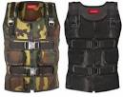 | - Heavy-duty vests that enables user to have more-realistic gaming experiences  - Feeling gaming characters’ sensory experience such as kicks, stabs and g-forces.
The list for these innovations can go on and on. Every industry is involved in using wearable technologies/computers to enhance and modernize their products to fit the customer demand and remain competitive (Ranck, 2012).

Trends
There are a number of technological and social trends that will play a role in wearable technologies. Material sciences, like GraphExeter that conduct electricity will need further advancement. New form factors and materials will need to be made available for wearable computing and electronics – materials that will be more flexible such as indium tin oxide which is believed to run out by 2017.
The Bluetooth 4.0 which uses less power and can pair instantaneously with devices will also be a huge factor in the wearable computing industry. The Bluetooth 4.0 will be a boost especially in the health market. Connectivity for medical devices and bracelets and watches which monitor biometrics will need the Bluetooth for faster connectivity.
Near field communication (NFC) will become more commonplace technology for mobile-money applications. NFC will be available to be embedded in wearable technologies so users can pay for movie tickets, sporting events, coffee and more without having to pull out a card and without the stress of identity theft.

Customer Demographics
The wearable technology industry has a wide-range of consumers with almost every demographic. Current demographic of wearable technology includes young health conscious adults, athletes, elderly and the military. Also, there are the innovators, who purchase a new product when it’s released because they want to be the first to experience it. As previously discussed, depending on the type of technology the demographics will be skewed. A study conducted by Harris Interactive with regard to Samsung’s smartwatch, Google glass and tracking wearable devices and found that consumers are confused and concerned about the technologies. Some details of their study shows:
- 52% of respondents want to see wearables make a “major impact in the healthcare industry.” Note that the fitness industry was listed separately (and garnered 42%) so this question about healthcare is core healthcare, not weight loss.
- Price is the number one determinant about when consumers will purchase wearable technology, but only 17% say it is the primary factor, 19% say they will never buy and 36% are unsure.
- The number one benefit is to stay informed, rather than track biometrics, and the number one concern is that the technology will be too expensive.
The demographics of those educated on wearable technology skews strongly younger which puts it lower on the priority list for many healthcare marketers (Wearable tech, 2012):
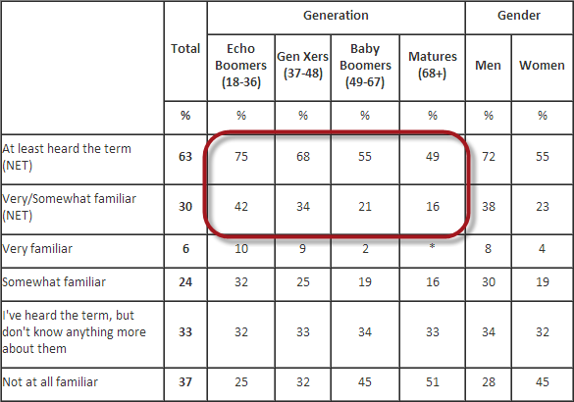

Apple Vertical Integration
Apple has been waiting to release its newest product, the iWatch. No one in the market knows how to apply the philosophy of vertical integration like Apple. As investors wait for the next “big thing” Apple is on the horizon of dominating the wearable tech market.
Research states that the wearable tech will become the “key consumer technology" this year. Catalyst predicts the smart wristband segment alone will grow from 8 million this year to 23 million in 2015 and more than 45 million in 2017.
And a Juniper Research study at the end of last year forecast that retail revenue from the wearable technology market will grow from $1.4 billion in 2013 to $19 billion in 2018. And what Apple has done is fixate on the single most compelling aspect of wearable tech – the one thing that will drive the most people to buy and use wearable tech devices (How apple, 2014).
Not much research was available in terms of vertical integration; however companies will need to facilitate cost effective operations to meet consumer demand and remain profitable.

Industry Profitability
The following is a list of the four main reasons why the Wearable technology is important to entrepreneurs and investors:

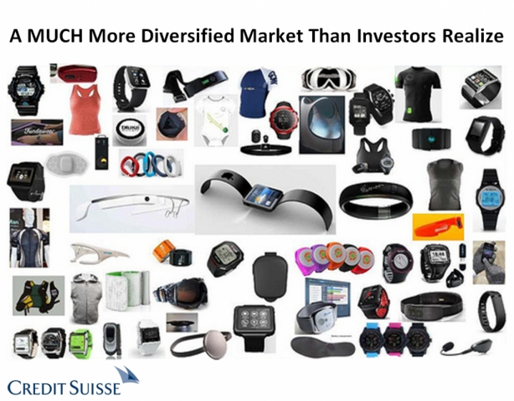
- Wearable Tech Can Accomplish Work: According to Mobile Marketer, the average employee checks his/her phone at least 150 times a day. The statistic will change significantly if someone wearing a device had the information broadcasting in front of their face.
- Wearable Tech Can Increase Your Health and Possibly Even Reduce Healthcare Costs: We already discussed how wearable tech can increase one’s health, but it can also help reduce costs. Wearable tech can help clinicians to work more efficiently and to gather more patient data outside of the hospital environment which would reduce facility use and staffing time and costs. Also, the increased information can lead to earlier detection of problems, prevention of readmission and better clinical outcomes.
- Influence Cost of Employee Insurance: Corporations are already offering reward points for employees who track and monitor the number of steps they take in a given day etc. With the help of wearable technology this information can be transferred to the health care insurer resulting in health insurance discounts.
- Wearable Tech Can Contribute to More Accurate and Targeted Marketing: While privacy is a concern, the data that consumers opt to provide will be extremely beneficial to future marketing efforts. Product developers will gain a new level of insight into consumers’ preferences and lifestyle, and will be able to design and promote their future products in a much more targeted way (Say, 2013).

Six Forces of Competition
The six forces model is an analysis of market opportunities that is basically an extension of Porter’s five forces analysis. This model is more robust than the standard SWOT analysis, but it does not include factors that are internal to firms. While utilizing the six forces to analyze the wearable technology industry, it was imperative to also look at each of the industry’s sub-markets – industrial and military, healthcare and medical, infotainment, and fitness and wellness – and how each of the six forces affect these key areas of business.

Both new startups and well-established, global companies are already preparing for a world where wearable technology will influence how we and others interact with and access our most valuable property. To do this, many leading industry players are spending an increasing amount of time in the world’s innovation centers looking for technology partners to power the next generation of products and services, while at the same time staffing up their own innovation efforts to at least keep pace with the industry.
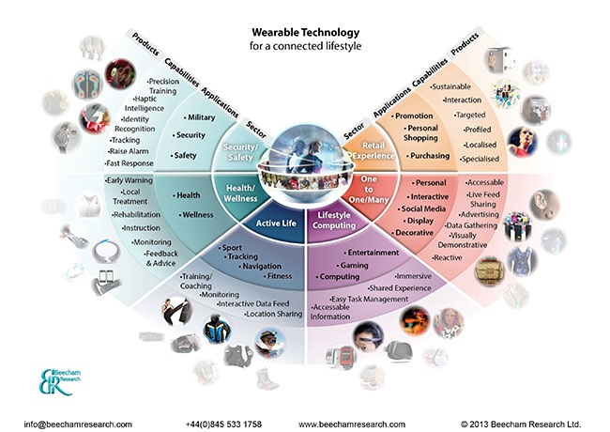
Image retrieved from http://www.beechamresearch.com/download.aspx?id=36

Threat of New Entrants
The threat of new entrants to the wearable technology industry affects the competitive environment for the existing competitors and influences the ability of existing firms to achieve profitability. There are a lot of players in the wearable technology market - from small startup companies like Pebble to globally established companies like Nike. The market is open to just about anyone with an idea and money to bring the idea to life. Also, the number of new entrants into the wearable technology market has been steadily growing since the calculator watch was introduced in the 1980s. As trends rise towards technically advanced products and the demand for wearable tech products increases, even more companies will be entering the market. According to a study done by ABI Research (2013), “due to the relative ease of compatibility with smartphones and other electronic devices, the wearable technologies market will spike to 485 million annual device shipments by 2018” (n.p.). This increase will occur because these products will need to be tested for the consumer demand. Because of this, in the next two years entrants into the market will continue to grow to a medium impact level. Realistically, over the long term it will be difficult for anyone to say how fast and large the market will grow.

Rivalry among existing firms (competition)
Competition was low in 2013, but expected to steadily increase through 2018. This trend was due to the fact that wearable computing represents an appealing and lucrative market that is currently shadowed with a great degree of uncertainty. Though, a significant grey area in the industry is regulation, as it has a major bearing on the potential market size. For example, there may be a lot of questions about how smart glasses will be used. The questions could have to do with anything said or seen by a smart glasses user to anything that could be captured, shared and saved.
The capability of wearable devices is likely to improve continually, but expectations should be set carefully. There are fundamental constraints of battery technology, acceptable weight and the bulk of wearable devices. This means that some ideas may be many years off or may never be realized.

Threat of substitute products or services
Threat from substitutes was expected to be high in the market during 2013 and 2015. Since wearable technology is relatively new and the products that are now being created and tested in the industry in most cases have not been seen before, there is little to no threat of substitute of products at this time. As more companies enter the market with similar products to those already available, substitute products will become a bigger threat. The level of threat is hard to determine given that there are many factors that affect whether a product will make it to consumers. Factors like regulation (i.e., there may be questions about the usage of wearable technology products), limits of technology (technology that may never be realized), fundamental constraints of battery technology, acceptable weight for products like smart glasses, and the bulk of wearable devices.

Bargaining power of end users/buyers
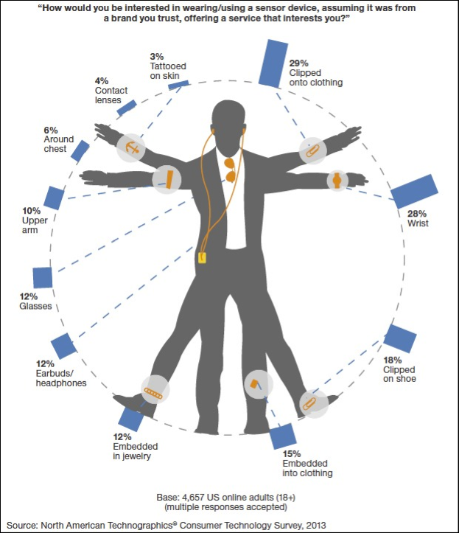
Buyer bargaining power will continue to increase steadily and is forecasted to have its highest impact in 2018. Consumers are uncertain about wearables and shelling out money for another device is not something at the top of their list. Currently, wearable technology has found its success in niche markets like fitness-tracking and medical monitoring as users in these areas prefer function over style. Buyers will continue to leverage their bargaining power as the industry must overcome several challenges, like making the price point accessible, specialization, fashion uniqueness, competition between operating system leaders, to gain mass adoption which would put the bargaining power in the industry’s hands. Buyers are looking for wearable technology that will influence their lives in a constructive and effective way; they want it to enrich their lives. Right now, buyers must be convinced of the value of wearable technology products. The chart here addresses the question: what kind of computers will people actually wear?

Bargaining power of suppliers
The power of suppliers is expected to gradually decrease from 2013-2018. As more companies enter the market and more product substitutes become available, suppliers will lose their bargaining power in the industry. The wearable tech industry has become an important customer to suppliers who see it as incredibly lucrative. With more companies demanding more products from suppliers, more suppliers have established themselves in the market. More suppliers mean more choices for buyers and therefor a loss of bargaining leverage for suppliers.

Relative power of Other Stakeholders
The sixth force in this model can refer to a number of other groups or entities, depending on which factor has the greatest influence, including:

Complementors – Complementors are companies or entities that sell or offer goods or services that are compatible with, or complementary to, the goods or services produced and sold in a given industry. Complementary goods offer more value to the consumer together than apart. The presence of complementors can influence the competitive structure of an industry. It is a company outside the industry that has a significant influence at a certain moment over customers. A complementor can provide a company with crucial customer information before the customer actually makes a buying decision. This gives a company a great advantage in influencing customers’ decisions.

The government – The government can also be considered the sixth force as it has the potential to impact all the other five forces (Gordon, 1997). “[T]he government can have both a direct impact in the industry as the sixth force, but can also have indirect impact or influence by affecting the other five forces, whether favorably or unfavorably (harshalone, 2010)

The public – This stakeholder is yet another that can be viewed as the sixth force, especially if the public has a strong influence on the dynamics of the industry that result in changes to the other forces or on the industry as a whole.

Shareholders – Shareholders have the potential to be the sixth force. As shareholders have become more active in companies’ boardrooms, their input has become increasingly more valuable and therefore has carried more weight in the decision-making process.

Employees – Employees can also be considered as the sixth force if the “collective voice” wielded an incredibly strong influence on a company in the industry. “For example, the automobile [industry] in the US, a large part of the workforce are unionized, and thus could be considered the sixth force instead of the government or complementors” (harshalone, 2010).

Six Forces Effect on Wearable Technology Market Segmentation by Application
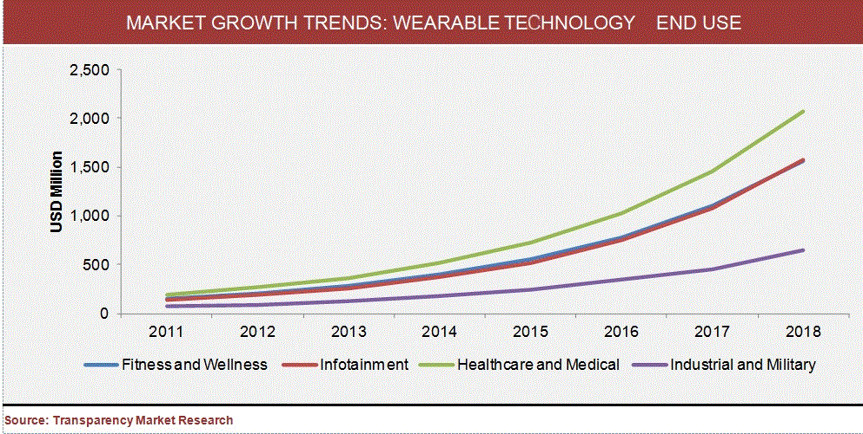

Graph retrieved from http://www.wearabletechworld.com/topics/from-the-experts/articles/323855-wearable-technology-next-mobility-market-booming.htm

Industrial and Military
Market growth in this sector has been, and will continue to be, the lowest in market growth of the four market sectors. Because of this lack of growth, the threat of new entrants into this area will remain at a low to medium level. The military has already invested significantly in wearable technology, and though we don’t think of military-driven wearable technology as more accessible in business and consumer markets, it is still an important area to keep an eye on. More often than not what ultimately emerges on the business and consumer side will have found its origin in military designs. Products like prototypes for digital eyewear with heads up display (HUD) are being developed by the US military, as well as headgear with displays for soldiers using a technology called holographic optics.

Factors that will have a high impact on the buying decisions in this segment are the safety and convenience of products and how the products will contribute to workforce automation. These factors, along with quality control and security, will also have a high impact on whether products introduced in this market will be well-received and adopted on a mass scale. With end user concerns being a major influence on how wearable technology products are developed, the bargaining power of buyers could stay at a medium level. Yet, as substitute products become more available, buyer leverage could decrease to a low level.

Defense-focused suppliers have found serious revenue from the military and thus, there is no shortage of suppliers in this area which will keep the bargaining power of those suppliers relatively low for the coming years.
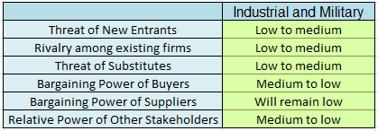

Healthcare and Medical
Among all the wearable technology end use segments, the healthcare and medical segment held the largest revenue share, followed by fitness and wellness, in 2012. That remained the case in 2013 but a shift is beginning to happen. The healthcare and medical segment accounted for about 35.1 percent of the overall wearable technology market in 2012 - primarily due to an increase in diabetes within the larger population, and generally because of the rising and aging population. Threats of new entrants will remain low as this market segment will likely remain unchanged in market size.

Wearable fitness and wellness products include smart clothing, activity monitors, sleep sensors and other such tech. Products such as continuous glucose monitors (CGM), drug delivery, and wearable patches are predominantly used in healthcare and the medical sector. Hand worn terminals, heads-up displays and other such products are being used in the industrial and military settings. There is such a saturation of products in this area that threat of substitutes is relatively high. The amount of product substitutions gives buyers less bargaining power. Though, the level of buyer bargaining power could reach a medium level due to consumer concerns for things like handling and portability, the ease and efficiency of accessing data, and monitoring of personal data that is seamless and competent.
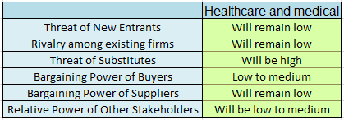

Infotainment
By 2018, the infotainment segment is expected to surpass the fitness and wellness segment, driven primarily by anticipated strong growth of smart watches and smart glasses. Products like smart watches, smart glasses and heads-up displays are becoming big news as the area of infotainment is just beginning to be explored. With this new exploration there is very much uncertainty as to how low or high the threat of new entrants may be in the near future. The same goes for rivalry among existing firms. The level of rivalry can vary greatly as there is much room in wearable technology for the leading firms to grow into, and all of the competing companies stand a fair chance to have a significant, longstanding impact in their respective fields. (FierceMobilIT, 2014) The bargaining power of buyers will shift a bit from a medium level to a low level in the near future as factors like: personalization, enhanced user experience, compactness, and convenience make a stronger impact on consumer buying habits. Infotainment will not have much of an effect on the bargaining power of suppliers and this force will remain at a low level. The relative power of other stakeholders is very much uncertain at this time and could be impacted greatly or not at all in this area depending on whether products that are developed and marketed are accepted by consumers on a mass level.
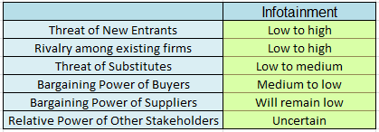

Fitness and Wellness
Currently, the fitness and wellness market is one of the largest markets in the wearable technology industry. The fitness market has been dominated by a number of popular tracking devices worn on the body, like Nike’s fuel band, Adidas miCoach, the Under Armour E39 shirt, and Fitbit tracking wristbands. Most of the popular products in this area, like smart clothing, activity monitors, and sleep sensors, are produced by companies that are well-established and have budgets R&D, thus entrants into this area are low. Rivalry among those companies is also low as each is pursuing different product ideas. The level of adoption of these products remains uncertain and relatively low at this time as well. The bargaining power of buyers remains low since this area is still a niche market for the most part. Demand for these products remains with very specialized groups, like: professional athletes, corporate wellness programs, and recreational fitness consumers. The bargaining power of suppliers is also low since so many suppliers have been saturating this area to provide components for products developed for fitness and wellness. Threat of substitute products is also low since there are not many substitutes for the products currently available in the market. Consumers are still learning about these products (like quality level, product differentiation, and price performance) and time will tell whether more similar products will be made available, thus creating a market where ease of substation will become a reality.

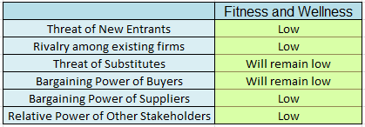

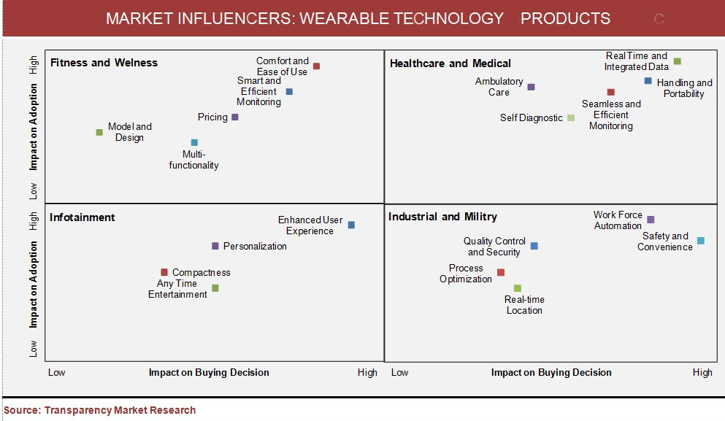
Graph retrieved from http://www.wearabletechworld.com/topics/from-the-experts/articles/323855-wearable-technology-next-mobility-market-booming.htm

Competitive Position of Major Companies and Competitor Analysis
ABI Research estimates the global market for wearable technology in health and fitness is the largest component of wearable technology products. This could reach 170 million devices by 2017. It is estimated that 60% of the wearable technology market can be attributed to sport and activity trackers in 2013. Juniper Research forecasts that the retail revenue from smart wearable devices, including smart watches and glasses, will reach $19 billion by 2018 compared to $1.4 billion this year.
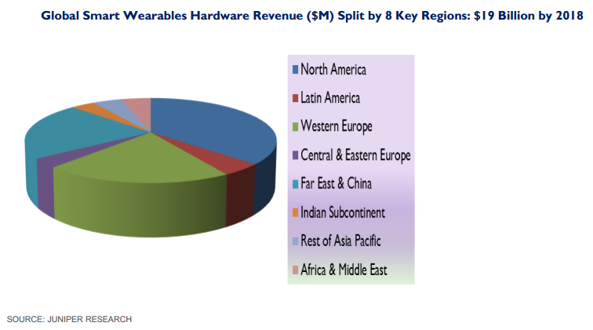

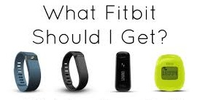
Location | 405 Howard Street  San Francisco, CA 94105
Number of Stores | Carried in over 20,000 North American retail stores
Sales | Not Public
Employees | Approximately 200
Financial Metrics | Not Public
Funding: Backed by | Foundry Group, Qualcomm Ventures, SAP Ventures, Softbank Capital, SoftTech VC, True Ventures
Price Point of wearable technology devices | $60.00 - $130.00

Fitbit is known for its products of the same name, which are activity trackers, wireless-enabled wearable devices that measure data such as the number of steps walked, quality of sleep, and other personal metrics.
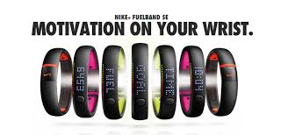
Location | One Bowerman Drive  Beaverton, OR 97005
Number of Stores | 338
Sales (entire company) | $24.1 Billion in 2012
Employees | 44,000
Financial Metrics: Consolidated Statements of Income | Nike’s equipment division saw an 18% increase in profit in 2012 due to Fuelband. Previous year profits were a -1% in 2011.
Funding | Public company; Nike is currently purchasing back billions of its public stock
Price Point of wearable technology devices | $149.00

Nike advertises its Fuelband as smart, simple and fun way to get more active. It is known for tracking an active life, “a universal way to measure movement for all kinds of activities.”
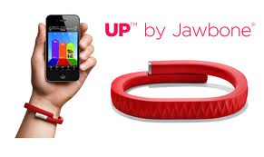
Location | 99 Rhode Island Street 3rd Floor  San Francisco, CA 94103
Number of Stores | Sold online and in electronic retail locations (i.e. Best Buy)
Sales | Not Public
Employees | 400
Financial Metrics: | Not Public
Funding: Backed by | Sequoia Capital, Khosla Ventures, and Andreessen Horowits
Price Point of wearable technology devices | $129.99

Jawbone UP integrates its product with a mobile app to help track “smarter choices.” The app displays movement and sleep details, delivers insights, and celebrates milestones.
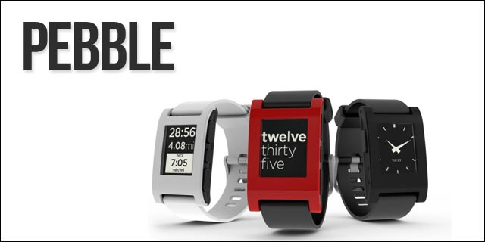
Location | 925 High Street  Palo Alto, CA 94301
Number of Stores | Sold online and in electronic retail locations (i.e. Best Buy)
Sales | Not Public
Employees | 85,000+
Financial Metrics | Not Public
Funding: Backed by | $25.70M (Series A; Product Crowdfunding; Angel); Kickstarters
Price Point of wearable technology devices | $149.99 - $249.99

Pebble is infinitely customizable, with downloadable watchfaces and useful internet-connected apps. Pebble connects to iPhone and Android smartphones using Bluetooth, alerting you with a silent vibration to incoming calls, emails and messages.
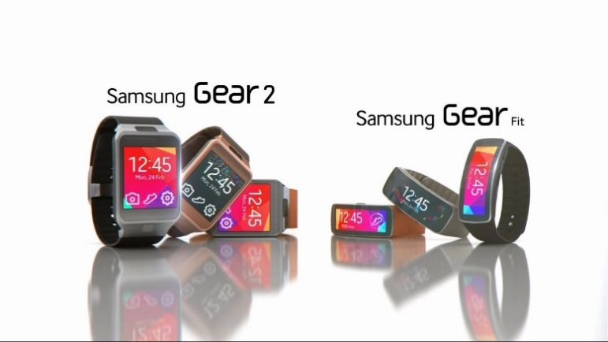
Location | Samsung Electronics USA Corporate Office Headquarters HQ  105 Challenger Road Ridgefield Park,  New Jersey 07660
Number of Stores | Sold online and in electronic retail locations (i.e. Best Buy)
Sales | 1.2 million watches sold in 2013
Employees | 236,000
Financial Metrics | Public company
Funding: Backed by | Not Public
Price Point of wearable technology devices | $199.99 - $299.99

This stylish wearable device connects seamlessly with your Samsung smartphone to make life easier on the go. With the Galaxy Gear on your wrist, you can control your phone, make calls and answer them, see new messages and more. When you're wearing your Samsung Galaxy Gear, you can answer and make calls from your wrist. It's always conveniently at hand whenever you need it. When you get an important notification on the GALAXY Gear, your phone will automatically show the message by picking up the phone.

Key Success Factors

Sustained Engagement - If a wearable device fails to have a meaningful impact on users’ behaviors and habits, it will not survive. To accomplish sustained engagement, the following factors need to be addressed:

Habit Formation: A device should help users form, and stick with, new habits Wearable devices have the potential to make the habit formation process more effective and efficient than ever before. Beyond merely presenting data (steps taken, calories burned, stairs climbed) and directly addressing the elements of the habit loop (cue, routine, reward), wearables ought to trigger the “deep-seated psychological sequences that lead to the establishment of new habits.” An example of such a wearable is the Basis Health Tracker, which sets up a sequence of key habit formation elements such as cues, routines, and rewards. Users are able to unlock the ability to add new habits after earning points upon completion of a previous goal related to successfully achieving a habit. These cues, routines, and rewards are continuously sequenced from there on out to develop habits for improved health.

Social Motivation: Motivation is the key to sustained engagement. A powerful source of motivation is social connection, which can be leveraged in a variety of creative ways. In addition to using social connections to influence behavior, social media and networking sites can be used to alter habits for positive outcomes. There are three important mechanisms that support motivation and attainment of goals. First, users tend to be more committed to achieving goals when they are able to share or compete for those goals. Second, the social cognitive theory suggests that we learn not just from our own experiences, but also vicariously from others around us. Third, social factors are major determinants in our overall health. Social connection is as basic a need as food, water, and shelter. “The extent to which wearables facilitate social connections has a broad secondary effect on users’ health and wellness.” Nike’s Fuelband SE Platform motivates users by leveraging social connections. Nike+ Platform users can challenge platform users through Facebook or contact lists. The Nike+ software allows users to categorize friends into specific lists and groups in order to compare activity with other Nike+ users and separate those friends into micro-communities based on a similar running pace, for example.

Goal Reinforcement: Another factor in the achievement of sustained engagement is the feeling of progress toward defined goals. Research shows that the achievement of several smaller goals provides the positive momentum needed to achieve bigger goals. Real-time updates that are powered by big data and insights are one way wearable technology can help people experience continuous progress. “Facilitating personal progress in this way leads to improved health, user satisfaction, and long-term sustained engagement.” Fitbit, for example, uses haptic buzzes and text-message push notifications to reinforce progress and remind its users of the necessary steps in order to achieve their set goals.

Aesthetics/Design - Wearable technology has to look good in order for a potential user to consider its purchase. Anything we wear as individuals communicates something about our identity. Beauty is not everything, but it is definitely an important consideration. To make a wearable device more aesthetically pleasing, designers should consider mixing classic forms with materials. Materials alone can help to make a product more beautiful. In regard to form, one of the many technology challenges that wearable designers run into is creating devices that are thin, flexible, and hold a smaller form. Many of the wearable devices being introduced to the wearable market are on the bigger and bulkier side because of what it takes to power them (batteries are an example). “As a wellness-management device, a trendy wristband heart rate monitor may be accepted as status symbol, whereas a wristband alarm device that looks too much like a technical aid may be considered stigmatizing by an elderly person.” Elderly people tend to prefer wearable devices that are smaller, less obtrusive and more discreet.

Fit/Comfort - Physical comfort and safety is an essential consideration when choosing a wearable device. Obviously, the size and weight of a device, and how it affects one’s body movement, affects comfort. The majority of users prefer wearable devices that have minimal bulk and weight. A significant barrier to acceptance is the fear that a device may cause physical harm.

Mobility - Everyone is mobile to one extent or another. For a wearable to be suitable for mobility, characteristics such as size, weight, placement, and attachment to the body must be considered.

Ease of Use - If a wearable device is perceived as being complicated and difficult to use, the user will tend to become anxious and worried about making mistakes that could potentially cause them bodily harm and/or inhibit effectiveness.

Selectability/Adoptability - Considering that many wearable players are entering the market, there are (and will continue to be) a wide variety of wearable devices from which to choose. Due to the variety of choices, potential consumers could become overwhelmed and avoid the purchase of a wearable altogether because they do not want to make “the wrong choice.” The frequency of such a dilemma can be lessened by providing potential consumers with a clear, relevant, and unique value proposition. Consumers need to know how a particular wearable product is better suited to meet their needs and wants than its competitors.

Setup Experience - A critical success factor that one may not initially think of is consumer setup experience.

User Experience - Once a user has purchased a device, they ought to have an immediately intuitive, familiar, and seamless experience. Such an experience must “transcend the device, the mobile app, web-services, and overall support.”

Lifestyle Compatibility - The less behavior change a device requires in order for a consumer to simply wear it the better. The chances of consumers engaging with a device long-term is greatly dependent upon the amount of time the user has to invest charging, syncing, or even removing, the device. It is important to consider design trade-offs such as size/weight vs. battery run-time.

Integratability - The integration of enhanced application programming interfaces (APIs) greatly improves a user’s overall wearable experience.

Durability - Wearables must be built to last. Wearables should be built to meet the physical demands anticipated within various environments. The wearable might be exposed to sweat, other bodily fluids, and rain regularly; it may be squeezed, dropped, and mechanically shocked constantly. If a particular wearable device failure is acceptable in a particular environment, the wearable must be setup to fail safely.

Overall Utility - Wearables need to benefit their users. If wearable devices and services built around them are not designed with a clear intent of how they will help people, they will not survive in the wearable market. Beyond gathering data, and simply providing distillations of that data, wearables need to enhance the user’s life in some way with that data.

Industry Matrix (See Appendix for an industry matrix on each of the following segments)

Fitness and Wellness:
Those designing/creating wearables in the fitness and wellness category should pay attention to all of the key success factors listed above. Sustained engagement factors, ease-of-use lifestyle compatibility, and integratability are especially important considerations. Wearable users in this segment desire relevancy and significance in regards to the data provided by the wearables.

Infotainment:
Predominate key success factors to consider within the infotainment segment of the market is integratability, user experience, aesthetics/design, and selectability/adoptability. Potential users within this segment are primarily concerned with convenient and enhanced entertainment. The success of an infotainment wearable is greatly dependent upon its Integratability capabilities.

Healthcare and Medical:
All of the key success factors listed above are important to consider for wearables. Wearables in this segment should feature clear, simple, and intuitive user interfaces. “Some patient populations may not have the experience, eyesight, or hearing acuity required to operate small controls or react appropriately to status indicators or alarms.” Complex setup and interactions should be taken care of by medical professionals. If possible, wearables in this segment should not be made with small, easily removable parts that could be unintentionally, or intentionally, disconnected from the device and render that device useless. These wearables are exposed to all of the activities and chaos of daily life. Healthcare and medical specific considerations are the following:

- Biocompatibility: wearables must comply with ISO 10993, which is an evaluation of a medical device’s biocompatibility. The acceptability of materials intended for patient contact is “classified based on the amount that the materials is expected to remain in contact with the patient.”
- IEC Standard 60601-1-11 and the FDA Draft Guidance for Industry and Food and Drug Administration Staff, Design Considerations for Devices Intended for Home Use: Wearable devices that are to be used at the patient’s home must follow these guidances. These guidances address safety and usability requirements that a wearable device or a system that includes a wearable device will need to meet.
- Electromagnetic Compatibility (EMC): Medical wearable devices worn in the home are subject to tighter EMC regulations than equipment intended for use in a healthcare facility.
- Wireless and Self-contained: When possible, wearables should be wireless and self-contained. Devices that are wired together in order to create a system when the device is being worn can cause patient discomfort and/or disconnect as the wires tug on the device components or become tangled in the patient’s clothing. Failure points are also a possibility.

Industrial and Military:
In the military segment, smart applications and devices will combined with those in the mobile health segment to make it possible to “monitor the physical activity and various other parameters of the soldiers condition and detect and resolve any physical or health problems if necessary.” An example of a wearable in this category is the BioHarness, which integrates into a shirt and measures the stress level of firemen, soldiers, and even astronauts. Another would be a sensor manufactured by a company called MC10 that is applied to helmets in order to identify possible head wounds. These sensors, which are placed inside a soldiers’ armor, “form complete monitoring systems for breathing, cardiac activity, body temperature, and other parameters that are helpful for training in missions and combat.” The future holds potential for combining these sensors with acoustical ones, allowing for bullet impact or trauma detections. If implemented, doctors would be able to treat affected areas more quickly and precisely.
Moreover, some wearables in this category are aimed at monitoring the physical condition and activity of a soldier while others are designed to improve mobility. For instance, a solar energy kit developed by various universities in the UK enables military uniforms to collect solar energy with photovoltaic cells. There also exist thermoelectric devices that convert temperature differences in electricity.

Furthermore, there are some equally incredible proposals being made for combat pilots. Currently in the works are systems for pilots of helicopters and other combat aircraft that do not require pilots to actually be inside the aircraft to operate it. Such a “situational awareness” system would allow the pilot to see, feel, and hear everything going on around the helicopter or plane without having to be physically seated in the cockpit. Though measured in the fitness and wellness segment, originally (and surprisingly), the Google Glass was designed for use within this segment to aid in combat situations.

Based on the assortment of wearables within the industrial and military segment, the aforementioned key success factors would all be relevant with the exception of habit formation, social motivation, and goal reinforcement. Some of the lesser important, but still considerable, factors include aesthetics, setup experience, and lifestyle compatibility. Ease of use is also considerable; however, industrial and military wearables are known to be more complex when considering than the majority of wearables in other segments. Wearables in this segment ought to deliver in terms of mobility, durability, comfort, integratability, user experience, and overall utility.

INDUSTRY MATRIX (See Appendix for an industry matrix on each of the following segments)

Industry Prospects and Overall Attractiveness

TRENDS
Wearable technology has continued to be one of the hottest trends in the technology world. At every big tech event, the number of wearable devices available to consumers from wristbands, watches, gloves to glasses, helmets and armbands keeps growing at an exponential rate. These wearable devices can lead to revolutionary product offerings. “The future is already here, it’s just not evenly distributed yet,” famously noted by William Gibson. Right now is an exciting time for watching the wearable market trends because nobody knows which way it’s going to go!

Enterprise
With the integration of the internet in enterprises, wearable technology can also be intertwined with the existing technology. The possibilities vary greatly across the different industry of how wearables can be incorporated. “For example, shoppers could pick up a wearable device and engage in virtualized shopping, scanning outfits to see what they look like on virtual versions of themselves.” In a business environment there are potential opportunities to aid in increased productivity and enhancement security. Here are a few example possibilities of how wearables can be incorporated into the enterprise system from the article written by Tom Bice:
- Augmented Reality (AR): With wearable devices such as Google Glass, businesses have an opportunity to create very personalized and efficient office experiences throught AR and GPS. Human resources could offer new employees guided tours withi commentary and details as well as reality sessions could be implemented for employee training that is customized to each user based on data the device gathers through the session.
- Improved Productivity & Support: As wearable technology adoption increases, anyone in the customer service business could enable a better experience by allowing service representatives to see what the customer sees. From a retail perspective, a support person could see a damaged product and help a customer fix the issue first hand, or verify it is unfixable and discuss next steps for a replacement or refund, thus enhancing the customer experience.

- Collaboration: As adoption becomes more widespread, we’ll see enhanced hands-free collaboration and productivity. Voice recognition will continue to improve, becoming much quicker and more fluid so that employees can call up orders and charts quickly to enable more efficient meetings. If wearables can integrate with existing enterprise collaboration tools, we may be able to take this a step further by instantly sharing screens, allowing business colleague across the county to see what I see through tech such as Google Glass.

There are also several other ways the enterprise could benefit from employees use of wearable computing devices. “For example, Eurotech’s Zypad delivers a wrist-mounted mini-PC to those needing high-tech mobility and connectivity in the field, such as emergency personnel, search-and-rescue teams, warehouse workers or anyone on the move.” Smartglasses are capable of displaying schematics to a technician repairing a specialized piece of machinery; all the information the worker needs would be right before their eyes. The opportunities are here for enterprises and whether or not they are ready for the next change in technology, it is here and at their door step.

Healthcare
We have seen many breakthroughs in the healthcare industry and it is changing rapidly, due to technology. With rapid developments in wearable technologies consumers now have the ability to virtually track their health everywhere they go. Apple is most likely planning to introduce some type of health and fitness solution device to the wearable market and history has shown, Apple has the ability to change behaviors and expectations of people around the world. Apple has been involved with the medical industry lately by meeting with the Food and Drug Administration which suggests that Apple is interested in more than just apps to take to the gym. “There’s a very large opportunity for health monitoring, As we get older, we want to monitor our health more--our heart rate, our blood pressure...” Angela Mclntyre (Mclntyre) a Gartner research director.

Apple has various ways it could use to serve as a hub of sorts for the kind of data people have begun keeping track of, “We could all have an account and be part of an Apple community...get information about healthier living, connect with people who have similar goals or health concerns.” (Mclntyre) Apple doesn’t necessarily have to specifically focus on healthcare, but more on the consumer and let people make healthcare more applicable for themselves.

The greatest potential impact of wearable technology lies in healthcare. “Wearable technology has started to revolutionize health care by assisting doctors in the operating room and providing real time access to electronic health records.” Wearable technology goes beyond directly assisting doctors, patients can now continuously monitor their own health. With the acceptance of wearables from consumers this is the perfect application to incorporate into healthcare. David Peterson, Chief Marketing Officer for Emdeon, a company well-experienced in linking healthcare payers, provider and vendors, believes that the adoption of wearable-healthcare-related devices could be an significant step in patient engagement which will in turn improve population health which also happen critical success factors driving today’s increasingly complex healthcare environment. Wearable health technology brings three beneficial trends to the table, connected information, community and gamification. “By harnessing this trifecta, health care leaders have new ways to build engagement and create accurate, far-reaching views of both personal and population health.”

Futuristic Fashion Wear
The movie “Back to the Future” wasn’t too far off with its wacky ideas of how people in the future would use clothing that was “smart” and use glasses to watch TV (internet). There are designers that are currently creating apparel, accessories and fitness wear that can do everything from monitor your heart rate to charge your smartphone. Wearable technology is becoming more than Google Glasses and smart wrist bands or watches. The wearable craze is taking on new advancements and innovations every day. With flexible solar panels, it has inspired designers to come up with clothes and accessories that can power electronics. “Start-up Wearable Solar is using the technology to make lightweight wired garments that enable the wearer to charge a smartphone up to 50 percent if worn in the sun for a full hour.”

As chips and printed circuits get smaller and smaller the techy clothing becomes easier to make. In 2008 TechRadar reported miniature mechanical power plants being developed by the Georgia Institute of Technology where electricity-generating wires create a charge when stretched and releases, and if woven into a pair of trousers it could generate enough electricity to charge wearable sensors. In the future wearable technology can also spawn clothing that requires less water to clean and contain washable electronic circuitry. “When clothing is able to monitor the local environment and wireless networks, they’ll present an incredible opportunity, not just for the health-wise and sporty, but for retailers as well.”

Security
Most of the hype of wearable technology has been focused on consumer applications, fitness and healthcare but there is another potential market that has been less talked about and that is security. There are companies mapping sophisticated identity management and access control technology to hardware. We could see in the near future people using wearable devices to unlock devices, home, cars, offices, etc.

Home security is a huge market and according to IBISWorld, security alarm service firms alone will amass $16.8 billion in revenue in 2013 and revenues are expected to increase by 2.8% annually in the next five years. The expected growth is powered by innovation technology. Bionym’s Nymi bracelet offers a fresh solution to identification and access control. “Based on the principle that everyone’s electrocardiogram (ECG) is as unique as a fingerprint or retina, Nymi identifies users and grants them access to compatible electronic devices, doors and even bank accounts.” Nymi offers a more secure solution that doesn’t depend solely on physical attributes because unlike a fingerprint, a copy of your ECG cannot be easily lifted. “It is inevitable that new identification and access technologies and services will cause disruption in the home and business security market.” We are not far from a future where homeowners and business operators will able to manage their premises from anywhere with a wearable device using some combination of sensor, image recognition, or motion capture.

Potential Threats
Although wearable technology seems to have caught the attention of the masses will it just fade out and not be adopted by the consumer industry? In technical fields such as doctors, one can easily see how wearable technology will fit in nicely and complement the work well, but from a consumer standpoint it may not seem as necessary to own a wearable device. Below are potential negative aspects of the growing wearable craze that industry participants should we cognoscente of.

Fad or Future?
There are tons of reports trumpeting prospects of the wearable sector estimating the shipments of wearables. It’s typical when industries are in their infancy stage for them to go through hypergrowth. All the forecasts should be taken with a grain of salt. “Imagine what a 2007 forecast about smartphone would have projected for 2013 - and just how woefully it would be undershot realist.” It’s not clear that wearable technology can be a sure thing because technology lies in creating entirely new classes of products, forging new markets and making people realize they have been missing certain things in their lives. Wearables could become the next smartphone and blow out the young market or it could just be a fad that will fade out.

While looking at the smartphone it represents important innovations to a series of mass behaviors. Before the iPhone and other smartphones came along people were already carrying around their music, making phone calls, taking pictures, sending emails, playing games and accessing information through the internet. Society was already accustomed to carrying objects around, having to plug them in to charge them and using them on a daily basis. So when smartphones came along it made doing all those things listed above much more convenient in an all-in-one place. There wasn’t a huge change for consumers by switching to smartphones that required a difference in their behavior.

Wearable technology on the other hand is asking more of their customers. Customers will need to develop new habits and need to stick with them. “The idea behind many wearable tech products is not simply to sell the hardware, but also to sell services like, diet and exercise advice to go along with your Up band.” Wearable technology is requiring people to incorporate these new gadgets into their daily routine when they haven’t previously. Unlike a smartphone, wearable technology is an add-on, it’s something that comes on top.

Have you ever left the house and forgot your phone and it leaves you feeling somewhat “naked” like something is missing? We as consumers have grown so attached to using our phones for everything. These days we use smartphones as communication device for e-mail, music, work and various other activities, which usually you can’t get through your day without it. Wearable technology on the other hand is just an add-on, a new accessory that you can get through your day without. For example, a person that wears prescription glasses literally won’t be able to leave the house or get out of bed without them. If that same person were to leave the house without their Google glasses, they would be able to function perfectly without them.

Fitness nuts on the other hand I’m sure would see the value in a wearable device because it would help measure everything the person does. At this time the vast majority of people I would say are mostly indifferent to the wearable market.

Lack Innovation: Infographic
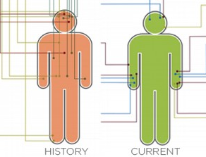
A survey was conducted about consumer preferences in wearable technology paired with an analysis of the tech trends history and current options in the market. From the picture displayed above a gap between consumer needs and current market options exists because the wearables are falling short of expectations. “Most consumers (75%) are open to having wearable devices learn from their behavior. Consumers picked the hand as the best place for wearable technology and said the wrist was the worst. Of the 16 wearable technologies featured, 63% are worn on the wrist.”

There are still lots of gaps between consumer knowledge of the wearable market and how the product will integrate into their lifestyle. There is a vast majority of consumers eager to try a wearable device but adoption is still on the low side. Consumer adoption to the wearable market is a key factor for its success.

Power
We’ve come to a point where consumer electronics is becoming highly advanced and becoming smaller and yet more powerful. Consumers are using smartphones in ways we couldn’t of even imagined a decade ago. However an issue and limitation wearables have to overcome is battery life. Compared to smartphones, wearable devices have much smaller screens because they themselves are tiny and yet they have little to no room to store a battery. In a survey I conducted for another class consumers expressed the limitation on battery life and how they wanted it to last longer.
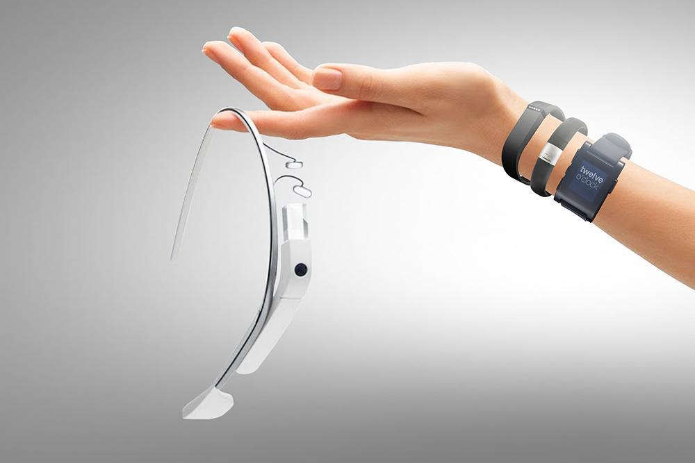

Until a “super” battery becomes available that promises higher energy density, extended cell lives and reduced charging times it will be a long while until we see this on the market commercially. Even when a battery like this will become available it will most likely come at a high price. Until the “super” battery gets here manufacturers of wearable devices are making compromises. “With Google Glass, for instance, this has led to a rather bulky battery compartment that lives behind your right ear.” Designs in the future may be different where the battery is separate from the main hardware but in all reality there has to be some kind of battery to power the device. Manufacturers have the hurdle of trying to tuck away the bulky battery somehow.

Connectivity
With wearable gear and its access to data at the moment it is tethered. Wearable gear isn’t pulling updates or information off of a cell tower itself instead it is drawing the data through some other device such as a smartphone or tablet. Wearables pull information from other devices through bluetooth connection. I’m sure this will progress and wearable will eventually work autonomously but how are consumers going to pay for that data? For instance if the data was retrieved from cellular towers what are those companies going to charge consumers for the use? Right now cellular companies are already “pushing their luck” with charging users once for smartphone data connections and again for tables. When another data device is added such as a wearable watch how much more will the consumer have to pay? There will come a point where the nickel-and-diming becomes too much to stand.

Conclusion
Though the wearable technology industry is relatively new and viewed by some as merely a “fad,” it has already shown incredible market growth and has the potential for even greater future growth. Through 2018, we see North America experiencing the largest wearable growth, followed by Europe, and then Asia-Pacific. Since the 1960s, when the military created the headgear with displays for aviators in combat which were the first wearable technology, companies large and small have been developing technology with expectations that demand for wearable tech products would explode. Most recently, technology has reached a level that has enabled companies to make science fiction movie fantasies functional realities. Throughout the report, we analyzed the global market and presented detailed insights of the market by technology, products and components, applications and form factor, and geographies. We also presented a detailed analysis on the drivers, restraints, and opportunities of the market, along with an quantitative six forces Porter’s analysis of the market.
Because there is prediction of huge market expansion, there will be many entrants joining the mix over the next few years. Some of the major trends that are encouraging wearable expansion are increased enterprise efficiency and productivity, improved healthcare, and the need for enhanced security.

To achieve, and maintain, strong positioning, wearable tech companies need to consider key success factors, such as sustained engagement, ease of use, integratability, durability, user experience, comfort, design, and mobility. Wearables must demonstrate overall uniqueness and quality in order to beat out its competitors. In the fitness and wellness segment, for example, the Fitbit has established a leading position in the minds of wearables users. Its differentiation is clear.
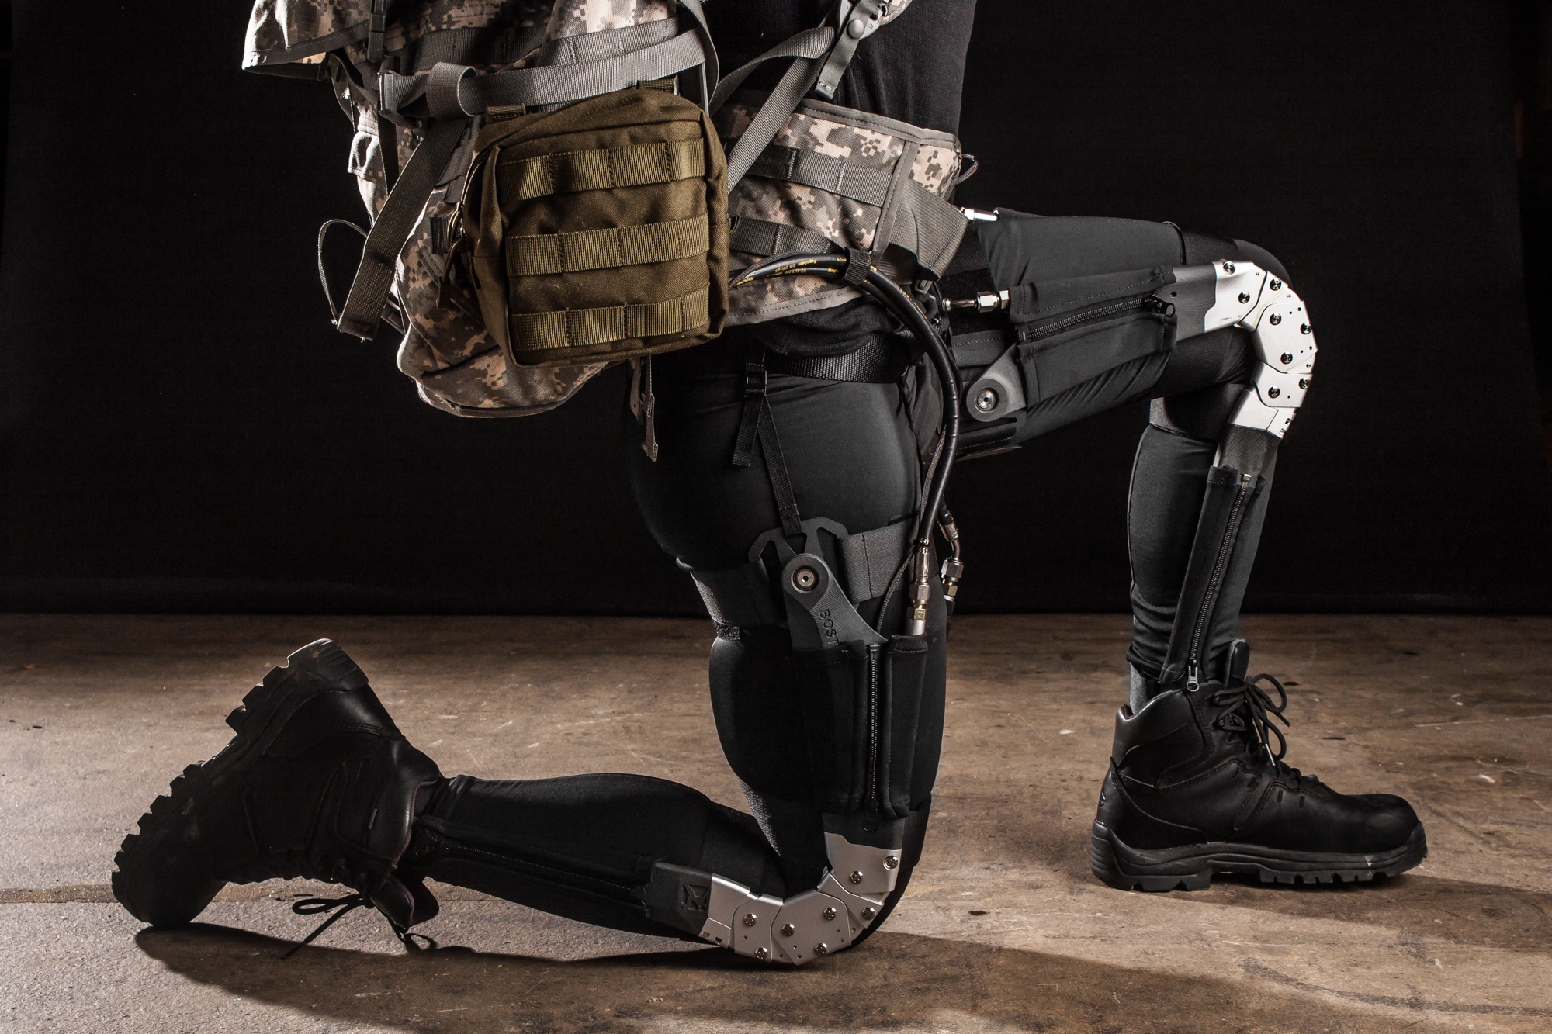
As we look to the future, we can expect to see Iron-Man-like soldier suits, clothes that go transparent when the wearer’s heart races, a quilted onesie that doubles as a Wi-Fi hotspot, clothing with in-built solar panels, devices that scan one’s body for disease, and self-repairing trainers.

And to end with some “fun” facts:
- Five of the ten all-time top funded design projects on Kickstarter are wearable devices
- To our knowledge, the most expensive device is Mirama Digital Glasses at $29,400, and the least expensive is MOV Band at $19.
- The most popular component of wearable devices is an accelerometer
- There exist 58 devices with a clock, 4 devices with an EMG sensor, but only 2 devices with a textile strain sensor.
- Chris Dancy has been labeled the “most connected human on earth“. He uses a variety of devices to track what he eats, when he sleeps, as well as the environment around him. Dancy has built his own personalized surveillance grid in his home that, “…is also hooked up with numerous sensors for products such as the smartphone-controlled Hue lighting system and a Beddit mattress cover, which collects data on his sleep. The dedicated technophile also tracks the progress of his two dogs by collecting data on their daily activities via pet GPS system, Tagg.” While Dancy is on the fringe at the moment, this kind of personal data collection through wearable technology could become common place for the average individual in the near future. But will the people accept it? IBM recently announced that we need to embrace the fact that “everything will be monitored” in an era of pervasive biometric surveillance. According to Peter Waggett, the Program Leader at IBM’s Emerging Technology Group, “The information is out of the bottle already.”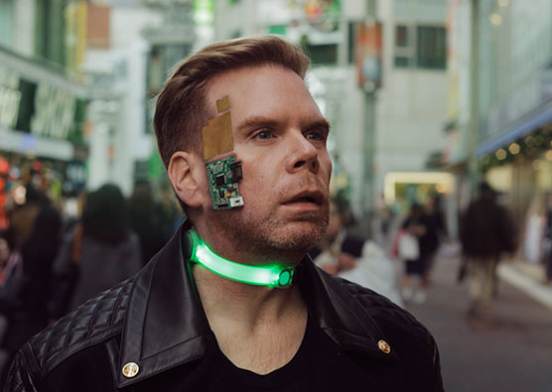

Key Take-Aways
- The global market’s volume is expected to reach 134.27 million units by 2018, growing at a CAGR of 30.36% for the five year period of 2013 to 2018.
- The wearable technology ecosystem market revenue was $4.3 billion as of 2012 and is expected to reach to $14.0 billion by 2018, growing at an estimated CAGR of 18.93 % from 2013 to 2018.
- The global smart, intelligent, digital & interactive fabrics market revenue was $708.31 million as of 2012 and is expected to reach to $2.03 billion by 2018, growing at an estimated CAGR of 17.7 % from 2013 to 2018.
- Components accounted for the largest percentage share of the overall revenue of global wearable technology, i.e. 66.2% in 2012 ($1.83 billion) in 2012 and is expected to account for 73.0% of the total market in 2018.
- Product shipments are likely to experience the highest growth at a CAGR of 53.07% from 2013 to 2018, reaching a volume of 2.7 billion units in 2018.

Appendix
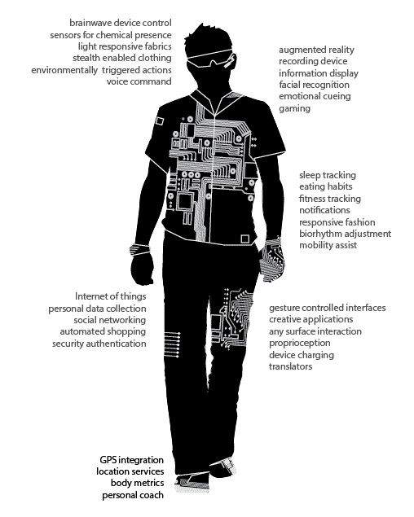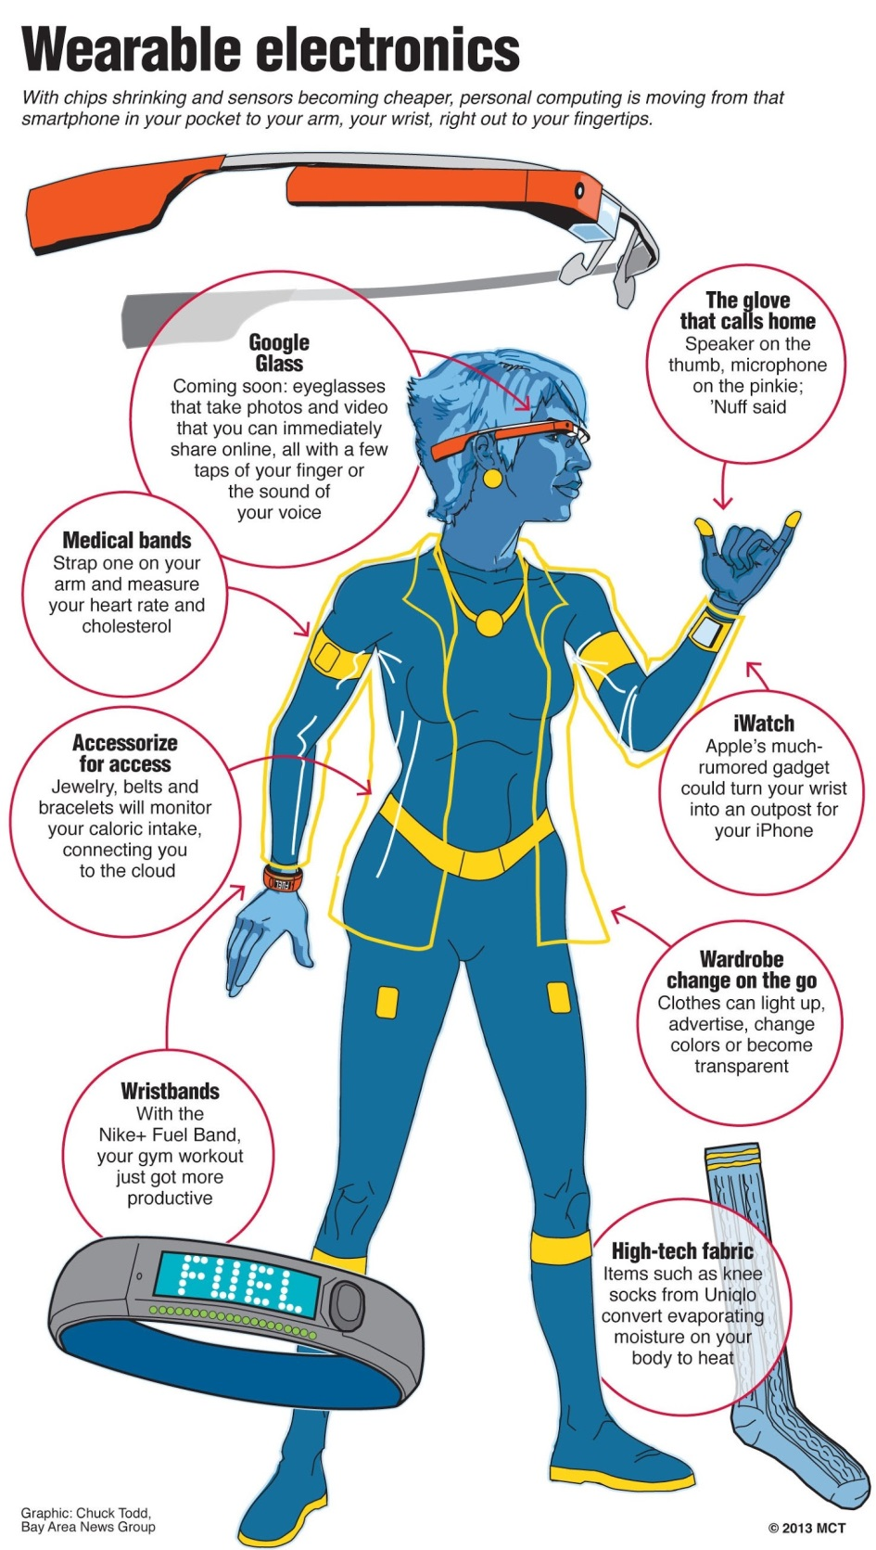

INDUSTRY MATRICES BY SEGMENT:

Fitness and Health:

BasisB1: Features one of the largest arrays of sensors on a wristband. It measures REM, light and deep sleep as well as activity duration and calories burned. The objective of this device is to reduce stress and increase performance.

Nike Fuelband SE: Activity monitor that measures user’s movement throughout the day. User submits their height, weight, age, and gender to increase the accuracy of the band. Determines calories, steps, and NikeFuel (Nike’s proprietary metric for quantifying daily activity levels).

Fitbit Force: Wristband that provides real-time stats on a user’s daily fitness activity. Uses leading edge sensor technology that tracks all active minutes throughout the day. Equipped with wireless connectivity abilities that allows wristband to sync automatically to computers and smart phones.

Jawbone UP: A wrist-worn motion, sleep, and diet recorder. Tracks weight, evaluates sleep patterns and moods, offers food libraries and logs workout sessions.

Polar Loop: An activity monitor that provides 24/7 activity tracking as well as sleep monitoring. Calculates calories burned, sleep duration and quality, as well as inactivity.

Withings Pulse: 8-gram tracker that monitors user’s daily activities and heart rate. Features multiple functions which include monitoring fitness statistics, analyzing sleep cycles, measuring heart rate and calculating nutrition intake. Data can be displayed on smart phones in easy-to-read graphs.

Key Success Factors:  Fitness and Wellness | Weight | Basis B1 Rating | Basis B1 Weight | Nike Fuelband SE Rating | Nike Fuelband SE Weight | Fitbit Force Rating | Fitbit Force Weight
Habit Formation | .1 | 5 | .5 | 3 | .3 | 4 | .4
Social Motivation | .1 | 2 | .2 | 3 | .3 | 5 | .5
Goal Reinforcement | .1 | 5 | .5 | 3 | .3 | 4 | .4
Aesthetics/Design | .05 | 3 | .15 | 5 | .25 | 4 | .2
Fit/Comfort | .05 | 3 | .15 | 3 | .15 | 4 | .2
Mobility | .05 | 4 | .2 | 4 | .2 | 5 | .25
Ease of Use | .05 | 5 | .25 | 3 | .15 | 4 | .2
Selectability/Adoptability | .05 | 5 | .25 | 5 | .25 | 4 | .2
Setup Experience | .05 | 5 | .25 | 5 | .25 | 4 | .2
User Experience | .05 | 4 | .2 | 5 | .25 | 4 | .2
Lifestyle Compatibility | .1 | 4 | .4 | 2 | .2 | 5 | .5
Integratability | .08 | 1 | .08 | 3 | .24 | 5 | .4
Durability | .05 | 5 | .25 | 5 | .25 | 4 | .2
Overall Utility | .05 | 5 | .25 | 3 | .15 | 4 | .2
Total | 1.0 | 4 | 3.6 | 3.7 | 3.2 | 4.2 | 4.1

Key Success Factors:  Fitness and Wellness | Weight | Jawbone Rating | Jawbone Weight | Polar Loop Rating | Polar Loop Weight | Withings Pulse Rating | Withings Pulse Weight
Habit Formation | .1 | 4 | .4 | 4 | .4 | 3 | .3
Social Motivation | .1 | 3 | .3 | 5 | .3 | 4 | .4
Goal Reinforcement | .1 | 4 | .4 | 5 | .5 | 4 | .4
Aesthetics/Design | .05 | 5 | .25 | 4 | .2 | 4 | .2
Fit/Comfort | .05 | 4 | .2 | 4 | .2 | 3 | .15
Mobility | .05 | 5 | .25 | 5 | .25 | 2 | .1
Ease of Use | .05 | 3 | .15 | 3 | .15 | 3 | .15
Selectability/Adoptability | .05 | 3 | .25 | 5 | .25 | 3 | .15
Setup Experience | .05 | 3 | .15 | 2 | .1 | 2 | .1
User Experience | .05 | 4 | .2 | 5 | .25 | 3 | .15
Lifestyle Compatibility | .1 | 3 | .3 | 4 | .4 | 2 | .2
Integratability | .08 | 2 | .16 | 3 | .24 | 3 | .24
Durability | .05 | 3 | .15 | 4 | .2 | 2 | .1
Overall Utility | .05 | 4 | .2 | 5 | .25 | 3 | .15
Total | 1.0 | 3.6 | 3.4 | 4.1 | 3.7 | 2.9 | 2.8

INFOTAINMENT:

GoPro: The GoPro is a high-definition personal camera that is known for being a lightweight, rugged, wearable or mountable device.

Pebble Smartwatch: An e-ink display smart watch that first garnered its success from its famous crowd funding campaign. Features an always-on e-ink display and a host of native applications.

Google Glass: head-mounted wearables computer that projects a transparent screen in front of the user’s field of vision. Similar to a pair of glasses and contains a prism display above the user’s right eye. Combined with its other componentry and software, the Google Glass has similar capabilities to that of a SmartPhone.

Key Success Factors:  Infotainment | Weight | GoPro Rating | GoPro Weight | Pebble Smartwatch  Rating | Pebble Smartwatch  Weight | Google Glass  Rating | Google Glass  Weight
Aesthetics/Design | .2 | 4 | .8 | 2 | .4 | 5 | 1
Fit/Comfort | .05 | 3 | .15 | 3 | .15 | 3 | .15
Mobility | .05 | 5 | .25 | 4 | .2 | 5 | .25
Ease of Use | .1 | 4 | .4 | 3 | .3 | 4 | .4
Setup Experience | .05 | 5 | .25 | 5 | .25 | 4 | .2
User Experience | .2 | 5 | 1 | 4 | .8 | 5 | 1
Lifestyle Compatibility | .05 | 5 | .25 | 4 | .2 | 5 | .25
Integratability | .2 | 3 | .6 | 2 | .4 | 4 | .8
Durability | .1 | 5 | .5 | 4 | .4 | 5 | .5
Total | 1 | 3.9 | 4.2 | 3.1 | 3.1 | 4.0 | 4.6

HEALTHCARE AND MEDICAL

MC10 BioStamp: A smaller-than-a-Band-Aid device that provides full-time monitoring of signs, such as heart-rate and brain activity. The device streams the data to a user’s smartphone or physician.
Phyode W/Me: A Heart rate monitor that uses heart rate variability to determine respiration, emotion, and automatic nervous system state. Pairs with a mobile application that can be used to assist with tracking data and also provides breathing exercises.
IMEC EEG Headset: A wearable health monitor with electroencephalographic (EEG) capabilities. Designed to be worn during daily activities and allows for comfortable, continuous, and reliable health monitoring.

Key Success Factors:  Healthcare and Medical | Weight | MC10 BioStamp Rating | MC10 BioStamp Weight | Phyode W/Me  Rating | Phyode W/Me  Weight | IMEC EEG  Headset Rating | IMEC EEG  Headset Weight
Fit/Comfort | .2 | 4 | .8 | 4 | .8 | 2 | .4
Mobility | .1 | 3 | .3 | 4 | .4 | 4 | .4
Ease of Use | .1 | 5 | .5 | 5 | .5 | 5 | .5
Durability | .1 | 3 | .3 | 4 | .4 | 4 | .4
Setup Experience | .05 | 4 | .2 | 5 | .25 | 5 | .25
User Experience | .2 | 3 | .6 | 4 | .8 | 4 | .8
Lifestyle Compatibility | .1 | 3 | .3 | 4 | .4 | 5 | .5
Integratability | .1 | 2 | .2 | 3 | .3 | 2 | .2
Overall Utility | .05 | 3 | .15 | 4 | .2 | 4 | .2
Total | 1.0 | 3.3 | 3.4 | 4.1 | 4.05 | 3.8 | 3.7

Industrial and Military

Zephyr BioHarness: An advanced Physiological Monitoring Module that incorporates class one BlueTooth technology, has a smaller form factor, and provides heart rate, breathing rate, and 3-axis accelerometery. It is built to meet the needs of Professional Athletes, NASA and U.S. Special Operations, the BioHarness 3 is so technologically advanced that other systems were based on it.

Q-Warrior: high-tech headset system designed to live-stream data to soldiers; gives soldiers the ability to track the location of friendlies and enemies, watch live video from different feeds (including drones), and display 3D maps of the battlefield as well as the zones outside their field of vision in real-time.
Ratheon’s Aviation Warrior: Includes a helmet equipped with a flip-down viewing monocle and taps into the cockpit’s digital display. The system provides access to important tolls that help Army helicopter pilots maintain “situational awareness.”

Key Success Factors:  Industrial and Military | Weight | Zephyr BioHarness Rating | Zephyr BioHarness Weight | Q-Warrior  Rating | Q-Warrior  Weight | Raytheon’s Aviation Warrior Rating | Raytheon’s Aviation Warrior Weight
Fit/Comfort | .1 | 3 | .3 | 3 | .3 | 3 | .3
Mobility | .2 | 5 | 1 | 5 | 1 | 5 | 1
Ease of Use | .1 | 5 | .5 | 3 | .3 | 3 | .3
Durability | .2 | 4 | .8 | 4 | .8 | 3 | .6
User Experience | .1 | 3 | .3 | 5 | .5 | 4 | .4
Integratability | .2 | 3 | .6 | 5 | 1 | 4 | .8
Overall Utility | .1 | 3 | .3 | 4 | .4 | 4 | .4
Total | 1.0 | 3.7 | 3.8 | 4.1 | 4.3 | 3.7 | 3.8

References
ABI Research, (2013, February 21). Wearable Computing Devices, Like Apple’s iWatch, Will Exceed 485 Million Annual Shipments by 2018. Retrieved from https://www.abiresearch.com/press/wearable-computing-devices-like-apples-iwatch-will
Afshar, V., (2014, May 4). “Wearable Technology: The Coming Revolution in Healthcare,” Huff Post. Retrieved on May 10, 2014 from http://www.huffingtonpost.com/vala-afshar/wearable-technology-the-c_b_5263547.html
"BAE Systems and Its Version of Google Glass for Military Application." BAE Systems
and Its Version of Google Glass for Military Application. N.p., n.d. Web. 10 May
2014. <http://www.wearabletechworld.com/topics/wearable-tech/articles/373439-
bae-systems-its-version-google-glass-military-application.htm>.
Basis B1 | Vandrico Inc. (n.d.). Basis B1 | Vandrico Inc. Retrieved May 14, 2014, from
<http://vandrico.com/device/basis-b1>.
Bice, T., (2014) “Is Wearable Technology a Real Possibility for the Enterprise?” Innovation Insights. Retrieved May 11, 2014 from http://insights.wired.com/profiles/blogs/is-wearable-technology-a-real-possibility-for-the-enterprise#axzz31ubLeBBL
"BioHarness 3 - Wireless Professional Heart Rate & Physiological Monitor with
Bluetooth." www.zephyranywherestore.com. N.p., n.d. Web. 16 May 2014.
<http://www.zephyranywherestore.com/BioHarness-Wireless-Professional-
Physiological-Bluetooth/dp/B009ZUWWG6>.
Boxall, A. (2014, February 13). 2 million smartwatches were sold last year, and Galaxy Gear is leading. Digital Trends. Retrieved May 7, 2014, from http://www.digitaltrends.com/mobile/galaxy-gear-top-selling-smartwatch/#!LoNPT
Buenaflor, Cherrylyn and Kim, Hee-Cheol. (2013, May). “Six Human Factors to
Acceptability of Wearable Computers.” Int’l Journal of Multimedia and Ubiquitous
Engineering. Retrieved May 10, 2014, from http://www.sersc.org/journals/IJMUE/vol8_no3_2013/10.pdf
Chu, Dominic, and Jessica Golden. "Nike's Latest Wearable Technology: FuelBand SE."CNBC.com. CNBC LLC, 16 Oct. 2013. Web. 1 May 2013.

Clinch, M. (12 Feb. 2014). Wearable smart bands set for 350% growth in 2014. (n.d.).

CNBC.com. Retrieved May 13, 2014, from http://www.cnbc.com/id/101410507
"Consolidated Statements of Income." Nike. Nike, Inc., 31 May 2013. Web. 1 May 2014.
CNBC. (2014) “Future Fashion: 10 Wearable Tech Trends to Watch.” CNBC. Retrieved May 11, 2014 from http://www.cnbc.com/id/100853138/page/2
David Stern, A. Kane, A. Memarzadeh, and M. Zubkov, “How wearable technology will upturn the security industry,” Cite World. Retrieved on May 14, 2014 from http://www.citeworld.com/article/2114755/mobile-byod/how-wearable-technology-will-upturn-the-security-industry.html
"Developing a Better Wearable Medical Device â“ 14 Critical Issues to Consider."
Medical Plastics News. N.p., n.d. Web. 10 May 2014.
http://www.medicalplasticsnews.com/opinion/developing-a-better-wearable-medical-device-–-14-critical-is/
Dimensional Innovation. (nd) “Wearable Technology Lacks Innovation: Infographic.” Dimensional Innovations. Retrieved May 9, 2014 from http://www.dimin.com/blog/wearable-technology-lacks-innovation-infographic/
"Experience the Amazing Exynos by Visiting Samsung Exynos Website.." Samsung
Exynos. N.p., n.d. Web. 10 May 2014.
<http://www.samsung.com/global/business/semiconductor/minisite/Exynos/blog_The_Future_of_Wearables.html>
FierceMobileIT, (2014, April 15). '2014 will be the crowning year for wearable technology, with the global market growing exponentially both in terms of revenue and the number of devices introduced,' says latest Visiongain report. Retrieved from http://www.fiercemobileit.com/press-releases/2014-will-be-crowning-year-wearable-technology-global-market-growing-expone
Fitbit Force | Vandrico Inc. (n.d). FitbitForce | Vandrico Inc. Web. 14 May 2014, from
<http://vandrico.com/device/Fitbit-force>.
Google Glass | Vandrico Inc. (n.d). GoogleGlass | Vandrico Inc. Web. 14 May
2014, from <http://vandrico.com/device/google-glass>.
GoPro. (n.d.) Wikipedia. Web. Retrieved on May 11, 2014, from
<http://en.wikipedia.org/wiki/GoPro>.
Gordon, P.J., (1997). Ten strategic audit questions. Business Horizons, 40(5), 7-14.
Harshalone, (2010, November 18). Porter’s 5 Forces analysis [Web log comment]. Retrieved from http://lonare.blog.com/2010/11/18/porters-5-forces-analysis/
IMEC EEG Headset | Vandrico Inc. (n.d). NikeFuelbandSE | Vandrico Inc. Web. 14 May
2014, from <http://vandrico.com/device/imec-eeg-headset>.
Inside Wearables: How the Science of Human Behavior Change Offers the Secret to
Long-Term Engagement. (2014, January). Endeavor Partners. Retrieved May 2,
2014, from
http://endeavourpartners.net/assets/Endeavour-Partners-Wearables-White-Paper-20141.pdf
Jawbone UP | Vandrico Inc. (n.d). JawboneUP | Vandrico Inc. Web. 14 May 2014, from
<http://vandrico.com/device/jawbone>.
Lomas, N. (2014). Wearables Market Heating Up, With More Than 17M Bands
Forecast To Ship This Year, Says Canalys | TechCrunch. TechCrunch. Retrieved May 13, 2014, from http://techcrunch.com/2014/02/12/wearables-market-heating-up/
MC10 pushes wearable sensors with Medtronic co-sign. (n.d.). FierceMedicalDevices.
Retrieved May 16, 2014, from http://www.fiercemedicaldevices.com/story/mc10-
pushes-wearable-sensors-medtronic-co-sign/2013-06-14
Nike Fuelband SE | Vandrico Inc. (n.d). NikeFuelbandSE | Vandrico Inc. Web. 14 May
2014, from <http://vandrico.com/device/nike-fuelband-se>.
"Pilot of the future: U.S. Army gets wearable tech for the battlefield - CNET." CNET.
N.p., n.d. Web. 10 May 2014. <http://www.cnet.com/news/pilot-of-the-future-u-s-
army-gets-wearable-tech-for-the-battlefield/>.
Polar Loop | Vandrico Inc. (n.d). PolarLoop | Vandrico Inc. Web. 14 May 2014, from
<http://vandrico.com/device/Polar-Loop>.
Ranck, J. (2012, July). The wearable computing market: a global analysis Retrieved May 15, 2014, from http://go.gigaom.com/rs/gigaom/images/wearable-computing-the-next-big-thing-in-tech.pdf
Rossler, E. (2013, September 12). Jawbone Closes $100M in New Funding to Push Mobile, Wearable Tech. mHealthWatch. Retrieved May 14, 2014, from http://mhealthwatch.com/jawbone-closes-100m-in-new-funding-to-push-mobile-wearable-tech-21605/
Say, M. (2013, May 21). 3 Ways Wearable Tech Can Make You More Profitable. Forbes. Retrieved May 16, 2014, from http://www.forbes.com/sites/groupthink/2013/05/21/3-ways-wearable-tech-can-make-you-more-profitable/
Stinson, B. (2014) “How wearables became the key tech trend of 2014”. Techradar. Retrieved May 14, 2014 from www.techradar.com/us/news/world-of-tech/future-tech/how-wearables-became-the-key-tech-trend-of-2014-1231194#null
"The military Industry: a niche market for 'wearable Technology'." The Military Industry:
a niche market for 'wearable Technology'. N.p., n.d. Web. 14 May 2014.
<http://mobileworldcapital.com/en/article/225
"The three critical factors wearable devices need to succeed." Gigaom. N.p., n.d. Web.
30 Apr. 2014.
http://gigaom.com/2014/02/22/the-three-critical-factors-wearable-devices-need-
to-succeed/
"The Three Things That Will Make Consumers Want Your Wearable Technology."
Wearable Tech. N.p., n.d. Web. 30 Apr. 2014.
http://www.wearabletechworld.com/topics/wearable-tech/articles/346825-three-t
hings-that-will-make-consumers-want-wearable.htm
Transparency Market Research, (2013, January 14). Wearable Technology Market: Global Industry Size, Share, Trends, Analysis and Forecast, 2012-2018 [Report Sample]
Wearable Electronics Market and Technology Analysis (2013 - 2018): By Components (Sensors, Battery, Display, Networking); Applications (Consumer, Healthcare, Enterprise); Products (Smart -Textiles, Glasses, Watches);e-Materials & Geography. (n.d.). Wearable Electronics (Smart Textile) Market By Components, Applications, Products & E-Materials -2018. Retrieved May 13, 2014, from http://www.marketsandmarkets.com/Market-Reports/wearable-electronics-market-983.html?gclid=CI2enq3yp74CFRWRfgod4zMAKw
Wearable tech – who wants it and why? | Klick Health. (n.d.). Klick Health. Retrieved May 16, 2014, from http://www.klick.com/health/news/blog/mobile/wearable-tech-who-wants-it-and-why/
Wearable Technology, Fashioning the Future. (n.d.). Retrieved April 29, 2014, from http://www.flextronics.com/Documents/White%20papers/WT%20Fashioning%20the%20Future%20-%20FINAL_AE.PDF
Withings Pulse | Vandrico Inc. (n.d). WithingsPulse | Vandrico Inc. Web. 14 May 2014,
from <http://vandrico.com/device/withings-pulse>.
Who We Are. (n.d.). About the Company. Retrieved April 29, 2014, from http://www.fitbit.com/company
Zeiler, D. (2014, March 11). Retrieved May 14, 2014, from
http://moneymorning.com/2014/03/11/stocks-buy-investing-wearable-technology-inside/
Zeiler, D. (2014, March 20). How Apple Inc. (Nasdaq: AAPL) Will Dominate the Wearable Tech Wars. Money Morning Only the News You Can Profit From. Retrieved May 16, 2014, from http://moneymorning.com/2014/03/20/apple-inc-nasdaq-aapl-will-dominate-wearable-tech-wars/

Wearable Technology, Fashioning the Future. (n.d.).
Who We Are. (n.d.).
"Consolidated Statements of Income." Nike. Nike, Inc., 31 May 2013. Web. 1 May 2014.
Chu, Dominic, and Jessica Golden. "Nike's Latest Wearable Technology: FuelBand SE."CNBC.com. CNBC LLC, 16 Oct. 2013. Web. 1 May 2013.
Jawbone | About Us. (n.d.). Jawbone.com.
Pebble Smartwatch. (n.d.). Pebble Smartwatch.
Pebble. (n.d.). CrunchBase.
Boxall, A. (2014, February 13). 2 million smartwatches were sold last year, and Galaxy Gear is leading. Digital Trends
Samsung re:Vision Profile 2013. (n.d.).
Product Feature. (n.d.)
"The three critical factors wearable devices need to succeed." Gigaom
IBID
IBID
"The Three Things That Will Make Consumers Want Your Wearable Technology." Wearable Tech.
Buenaflor, Cherrylyn and Kim, Hee-Cheol. (2013, May). “Six Human Factors to Acceptability of Wearable Computers.” Int’l Journal of Multimedia and Ubiquitous Engineering.
IBID
IBID
Inside Wearables: How the Science of Human Behavior Change Offers the Secret to Long-Term Engagement. (2014, January). Endeavor Partners.
"Experience the Amazing Exynos by Visiting Samsung Exynos Website.." Samsung Exynos. N.p., n.d. Web. 10 May 2014.
"Developing a Better Wearable Medical Device â“ 14 Critical Issues to Consider." Medical Plastics News
IBID
"The military Industry: a niche market for 'wearable Technology'." The Military Industry: a niche market for 'wearable Technology'. N.p., n.d.
"The military Industry: a niche market for 'wearable Technology'." The Military Industry: a niche market for 'wearable Technology'. N.p., n.d
Dominic Basulto, “How Wearable Tech Goes from Geek Fad to Mega-Trend,” www.washingtonpost.com, (March 11, 2014)
Tom Bice, “Is Wearable Technology a Real Possibility for the Enterprise?,” www.insights.wired.com, (May 7, 2014)
Tom Bice, “Is Wearable Technology a Real Possibility for the Enterprise?,” www.insights.wired.com, (May 7, 2014)
Robert Sheldon, “Wearable computing devices could have enterprise prospects,” www.searchconsumerization.techtarget.com, (nd)
Michelle Maisto, “Apple’s Health Care Prospects Intrigue Industry Observers,” www.eweek.com, (May 10, 2014)
Maisto, “Apple’s Health Care Prospects Intrigue Industry Observers,” (2014)
Vala Afshar, “Wearable Technology: The Coming Revolution in Healthcare,” www.huffingtonpost.com (May 4, 2014)
Afshar, “Wearable Technology: The Coming Revolution in Healthcare,” (2014)
Afshar, “Wearable Technology: The Coming Revolution in Healthcare,” (2014)
“Future Fashion: 10 Wearable Tech Trends to Watch,” CNBC, www.cnbc.com (nd)
Ben Stinson, “How wearables became the key tech trend of 2014,” www.techradar.com (March 22, 2014)
David Stern, A. Kane, A. Memarzadeh, and M. Zubkov, “How wearable technology will upturn the security industry,” www.citeworld.com (September 12, 2013)
Stern, Kane, Memarzadeh, and Zubkov, “How wearable technology will upturn the security industry,” (2013)
Robyn Beck, “Is Wearable Technology a Fad or the Future?.” www.thedailybeast.com (January 9, 2014)
Beck, “Is Wearable Technology a Fad or the Future?.” (2014)
Beck, “Is Wearable Technology a Fad or the Future?.” (2014)
Beck, “Is Wearable Technology a Fad or the Future?.” (2014)
Beck, “Is Wearable Technology a Fad or the Future?.” (2014)
“Wearable Technology Lacks Innovation: Infographic,” www.dimin.com (nd)
Schenck, “The Two Biggest Threats Facing the Coming Wave of Wearable Tech,” (2013)
Stephen Schenck, “The Two Biggest Threats Facing the Coming Wave of Wearable Tech,” www.pocketnow.com (April 11, 2013)
Schenck, “The Two Biggest Threats Facing the Coming Wave of Wearable Tech,” (2013)
"Basis B1 | Vandrico Inc." Basis B1 | Vandrico Inc. N.p., n.d.
"Nike Fuelband SE | Vandrico Inc." NikeFuelbandSE | Vandrico Inc. N.p., n.d.
“Fitbit Force| Vandrico Inc." FitbitForce | Vandrico Inc. N.p., n.d.
"Jawbone | Vandrico Inc." Jawbone | Vandrico Inc. N.p., n.d.
"Polar Loop| Vandrico Inc." PolarLoop | Vandrico Inc. N.p., n.d.
"Withing Pulse | Vandrico Inc." WithingsPulse | Vandrico Inc. N.p., n.d.
GoPro. (n.d.) Wikipedia. Web.
"Pebble Smartwatch | Vandrico Inc." PebbleSmartwatch | Vandrico Inc. N.p., n.d.
"Google Glass | Vandrico Inc." GoogleGlass | Vandrico Inc. N.p., n.d.
MC10 pushes wearable sensors with Medtronic co-sign. (n.d.). FierceMedicalDevices.
"Phyode W/Me | Vandrico Inc." PhyodeWMe | Vandrico Inc. N.p., n.d.
"IMEC EEG Headset | Vandrico Inc." ImecEEGHeadset | Vandrico Inc. N.p., n.d.
"BioHarness 3 - Wireless Professional Heart Rate & Physiological Monitor with Bluetooth." www.zephyranywherestore.com. N.p., n.d
"BAE Systems and Its Version of Google Glass for Military Application." BAE Systems and Its Version of Google Glass for Military Application. N.p., n.d.
"Pilot of the future: U.S. Army gets wearable tech for the battlefield - CNET." CNET. N.p., n.d.

