Simple Linear Regression Using Statgraphics

Introduction

Importing Excel files into Statgraphics
Select the Open Data File button on the main tool bar (the third button from the left). If the file you want is a Statgraphics file then it will appear in the subsequent dialog box. If, however, the file is in Excel you must first change the “files of type” to Excel. Upon selecting an Excel file a “Read Excel File” dialog box appears. If the first row of the Excel spreadsheet contains variable names (usually the case in this class) then click OK and the spreadsheet will be imported into Statgraphics.

- If it seems to be taking “forever” for the file to be imported then you probably forgot Rule # 1 for importing an Excel file: The file must be a Worksheet 4.0 file. To correct the problem you must exit Statgraphics (you may need to “crash” the system by hitting Ctrl > Alt > Delete to accomplish this). Next, load Excel, import the file into Excel, and re-save it under a new name or destination as a Worksheet 4.0 file. Statgraphics should now be able to import the Worksheet 4.0 file.

Models: Deterministic versus Probability
In the physical sciences one often encounters models of the form v = -32t, which describes the velocity v (in feet per second) of an object falling freely near the Earth’s surface t seconds after being released. Such a model is called Deterministic because it allows us to predict the velocity exactly for different values of t.

Outside of the physical sciences, however, deterministic models are rare. Instead, Probability models, which take the form Actual Value = Predicted Value + Error (where the error term is considered random, i.e., unpredictable), are used. All models employed in this course are probability models. The first probability model we consider is the Simple Linear Regression model.

The Simple Linear Regression model
The model for Simple Linear Regression is given by Y = β₀ + β₁X + ε, where

- Y is the dependent variable
- X is the independent variable
- ε is the random error variable
- β₀ is the y-intercept of the line y = β₀ + β₁x
- β₁ is the slope of the line y = β₀ + β₁x

In the model above:

Y and X are assumed to be correlated, i.e., linearly related, and thus the model function takes the form of a line, Y = β₀ + β₁X. Although we will discuss ways to test the validity of this hypothesis later, a simple visual check can be performed by graphing a scatterplot of the x and y values and deciding if a line appears to fit the plot reasonably well. There is a button on the main toolbar for creating scatterplots.

In most applications, the independent variable X is just one of many variables affecting the value of the dependent variable Y. For example, while we expect the size of a house (in square feet) to be correlated to the price at which it sells, we also expect the price to be influenced by other variables: the number of bedrooms, the size of the lot, the neighborhood, etc. Those variables affecting sales price which are not included in the model create variability in the sales price unaccounted for by differences in house size alone. The error variable, ε, represents the random variation in the sales price of a house due to all of the important variables missing from the model Price = β₀ + β₁Sqft + ε.

In the model, Y and ε are both random variables, while X is considered fixed. For example, several houses with the same fixed size of 1520 ft² will, nonetheless, have different sales prices for reasons discussed in the previous paragraph. For each of these houses, Y and ε represent the actual sales price and the difference between the actual and predicted price, respectively. They’re both random because the model has excluded other variables important to determining sales price.

β₀ and β₁ in the model Price = β₀ + β₁Sqft + ε are called model parameters. They are unknown constants of the model, i.e., numbers rather than variables. Statgraphics estimates β₀ and β₁ using the data. The sample statistics b₀ and b₁ estimate the model’s parameters β₀ and β₁, respectively.

Model Assumptions

The Simple Linear Regression model, Y = β₀ + β₁X + ε, makes two different types of assumptions.

- The first of these, mentioned previously, postulates that Y and X are linearly related, i.e., that the line Y = β₀ + β₁X appropriately models the relationship between the dependent and independent variables.
- The second set of assumptions involves the distribution of the error variable, ε. Specifically:
- The random variable ε is assumed to be normally distributed, with mean μ_{ε} = 0, and constant variance σ²_{ε}. (Although the normality of the error variable, ε, isn't an essential assumption, it is required if we wish to do inference on the model parameters and .)
- The errors are assumed to be independent of each other.

The first assumption about the error variable makes construction of confidence intervals for the mean value of Y, for particular values of X, possible. It also allows us to conduct useful hypothesis tests. The constant variance part of the assumption states that the variation in the values of the dependent variable Y about the line Y = β₀ + β₁X is the same for all values of X.

The second assumption about the error variable (that the errors are independent) is important in time-series regression, and will be addressed when we discuss the regression of time-series.

It is important to note that the assumptions made in Simple Linear Regression may not be justified by the data. Using the results of a regression analysis when the assumptions are invalid may lead to serious errors! Prior to reporting the results of a regression analysis, therefore, you must demonstrate that the assumptions underlying the analysis appear reasonable given the data upon which the analysis is based.

The Analysis Window

Example 1: In the following discussion we’ll use the file EUGENE HOUSES consisting of 50 houses in Eugene, Oregon, sold in 1973. Below is a brief description of each of the variables.

- Price – sales price, in thousands of dollars
- Sqft – size of the house, in hundreds of square feet
- Bed – number of bedrooms
- Bath – number of bathrooms
- Total – total number of rooms
- Age – age of the house, in years
- *Attach – whether the house has an attached garage
- *View – whether the house has a nice view

* Note that Attach and View are qualitative (categorical) variables, while all other variables are quantitative. (We will postpone the discussion of the use of qualitative variables in regression until the notes for Multiple Linear Regression.)

To reach the analysis window for simple linear regression in Statgraphics, follow: Relate > Simple Regression and use the input dialog box to enter the dependent and independent variables. The example for “Eugene Houses”, regressing price on sqft, appears below.

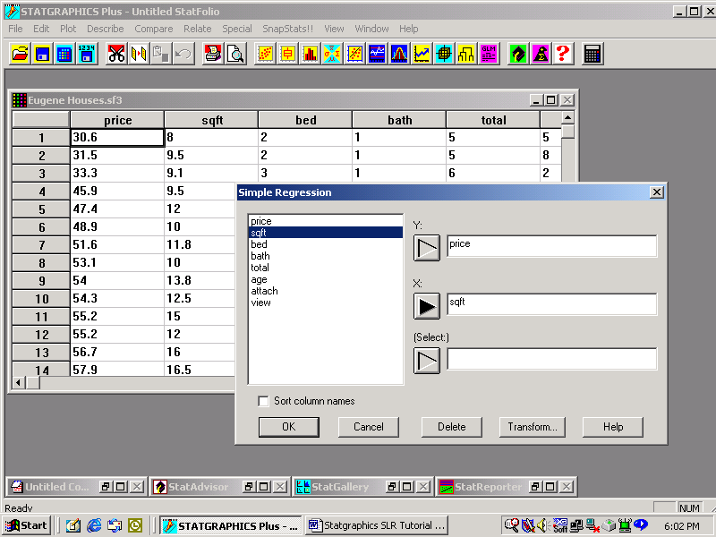
The analysis summary window, shown below, is the default Tabular Options (text) window. We next discuss the interpretation of some of the output appearing in the analysis window.

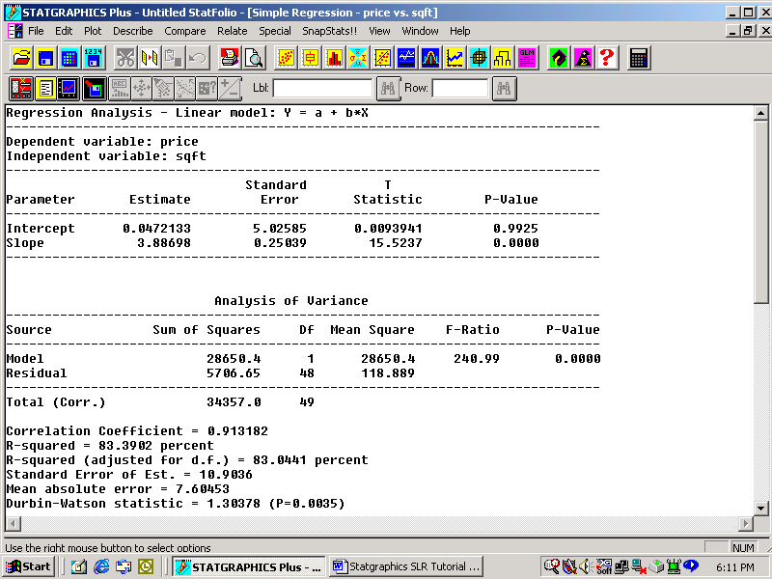

The Three Sums of Squares

Let (x_{i}, y_{i}) represent the x and y – values of the i^{th} observation. Define ${\hat{y}}_{i}$ to be the model’s predicted value for y when x = x_{i}, i.e., ${\hat{y}}_{i}=b_{0}+b_{1}x_{i}$.

From the picture below, we derive the following three (vertical) differences for the i ^{th} observation:
(a) $y_{i}−\bar{y}$ = The deviation from the mean
(b) $y_{i}−{\hat{y}}_{i}$ = The prediction error (or i ^{th} residual, e_{i} ) for the line
(c) ${\hat{y}}_{i}−\bar{y}$ = The difference between the lines $\hat{y}=b_{0}+b_{1}x$ and $y=\bar{y}$ at x = x _{i}
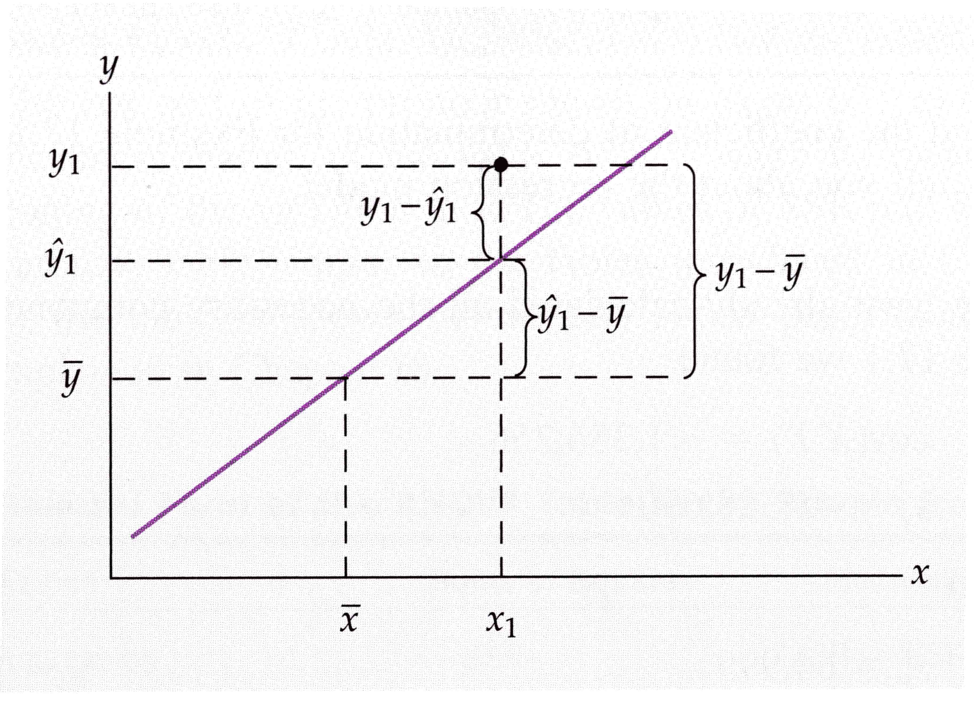
e₁ =
(a)
(b)
(c)

From the picture, we note that part of the difference between y_{i} and $\bar{y}$ is explained by the difference between x_{i} and $\bar{x}$ (the explained part is given by the “rise” ${\hat{y}}_{i}−\bar{y}$ for the “run” $x_{i}−\bar{x}$). The unexplained part of the difference between y_{i} and $\bar{y}$ is given by the i^{th} residual e_{i} = ($y_{i}−{\hat{y}}_{i}$). {You can verify, algebraically as well as visually, that the explained difference plus the unexplained difference equals the deviation from the mean: (${\hat{y}}_{i}−\bar{y}$) + ($y_{i}−{\hat{y}}_{i}$) = $y_{i}−\bar{y}$.} The goal in regression is to minimize the unexplained differences, i.e., the prediction errors e_{i} .

To find the equation of the line ${\hat{y}}_{i}=b_{0}+b_{1}x_{i}$that minimizes the error (and to determine the effectiveness of X in explaining Y), we might begin by examining the totals (by summing over all n observations in the sample) of the differences discussed in the previous paragraph. However, since each of the three differences sum to zero, it is necessary to square the differences before summing them. This leads to the definition of the following three sums of squares:

Total Sum of Squares, $\text{SST}=\sum_{i=1}^{n}{{\left(y_{i}−\bar{y}\right)}^{2}}$, is a measure of the total variation of Y (about its mean)
Note: is just the sample variance of the y values in the data.
Regression Sum of Squares, $\text{SSR}=\sum{{\left({\hat{y}}_{i}−\bar{y}\right)}^{2}}$, measures the variation of Y explained by the variation in X

Error Sum of Squares, $\text{SSE}=\sum_{i=1}^{n}{{\left(y_{i}−{\hat{y}}_{i}\right)}^{2}}$, measures the variation of Y left unexplained by the variation in X, i.e., the variation of Y about the regression line.

Note: Statgraphics refers to SSR as the Model Sum of Squares because it results from the regression model, and SSE as the Residual Sum of Squares because it equals the sum of the squared residuals. In Statgraphics, the three sums of squares appear in the second column of the Analysis of Variance table in the Analysis Summary window as shown below.

Example 1 (continued): The ANOVA Table for the Eugene data, regressing house price (the variable Price) on house size (the variable Sqft), appears below. Here SSR = 28,650; SSE = 5,706; and SST = 34,357 (all in units of $1,000 squared).

The Least-Squares Criterion

The goal in simple linear regression is to determine the equation of the line$\hat{y}=b_{0}+b_{1}x$ that minimizes the total unexplained variation in the observed values for Y, and thus maximizes the variation in Y explained by the model. However, the residuals, which represent the unexplained variation, sum to zero. Therefore, simple linear regression minimizes the sum of the squared residuals, SSE. This is called the Least-Squares Criterion and results in formulas for computing the y – intercept b₀ and slope b₁ for the least-squares regression line. At this point there is no need to memorize the formulas for b₀ and b₁. It is enough to know that Statgraphics computes them and places them in the Analysis Window in the column labeled “Estimate.”

Example 1 (continued): Below is the output for the regression of house price (in thousands) on square footage (in hundreds). The numbers in the “Estimate” column are b₀ and b₁.

The Mathematics of Least Squares

The quantity to be minimized is . In particular, we seek to fit the observed values with a line . Replacing in the equation for SSE with , we obtain . The only free variables in the equation for SSE are the intercept and slope . From Calculus, the natural thing to do to minimize SSE is differentiate it with respect to and and set the derivatives to zero. (Note: since SSE is a function of the two independent variables and , the derivatives are "partial" derivatives.)

Setting the right-hand sides above equal to zero leads to the following system of two equations in the two unknowns and .
Expanding the sums, we have:

Rearranging terms, we arrive at the following system of two equations in the two unknowns and :

Because the system is linear in and , it can be solved using the tools of linear algebra! We we'll postpone this until we introduce the matrix representation of the simple linear regression model later. For now it's enough to know that a solution to the system is

Note: To show that the two forms given above for are equivalent, we use (for the numerator)
A similar manipulation is used to show that in the denominator.

Remember that despite the use of lowercase letters for and in the equations above, they should be viewed as random variables until the data has been collected (it is somewhat unfortunate that the same symbols are used here for both the random intercept and slope, on the one hand, and their "observed" values for the data). As random variables, and have probability distributions. We will investigate the distribution of later.

Extrapolation

In algebra, the line y = b₀ + b₁x is assumed to continue forever. In Simple Linear Regression, assuming that the same linear relationship between X and Y continues for values of the variables not actually observed is called extrapolation, and should be avoided. For the Eugene data, the houses observed range in size from 800 ft² to 4,000 ft². Using the estimated regression line to predict the price of a 5,000 square foot house (in Eugene in 1973) would be innapropriate because it would involve extrapolating the regression line beyond the range of house sizes for which the linear relationship between price and size has been established.

Interpreting the Estimated Regression Coefficients

Example 1 (continued): The sample statistics b₀ = 0.0472 and b₁ = 3.887 estimate the model’s y-intercept β₀ and slope β₁, respectively. In algebra, the y-intercept of a line is interpreted as the value of y when x = 0. In simple regression, however, it is not advisable to extrapolate the linear relationship between X and Y beyond the range of values contained in the data. Therefore, it is unwise to interpret b₀ unless x = 0 is within the range of values for the independent variable actually observed. We will now interpret the estimated regression coefficients for the Eugene data.

- b₀: This would (naively) be interpreted as the estimated mean price (in thousands of dollars)of houses (in Eugene in 1973) with zero square feet. However, since no such houses appear in the data we will not interpret b₀.
- b₁: The estimated mean house price increases by $3,887 for every 100 ft² increase in size. Note that I have included the proper units in my interpretation. Note, also, that we are estimating the increase in the mean house price associated with a 100 ft² increase in size. This reminds us that the estimated least-squares regression line is used to predict the mean value of Y for different values of X.

E. The Standard Error of the Estimate: S_{ε}

The Distribution of Y: In the simple linear regression model, , only Y and are random variables, and the error is assumed to have mean 0. Thus, by the linearity of expectation, . This states that the regression line is a line of means, specifically, the conditional means for Y given X.

Once again, because , , and X are fixed, the variance of Y derives from that for , i.e., . So now we know the mean and variance of Y, at least in theory (except for the small detail that we don't actually know the values of any of the parameters , , and , which is why we estimate them from the data.)

Having established the mean and variance of Y, all that remains is to identify the family of distributions it comes from, i.e., its "shape." Here we make use of the assumption that the error is normal, . Because linear combinations of normal variates are normal, and Y is linear in in the model , Y is itself normal.

Putting the previous three paragraphs together, we have

Having seen that the variance of Y is derived from , it will be seen later that other random variables, especially the estimator of the slope, , also have variances that are functions of the unknown parameter. So it's time to estimate !

Estimating the error variance, : The model assumes that the variation in the actual values for Y about the TRUE regression line is constant, i.e., the same for all values of the independent variable X . (Sadly, this is not true of the variation about the estimated regression line , but more on that shortly.) σ², the variance of the error variable, is a measure of this variation. is an unbiased estimator of , called the mean square error, or MSE for short. The estimated MSE for the Eugene house price example appears in the row containing the Error Sum of Squares, SSE, in the column labeled "Mean Square."
Although we will not derive the formula for the mean square error, , we can justify the degrees of freedom in the denominator as follows. We begin the problem of estimating model parameters with the n independent bits of information obtained from the sample. However, prior to estimating the error variance , we had to estimate the intercept and slope of the regression line that appears in the numerator of the formula for the MSE, . In general, every time you estimate a parameter, you lose one degree of freedom, and we've estimated the two parameters and . Therefore, there are only n - 2 degrees of freedom (independent bits of information) still available for estimating .

Finally, the standard error of the estimate, , estimates the standard deviation of the error variable, . The estimated value of the standard error of the estimate, in units appropriate for the dependent variable (thousands of dollars in the Eugene house price example), appears in the Analysis Summary window below the Analysis of Variance table.

F. Are Y and X correlated? Testing β₁

If the slope, β₁, of the true regression line y = β₀ + β₁x is zero then the regression line is simply the horizontal line y = β₀, in which case the expected value of Y is the same for all values of X. This is just another way of saying that X and Y are not linearly related. Although the value of the true slope β₁ is unknown, inferences about β₁ can be drawn from the sample slope b₁. A hypothesis test of the slope is used to determine if the evidence for a non-zero β₁ is strong enough to support the assumed linear dependence of Y on X. For the test,

- H₀: β₁ = 0, i.e., X and Y are not linearly related
H_{A}: β₁ 0, i.e., the two variables are linearly related
- The Test Statistic is $t=\frac{b_{1}−β_{1}}{s_{b_{1}}}=\frac{b_{1}}{s_{b_{1}}}$(because β₁ = 0 in the null hypothesis), where $s_{b_{1}}$is the sample standard deviation of b₁ (called the standard error of the slope).
(Note: the test statistic has a t distribution with n – 2 degrees of freedom iff the error variable is normally distributed with constant variance.)

Statgraphics reports the values of b₁, $s_{b_{1}}$, t, and the p-value for the test in the second, “Slope,” row of the Analysis Summary window. The results for the Eugene example are shown below. The p-value of 0.0000 for the estimated slope allows us to reject the null hypothesis, H₀, and conclude that the data strongly suggests that X and Y are linearly related.

The Distribution of the Sample Slope, b₁

The t-test of the slope , conducted above in StatGraphics, is only valid if the distribution of is normal. We now set out to derive the distribution of the sample slope . The distribution of is based upon the following:

- can be written as a linear combination of the
- The are independent and have distribution

To show that the sample slope can be written as a linear combination of the observations on Y, rewrite

, where we have used the fact that

the deviations sum to zero. We can now see that the sample slope is linear in the by rewriting it as

, where the are constants (because the are treated as fixed), and are functions only of the ! Thus is a linear combination of the, as claimed.

An immediate consequence of the previous paragraph is that the sample slope is normally distributed. Beyond that, however, it also allows us to determine the mean and standard error of . It makes a nice, and not too difficult, homework problem to show that:

- , i.e., the sample slope is an unbiased estimator of the true slope
- The variance of is , and is estimated by, where is the mean square error, MSE, derived earlier.
- The standard error of is

Confidence Intervals for the true slope,

Because , we can construct a confidence interval for the true slope using a t-distribution with n - 2 degrees of freedom (see the previous discussion about the choice of degrees of freedom). Therefore, aconfidence interval for is given by , where . Confidence intervals for the true slope can be obtained from StatGraphics (or other software), so, in practice, there is no point in constructing them by hand.

G. Measuring the strength of the correlation: R²

Having first determined, from the hypothesis test of β₁, that a statistically significant linear relationship exists between the dependent and independent variables, the strength of the linear relationship is measured by the coefficient of determination, $R^{2}=\frac{\text{SSR}}{\text{SST}}=\frac{\text{the variation in Y explained by }X}{\text{the total variation in Y}}$. From its definition, R² equals the proportion of the variation in Y explained by X. Thus $0≤R^{2}≤1$, with $R^{2}≃1$ if the line fits the data well, and $R^{2}≃0$ if the line fits poorly. Finally, $R^{2}×\text{100}\text{\%}$ equals the percentage of the variation in Y explained by X. Statgraphics displays R², as a percentage, beneath the Analysis of Variance table.

The Plot of the Fitted Model

Statgraphics plots the scatterplot of the observations, along with the least squares regression line and the prediction and confidence interval bands (see Section VI on estimation for a description of prediction and confidence intervals). The Plot of the Fitted Model for the Eugene example appears below.

Checking the model assumptions: Residual Analysis

It is important to validate the model’s assumptions about the error variable prior to testing the slope β₁ or using the estimated regression line to predict values for Y because both the hypothesis test of β₁ and the interval (confidence and prediction) estimates in a regression analysis use the assumptions.

Constant Variance: the Plot of Residuals vs. Predicted Y

The assumption that ε has constant variance σ²_{ε} can be checked visually by selecting the plot of Residuals versus Predicted from the Graphical Options menu. If the spread of the residuals is roughly the same for all values of $\hat{y}$ then the assumption is satisfied. If, however, there is a dramatic or systematic departure from constancy then the assumption is violated and a remedial measure, such as a transformation, should be attempted before using the estimated regression equation. (Transformations are discussed later.)

Example 2: The file TAURUS contains the price (in dollars) and odometer reading (in miles) for 100 similarly equipped three-year-old Ford Tauruses sold at auction. Regressing price on odometer reading produces an acceptable Residuals versus Predicted plot, shown below.

Example 3: The file CANADIAN HEALTH contains the age and mean-daily-health-expense for 1341 Canadians.The simple linear regression of mean-daily-health expense versus age produces an example of an unacceptable plot of Residuals versus Predicted. Looking at the plot, you can see that as the predicted expense increases (moving from left to right) the spread about the model also increases, giving the graph a distinctive “fan” or “cone” shape. This is one of the most common forms that a violation of constant variance may take.

Normality: Graphing a Histogram of the residuals

The assumption that the error variable ε is normally distributed can be checked visually by graphing a histogram of the residuals. To create the histogram, first save the residuals using the Save Results button (fourth from the left) in the simple regression analysis window. Then select the Histogram button on Statgraphics’ main toolbar. If the histogram appears to be roughly bell shaped then the assumption is satisfied. If, however, it is strongly skewed then the assumption is violated and a remedial measure, such as a transformation, should be attempted before using the estimated regression equation. (Selecting Describe > Distributions > Distribution Fitting (Uncensored Data), instead of the histogram button on the main toolbar, produces a histogram of the residuals with a normal curve superimposed; making the determination of normality easier.)

Example 2 (continued):, The Taurus data below demonstrates an acceptably normal histogram of the residuals.

Example 3 (continued): The Canadian Health data below demonstrates an unacceptable histogram of the residuals (the histogram is strongly skewed to the right).

Time-Series and Independent Errors: the Plot of Residuals vs. Row Number

The assumption that the errors are independent of one another is often violated when regressing time-series data. Therefore, when modeling time-series data, you should look for patterns in the plot of Residuals versus Row Number selected from the Graphical Options menu. (Note: for time-series data the row number corresponds to the time period in which the values were collected.) A detailed discussion of this topic will be postponed until the notes on Multiple Linear Regression, where the regressing of time-series data is considered.

Influential Points and Outliers

Influence

An observation is said to be “influential” if the estimated regression coefficients b₀ and b₁ change markedly when the observation is removed and the least squares regression line is recalculated. This can be seen graphically by using the cursor to select the corresponding point on the Plot of the Fitted Model and then selecting the red and yellow +/- (include/exclude) button on the analysis toolbar.

Leverage is the potential an observation has to influence the slope of the least squares line. The further the x coordinate of the point is from $\bar{x}$ the more “leverage” the point has. It’s useful to think of the line as a seesaw with the fulcrum at $\bar{x}$: the further the point is from the fulcrum, the more potential it has to “tilt” the line toward itself. The observations with the greatest leverage are listed in the Influential Points window under Tabular Options.

Outliers

Definition

An outlier is any point that does not seem to fit the overall pattern of the scatterplot. Any point that lies unusually far from the estimated regression line thus qualifies as an outlier. To determine potential outliers, Statgraphics computes the studentized residual, (because the mean of the residuals, μ_{e}, is always zero), for every point on the scatterplot. (Studentizing a residual is similar to standardizing it, but uses the estimated standard deviation instead of the unknown standard deviation: see the Review of Basic Statistical Concepts notes for a discussion of standardizing and studentizing.) Statgraphics then lists the row numbers of those points whose studentized residuals have an absolute value greater than 2 in the Unusual Residual window under Tabular Options. These observations should be considered potential outliers. (Note: We won't derive the standard error of the residual, , where is the estimated standard deviation of the error variable, in this course.)

Note: the studentized residual given above is not constant for all residuals, because the sample statistics and merely estimate the regression parameters β₀ and β₁ ! This has absolutely nothing to do with the assumption of constant variance of the errors in the model, but simply reflects the random nature of sampling.
(Note: An outlier is any point on the scatterplot that is far removed from the bulk of the other points. Thus, a point with a large leverage value, because its x-coordinate is far from the average, may be an outlier even though it lies close to the regression line. Therefore, you should consider observations with either large studentized residuals or large leverage to be potential outliers.)

Sources

The most common sources of outlying observations are the following:

- A mismeasured or misreported value. For example, the value 39.4 is mistakenly entered as 394.
- The observation doesn’t really belong to the population of interest. For example, a study of incomes in the software industry, using randomly selected employees, might include the income of one Bill Gates. However, as an owner of the company, as well as an employee, he may not be part of the population of interest in the study.
- The observation may represent a unique event that is not likely to be repeated. For instance, a study of retail sales in Sydney, Australia, might show a sharp spike in September 2000. A little research, however, would reveal that Sydney was hosting the Summer Olympics that month. The hosting of the Olympics is a rare event that is not likely to reoccur anytime soon.
- Finally, it is possible that the outlier is not the result of any of the above, in which case it may be considered a legitimate point for inclusion in the analysis. If this is the case then the observation has the potential to reveal important information about the dependent variable being studied, such as the nature of important independent variables not included in the regression model.

Remedies

If an outlier belongs to one of the first three categories above then it may be appropriate to remove the observation from the data set before conducting the analysis. However, one should never remove an observation from time-series data. We will discuss a technique for removing the effect of such an observation in time-series data when we cover time-series regression.

Estimation

It is often of interest to be able to predict values of the dependent variable for given values of the independent variable. This may include the computation of point estimates, confidence interval estimates, or prediction interval estimates.

Point Estimates

The predicted or fitted value is obtained by substituting the required value of the independent variable into the estimated regression line. The result is a point that lies on the regression line with the required X-value.

Confidence Intervals

Confidence intervals play the same role in regression as they do in single variable statistics: they provide an interval with a specified likelihood (the confidence percentage for the interval) of containing the true mean value of Y for the required X-value. The interval provides an indication of the accuracy of the estimate. A narrower interval indicates a more precise estimate than a wider interval bearing the same degree of confidence.

Prediction Intervals

While confidence intervals estimate the mean value of Y for a required value ofX, prediction intervals estimate an individual value of Y given the required X-value. Remembering that there is more variability in individual values than there is in averaged values, it shouldn’t surprise you to learn that prediction intervals are wider than confidence intervals. Both intervals, however, are centered about the point estimate for Y given the required value of X.

Confidence and Prediction "Bands"

In addition to constructing confidence and prediction intervals for Y for specific values of X, we can construct curves, or "bands," which are functions of X. Note how the confidence band (orange curve) and prediction band (magenta curve) produced by StatGraphics below become wider as X varies more fromin the data. I'll give a heuristic reason for this in class, but it's because confidence and prediction intervals are more sensitive to errors in the estimation of the slope than to errors in the estimation of the intercept . Far from the center of the scatterplot, i.e., far from , a small error in estimating the slope results in a greater error in estimating . Thus, both types of intervals become wider to accommodate the additional uncertainty, causing the bands to bow out.

Using Statgraphics

To obtain predicted values, confidence intervals, and prediction intervals for a particular x-value use the Forecast window under Tabular Options. Right click and select Pane Options. The Forecast Options dialog box lets you enter up to 10 values for the independent variable and/or change the level confidence from the default value of 95%.

Example 1 (continued): Forecasts for the price of a house (or the mean price of all houses) in Eugene with 1500 square feet, applicable to 1973, appear as follows:

Before using these forecasts, remember that all values are in the units for the variables as they are presented in the data set, i.e., X is in hundreds of square feet and Y is in thousands of dollars. Also, be careful not to report forecasted values that aren’t possible in practice. Statgraphics isn’t expected to know that a negative house price doesn’t make sense as a lower limit in an interval estimate, but you are!

Transformations

While performing diagnostics for a particular regression model, you may discover serious violations of one or more of the error variable assumptions. It is natural to ask whether remedial measures can be taken that would allow us to use regression with more confidence. Here we explore a relatively simple remedy to the problems of non-constant variance and non-normality of the error variable. (Violations of the last assumption, row independent errors, are discussed in the notes on Multiple Linear Regression, where we consider time-series.)

Consider the original specification for the model, Y = β₀ + β₁X. This is the Simple Linear Regression model. This model may be inappropriate for either of two reasons: (1) a straight line may not provide the best model of the relationship between X and Y, and/or (2) the error variable assumptions may be violated for the model.

In case (1) the solution may involve specifying a curvilinear (curved) relationship between X and Y. For instance, sales of a new product may increase over time, but at a decreasing rate, because of market saturation, the product’s life cycle, etc. In this case, a polynomial model, such as Y = β₀ + β₁X + β₂X², or the logarithmic model Y = β₀ + β₁log(X) may be more appropriate. The latter is an example of a transformation of the independent variable X, whereby X is replaced by log(X) in the model. If the respecified model fits the data better than the original model, we work with it instead. Although we will not discuss transformations of the independent variable X in detail in this course, we will consider polynomial models in the Multiple Linear Regression notes.

In case (2), where the assumptions about the error variable appear to be seriously violated, the solution may involve a transformation of the dependent variable, Y. The transformation involves replacing Y in the model with some simple function of Y. Although many transformations are possible, the most popular involve replacing Y with log(Y), Y², $\sqrt{Y}$, $1Y$. Below I have provided the Statgraphics format for each of the four that must be entered into the dependent variable field of the input dialog box:

- Log: use LOG(variable) {Note: this is the natural logarithm, base e}
- Square: use variable^2
- Square-Root: use SQRT(variable)
- Reciprocal: use 1/variable

You can either type the appropriate transformation directly into the dependent variable field, or use the TRANSFORM button at the bottom of the input dialog box and use the built-in keypad and operators.

Although it is not always clear which, if any, of the four transformations listed above will improve the model, some general guidelines are provide below.

- Log: use LOG(variable) – may be useful, provided y > 0, when the variance increases as $\hat{y}$ increases or the distribution of ε is skewed to the right.
- Square: use variable^2 – may be useful when the variance is proportional to $\hat{y}$or the distribution of ε is skewed to the left.
- Square-Root: use SQRT(variable) – may be useful, provided y > 0, when the variance is proportional to $\hat{y}$.
- Reciprocal: use 1/variable – sometimes useful when the variance increases significantly beyond some particular value of $\hat{y}$.

Example 4: The file FEV contains data collected from children for the following variables:

- FEV - Forced Expiratory Volume (in liters) is a measure of the child’s lung capacity.
- Age - the child’s age (in years)
- Height - the child’s height (in inches)
- Sex – male (0) or female (1)
- Status – nonsmoker (0) or smoker (1)
- ID – not really a variable, the ID number identifies the child

Suppose that we wish to use a child’s height to predict forced expiratory volume. (For instance, a child whose forced expiratory volume, as measured by appropriate instruments, is significantly below the predicted FEV for their weight may qualify for a referral to a respiratory specialist.) Using FEV as the response variable, we obtain the following Statgraphics’ output.

Although the histogram is not particularly skewed, there are several outliers with large studentized residuals. More dramatic evidence of problems, however, comes from the scatterplot (which displays curvature) and the residual plot (which shows variance increasing with increasing predicted FEV). Trying a logarithmic transformation on FEV (see the input dialog box below for details), we obtain the new model log(FEV) = β₀ + β₁X + ε, which produces output more consistent with the regression assumptions (see output on the following pages).

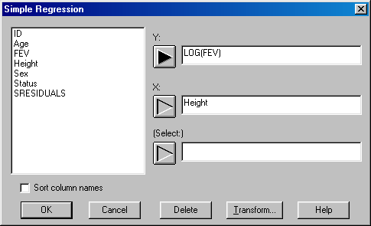

- Note 1: If a transformation of Y is employed then all predictions pertain to the transformed variable. For instance, if we wish to predict the FEV for a child who is 60” tall we first use Statgraphics to predict log(FEV) for the child, and then raise the natural number e to that value (thereby “undoing” the log).

In this example, the predicted FEV for the child is e^{0.855835} = 2.353 liters.

- Note 2: Sometimes transformations of both X and Y may be necessary.

Cautionary Note: Inferring Cause and Effect

One of the most common mistakes made in the analysis of a simple regression model is that of assuming that the establishment of a statistically significant relationship between the independent and dependent variables implies that the former causes the latter. There are many examples of erroneous attributions of causation, but my personal favorite involves the statistician who established a statistically significant linear relationship between the price of rum in Cuba and the salaries of Protestant ministers in New England. Noone (certainly not the statistician who reported the relationship) would suggest that the price of rum in Cuba is somehow driving the salaries of Protestant ministers! In this situation, it is probable that both the price of rum and the ministers’ salaries are affected by underlying economic variables. The exitence of such confounding variables (so called because they serve to confuse or confound the analysis) makes it difficult to infer a cause and effect relationship to the independent and dependent variables, respectively, from a regression analysis.

Usually, the only way to establish a cause and effect relationship between two varaibles is through a designed experiment, where levels of the independent variable (different dosages of a drug, for example) are randomly applied to subjects, and the corresponding value of the dependent variable for the subjects (life expectancy, perhaps) are recorded. By randomizing the treatments, the effects of confounding variables are reduced or eliminated (rather like shuffling a deck of cards to “randomize” it), making it possible to attribute any systematic changes in the dependent variable in response to different levels of the independent variable to cause and effect.

Financial Application: The Market Model

A well known model in finance, called the Market Model, assumes that a stock’s monthly rate of return, R, is linearly related to the monthly rate of return on the overall market R_{m}, i.e., $R=β_{0}+β_{1}R_{m}+ε$. For practical purposes, R_{m} is taken to be the monthly rate of return on some major stock index, such as the New York Stock Exchange Composite Index. The coefficient $β_{1}$, called the stock’s “beta” coefficient, measures how sensitive the stock’s rate of return is to changes in the overall market. For example, if $β_{1}$>1, the stock’s rate of return is more sensitive to changes in the overall market than is the average stock, i.e., the stock is more volatile. While a “stock beta” less than one means that the stock is less sensitive (volatile) to changes in the overall market than is the average stock

Example 5: The monthly rates of return for IBM and the overall market (NYSE) over a five-year period were used to construct the analysis below. Is there sufficient evidence to conclude at the 5% significance level that IBM is more sensitive than the average stock on the NYSE?

- State the hypotheses for the significance test.
- Use the computer output below to compute the appropriate test statistic.
- Use the critical value $t_{0\text{.}\text{05},\text{58}}=1\text{.}\text{672}$ to answer the question.

Summary

The order in which the material has been presented in these notes is traditional. In a practical application, the residual analysis would be conducted earlier in the process. It is appropriate to investigate violations of the required conditions when the model is assessed and before using the regression equation to forecast. The following steps describe the entire process.

Develop a model that has a theoretical basis. That is, for the dependent variable of interest find an independent variable that you believe is linearly related to it.

Gather data for the two variables. Ideally, conduct a controlled experiment that will allow you to control for confounding variables and/or establish causation. If that is not possible, collect observational data.

Begin a Simple Regression analysis and look at the Plot of the Fitted Model to see if the scatterplot supports the conclusion that the two variables are correlated (linearly related).

Determine the regression equation.

Save the residuals and check the required conditions.

- Is the error variable normal?
- Is the variance constant?
- Are the errors independent (applicable to time-series)?
- Check the outliers and influential observations, and investigate them if necessary.

Assess the model's fit.

- Compute the standard error of estimate s_{ε}.
- Test the slope $β_{1}$to determine whether X and Y are correlated.
- Compute R ² and interpret it.

If the model fits the data, use it to predict a particular value of the dependent variable, or to estimate its mean.

