Fall 2004 Hopfe

CALIFORNIA STATE UNIVERSITY, SACRAMENTO
College of Continuing Education

MIS 206 – Managerial Statistical Analysis

SYLLABUS

INSTRUCTOR: Manfred W. “Bob” Hopfe, Ph.D.
Professor Emeritus of Decision Sciences and Human Resources Management

OFFICE: Tahoe Hall 2087

MESSAGES: E-mail: hopfe@csus.edu [preferred]
Voice: (916) 278.7105
FAX: (916) 278.6757
Home page: http://www.csus.edu/indiv/h/hopfem/

OFFICE HOURS: by appointment

PREREQUISITES: You are expected to be proficient in mathematics, statistics and computer usage. [These skills may be attained through prior coursework, review classes or experience.]
- Statistics: introductory coursework in probability and statistics is strongly preferred
- Mathematics: at least one semester of calculus is strongly preferred [college algebra is acceptable to instructor]
- Computer usage: ability to use common personal computing hardware and software, particularly word processing and spreadsheet programs

REQUIRED TEXT: Taylor and Hopfe, Notes for Data Analysis, 9th Edition [instructions for downloading will be given the first day of class.]

COURSE OBJECTIVES: To prepare you to:

- Understand variation. Be able to differentiate between specific variation and common variation, as applied to managerial decision-making situations.
- Develop an intuitive feel for statistical techniques.
- Use statistical software [StatGraphics for Windows version 5+ and Microsoft Excel] and interpret computer outputs.
- Communicate, verbally and in written form, statistical results.
- Understand the important characteristics of forecasting. Remember, "Some people predict the future. You can intelligently compute it."
- Create and manipulate data files in order to conduct appropriate statistical analysis.
COURSE OVERVIEW: A computer-based course in data analysis. Business case studies are used to differentiate between common and specific sources of statistical variation and to construct statistical models such as multiple regression, time series, and statistical quality control. Emphasis is placed on intuitive statistical thinking and communication of results. [2 units] (StatGraphics Plus Win® and Microsoft® Excel are used in this course.)

E-mail Distribution List: Since homework questions and answers and updates are sent via e-mail, you may find it helpful to “log-on” to Dr. Bob’s MIS 206 e-mail account as follows: to: hopfe@csus.edu subject: MIS206F04 message: <please add me to your e-mail list>. To use multiple e-mail addresses, send request from e-mail address(es) you wish to have recorded.

Mid-term and Final Exam: A computer-based midterm and a computer-based comprehensive final exam are designed to test your knowledge of the material presented in class (i.e., during lectures, from in-class discussions, from readings, and from statistical software assignments). A make-up midterm exam or final exam is not given [the only exception is for a documented university-related event that requires a student to be off campus]. Once an exam is graded, further clarification of your answers will not be solicited.

Quizzes: Quizzes are given on an unannounced, random basis, during class. Make-up quizzes are not given. Once a quiz is graded, further clarification of your answers will not be solicited.

Recommended:

- StatGraphics Plus Win® and Microsoft® Excel software. StatGraphics Plus Win® may be downloaded using your Saclink account (if you need an account, you may request by going to the Computer Center Service Desk, Sequoia Hall, third floor [you will need a current, validated, CSUS Student ID card.] For your convenience, the software has been installed on the networks located in the CSUS Computer Labs and the Library.
- Diskette (data) - 3.5" or zip-disk [caution: make sure your computer has a compatible zip-drive]; or CD-R for “burning” in-class files; or “mass storage” storage device (USB compatible).
- E-mail address, either commercial or Saclink account, for assignments and other information pertinent to the course.
- Worldwide Webb accessibility for syllabus, data, and course information.

Grading Policy: Your final grade in the course will be based on your performance on the course components. Course components, with individual points and overall percentage of grade, are:

Item | Weight | Percent
Exams | 100 Points | 70%
Quizzes | 10 Points | 20%
Cases | Varies | 5%
Homework Assignments | Varies | 5%

Grades are assigned in accordance with the following percentages:

A = 93 - 100% | C = 73 - 76%
A- = 90 - 92% | C- = 70 - 72%
B+ = 87 - 89% | D+ = 67 - 69%
B = 83 - 86% | D = 63 - 66%
B- = 80 - 82% | D- = 60 - 62%
C+ = 77 - 79% | F = < 60%

Note: the grade “I” (Incomplete) is generally not awarded in this class. [An incomplete grade (I) will only be issued in accordance to CSUS policy. Among the conditions imposed by the instructor that must be met (but are not limited to) are (1) a current passing grade (70 percent or better), (2) the successful completion of all prior assignments and exams, and (3) an unforeseen and unusual event beyond your control which prevents you from completing the semester, and can be documented and verified. (4) An incomplete will only be considered after it has been determined that a withdrawal (W) cannot be issued. If you do not meet (1) through (4), you do not qualify for an incomplete. As stipulated by the University, an incomplete cannot be assigned when it is necessary for the student to attend additional class meetings to complete the course requirements.]

The grade “U” (unauthorized withdrawal) will awarded only to those students who have not attended class and/or have no recorded scores. The grade “W” (withdrawal) will be awarded up to, but not including, the last week of the semester (commonly know as “Dead Week”). If the student does not possess sufficient points to pass, a letter grade of “F” will be assigned. Extra credit exercises, or projects, are not assigned nor will they be accepted for credit.

Academic Dishonesty: Unfortunately, the topic of academic dishonesty must be addressed. Unless otherwise permitted by the instructor, all individual assignments submitted for credit shall represent the sole efforts of the individual submitting the assignment. The result of another student’s efforts or of a group effort, or is a copy of another student’s efforts [current, or past, semester(s)], is considered academic dishonesty.

Academic dishonesty involves acts that may subvert or compromise the integrity of the educational process of the university. Included is any act by which a student gains or attempts to gain an academic advantage for him/herself, or another, by misrepresenting his/her, or another's work or by interfering with the completion, submission, or evaluation of work. These include, but are not limited to, accomplishing or attempting any of the following acts:

- Using any materials that are not authorized by the instructor for use during an examination.

- Copying from another student's paper during an examination.

- Collaborating (i.e., talking, passing notes and/or signals, etc.) during an examination with any other person by giving or receiving information without specific permission of the instructor.

- Stealing, buying or otherwise obtaining information about an unadministered examination.

- Substituting for another person or permitting any other person to substitute for oneself to take an examination.

- Submitting another person's work as yours either in its original or altered form.

- Giving someone else your work to fulfill his/her assignment.

- Using the assignment of another class to fulfill an assignment for this class without authorized consent of the instructor.

- Plagiarizing.

For exams, quizzes, and the research project, you will be expected to sign a pledge. For exams and quizzes the pledge will state, "It is my understanding that this [exam or quiz] may be given at a later time. On my honor, I have neither given nor received aid nor will I give aid in the completion of this [exam or quiz]."

For individual assignments you are to computer-generate and sign the pledge "On my honor, the files created and the work submitted are the results of my efforts. The files created and the work submitted are neither a copy nor the results of another individual's efforts in the completion of this assignment."

For group assignments you are to computer-generate the pledge "On our honor, the files created and the work submitted are the results of our efforts. The files created and the work submitted are neither a copy nor the results of another individual's or group's efforts in the completion of this assignment." Each member of the group, with the group leader listed first, shall sign the pledge. The printed and signed pledge is to appear at the bottom of the Table of Contents page.

Violations of proper ethical conduct will NOT be tolerated. The attempt by a student to cheat on an exam or other academic assignment or engage in plagiarism is a violation of a fundamental principle of academic honesty and integrity and will not be tolerated in the University. Penalties will be imposed on students who are found guilty of academic dishonesty. The Department Chair and Vice President of Student Affairs will be notified. At a minimum, a student guilty of academic dishonesty must withdraw from the course or the student will be awarded the letter grade of F in this course.

TENTATIVE COURSE SCHEDULE

Dates | Topics | Readings
Aug 5 | Course Overview and Review of Stat I [Mean and Variance, Parameters v. Statistics, Random Variables, Sampling, Sampling Distribution, Normal Distribution, Confidence Intervals, Hypothesis Testing, P-Values] | PowerPoint Introduction & Hypothesis Testing [Self-review as needed]
Aug 12 | Sources of Variation - Specific v. Common [Red Bead Experiment]  - Data Types  Statistical Quality Control [StatGraphics & Excel] | pp 116-136, 13-25, PowerPoint Deming -Process of Management and Statistical Quality Control
Aug 19 | Analysis of Variance (ANOVA) [one- and two-way] [StatGraphics] | pp 101-110, PowerPoint ANOVA
Aug 26 | Model Building – Three Phases  Simple Linear Regression [StatGraphics & Excel] | pp 31-41, PowerPoint Model Building and Simple Regression
Sept 2 | Mid-term [75 minutes] [StatGraphics & Excel]  Transformations / Random Walk [StatGraphics] | Computer-based  pp 27-30, PowerPoint Random Walk
Sept 9 | Measures of Association [multiple regression – cross-sectional analysis] multicollinerity, residual analysis, stepwise, parsimony, prediction model building [StatGraphics & Excel] | pp 49-58, 63-68, PowerPoint Multiple Regression – Cross-sectional
Sept 16-23 | Measures of Association [multiple regression – time series analysis] auto/cross correlation, seasonality, forecasting building [StatGraphics] | pp 65-68, 71- 73, PowerPoint Multiple Regression –Time Series Herr Lüthi Case
Sept 30 | Review [StatGraphics & Excel] | Practice Problems
Oct 7 | Final Exam [StatGraphics & Excel] | Computer-based

PowerPoint slide presentations are used to introduce all topics. All PowerPoint slides are available for downloading on my homepage [www.csus.edu/indiv/h hopfem] and in the classroom. [PowerPoint slides are not available at other sites.]
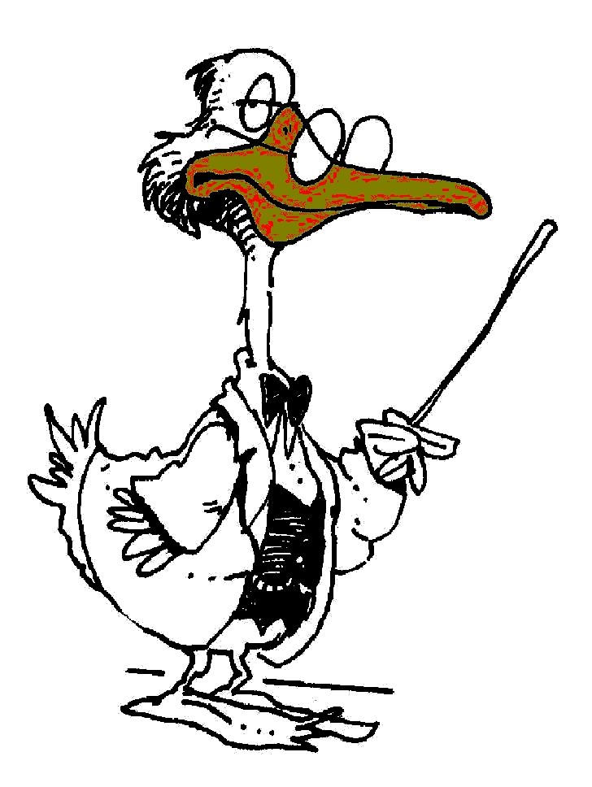

Prepared: 4/16/04

