Name ________________________ Geology 230
Midterm Exam

Directions: You will have 75 minutes to complete the test. Budget your time so that you can spend enough time on the longer essay questions. This test is open book and open note. Outside input (internet) is not allowed.

Short answer questions (5 points each):

1) What do POM and DOC stand for? Which is the more labile form, and what does this imply for nutrient availability?

2) What physical or morphometric criteria does Rosgen use to classify a stream?

3) What anthropogenic sources contribute nitrate to stream systems?

4) What molecular-scale factors affect solute transport?

5) Label or define each part of the mass balance equation that is commonly used to define the extent of hyporheic interaction:

dQ/dx = q^{in}_{L} + q^{in}_{h}+ q^{out}_{L}+ q^{out}_{H}

6) What is the difference between an influent and an effluent stream? Draw a simple diagram to support your answer.

7) Describe what each (major) term represents in the advection/dispersion equation (use arrows and simple labels):
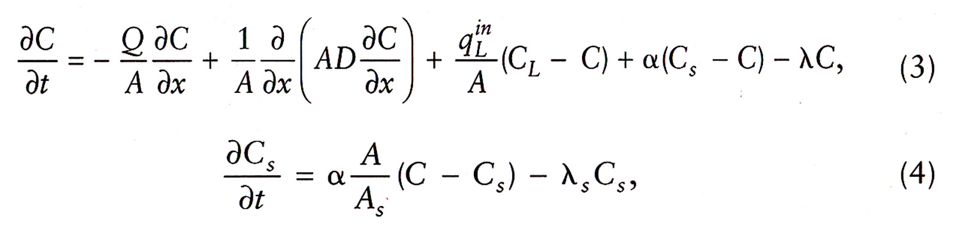

8) What happens to storage coefficient estimates when a tracer test is conducted over too long a distance?

9) What does it mean when a stream is hydraulically connected to the surface water system? Draw a simple diagram to support your answer.

10) What geochemical conditions in the subsurface favor methylmercury formation?

11) Describe a typical relationship between nitrate and nitrate in hyporheic water. Draw a simple graph to support your answer.

12) Describe the different input paths as phosphorus is added to a stream during low flow conditions, and during a rainfall event.

13) Discuss the strengths of Montgomery and Buffington’s stream classification system.

14) List the methods that we have discussed in class that are used to identify gaining and losing stream reaches. Give a very brief description of each.

15) What is the difference between a glide and a run?

16) What processes lead to retention of phosphorus in soils? What physical or geochemical conditions favor this retention?

17) Your company has been hired to conduct hyporheic tracer tests under two different conditions: low flow and high flow. Predict what will happen to the following variables as flow increases: 1) exchange coefficient 2) storage time 3) length and depth of subsurface flow paths 4) concentration of dissolved cations and anions in surface water 5) concentration of dissolved organic matter in surface water. (10 points)

18) Compare and contrast the following variables between an upwelling zone and a downwelling zone: dissolved oxygen content, nitrate concentrations, algal community abundance, dissolved inorganic phosphorus concentrations. What scales (flowpath lengths) are involved when we talk about upwelling and downwelling zones? (10 points)

