Geol 230 Week 10 Lecture
GW/SW interaction Primary productivity, microbes

Reading: Ch. 12, Jones and Mulholland, pp. 287-306, by Findlay and Sobszak

I) Introduction

Microbes: < 100 μm
First described in hyporheic sediments: in late 1980’s
Importance of microbes:
Contribute nutrients:
Carbon cycle: decomposers
Nitrogen cycle
Heterotrophs: Bacteria and fungi
Are decomposers
Types present in the hyporheic zone are largely unknown
Account for most diversity in the hyporheic zone
Are usually associated with biofilms or organic particles

See Fig. 1 from J&M, p. 289

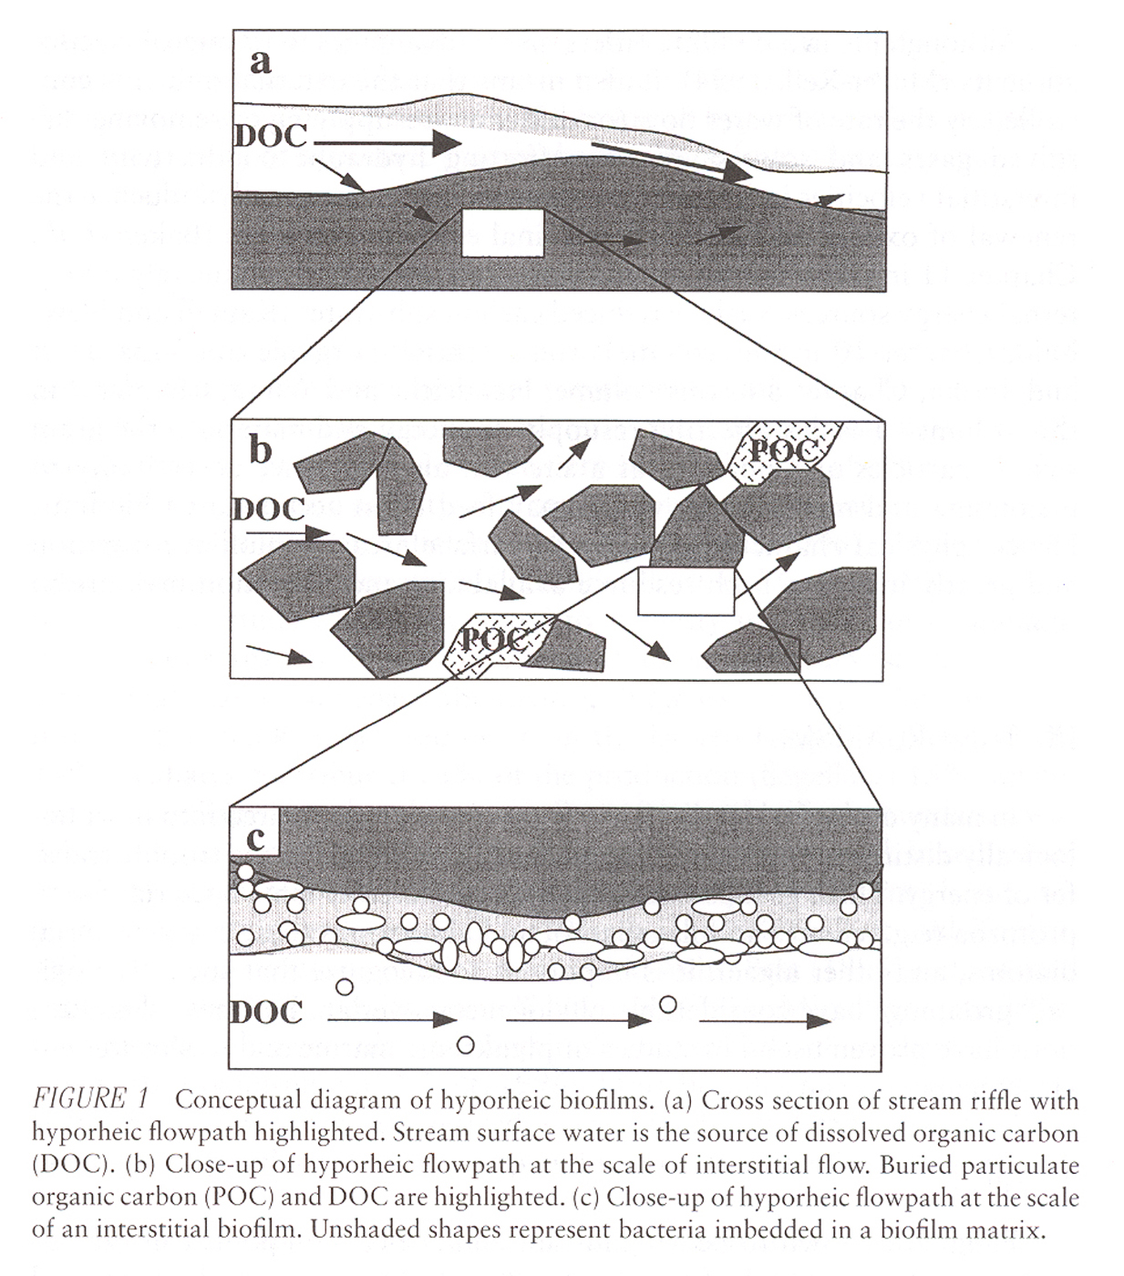

Microbes are attached to surfaces: don’t move freely.
Diffusion limits nutrient intake, waste removal
Rely on external energy sources
II) Organisms present

A. Fungi

Often associated with woody debris and decay products
Extent and volume (biomass) in hyporheic zone is largely unknown

B. Protozoans

Unicellular
Eukaryotic (lack cell walls)
Join the food web between bacteria and larger invertebrates: graze on bacteria
2 types: ciliates, flagellates
Biomass, estimates of importance and abundance are largely unknown

C. Bacteria

Generally decline in abundance and biomass with depth
Abundance may be related to concentration of organic matter

See J&M Fig. 2, p. 294

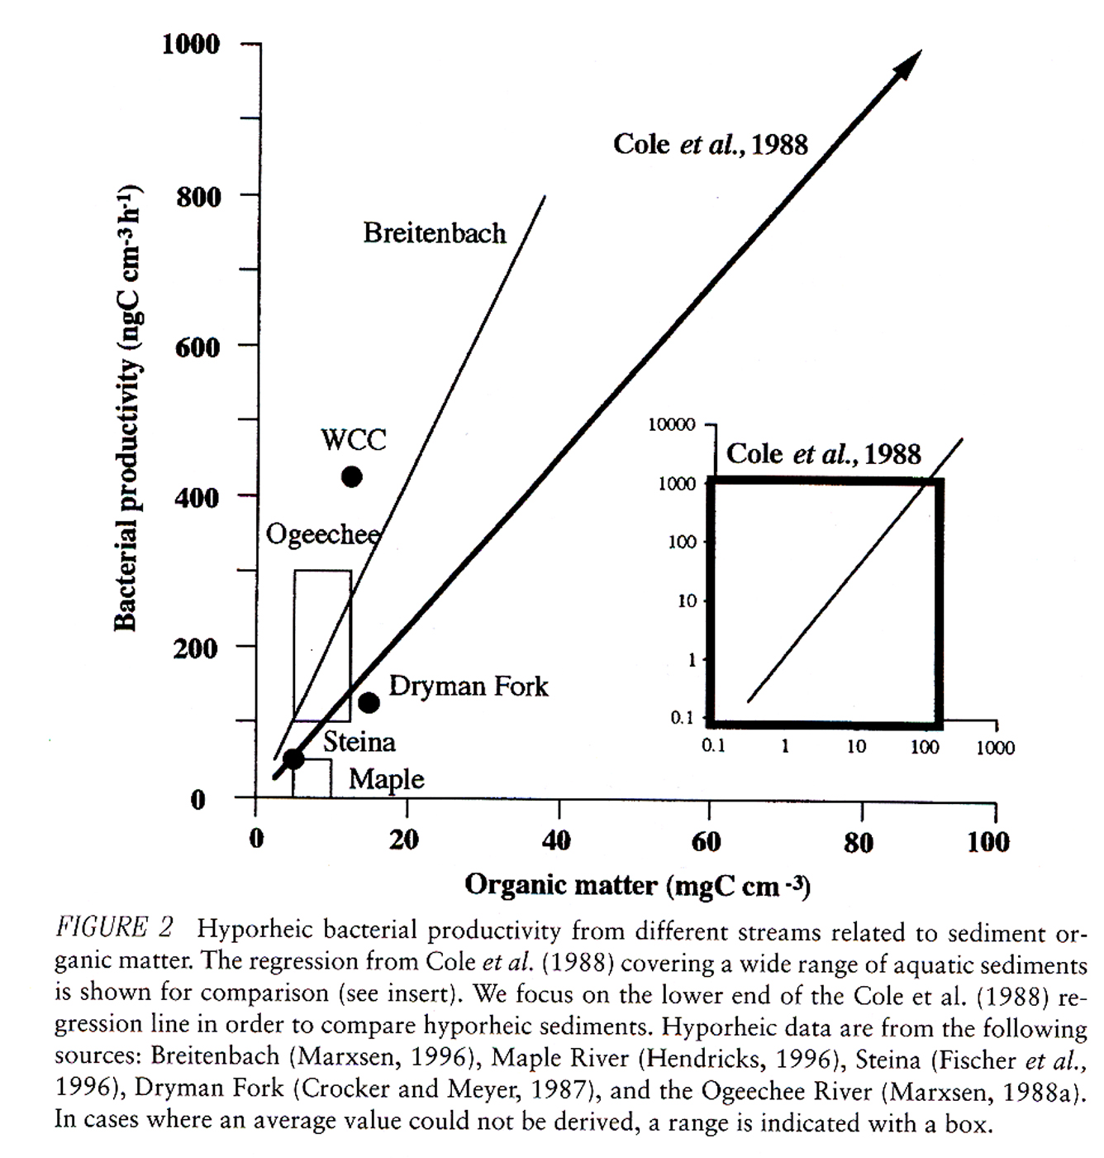

III) Respiration

HAS been measured in some hyporheic studies (better known than some properties)
Was higher at downwelling sites than upwelling sites (Sycamore Creek)
Is temperature dependant
Consumes oxygen
Rates of hyporheic respiration are probably similar to rates of surface respiration
Is related to carbon supply:

See J&M Fig. 3 p. 296
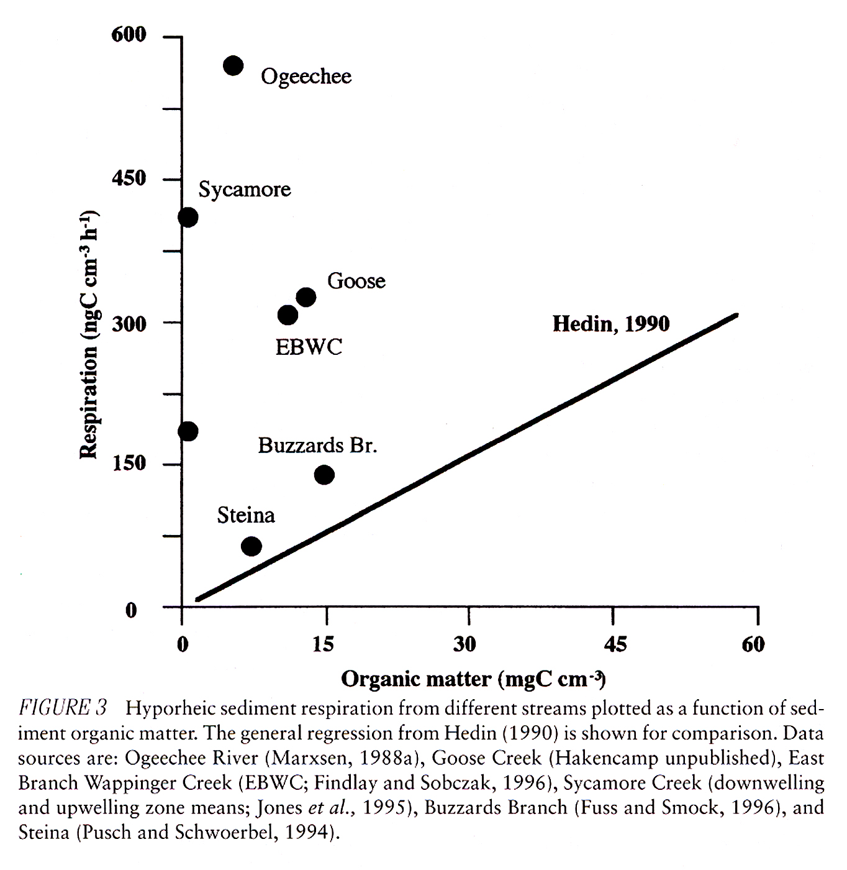

IV Carbon supply

May be the fundamental control over bacterial abundance (see above)
Is found as DOC and POC
There is really a spectrum between these two!
DOC = dissolve, mobile input
POC = buried

See Fig. 4 from J&M, p. 297

Carbon quality may be as important as carbon quantity to bacteria

V) Other influences on hyporheic bacteria:

A) Sediment size:
Coarse sediment: delivers more nutrients, but has fewer sites for bacterial attachment

B) Abundance of oxygen or other terminal electron acceptors

Anaerobic: requires a different set of microbes

C) Grazing

Bacteria are eaten by micrograzers
May control populations
Poorly understood

V) Community composition:

Very poorly understood
Processes are better understood than abundances

