Geol 230 Week 4 Lecture
GW/SW interaction Arid zone hydrology and hyporheic exchange

Reading: Ch. 4, Jones and Mulholland, pp. 111-136, by Marti, Fisher, Schade and Grimm

I) Intro and approach:

- Riparian zone influences interaction between stream (aquatic environment) and upland areas (terrestrial environment).

- Authors: examine effects of episodic flooding on nutrient distribution

- Propose a “disturbance model” based on frequency, intensity, evenness

- Hypothesis: nutrient supply may be a limiting factor in addition to water supply (in arid catchments)

II) Mesic vs. Arid hydrology- general relationships

Mesic- “Requiring a moderate amount of moisture”
p. 113
Arid- … correlation between stream and GW levels indicates hydrologic connection between the two
“… therefore the system requires periodic flooding if riparian trees are to persist”

NOTE: I have a fundamental problem with these statements: seem way too broad!!!
I would say the system requires BASEFLOW if riparian trees are to persist
Connection between GW and SW is another issue (i.e. see perched aquifers!!)

p. 113
Hyporheic zones below down-welling zones are metabolically more active than those below upwelling zones.”

Pathways are different between mesic and arid zones

See Fig. 1, pl 114 from J&M

Temperate/ Mesic pathway: Upland: Upland soils are highly permeable
Overland flow is minimal
Infiltration is rapid

My comment: These generalizations MAY be true if vegetation slows overland flow. Statement about permeability is questionable

Riparian zone: Lateral GW flow toward stream
Stream: Most water reaches stream via baseflow

My comment: This may not be true. Saturated soils in humid regions may result in a strong overland flow component.

Arid pathway: Upland: Soils are less permeable
Flow is limited to higher order streams
Overland flow is main contributor to streams
Riparian zone: Is bypassed during floods
Stream: Exchanges water with riparian zone, depending on stage, saturation etc.
See Fig. 1, p. 114

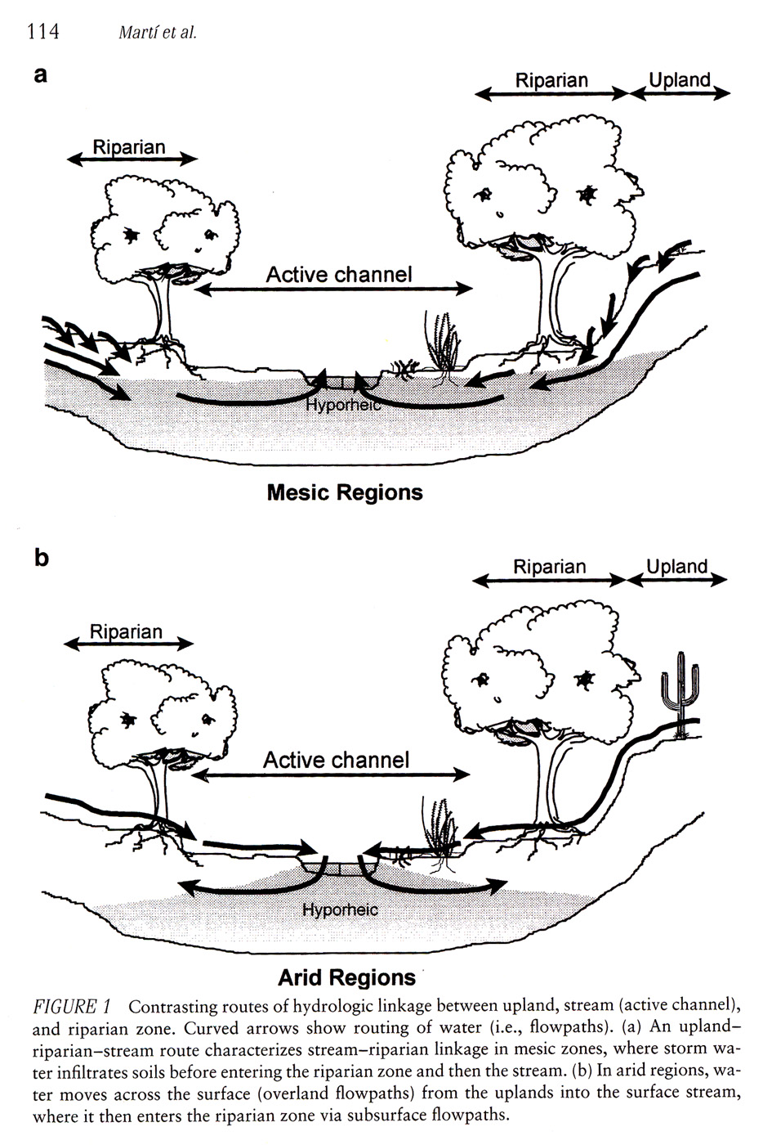

“Capacity of riparian zones (in arid regions) to absorb floodwater from the stream channel is partially a function of the position of the riparian water table relative to the surface stream, which in turn is related to elapsed time since the last flood.”

My comment: Magnitude of flooding is (at least) as important as interval between floods.
Another annoying question: Is flooding really the major mechanism of recharge in arid environments? I don’t know!

See Fig. 2, p. 116 for Disturbance Model:

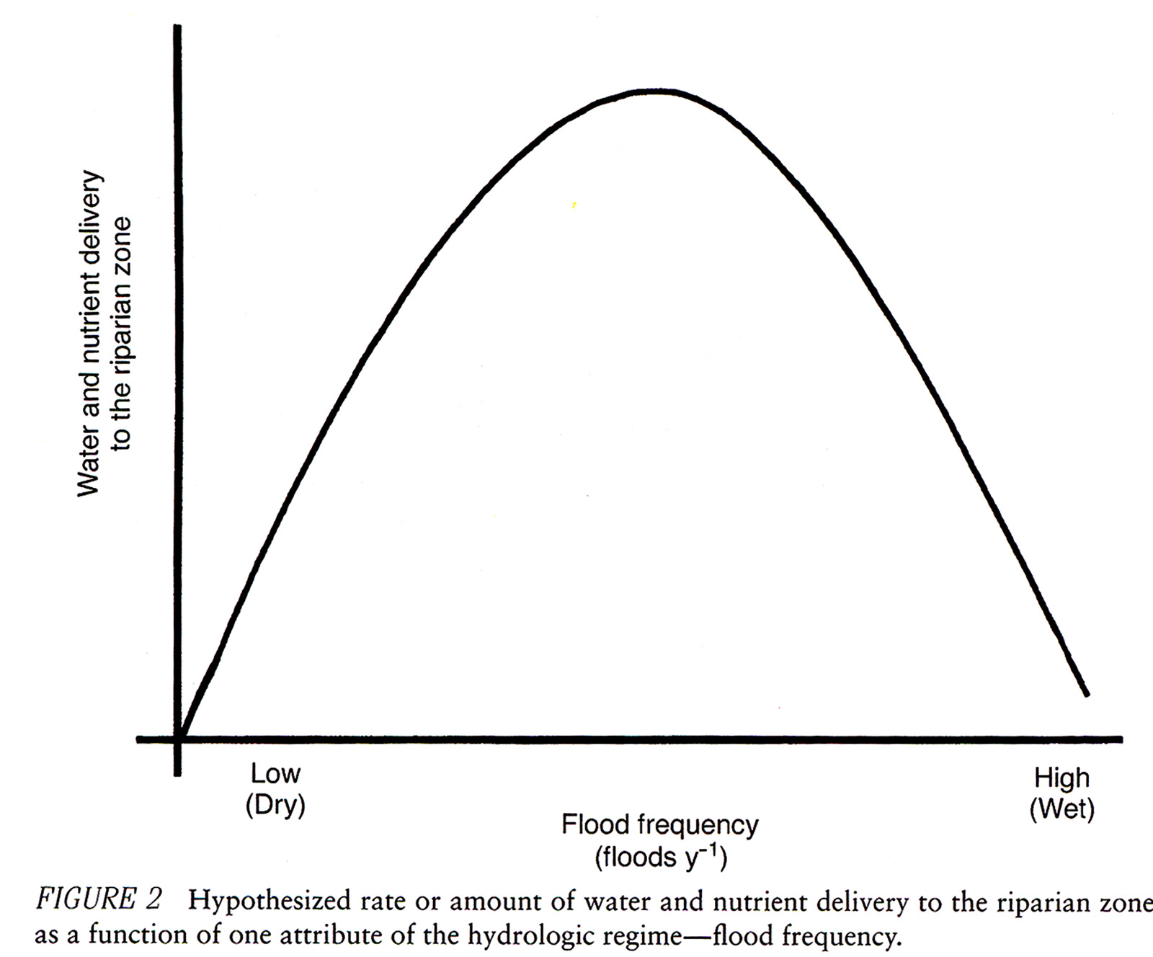

My comment: 2 issues here: magnitude and frequency:

1) Less frequent events (may) actually deliver HIGHER concentrations of nutrients. Example: “First flush” effect. I think their data show this later (see EC in Table 1 below).

2) Higher magnitude events (may) also deliver higher concentrations of nutrients).
Example: Also see DON in Table 1 below. Higher magnitude event after 131 d delivers more DIN)!!

I think I agree with the upper part of their curve- greater frequency results in lower nutrient delivery.

p. 117: 4 predictions:
1) Water table in riparian zones will rise quickly after floods

2) The rise will be greater after a long interflood period, regardless of flood magnitude
(Note: This seems to contradict statement IIIb1 below)
3) High nutrient concentrations in floodwaters will be reflected in the subsurface of the riparian zone.

4) The influence of an individual flood event will decrease as flood frequency increases

(My comment: OK- this statement may be the main value of this paper)

BUT: Note SRP after 14 day event in Table 1 (below)

III) Case study- Sycamore Creek

1) Effect of floods
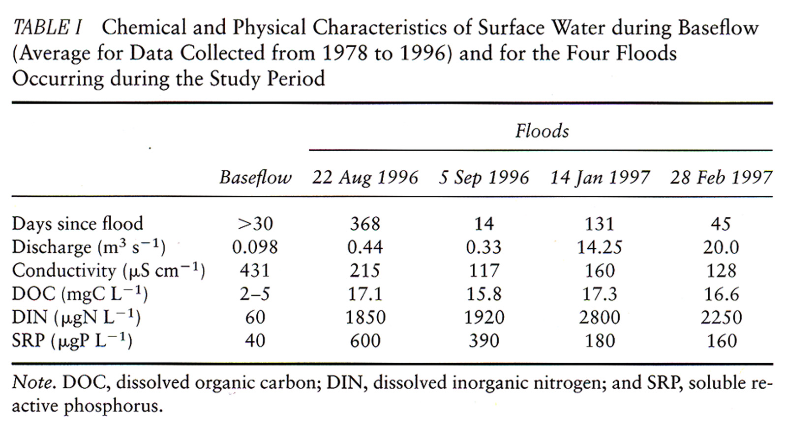

Generally: Floods are a source of nutrients and/or other solutes

My comment: Data seem to contradict some statements above.

2) Patterns in water table variation:

a) With time:

- Water table is higher in winter, lower in summer
- Flood effect on water table is related more to existing saturation level more than flood magnitude

My comment: this makes sense!

THEREFORE: connection between water table and stream is controlled by frequency of flood events.

b) Longitudinal patterns:

- Water levels (and rate of increase) increase downstream following floods
- This corresponds with a decrease in SW (makes sense!)

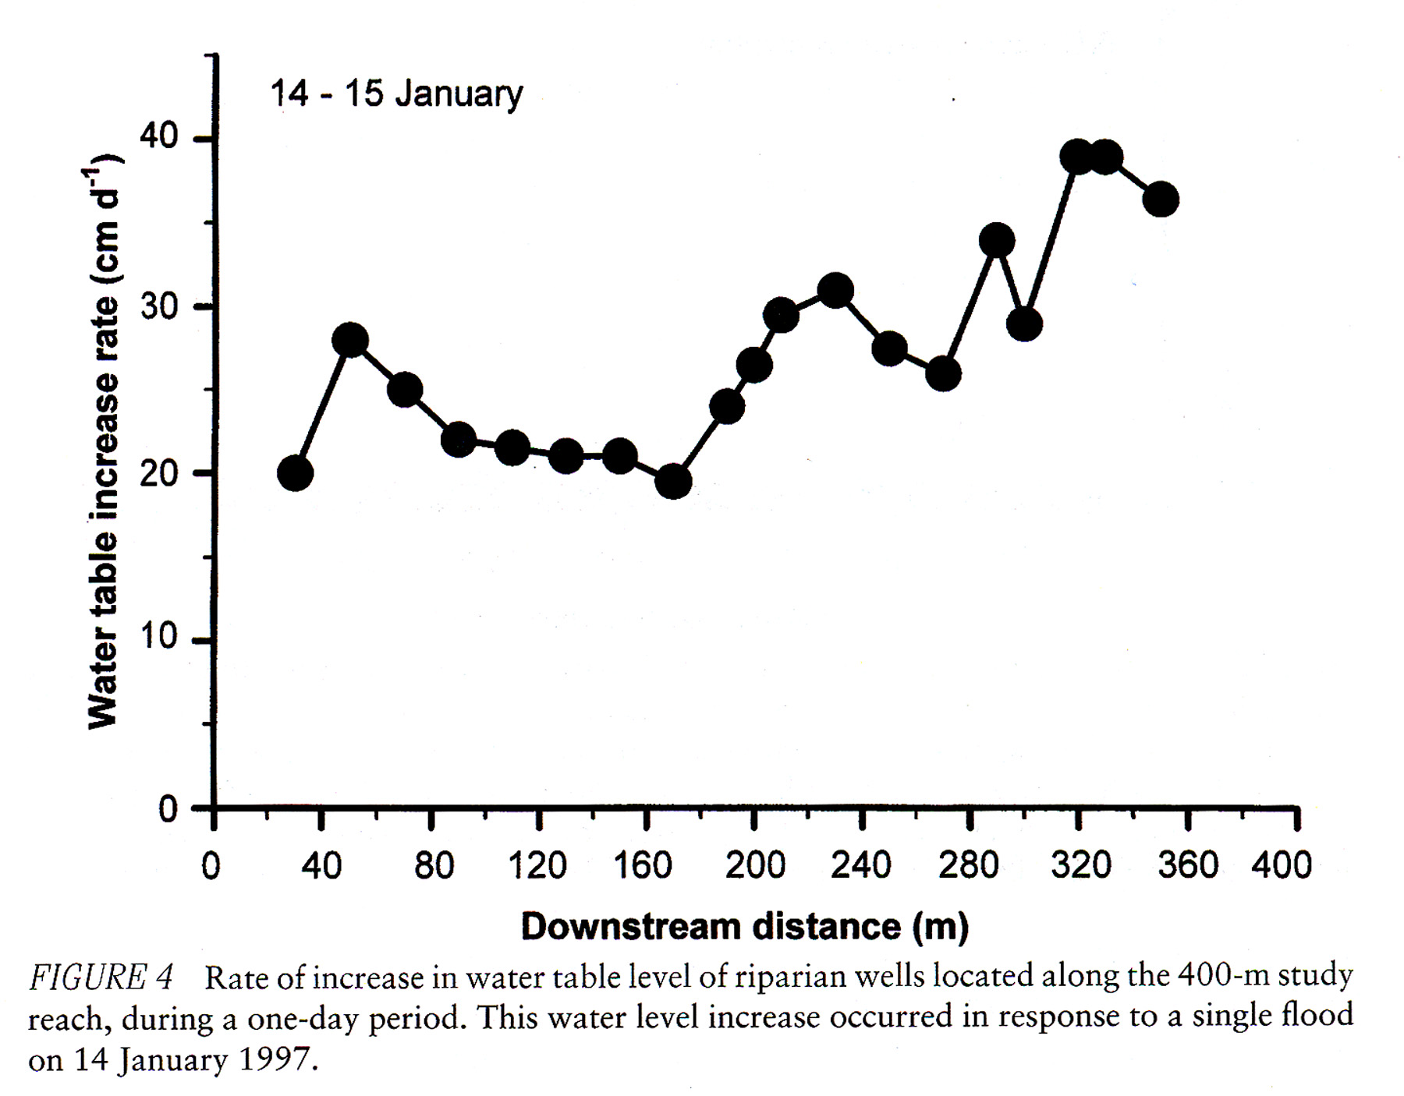

See Fig. 5: Longitudinal changes are explained as lower ET in Fall, contributing a pulse longitudinal flow downstream.

My comment: This doesn't seem right: timescale is not appropriate, trends are too abrupt. May be pumping??
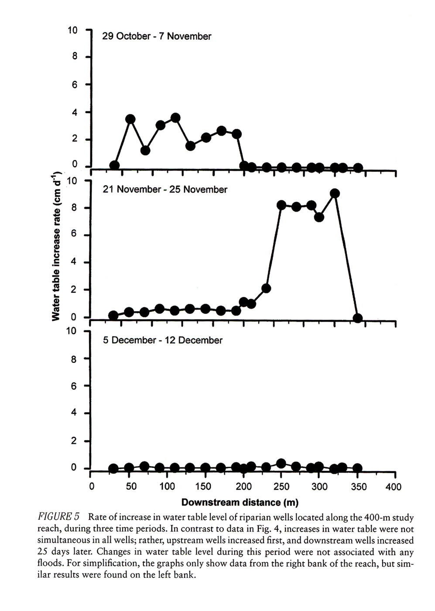
3) Patterns of solute variation

a) Solute variation with time:
- Doesn’t vary systematically with time
- Variation is more related to flood events
- Response of individual nutrients to flood events varies:
ex: SRP decreases as DIN increases

See Fig. 6, p. 124

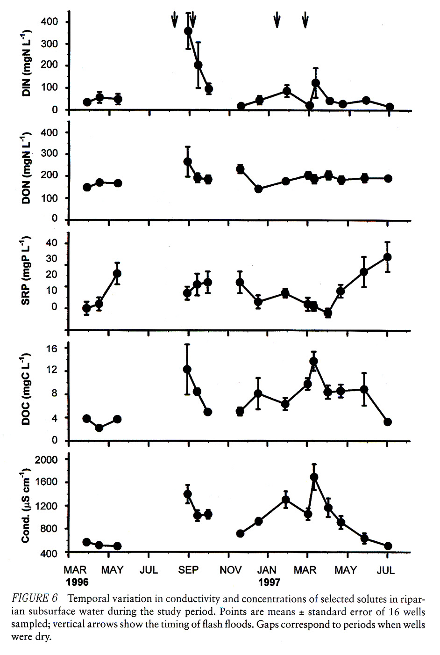

- Possible patterns: SRP is inversely related to flood events
- Nitrate (oxidized form) increases as nitrite (reduced form) decreases:

See Fig. 7, p. 126

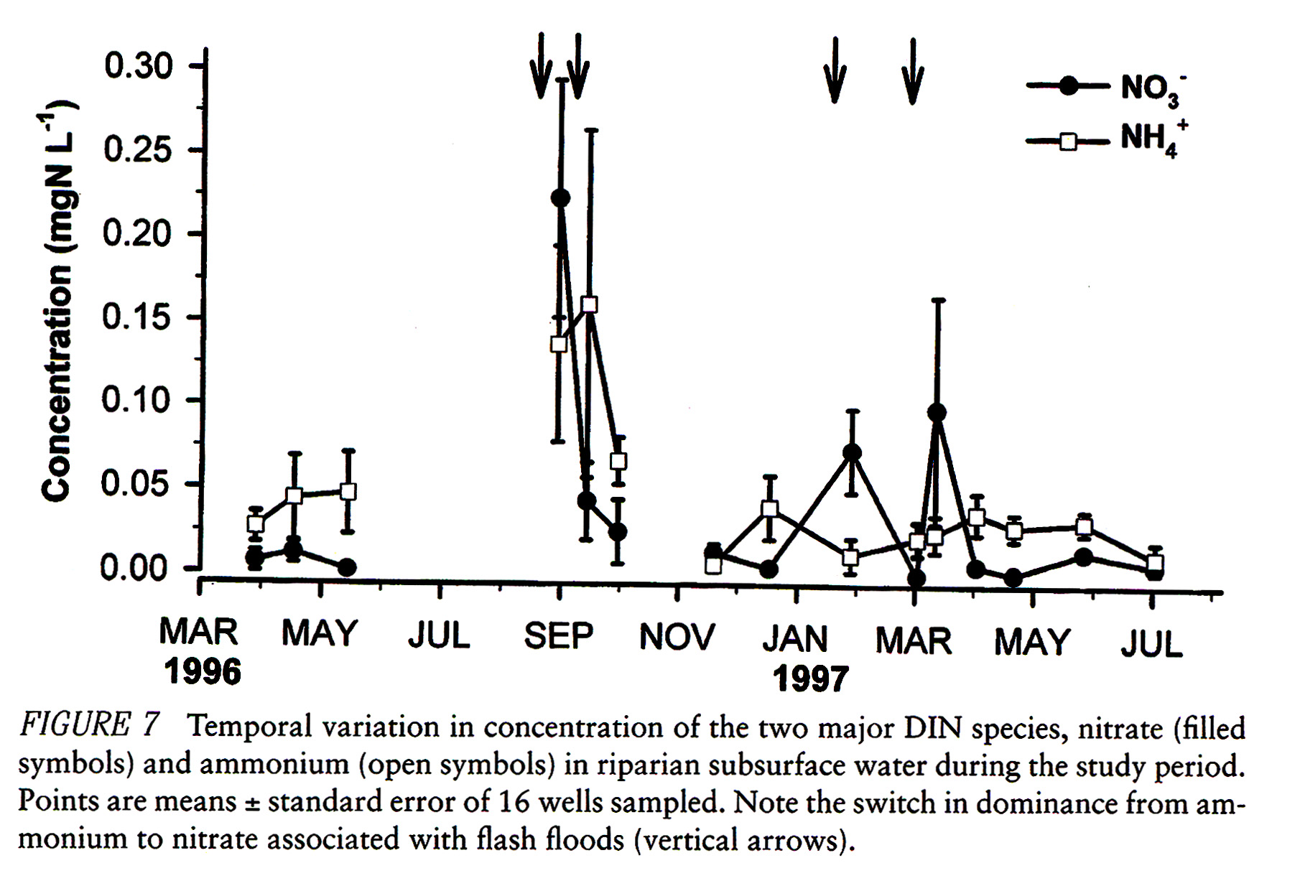

Conclusions:

Arid stormwater affects system quickly, must be from overland flow
Mesic stormwater is mostly from baseflow

My comment: Are we sure about this- seems like it may not be limited to baseflow.

Hydraulic linkage between stream and riparian zone is strongest during floods:
Higher gradient produces more flow, interaction

4) Conclusions: Intermediate disturbance and nutrient retention

- Initial conceptual model: Parabolic distribution of nutrient concentration vs. disturbance

- NOW: Intermittent floods may maximize exchange between stream and riparian zone
- Floods of intermediate variance will deliver more nutrients

My comment: did they prove this? I don’t see it

