Geol 230 Week 5 Lecture
GW/SW interaction Nitrogen Cycling

Reading: Ch. 8, Jones and Mulholland, pp. 197-216, by Duff and Triska

I) Intro to Nitrogen

Nitrogen- is used in proteins, nucleic acids, etc.
Often limits growth in natural systems
May make up several percent of biomass in higher plants (10% of bacteria)
Most nitrogen in aquatic systems is bound in organic matter, and isn’t useable
Useable forms by plants: Ammonium (NH⁺₄)
Nitrate (NO⁻₃)

Most steps in the nitrogen cycle are mediated by microorganisms. Common steps:
1) Reduce nitrate, release nitrogen to the atmosphere
2) Fix nitrogen, make it available for biological processes

Composition and concentration of nitrogen species in streams varies, depends on:
- (Terrestrial) source of nitrogen
- Rate of transformation processes
- Biotic community structure
- Transport/ retention processes in stream

Hyporheic zone influences:
- Variable D.O.
- Increased volume of sediment in contact w/ stream water
- Enhanced microbial rates
- Reduced nitrogen cycling distances
- Altered chemical form of nitrogen

Simple Nitrogen Chemistry:
Nitrogen varies from N⁻³ (reduced state) to N⁺⁵ (oxidized state)
Transformation from reduced state to oxidized state releases energy-
Used by chemolithotrophic bacteria
Transformation from oxidized state to reduced state requires energy (from sunlight or organic matter)

See Figure 1 from text, p. 199

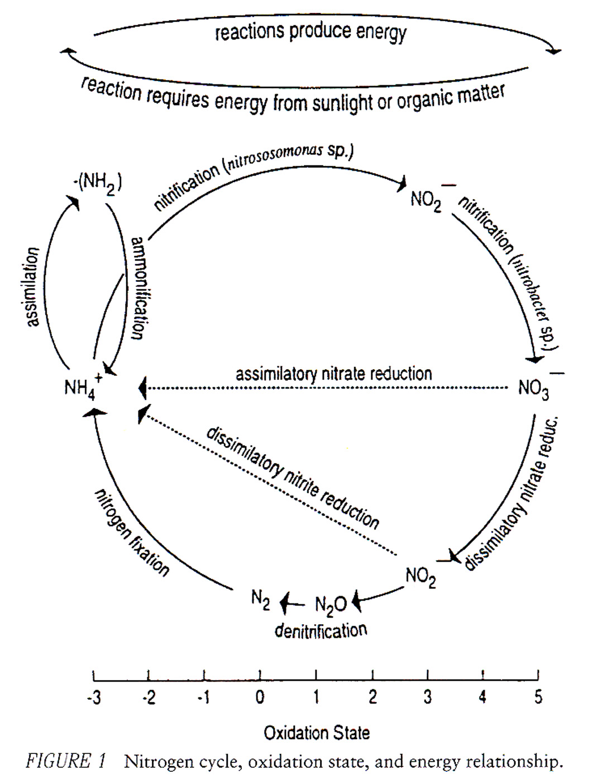

N₂ – Is the most common form of nitrogen
BUT: N₂ only enters biological pathways through nitrogen-fixing bacteria
N₂ fixing bacteria: have symbiotic associations with plant roots
Most N₂: is fixed in plants, released in organically bound form
Heterotrophic bacteria: liberate organically bound nitrogen as ammonia (NH₃) or ammonium (NH⁺₄) – process is called ammonification
NOTE: Ammonia is most common in stream environments, depends on pH
Nitrification:
Chemolithotrophic bacteria: Rapidly oxidize ammonium to nitrite, then nitrate
Each stage of nitrification releases energy, energy is used to assimilate (reduce) CO₂ into organic matter
Nitrate: is easily mobile

Reduction of nitrate: occurs when plants, algae, fungi, bacteria reduce Nitrate to ammonium- occurs prior to incorporation of nitrogen into cellular material.
- This is called “assimilatory nitrate reduction on Fig. 1.

Dissimilative nitrate reduction:
- Occurs when anaerobic bacteria reduce nitrate to nitrite, N₂O, N₂
- Happens in anoxic environments
- Nitrogen compounds serve as electron receptors
- THIS nitrogen is not used in organic matter
Summary:
Nitrification is a SOURCE of reduced nitrogen in stream systems
Denitrification is a SINK of reduced nitrogen in stream systems

II) Nitrogen sources in streams

- On the surface: Is linked to terrestrial environment, is mostly particulate input (litterfall, lateral movement, etc)
- Direct input of DON, DIN from precipitation is rare
- Most input to streams is from GW: particulate or dissolved nitrogen
DON in GW is the largest source to streams!!!
- Some (minor) input to streams is from dissolved nitrogen in GW
- Anthropogenic sources:
agriculture
forestry
urban runoff
- With “massive loading”:
Respiration becomes the dominant transformation process (instead of biosynthesis)
Dissimilatory processes become more important (nitrogen is released instead of retained)

III) Hydrologic retention in streams

- Retention of nitrogen results in a diverse and productive community
- Nitrogen is retained by a variety of processes
- Hyporheic flow increases the chance of nitrogen transformation
- Downstream nitrogen cycling is a “spiral”
- Spiraling = uptake length + turnover length (time to return to dissolved inorganic form)

IV) Redox and nitrate

D.O. varies widely in the subsurface: α input, consumption, residence time
When consumption > supply, anoxia results
In anoxic environments:
Denitrifying micro organisms become more common
Alternate electron acceptors (i.e. nitrate) are used
Denitrification converts nitrate to reduced forms
Nitrate respiration becomes important (vs. D.O. respiration)
This isn’t as efficient as using oxygen as the electron acceptor, but it works!
So: Nitrate is used (consumed) in anoxic environments
A nitrification/ denitrification interface may form

V) Ammonium sorption to hyporheic sediments

Ammonium may be sorbed, retained in the hyporheic zone
Storage pool is variable

VI) Examples of hyporheic exchange and effects on nitrogen transformations

Generally: low DIN in headwaters
DIN increases downstream- usually from GW contribution

Reduced nitrogen: can also be produced in the hyporheic zone

1) Little Lost Man Creek, CA (Triska et al., 1989)

- Reduced nitrogen from the hyporheic zone: can be oxidized to nitrate, transported to the channel for use
- Used tracer tests to determine flow direction (including flow from banks)
- Nitrate was NOT conservative (vs. chlorite)
- When nitrate is added to subsurface wells: it is probably from subsurface flow paths (nitrification)
- When nitrate is depleted from subsurface wells: it is probably from denitrification
(Processes (reactions) can go either way)

See Fig. 2, p. 207: Shows how D.O. influences nitrate, ammonium concentrations

- This study: injected ammonium to subsurface flow path for 9 days
- Found: downstream increase in nitrate concentration (from nitrification of ammonium)
- Effect lasted for several days after injection stopped: due to storage
- Nitrification is most common (possible) with high D.O.: produces nitrate
- Denitrification is also possible: when nitrate is added to the stream, reduces nitrate
- Denitrifying potential increases with distance from channel (due to low D.O. conditions)

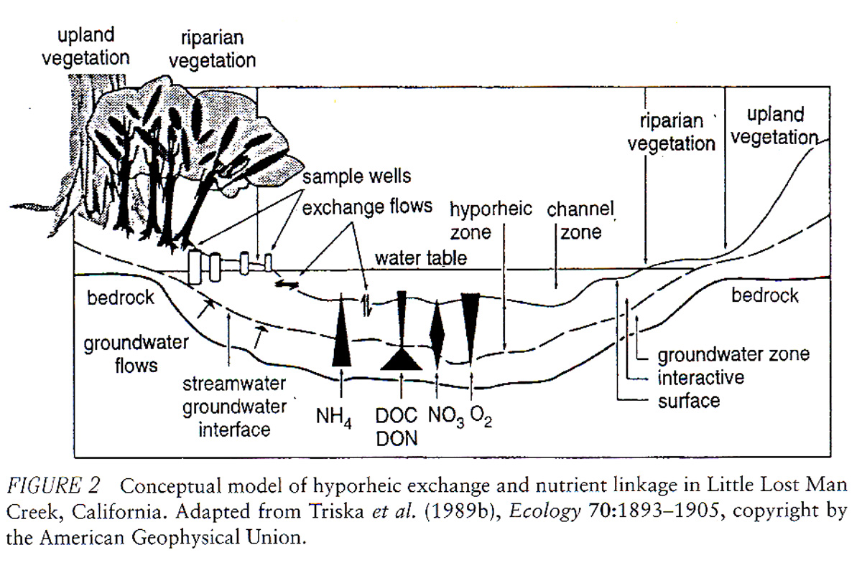

- This study: identified stream reaches that were nitrate sources and sinks
- Trends were seasonal, diel, and upstream/downstream:
Seasonally: more stream nitrate in the summer
Diel: stream nitrate decreases in mid-day (25-40%): from uptake by photosynthesis
Downstream: nitrate increased: from hyporheic nitrification?

2) Sycamore Creek, AZ (Jones et al., 1995)
Found that:
- In downwelling zones,
high D.O.
organic algal debris is flushed downward
heterotrophic organisms present, mineralize organic nitrogen to ammonium
- In the subsurface, reduced nitrogen (in organic matter) can be oxidized to nitrate by nitrifying organisms, then contributed back to the stream
- Nitrification was higher in downwelling zones (respiration, O₂ were higher)
- So: advected organic matter from the stream fueled nitrification

- Other studies have found similar nitrate increases along subsurface flow paths

See Fig. 3 from text, p. 209

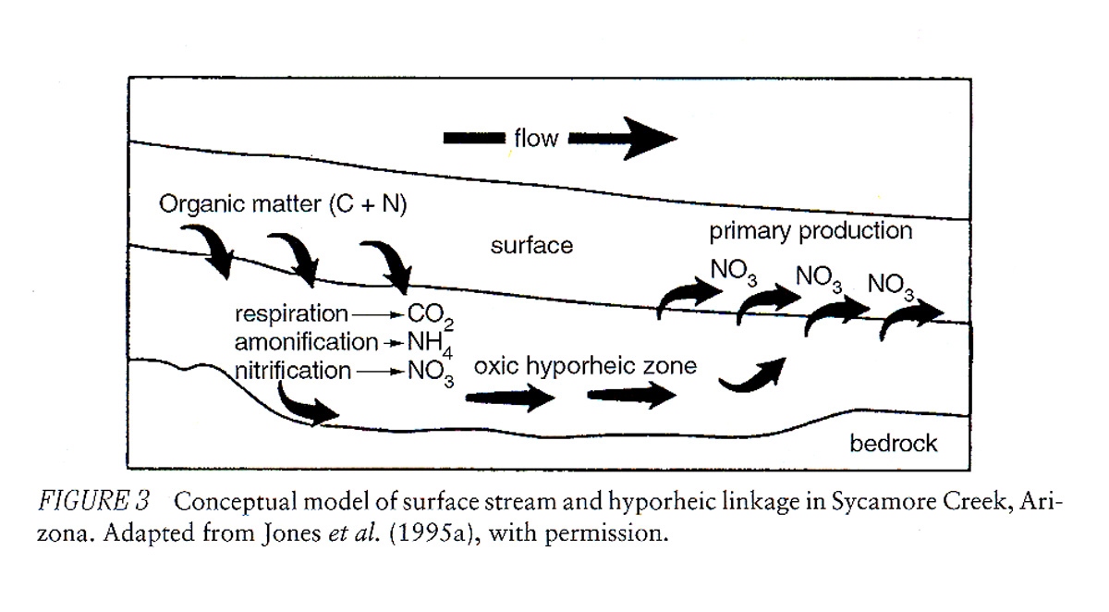
- Along a flow path: D.O. decreases, nitrate increases
- Note: This hyporheic system is still oxic
- Algal activity was highest in upwelling zones, where nitrate was delivered to the surface

3) Shingobee River, Mn

- Heavy ammonium flux in GW is retained in the hyporheic zone, oxidized to nitrate
- An oxic/anoxic interface forms in the subsurface
- Promotes rapid denitrification, removal of nitrate from the system

4) Platte River, Colorado

- Has large human input of DIN:
Ammonium from water treatment plants
Nitrate from agricultural use
- Nitrification becomes a dissolved oxygen sink in the subsurface
- The model:
Ammonium from surface (anthropogenic) is nitrified when added to hyporheic zone
Nitrate is produced
D.O. is consumed
- Then: Below 30 cm depth other reactions occur (not shown on Fig. 5!!)
- nitrate in pore water is denitrified, acts as a sink!!!
See Fig. 5, p. 213

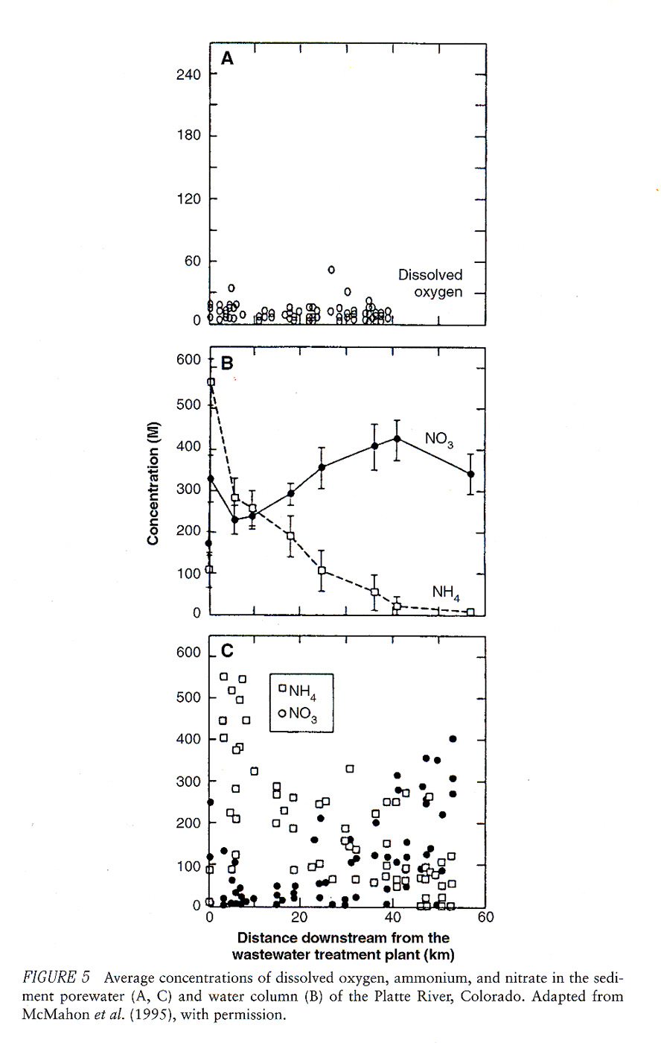

VI) Application to GW studies
- Why analyze for nutrients
- Answer:
Nitrogen species may be a quick/cheap indicator of GW geochemistry.
Nitrogen species: may indicate evolution of a plume (change from oxidizing to reducing conditions)
- Generally:
Nitrate = oxidizing conditions
Ammonium, nitrite = reducing conditions
- Should be done in conjunction with D.O. (or redox) measurements
- Many metals are more mobile in reducing conditions.
- Shifts in plume chemistry in time or space (toward anoxic) may mobilize compounds that were previously less mobile (lead, zinc, chromium, mercury….)

VII) Summary

Long residence time in hyporheic zone increases chance of nitrogen exchange, transformation
With increased hyporheic exchange:
Nitrogen uptake length decreases
Nitrogen regeneration rate increases
Nitrogen turnover length shortens
Aerobic and anaerobic zones can affect nitrogen concentrations and species that reach the stream
Aerobic respiration produces nitrate:
Common in headwater streams with high D.O.
Anaerobic respiration consumes nitrate, produces ammonium
Common in low gradient streams, low D.O.

