Geol 230 Week 6 Lecture
GW/SW interaction Phosphorus Cycling

Reading: Ch. 8, Jones and Mulholland, pp. 221-235, by Hendricks and White

I) Intro to Phosphorus

An essential nutrient (with C, N, O)
Often limiting in lakes, marine environment (ex: Lake Tahoe)
Stream investigations are recent
Hyporheic investigations are rare or absent

II) Sources and forms of phosphorus

Source: Geologic!!!
Occurs complexed with insoluble, inorganic forms of iron, aluminum or manganese
hydroxides
Occurs in clays and colloids (fine particulate matter)
Some phosphorus is contributed from decay of terrestrial organic matter
2 forms of phosphorus:
1) Dissolved inorganic phosphorus (DIP)
- Inorganic phosphate
- Organic compounds: polyphosphates, colloidal organic phosphorus
Phosphate ethers
2) Particulate inorganic phosphorus (POP)
- Complexes with inorganic substances: (clays, iron hydroxides,
carbonates, detrital matter)
- Cellular components: (nucleic acids, phosphoproteins, enzymes,
vitamins)
In a stream: several reactions control phosphorus concentrations:
- discharge
- erosion and sedimentation
- streambed geomorphology
- sediment properties: adsorption- desorption, redox, biotic interactions

III) Abiotic phosphorus retention (vs. biotic!)

Controlled by:
adsorption/desorption capacity
particle size distribution
mineral composition
precipitation/dissolution processes

- Sorption onto inorganic particles:
Occurs under oxic conditions (and high redox potential)
Occurs via chemical bonding, steric effects, electrostatic forces

- Materials with affinity for phosphorus:
Ferric and Al oxyhydroxides: especially important!!
Calcite, aragonite
Clay minerals

Sediments that have pH and redox differences tend to retain iron, phosphate compounds:

The interface, differences are important here

Ex: low pH: sorption of phosphate to Fe, Al and clay INCREASES

Stoichiometry (Fe:PO₄) ratios are also important: range from 2 to 40

Ex: high pH
Oxidizing environment
Fe:PO₄ >15

Iron absorbs most free phosphate

Ex: reducing environment
Fe:PO₄ < 10

Iron hydroxides dissolve, phosphate is released into solution

Free phosphate: can then bind to organic (humic) compounds

Ex: with high Sulfate (anoxic lake, estuary or wetland environment)

Lower redox potential
Phosphorus desorbs (returns to solution)

Hyporheic patterns are not well understood

IV) Biotic phosphorus retention (vs. abiotic!)

Bacteria are important
Factors that control biotic retention (may be related!):
Sediment properties
Oxic/anoxic conditions
Hydrology
Microbial activity

A) Aerobic microorganisms:

1) Mineralize organic matter: large, organic phosphorus molecules are
transformed to soluble, bioavailable forms (phosphate)

2) Participate in Biosynthesis:
inorganic phosphate is assimilated into organic matter

3) Participate in phosphorus cycling:
biofilms may modify the redox environment
During aerobic microbial respiration:
Reduction reactions occur along a thermodynamic gradient:
Terminal electron acceptor order:

O₂ > NO₃⁻ > Mn⁺⁴ > Fe⁺³ > SO₄⁺² > CO₂

Bacteria are available for each step:

Aerobes
Denitrifiers
Manganese and iron reducers
Sulfate reducers
Fermentation bacteria
Methanogens

This couples biologic factors (bacterial metabolism), organic matter mineralization, redox reactions, phosphorus uptake and release

Generally: organic phosphorus, organic compounds are complex:
Phytic acid, nucleic acids, adenosine phosphates, humic complexes

“Exoenzymes” hydrolyze these compounds:
acid and alkaline phosphatases, phosphodiesterase, RNase, DNase, phytase, phospholypase

Exoenzymes are located:
on bacterial cell surfaces
dissolved in interstitial water
associated with inorganic or organic surfaces

High phosphatase activity indicates strong phosphorus demand by bacteria, rapid
Cycling

V) Fluvial dynamics and physical retention of phosphate

Physical retention of phosphate is related to:

Discharge
Velocity
Physical retention devices:
Backwaters, gravel and sand bars, debris dams, woody (organic) accumulations, macrophyte beds
Longer retention = more time for biotic/abiotic interaction

Hyporheic zone and phosphorus: isn’t well understood

Subsurface transport of phosphorus probably increases biotic/abiotic interaction

Depends on oxygen content:

Oxic gravels: biological and geochemical immobilization of of phosphorus dominate

Anoxic fine sediments: anaerobic processes dominate

Gradients of oxic to anoxic may occur under riffles or gravel bars

VI) Conceptual model: surface/ subsurface exchange

Model: flow under a pool/ riffle sequence

Gradients form:
Thermal
Dissolved oxygen
Biogeochemical

Phosphorus is usually higher in interstitial water than in surface water

See Fig. 1, p. 227
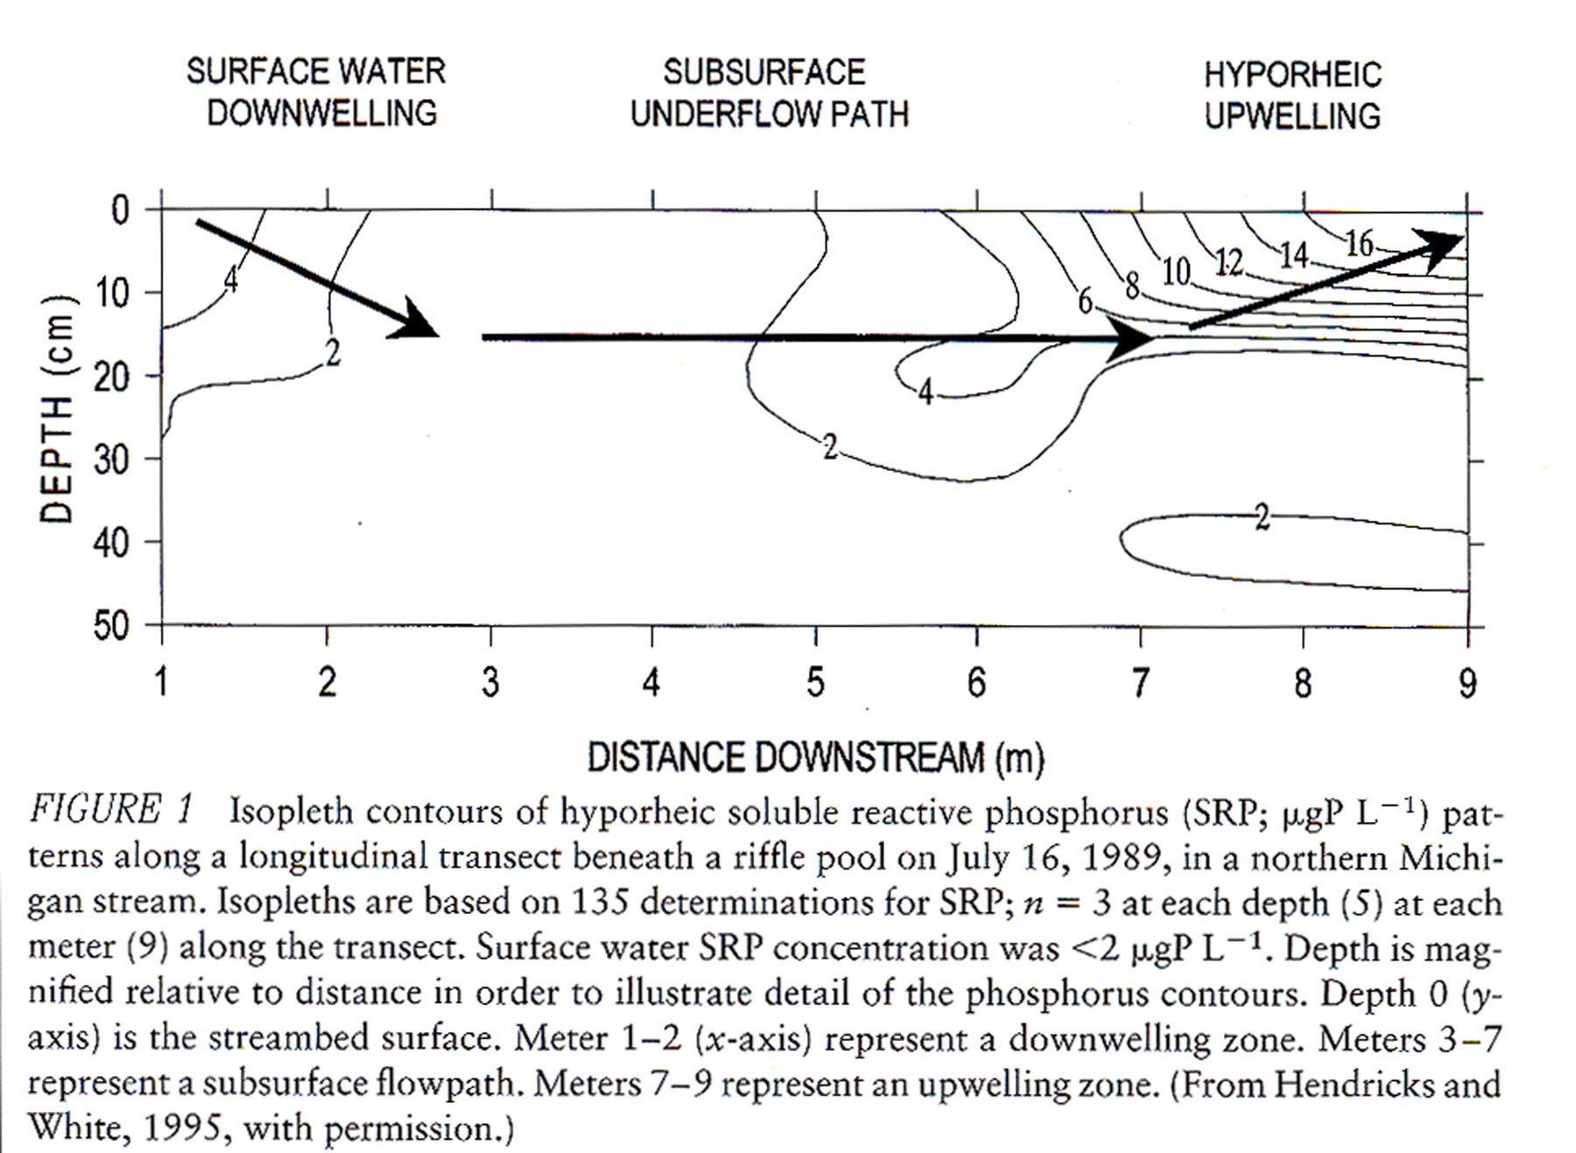

In anaerobic zones: D.O. may be inversely related to phosphorus content

See J &M Fig. 2, p. 229

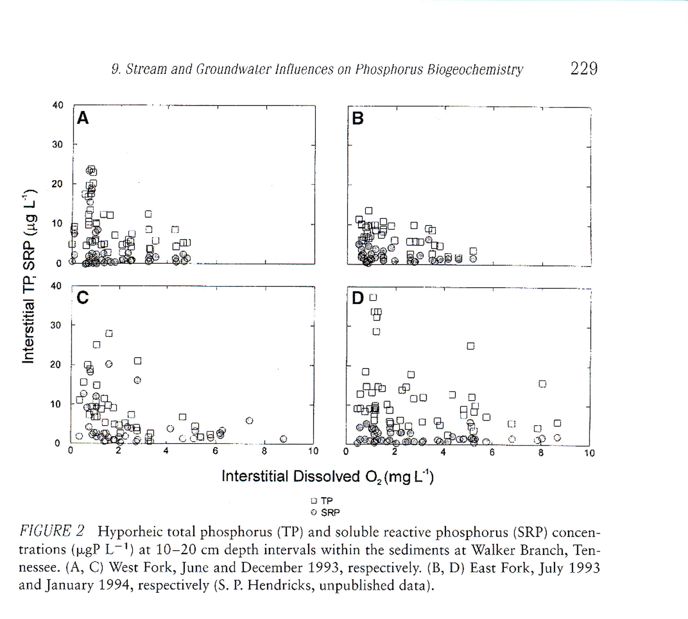

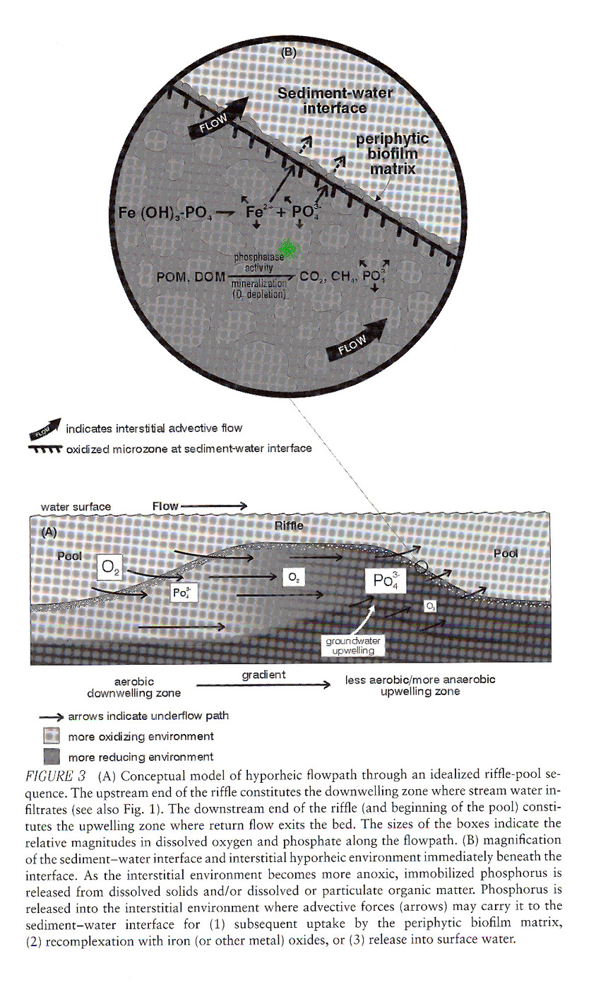
General model: shows the importance of redox

