Geol 230 Week 7 Lecture
GW/SW interaction Carbon Cycling

Reading: Ch. 8, Jones and Mulholland, pp. 237-258 by Kaplan and Newbold

I) Intro to Carbon:

- Subsurface (ground) water is a significant source of DOC to streams
- Subsurface DOC contributes significantly to stream metabolism
- Hyporheic metabolism may equal or exceed stream metabolism
- Possible patterns:
Downwelling zone: surface waters enriched with DOC fuel hyporheic metabolism
Upwelling GW (enriched with DOC) can aid surface metabolism

These are opposite!!

- Major issues: POC vs. DOC

Dissolved: can be labile (easily useable by microbes) or refractory (longer, more resistant carbon chains, less easily used by microbes)

POC also varies in “useability” by stream organisms for respiration:
Has more refractory components
Can be broken apart to produce labile forms, and DOC, but this process takes time!

II) DOC Concentrations vs. environment:

A) Stream DOC concentrations:

- Range from 0.5 (alpine) to 30 (swamps) mg/l

- Are affected by:
Vegetation Bedrock (substrate type)
Climate Input from riparian zone
Decomposer activity
Soil type
Hydrology

- Soil type is especially important:
and CLAY CONTENT!!
DOC complexes with aluminum and iron hydroxides
Aids adsorption to clays

- Clay content may explain some fundamental differences in stream types (vs. DOC):
High clay content holds DOC, streams are relatively low in DOC
Ex: NE U.S.
Lower clay content releases DOC to streams
Ex: “Blackwater” streams in sandy Atlantic coastal plain

My Note: This doesn’t seem well-supported. Pine barrens of N.J. may have other fundamental differences. (Type of organic matter?)

- Wetlands: have high DOC in soils (extensive leaching, slow rates of decomposition, saturated, anoxic soils)
- p. 239: some authors report a (direct) relationship between DOC and amount of wetlands present

My Note: This seems to contradict statements (above) about high DOC in mineral soils with low clay content!

- DOC also comes from:
throughfall
porewaters of unsaturated soils
GW

- DOC α discharge
- Floods increase DOC (usually)
- Spring snowmelt increases DOC
- Both cases: due to alteration of flow paths: vadose zone DOC is released
(overland vs. interflow/baseflow)
- NOTE: this DOC may be refractory/unprocessed/less useable

B) GW DOC:

- Varies by substrate type:
Bedrock = low DOC
Shallow GW that moves through UPPER (organic-rich) soil horizons may have high DOC
- May vary by environment, but there are exceptions:
Some GW from peaty soils is rich in DOC
Some GW from peaty soils is depleted in DOC

- Conclusion: PROCESSING of the DOC may be more important than environment in determining DOC content:

Low DOC in GW = extensive biotic or abiotic use
High DOC in GW = less biotic or abiotic use
See Fig 1, p. 243:

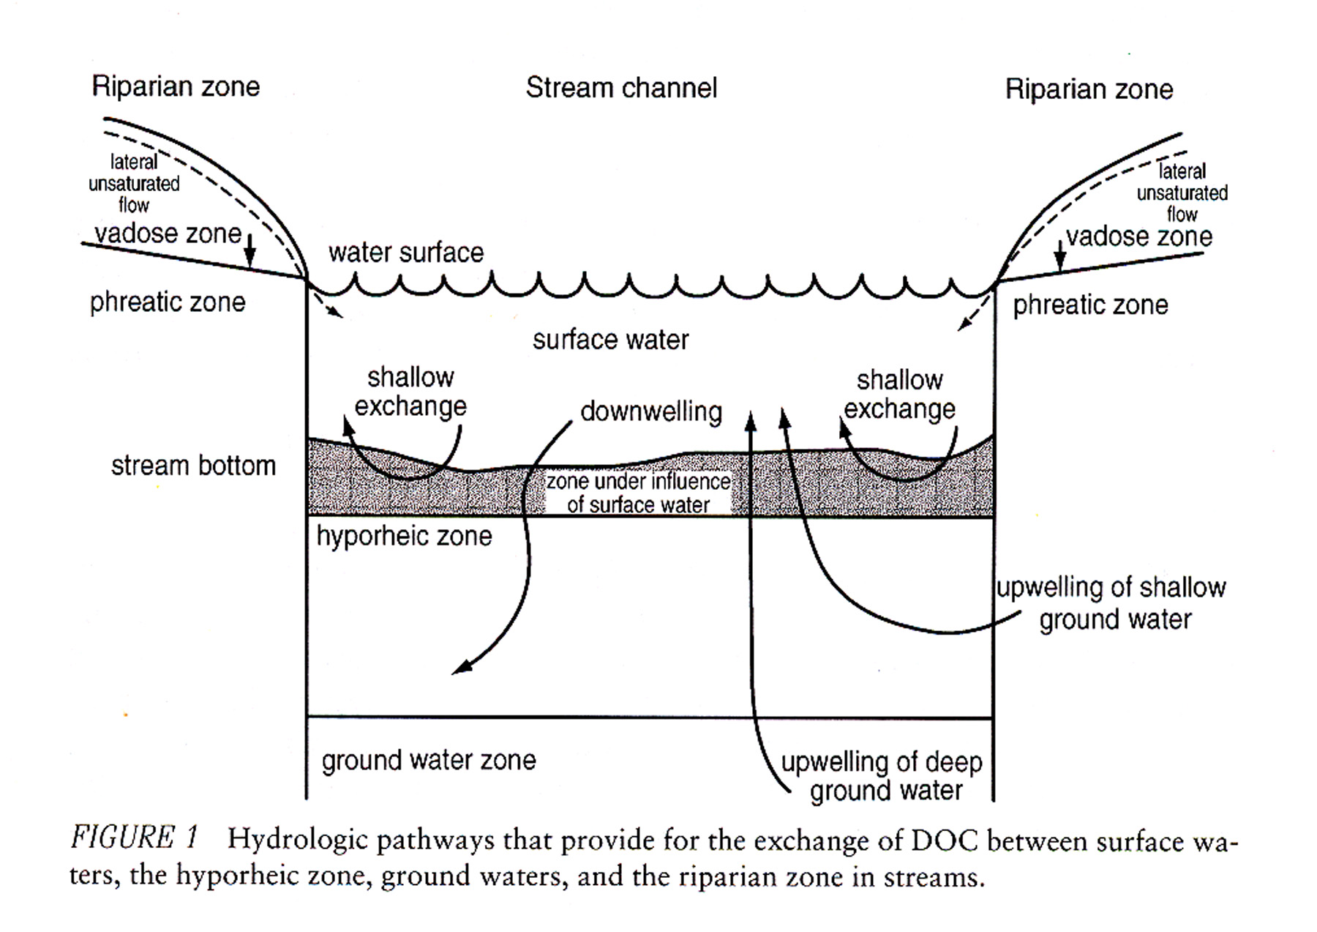

C) Hyporheic zone DOC:
- Doesn’t always fall midway between GW DOC and stream DOC
- Depends on exchange rates and pathways, abiotic and biotic processes
With high exchange: hyporheic DOC
- Hyporheic DOC often declines downstream, along pathways (Utilized!)

III) Hyporheic processes and DOC:

A) Large-scale hydrologic exchange:

3 types of large-scale hydrologic exchange:
- Upwelling
- Downwelling
- Lateral (subsurface) transport: including bank interactions and possible loss to subsurface

1) Downwelling:
- IF surface water is enriched in DOC, then exchanges in the hyporheic zone:
- Hyporheic zone will be a DOC sink

2) GW input:
- IF GW rich in DOC enters the hyporheic zone
- Hyporheic zone becomes a DOC source during exchange processes
- May provide DOC to the stream

B) Interactions on the particle level:

- 4 types of physical/chemical reactions:
Adsorption- the most important: favors “most hydrophobic, unionized molecules”
Desorption
Diffusion
(Degradation)- book doesn’t mention this!

- Biotic interactions:
- Kinetically slower, but volumetrically more important than adsorption
- 2 processes:
Enzymatic hydrolysis (Breaks up longer carbon chains)
Metabolism

See Figure 2, p. 245
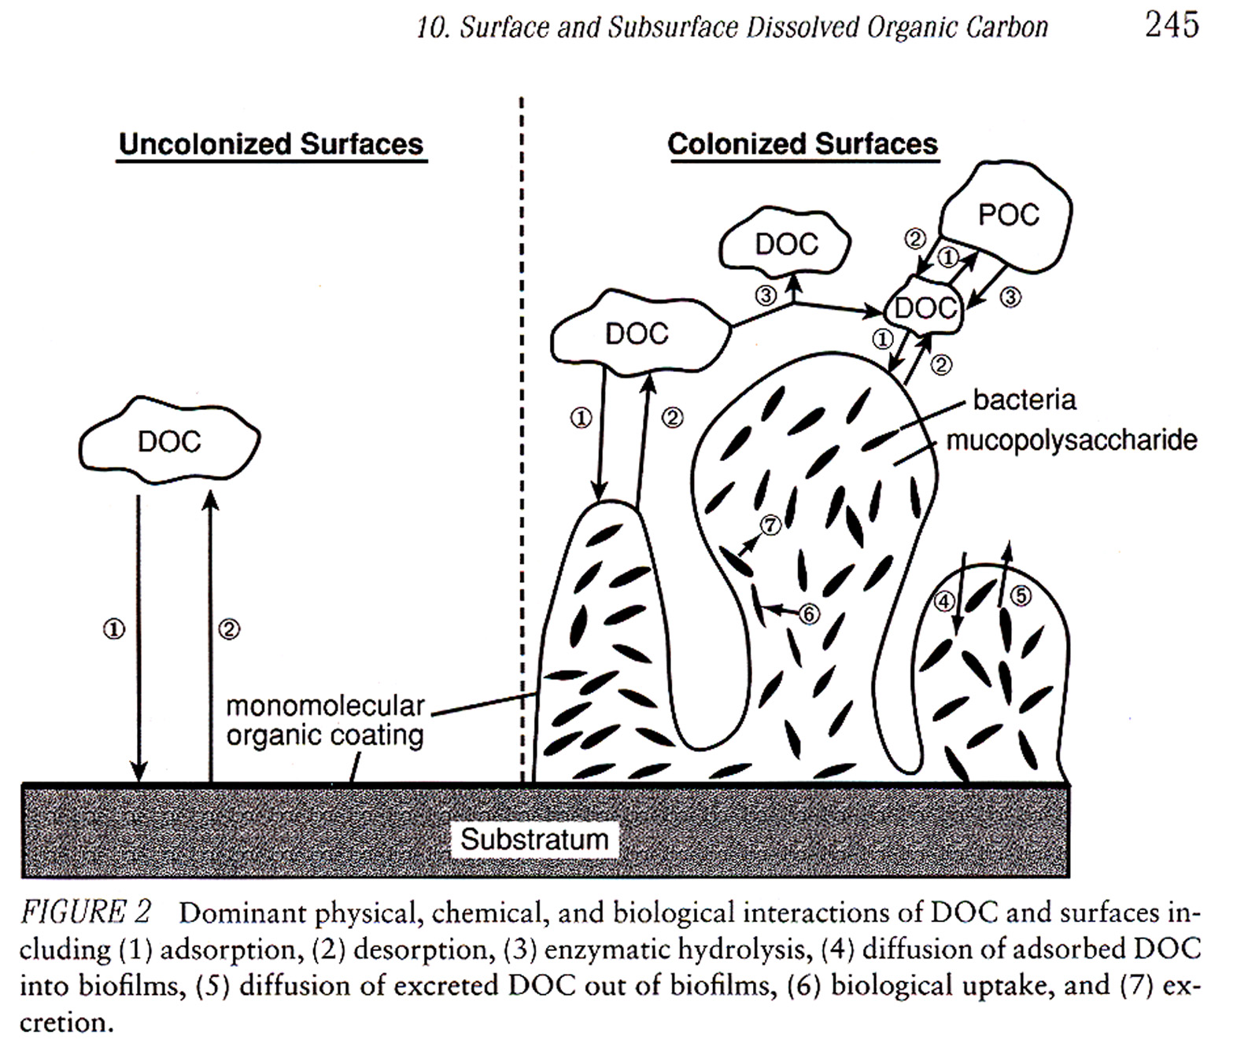

C) Profiles through the hyporheic zone

- Discusses 4 possible (hypothetical) patterns of DOC in the hyporheic zone:
- Includes discussion of upwelling, downwelling, and relations of DOC, O₂, microbial activity, microbial biomass
- Note: types of bacterial species vary:
some use labile constituents (rapidly), others use refractory compounds (more slowly) and at a greater distance from the source
- Gradients or patterns should exist for each of these factors:

See Figure 3, p. 247

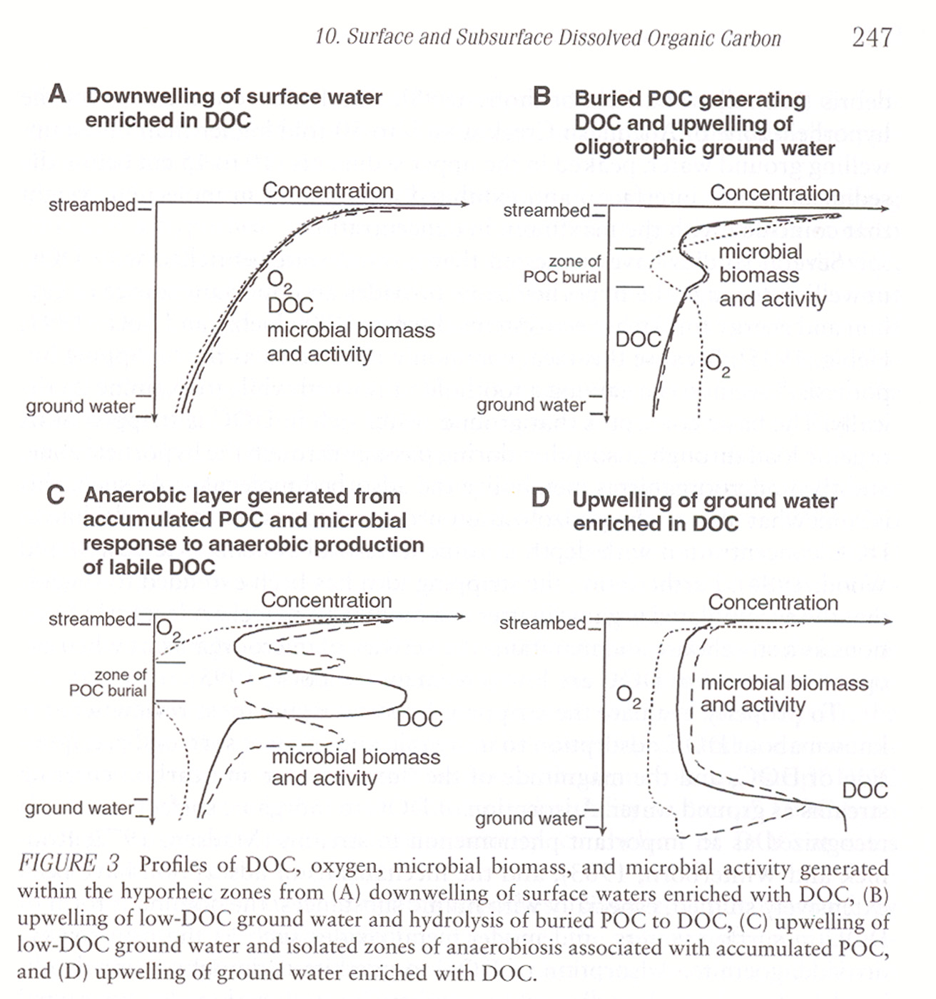

1) Downwelling of surface water enriched in DOC:
- Several factors decrease with depth:
- O₂, DOC, microbial biomass, activity (respiration??)
- Lateral transport through a gravel bar may enhance consumption of refractory components
- Factors listed above may also decrease downgradient in this case

2) Upwelling of GW depleted in DOC that encounters buried POC

- POC can be buried during (prior) flood events
- POC → DOC through leaching and enzymatic hydrolysis
- Produces:
Oxygen minimum where POC is buried
My comment: these must be heterotrophs????
Slight rise in DOC and microbial biomass

3) Dense layer of POC that produces anaerobic layer

- Leaf packs or debris dams reduce permeability
- Microbial decomposition removes all available oxygen
- Fermentation results, organic (fulvic) acids are produced
- Organic acids diffuse into nearby zones:
Note (downward) shift in curve from this diffusion
- This is an INORGANIC process!!
Microbial biomass and activity decrease in the anaerobic zone
- Note straddling peaks in microbial biomass and activity: from diffusion of DOC

4) Upwelling of GW enriched in DOC

- This is more controversial
- Called “stripping hypothesis”
- Parts if this cycle are haven’t been observed
- The theory:
- DOC is stripped from GW during upwelling by adsorption to inorganic surfaces
- Microbial action utilizes (metabolizes) the DOC
- May happen in a layer that is one microbe thick around the inorganic particles
- This could remove some DOC, but probably not all (based on lab studies)
Lab studies only showed 10-25% DOC removal by this method
- Continued removal of DOC would require continued microbial activity

D) Spiraling length and energy exchange in the hyporheic zone

- Hyporheic zone traps, transforms organic carbon
- Shortens spiraling length
- MAY decrease the downstream transport (availability) of DOC

My Note: This last statement seems controversial- authors spend the remainder of the paper talking about exceptions.

My thought: depends on rates of supply vs. rates of consumption. Some systems have a net surplus of DOC and net throughput, others use all DOC. Hyporheic exchange is a major factor here:

Fig. 4:

