Mountain Species, Climate Change, And The Escalator Effect
Mitch Tobin, EcoWest, Sept. 24, 2013
http://ecowest.org/2013/09/24/video-mountain-species-climate-change-and-the-escalator-effect/

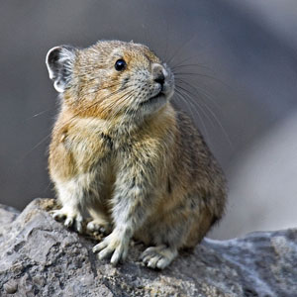
American pikas live near sea level in parts of Western Canada, but in the United States they’re found much higher up. In places such as Nevada and Southern California, they’re rarely observed below 8,200 feet. In North America, as one moves southward toward warmer climes, pikas live at progressively higher elevations.

Although relatively widespread and usually found in protected public lands, the American pika is considered an indicator species for climate change and may face a challenging future. These cute critters are super-sensitive to heat and can die in a matter of hours is exposed to temperatures of 78 degrees or above.
http://naturemappingfoundation.org/natmap/facts/american_pika_k6.html

The data provided shows the current range of the pika in the American West, and projections of its future range in the 21st century under different climate models (each model is based on a different set of assumptions about future carbon dioxide levels and how the atmosphere will respond. The B1 scenario is the most optimistic, the A2 is the least optimistic, and the A1B is in between.

- What do you see happening to the pika’s range? Can you explain why this is happening?
- DO you have any ideas about how to keep the pika from going extinct in many areas>

