Understanding Atmospheric Circulation, Modeling, and the Next Generation Science Standards
By Judi Kusnick and Rich Hedman

Fall Regional Meeting—Far Western Section
National Association of Geoscience Teachers (NAGT)
Sacramento State
10/12/14

Most of these lessons originated from teacher collaboration during the 2009-2010 supported through a UC Davis/National Science Foundation grant. The program was called Innovations in Science Instruction through Modeling (ISIM), which was coordinated by the Sacramento Area Science Project (SASP).



How to download all of the files used in this presentation:
Go to http://www.csus.edu/indiv/k/kusnickj/
Then follow the link to this presentation.

Feel free to use and adapt anything from our presentation for K-12 teaching purposes. However, our files and documents cannot be used for other purposes, such as publication or for profit, without the express permission of Judi Kusnick (kusnickj@saclink.csus.edu).

Model of Atmospheric Circulation ISIM Earth Science Group

Phenomena/Data Patterns:

Air rises at the equator (lower surface air pressure).
Air sinks at the poles (higher surface air pressure).
Air rises along the 60 latitude line (lower surface air pressure).
Air sinks along the 30 latitude line (higher surface air pressure).
Global wind directions in each band of latitude.
Apparent “deflection” of air in each latitude band.

Summary of the phenomena and data patterns in graphic representation:
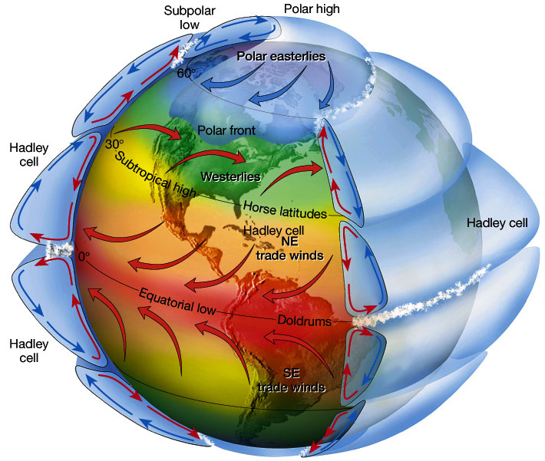

Questions:

Why does air rise at the equator?
Why does air sink at the poles?
Why does air rise at 60 latitude?
Why does air sink at 30 latitude?
Why isn’t there a single convection cell in each hemisphere?
Why do surface wind direction change with latitude?

What would atmospheric circulation would we predict:
- If earth was much smaller?
- If earth wasn’t spinning?
- If earth was spinning slower?
- If earth was spinning faster?

Model of Atmospheric Circulation
Constructs | Relationships
Sunlight  Earth’s Spherical Shape  Differential Heating  Temperature  Density  Gravity  Air Current  Convection Cell  Earth’s Spin Rate  Coriolis effect  Deflection  Earth’s Size  Latitudinal Extent | Because earth is a sphere, sunlight heats the earth differentially. The equator receives more concentrated sunlight, while the poles receive more spread out sunlight.  The differential heating of earth produces temperature differences on earth’s surface, which produce similar temperature differences in the atmosphere.  The temperature differences produce density differences in the atmosphere, and in earth’s gravitational field, the density differences create air currents.  Since there is a continuous heat input at the equator, and heat output at the poles, combined with heat loss to space at altitude, convection cells develop along longitude lines (air moves upward, polewards, downwards, equatorwards, and repeats, along a longitude line).  Because earth is spinning sphere, there is a relatively high tangential velocity at the equator, and no tangential velocity at the poles. As air moves, it is affected by this difference in tangential velocity, with the net result being that air is deflected to the east if it is moving toward the poles, and deflected to the west if it is moving toward the equator, and this is called the Coriolis effect. Faster spin rates produce higher deflection rates.  The convection cells which develop from the temperature/density differences described earlier are significantly affected by earth’s size, since earth’s size determines the distance the air travels from the equator to the poles.  The further the air travels at altitude away from the equator, the more heat is lost to space, reducing air temperature, eventually increasing density to the point where the air sinks. This is enhanced by Coriolis (see below). Because of earth’s large size, air sinks before it reaches the poles.  The further the air travels along the earth’s surface away from the poles, the more heat is gained from the surface, increasing air temperature, eventually decreasing density to the point where air rises. This is enhanced by Coriolis (see below). Because of earth’s large size, air rises before it returns to the equator.  Also, the further air travels, the more the air direction is deflected by the Coriolis effect. Eventually poleward or equatorward air is deflected perpendicular to its original direction of motion, and moves to the east or west along a latitude line. At altitude, this enhances the loss of heat to space (30 latitude line). Along the surface, this enhances heat input from the surface (60 latitude line and equator).  Therefore, the interaction of earth’s size with the convection cells, enhanced by the Coriolis effect, determines the latitudinal extent of each circulation cell, resulting in a three cell system in the northern and southern hemispheres, with air rising at the equator and 60 latitude, and sinking at the poles and 30 latitude.

Representation of Model of Atmospheric Circulation

