Winds and the Coriolis Effect on Other Planets
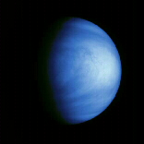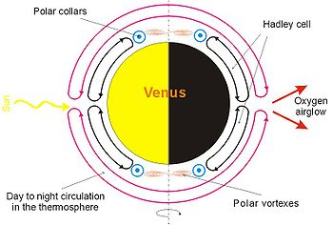
Venus
Venus is about the same size as the Earth. Its atmosphere is extremely dense. Because the planet rotates very slowly the Coriolis Effect on Venus is extremely weak.
Galileo image, courtesy National Space Science Data Center
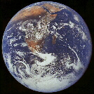
Earth
Rotating on its axis about once every 24 hours the Coriolis Effect on the motion of the Earth's atmosphere is quite strong, creating continent sized swirls of cloud systems which are easily visible from space.
Apollo 17 image, courtesy National Space Science Data Center
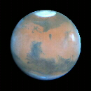
Mars
Mars has a very tenuous atmosphere. With the exception of vast dust storms, visible weather systems are not easily seen on Mars.
Mars' small size reduces the Coriolis Effect.
Hubble Space Telescope image, courtesy National Space Science Data Center
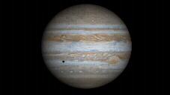
Jupiter
Jupiter is more than 11 times the diameter of the Earth, and rotates on its axis (one Jovian day) in 9.8 hours. Jupiter's large size and rapid rotation create a very large Coriolis Effect in its atmosphere. The winds in the Jovian atmosphere are deflected so strongly that they form hurricane-force gales blowing in East-West bands around the planet.
It is the Coriolis Effect that is responsible for Jupiters banded appearance.
Hubble Space Telescope image, courtesy National Space Science Data Center
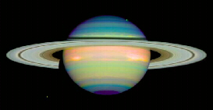
Saturn
Saturn is also a very large planet, almost 9.5 times the diameter of the Earth. A full day (one complete rotation) of Saturn lasts only 10.5 hours. As with Jupiter, the combined effect of rapid rotation and large size create a very large Coriolis Effect in Saturn's atmosphere.
The striped appearance of Saturn is created by a very large Coriolis Effect.
Hubble Space Telescope image, courtesy National Space Science Data Center

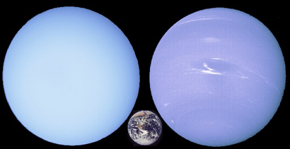
Uranus (earth size for reference) Neptune
Uranus and Neptune also have thick cloud decks but Uranus' atmosphere does not have the prominent bands and storms seen on the other jovian planets. This is because Uranus does not have an extra internal heat source like the other jovian planets, so it does not have the convective motions in its atmosphere. Neptune's clouds are deflected to form bands parallel to its equator because of its rapid rotation. Neptune can also have turbulent eddies form in its atmosphere. When the Voyager spacecraft flew by Neptune in 1989, it found a large dark storm, called the Great Dark Spot (very original, yes?), that was about the size of Jupiter's Great Red Spot. However, recent Hubble Space Telescope photographs show that the Great Dark Spot seems to have dissipated.

Prepared by R.Hedman 2010 from these two sources:
http://www.asc-csa.gc.ca/eng/educators/resources/mars/grade5_winds_planets.asp
http://www.astronomynotes.com/solarsys/s5.htm

