http://www.uic.edu/classes/bios/bios100/summer2002/blacksmoker.jpg
Subduction zone mineralization: hydrothermal deposits and pegmatites
Diverging boundary mineralization: black smokers
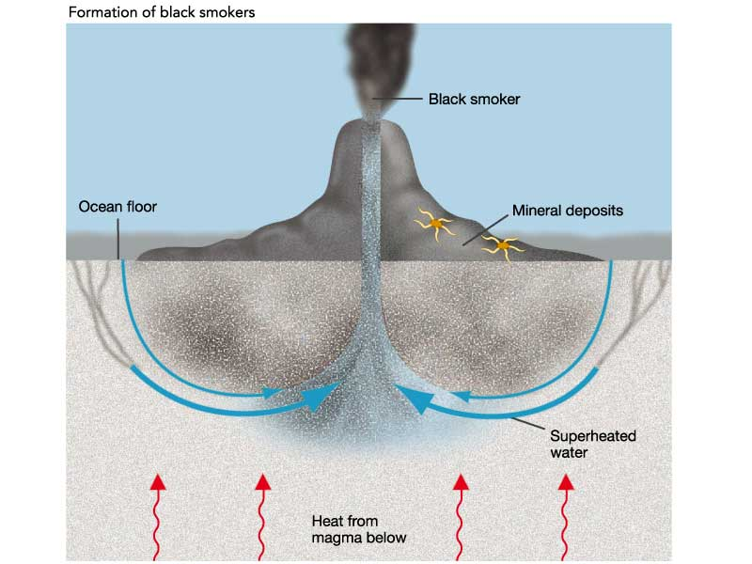
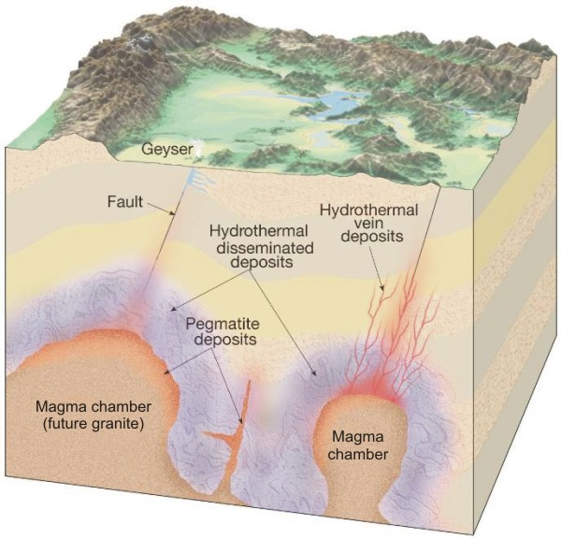
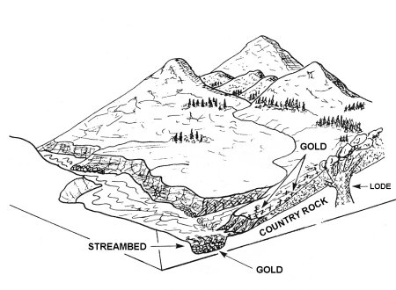
http://www.goldgold.com/gold-prospectingplacer-geology.html
Placer deposits: gold erodes from rock and concentrates in low spots in river.
http://www.nvcc.edu/home/cbentley/gol_135/prince_william/prwi.htm

