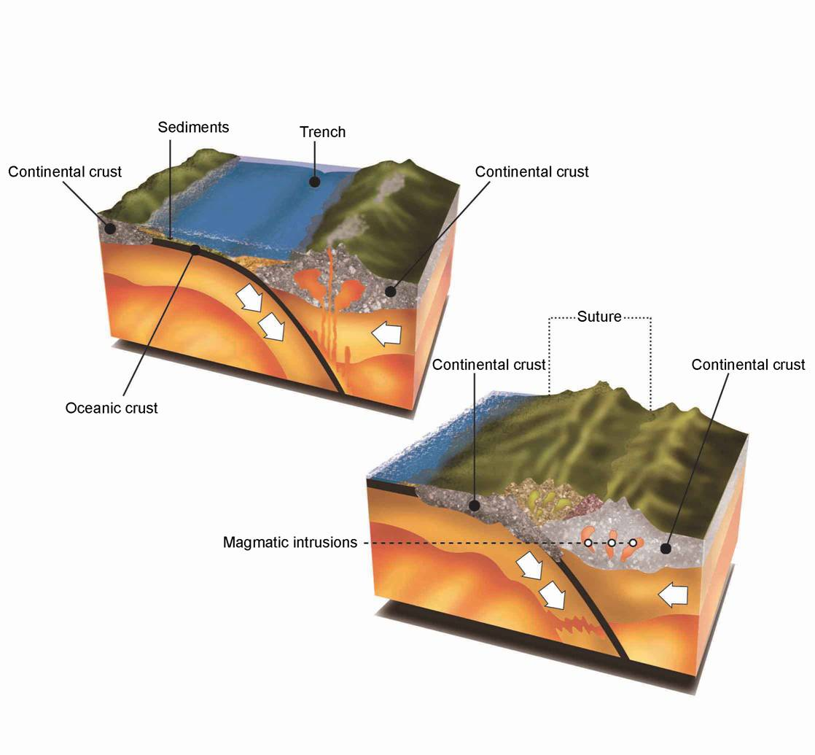
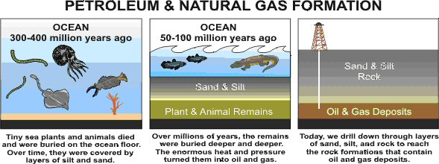
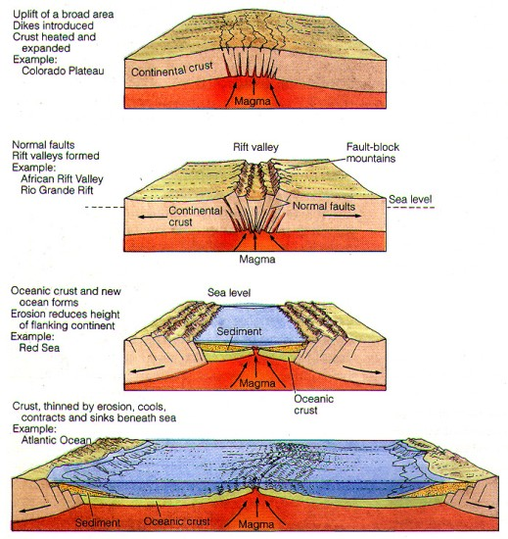
http://www.globalization101.org/oil/
http://www.tankonyvtar.hu/hu/tartalom/tamop425/0033_SCORM_MFFTT600120-EN/sco_08_01.scorm
http://www.geo.fu-berlin.de/fb/e-learning/geolearning/en/mountain_building/magmatism/generation_types/subduction/index.html
Organic material accumulates in narrow ocean basin

