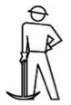
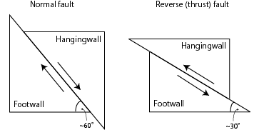
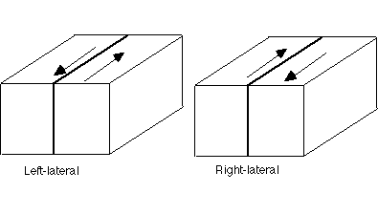
Hanging wall: upper surface of a fault
Footwall: lower surface of a fault
http://www.newworldencyclopedia.org/entry/Fault_(geology)
http://www.geoclassroom.com/structure/simplelab.shtml
Stress:

Shortens or lengthens?:
Stress:

Shortens or lengthens?:
Strike-slip fault

Stress:

What happens to the block?
Faults

