SASP 2011 Name:

Can You Name It?
Identifying Samples

Goal: We will figure out how all these powders are different from each other by comparing their properties.
Procedures: What properties would help you tell the substances apart? Chart the properties and your observations.
PROPERTIES
 | SAMPLE | Property  A | Property  B | Property  C | Property  D | Property  E | Property  F | Name the sample
sample
1
sample
2
sample
3
sample
4
sample
5
sample
6
sample
7

Follow-up Questions:

1. On the front side of this page, you studied each substance by looking at its properties or characteristics, such as its color.
List all the properties or characteristics that you used or studied on the front side of this page.

2. Are there other properties you did not use but that you could have used? Are there other properties that you could imagine being useful to someone else, such as a cook or a crime-detective or a scientist?

3. In questions 1 and 2 above, you listed some properties, such as color.
a) If you study a small sample of salt, it looks very white. If you study a large sample of salt, does it still look very white? or does the color depend on how much sample you look at? Explain.

b) Now think about the other properties you listed in questions 1 and 2, besides color.
Which properties depend on how much sample you look at? (In other words, if you look at a small amount of salt and then a larger amount of salt, does the property change?) Explain.

4. The substances in this activity were powders or crystals. If you had been given several liquids instead, would you have been able to identify them by the same properties that you mentioned in questions 1 and 2 above? or would you have needed to study other properties that you have not already mentioned? Explain.
TEACHER NOTES
Concept 1 (2 and 4)

Intended Learning Outcomes
Students will understand the following:
- The world is made of a variety of substances.
- These substances have properties—characteristics—that help us identify them and tell them apart.
- The basic or most essential properties of a substance do not depend on how much of the substance you have.
- Some of the properties describe how the substance is or acts all by itself; other properties describe how a substance behaves as it interacts with other substances.

Supplies
- 5 to 7 small containers (each one large enough to hold a few ounces of a food item)
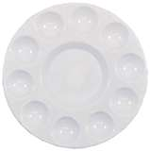
- 5 to 7 food items, such as…
flour fine corn meal
salt baking soda
granulated sugar powdered sugar
corn starch
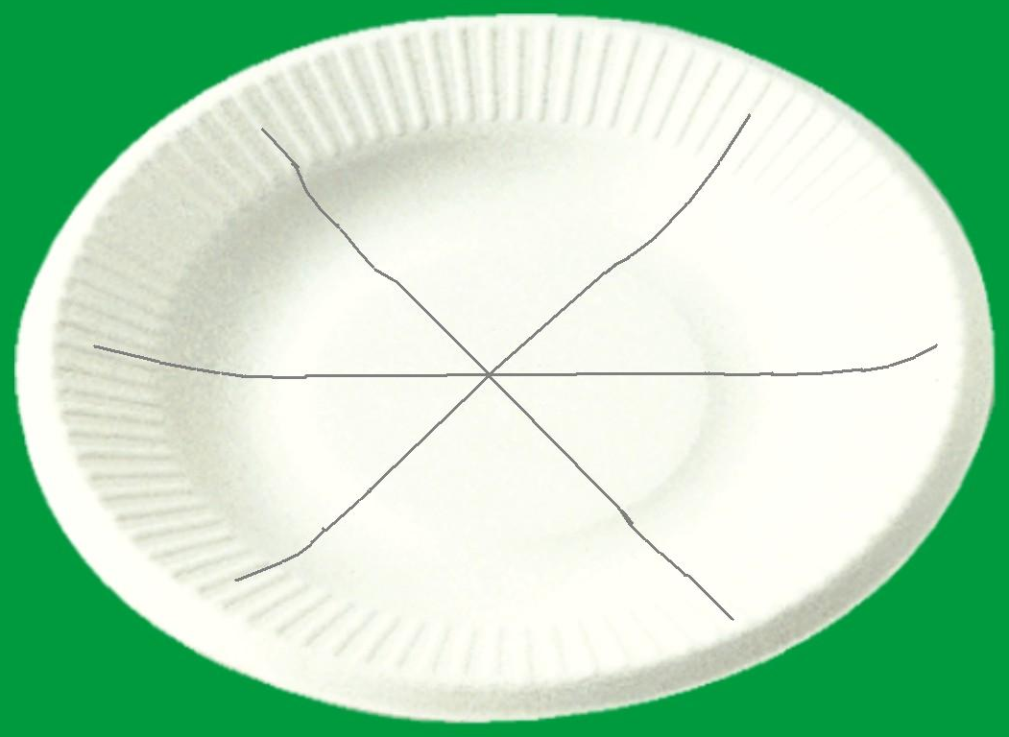
- something for students to place their food samples on
examples: clean paper plate with lines drawn to divide it into 5 to 7 spaces, or
clean plastic painting palettes with several small wells or mini bowels pressed into them
- baby-size spoons, or flat wood coffee stir sticks, or some other tiny scoops
(one goes into each food container, so students can get some of each sample onto their paper)
- toothpicks for students to use as a probe to explore their samples
- water and paper towels for clean up

Optional water and vinegar tests:
- water (from sink or other source)
- vinegar
- small condiment cups (so students can take a small cup of water and a small cup of vinegar to their lab table)
open end
fold and tape this end shut
- eye dropper
If you want, here is how you can make disposable eye-droppers out of drinking straws:
(1) Cut a straw in half. (Each half will make an eye dropper, so you’ll end up with two droppers.)
(2) Choose one of the halves. Seal one end of the straw so that it is air-tight (a simple way to do this: fold about ½ inch of the end of the straw over, and fasten that folded end closed with some tape.
(3) You now have an eye-dropper: Stick the open end of the straw into the water, squeeze and let go—it should suck up a few drops of water like an eye dropper.)

Class Time Needed
15 to 25 minutes… if you do not include the water and vinegar tests/20 to 30 minutes… if you do include the water and vinegar tests
Lesson Outline and Teaching Suggestions

Engage: what are properties
- Describe an object: foil (with group-1 minute)
- group discussion; create your own definition of “property” (write on sentence strip)
- Share out and post
- Chart all definitions; either they are similar enough to leave them or we create one good one (a characteristic that helps us describe and identify something).
Introducing the activity
Tell the class that today’s activity, “Can You Name It?”, will give them a chance to act a bit like detectives. Students will be given several mystery substances. Their main job is to collect evidence about the substances. At the end of the activity, they can use the evidence to try identifying (naming) the substances. Collecting and studying evidence is one of the main jobs of both a detective and a scientist.

Here are a few key points to highlight before you start them working with the substances:
- The evidence they will collect is this: Study and describe the properties of each substance. You might need to clarify what we mean by a property—a characteristic that helps us describe and identify something. We recognize a friend when they walk into the room because of characteristics like hair color, facial features, behavior, voice, etc. Give them examples of properties of something in the classroom such as a piece of paper; how do we distinguish the paper from a tree leaf? If we cut a 1-inch square of each, could you tell the paper apart from the leaf? The paper is white, flexible but not so fragile, etc.
- Emphasize that for now, naming the properties of the substances (describing the substances) is more important than naming the substances themselves. They must fill up most of the chart. (Students like to jump to the “answer” and skip over the hard part of studying properties.)
- You can tell students that the substances they are about to see are all commonly found around the house. But you do NOT need to tell them that the substances are food ingredients.
- Remind students that as a general rule it is NOT safe to taste substances in a science classroom.
- Explain how students can get a sample of each substance back to their lab table without spilling the samples and without mixing up the samples. If you are using paper plates, have students draw lines to divide up the plate into 6 or 8 wedges; have them number the wedges 1 through 8. Then they can put a small sample of substance #1 in wedge space #1, substance #2 in wedge space #2, etc. If you are using painting pallets, the teacher should number the wells before class.
- Each column on the student handout should be a different property. For example, you can suggest that Property A (the first blank column) could be color. Tell them to be very descriptive and specific; distinguish different shades of color.
- You don’t need to tell them what properties to use for the remaining columns B through F; let students come up with their own categories of properties. Other properties might include texture, graininess, stickiness, and smell. They should try at least three properties, but they don’t need to use all six property columns. (See the next bullet point below about the optional water / vinegar.)

Optional water and vinegar tests:
- If you choose to do the water and vinegar tests, initially tell students to leave the last two properties blank (columns E and F). Tell them you will instruct them what to do with these columns a bit later.

After students get working, some students may ask you (without you prompting them) if they can try using some water. If most groups have filled out at least two or three properties for most substances, you can suggest they try two additional properties:
- For column E, they can add a drop of water to a bit of the substance and see how the substance behaves.
- For column F, they can add a drop of vinegar to a bit of the substance and see how the substance behaves.

***When students are done with the chart, make sure they get to work on the follow-up questions on the back side of the student handout. (write answers in notebooks) (tape chart in notebook)

Whole-class discussion after the activity

The main goal of this activity was the study of properties. What kinds of properties did students come up with? Ask them to share some of the answers that they wrote on the back side of the student handout.

Include a discussion of question 2: properties that might have been useful to somebody, even if your students did not use them.

Also include a discussion of question 3: To be most useful, a property should not depend on how much of a substance you have. For example, a few salt crystals are white, and so is a 20-pound pile of salt.

If you have time and your class will study this idea later, you can tell students that scientists often divide properties into two categories:
(1) How a substance is or acts when it is all by itself. Scientists call these “physical properties”.
Examples: color, texture, graininess, smell, taste, etc.
- How a substance acts / behaves when you try to get it to interact with another substance.
Scientists call these “chemical properties” because they ask how the substance behaves around other chemicals.
Examples: interaction with water, with vinegar, or with other things you did not try in class.
Another example: the “flammability” of a substance describes its reaction with oxygen.

Notebook: We looked at the properties of the substances by themselves. When we combined a substance with water or vinegar, did the properties of the substance change or stay the same?

What do you know now that you didn't know before?

Notebooking Essences used:
Prior Knowledge-foil
Data Collection-chart
Sense Making-answering questions
Metacognition-last question

Crosscutting: Patterns
Structure and Function

S and E Practices: Analyze Data
Obtaining, evaluating, and communicating information

