SASP 2011 Name: _____________________________
Mesmerizing Colors

Get these: ● beaker or transparent cup
● food coloring
● water

Do this: Step A

• Fill one beaker with room-temperature tap water. Let it sit for a minute (do not disturb it).
• Gently put ONE drop of food coloring into the beaker.
• In the space below, observe and describe what the food coloring does.

• In your group, come up with a way to diagram the movement on paper or on a white board.

Step B

• Prepare three beakers of water:
(1) hot: As hot as a hot shower. If necessary, heat water on a hot plate, short of boiling, and pour using beaker tongs.
(2) room-temp (tap)
(3) cold: Put ice cubes into tap water in a beaker or cup, let sit about 5 minutes, and then strain out the ice.

Exact temperature are not needed, as you are going to make only qualitative observations.
After you prepare the three beakers, let them sit for about a minute (do not disturb them).

• Simultaneously, place ONE drop of food coloring in each container.
Observe and record the behavior of the food coloring.

• In your groups, come up with a way to diagram the different motions in the different temperatures of water. Do this on paper or on a white board.

TEACHER NOTES
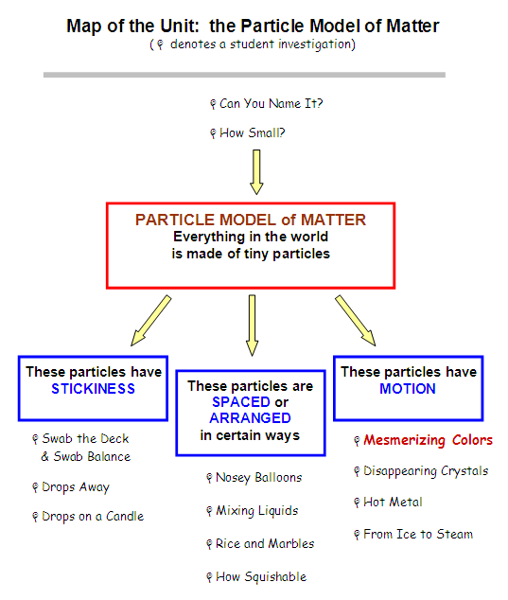
The activity “Mesmerizing Colors” is intended to introduce the property that particles (atoms/molecules) have motion. It is very similar to “Disappearing Crystals”; you may decide to use only one of these two investigations, or to use parts of both.
It is also possible to use “Mesmerizing Colors” earlier in the unit (anytime after “How Small”).

Intended Learning Outcomes
Students will understand the following:
- All particles are in motion.
- Temperature is an indicator of particle motion;
the greater the temperature that a group of particles have, the more they are moving, and thus the more motion energy they have.

Supplies

• transparent containers to hold water
(e.g. beakers, plastic cups) ⎯ 3 per group.
Make sure each group has at least one container that can handle hot water.
• food coloring (one per group is the most efficient way)
• access to hot water, either pre-heated, hot tap, or hot plates at each group (in which case you need beakers and beaker tongs as well)
• ice water (dumping ice in a common sink and allowing students to make their own ice-water works well ⎯ no need for sterile ice for this activity; tap-water ice cubes are fine)

Class Time Needed

30 − 40 minutes, depending on the amount of time required to find consensus on representation

Student’s Prior Knowledge & Experience

You may have had students complete several of the suggested activities so far in this unit. At a bare minimum, we recommend that you read through the activity “How Small” (an investigation of sugar cubes), including the Teacher Notes, before you do today’s activity “Mesmerizing Colors”. In the sugar-cube investigation, you introduced students to the basic theme of this unit—that we have proposed the following idea and are looking for evidence to test it and build it further:

PARTICLE MODEL of MATTER:
All things in the world around us are made of extremely tiny particles.

After “How Small”, we recommend students go through several other investigations that develop some properties of these tiny particles, investigations such as “Swab the Deck” and “How Squishable”. But it is also possible to introduce “Mesmerizing Colors” much earlier in the unit.

As students begin considering what these tiny particles are, and particularly how they hold together (such as in compounds and in different states of matter), the question of how these particles move may already have come up. Most students hold the idea that gas particles are moving, particles in a liquid may move a little, but particles in a solid state are ‘fixed’ and rigid.’ Some may have heard of “absolute zero”, but most will not know what it means. Most students do have a sense that hot particles move faster, so the inferences we want them to draw from these phenomena usually come quickly.

Lesson Outline and Teaching Suggestions

Introducing the activity

Because this activity is a simple phenomenon, it doesn’t require much introduction. It is most effective when students don’t know right off that they are looking for particle movement.

During the activity ⎯ Step A (students working in small groups) (Engage)

Have students perform the one-drop, one beaker activity. Walk around and ask them what is happening to the food coloring. They will give responses like, “it’s spreading out,” “it’s sinking,” “some of it is clumping.” Some students will be fascinated with the complex patterns in the plumes. Affirm that there are many interesting complex behaviors to observe (many of them are manifestations of the chaotic movement of the particles, impossible for us to predict, and therefore intriguing), but that you want them to focus on the basic fact that the food color is spreading.

As students identify that the food coloring is in motion, direct them to figure out WHY the particles of food coloring are dispersing. What is making them move? Why aren’t they just sitting on top, or sinking to the bottom and staying there? What is allowing them to move through the liquid water?

Students will usually begin to understand at this point that the water particles must be moving… This can be counter-intuitive for students, since the water is transparent (the particles seem invisible), so movement is hard to observe. But the food coloring ‘dyes’ the water and allows us to see the motion.

Ask students in their small groups to come up with a way to diagram this movement on paper or on a white board and notebook, and be ready to share their diagram with the class.

Whole-class discussion after Step A

Have students share their representations of particle motion, either by re-drawing their ideas on the classroom board or bringing large dry-erase boards to the front. As the instructor, discuss the ways in which each group has denoted movement. Most students will use some sort of arrow formation. Give them positive feedback for finding a way to communicate motion. Point out that in future activities, you will likely come to some consensus on how best to represent particle motion. Point out that questions like these ⎯ how to diagram and symbolize ideas like motion ⎯ are just as important in science as being able to write about the ideas in words.

During the activity ⎯ Step B (students working in small groups)

Have students return to lab groups and repeat the first activity, but this time they should simultaneously put drops into tap water, and hot and cold water. They should easily see that the color spreads faster in hot, slower in cold. Walk around to groups and ask why they are observing those different speeds of movement. Ask them what they think is different about the particles in each beaker to make this happen. Some may say that the water temperature is different. Press them to think more deeply; ask them, “What is the temperature actually measuring about the water particles?” Ultimately you want them to make a connection between the speed of the particles and the temperature of the water. Higher temperature indicates more speed, which is also more “motion energy”.

Next, have them come up with representations for the particle movement of each temperature — diagrams on poster paper or on a white board and notebook. This part is usually a challenge for students, as it necessitates a very graphic, visual memory. Not all students are great at creating such representations themselves, but most can recognize a representation that best communicates abstract ideas such as motion or vibration.

Whole-class discussion after Step B

Have students share their representations of particle motion, either by re-drawing their ideas on the board or bringing large dry-erase boards to the front. Most groups will have stayed with their previous notation from Step A. This time, be a bit more incisive about what works. Here are some points to highlight:
- Arrows can denote direction of motion, but you also need to denote speed.
Some students will use different lengths or widths of arrows to show
different speeds. Other students may use other ways to show speed.
- There are many different possible representations of motion, speed, etc. If a group comes up with a representation (a drawing with symbols) that correctly communicates their ideas, and others understand it, then it works.
- Too many possibilities can be confusing. For example, having one or two different ways to symbolize/represent a particle’s motion may be good; having nine or ten might be confusing. Sometimes we need to narrow down the possibilities; we come to a class consensus for how best to denote an idea such as particle movement. Scientists also need consensus to minimize confusion.

Optional: A discussion of Absolute Zero
Finally, an extrapolation of this discussion of particle movement is to wonder whether the particles can ever stop moving. This is not a key part of the Particle Model unit as we have outlined it, but it can be a great question for deeper study:

“Are all particles moving all the time? Do they ever stop moving? What would it mean if they stopped moving?”

For a physics or chemistry course, this is a good place for further exploration of the idea of temperature and what it means. NOVA has an excellent DVD on Absolute Temperature. In addition, there are many short videos on youtube demonstrating experiments to cool particles down, explaining what it means to slow particles down to the point of Absolute Zero and what properties the particles have at such low temperatures.

Notebooking Essences used:
Prior Knowledge-Step A
Data Collection-
Sense Making-Explain and draw models
Metacognition-Revise models and explanations

Crosscutting: Cause and Effect

S and E Practices: Obtaining, Evaluating, and Communicating Information
Developing and Using Models
Constructing Explanations

