Looking for a G.E. Course? (Area C4)

All readings, discussions and lectures in ENGLISH.
No German language requirement

German 142:

“German Folk Literature, Legend and Lore”

Course is a study of the traditional Folk Literature:
Grimm's Fairy Tales, Folk Tales, Legends, Ballads and Folk Songs of the German speaking people, and their holiday traditions, festivals and social customs.

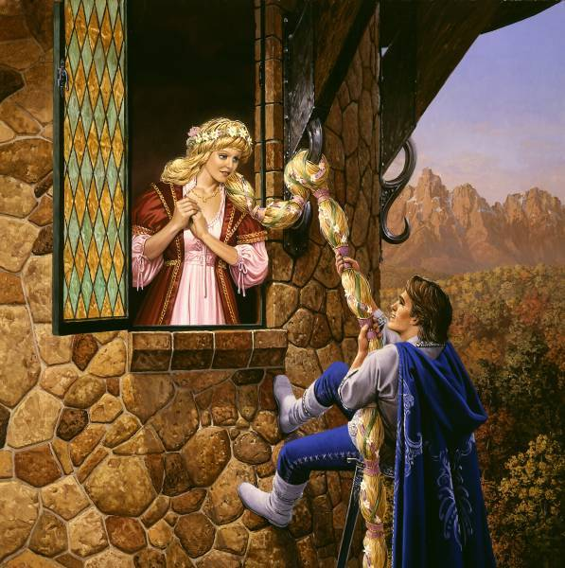
Reading List includes:
Grimms' Fairy Tales
German Festivals and Customs
Volsunga Saga

1) What are the origins of the Christmas Tree?
2) When does Saint Nikolaus bring presents in Germany?
3) What is served at the traditional Christmas Eve feast?
4) What were the circumstances of the first performance of the
world's favorite Christmas carol, "Silent Night"?
5) Who kisses the "Frog Prince"?
6) How does Odin's favorite Valkyrie become our beloved
"Sleeping Beauty" in fairy tale lore?
7) What tragic love stories are interwoven into the legends of the
castles of the Rhein?
8) Which castles have ghosts that still revisit the Rheinland?
9) What are the origins of the curse of the gold on the
"Nibelungen" in Richard Wagner's opera cycle?

Answer these questions in Spring 2006! German 142, MWF 12:00-12:50, Spring 2006

