Chapter 12 Energy From Fossil Fuels

Energy Sources and Uses
Energy Sources
What are the various sources of energy?
What is the local source of electricity?
When are the peak loads of electricity and for what purpose?
Is electricity a clean energy source? How is the electricity produced?

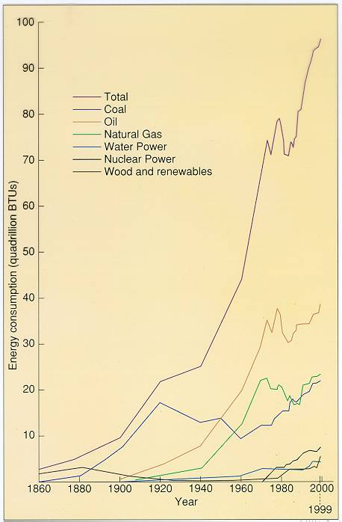

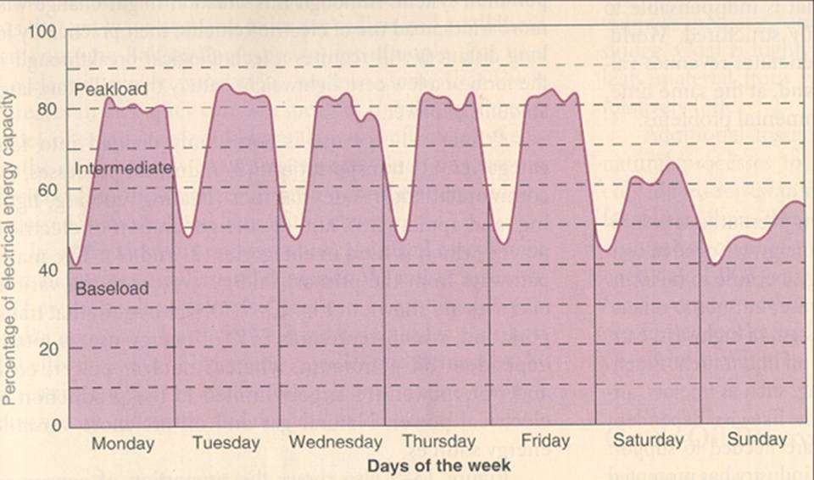

Primary and secondary energy sources...
The basic production of electricity - boil water to produce steam to turn turbines to generate electricity.

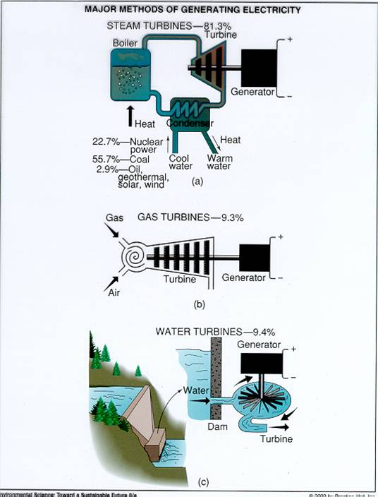

Matching Sources to Uses
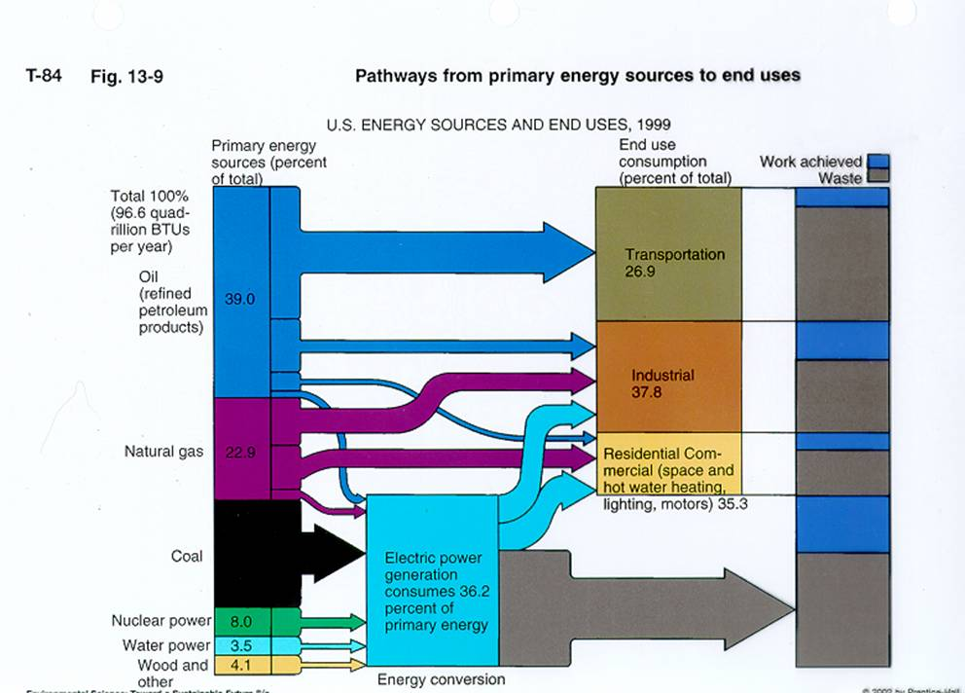

What Are Fossil Fuels and how are they formed?

What Are the Fossil Fuels Reserves?
Coal - several (400) hundred years
Natural Gas - at least a 50 year supply in the United States
Oil - about a decade until supplies peak
How Are Supplies Estimated?
Educated guesses based upon geologic formation
Knowledge of where fossil fuels have been found in the past
Why Do Our Estimates of Supplies Vary?

Oil - The Most Important Fossil Fuel in the American Economy
Declining U.S. Reserves and Increasing Importation
The Oil Crisis of the 1970s
Adjusting to Higher Prices
Victims of Our Success

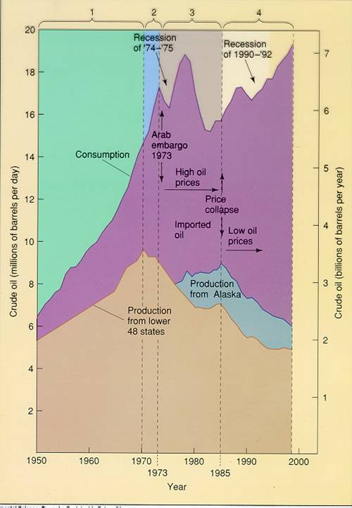

Problems of Growing U.S. Dependency on Foreign Oil
Costs of Purchase
Risk of Supply Disruptions
Resource Limitations

Environmental Consequences
Production: local ecosystem damage possible
Transport: oil spills causing local and regional ecosystem damage

Use: photochemical smog, particulates, acid precipitation, carbon dioxide

Coal
Large Reserves
Fossil Fuel of Choice Before the 1940s
Discuss why coal use was substantially curtailed in the 1940s.

Environmental Consequences
Production: ecosystem damage, reclamation difficult, acid mine runoff, mine tailings, erosion, black lung, radon
Transport: energy intensive because of weight and number of train cars needed
Use: fossil fuel with largest source of carbon dioxide and greatest quantity of contaminants, large volume of waste, acid precipitation

Natural Gas
Substantial Reserves
Possibly a transition fuel - between fossil fuel and alternative energy sources
Environmental Consequences
Production: local ecosystem damage possible if oil or coal is part of the deposit
Transport: can be explosive
Use: the least production of air pollutants of all the fossil fuels

Sustainable Energy Options
Conservation
The largest single source of energy available.
Proven ability to perform.
Disadvantages:
Expense born on the individual level.
Not appealing to many because it does not involve the building of new power plants or fancy equipment.

Deregulation
Impact on fuel conservation and price.
What happens when fuel availability is low?
What happens when fuel availability is high?
What happens when fuel prices are high?
strong emphasis to explore for more energy - ecosystem consequences, e.g., Arctic National Wildlife Refuge
drop in fuel consumption – conservation
interest in developing renewable energy resources

What happens when fuel prices are low?
interest in renewable energy resources decline
increase in fuel consumption - purchase of lower per mile gas consumption vehicles

