The Origins of Urban sprawl

"Most historians would say that up until 1920, we were a rural nation; after that, we became a predominantly urban nation, and that lasted for 40 or 50 years."

The end of the depression, WWII and the rapid growth of suburbs… the causes….
  - Accumulation of savings by soldiers &
their families
  - Availability of single family dwellings
  - Conversion of farm land
  - Easy access to automobile
d. Highways
i. Fueled economic growth
ii. Fueled urban exodus
d. Purposeful elimination of mass transit in LA
    - Red Car system of Los Angeles
    - Once mass transit was not convenient, the auto could dominate
ii. Los Angeles was built for cars- Is this a liveable city?

Environmental Impacts of Urban Sprawl
a. Depletion of Energy Resources
b. Air Pollution
c. Water Pollution and Degradation of Water Resources
d. Loss of Landscape and Wildlife
e. Loss of Agricultural Land

Urban Blight

A. Economic & Ethnic Segregation
a. People with money leave
b. Because of historic & continued discrimination, mainly non-whites remain in the urban core

B. The vicious Cycle of Urban Blight
a. As money leaves, housing demand declines, therefore property values decline, reducing the tax base.
b. As money leaves, retail business and restaurants disappear. Many urban areas have no supermarkets. Folks left behind rely on small, more expensive stores for food because they lack automobiles.
c. As money leaves, businesses fail and jobs are lost. New jobs are created in suburbs, beyond the reach of inner-city poor.

C. What Makes A City Not Livable?
a. High crime rates
b. High pollution rates
c. Reduction in parks & other green space
d. Few recreational opportunities
e. Few high-paying jobs

D. Cities Are Livable if….

E. In summary, a city is livable if it has a :
a. High population density (needed to support businesses & provide a tax base)
b. Mix of residences, businesses, stores and shops
c. Layout on a human dimension (it is a pleasant place)

Moving toward Sustainable Communities
A. Reigning in Urban Sprawl: Smart Growth
a. Sustainable Cities Program:
i. Clarification of environmental issues
ii. Agreement on joint strategies
iii. Coordination of action plans
iv. Implementation of technical support and capital investment programs
v. Establishment of a continuing environmental planning and management process

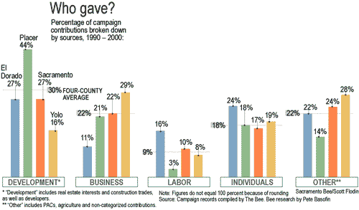

So it becomes clear, regionally, that one campaign dollar out of four came from development and real estate. In slow-growth Yolo County, however, that statistic is one dollar out of six. And in burgeoning Placer County, it's nearly one campaign dollar out of two.

