- Evolution is the change in the gene pool over time.
  - What is a gene pool?
    - The sum total of all the genes that exist among all the individuals of a species.
  - What is a gene?
    - All inherited characteristics of an individual organism are expressions of its genetic (DNA) makeup.
    - A gene is the sequence of bases on DNA that code for protein.
    - Genes are the road map for construction and function of living things.
    - DNA = Deoxyribonucleic acid: the genetic code material
(de = from, down, out; deoxy = without oxygen)
      - DNA consists of:
        - Deoxyribose (a sugar with only one oxygen)
        - Phosphate
        - Bases
          - Purines: adenine and guanine
          - Pyrimidines: thymine and cytosine
      - The three molecules that comprise DNA are called a nucleotide and because nucleotides repeat themselves throughout the DNA molecule, DNA is called a polymer. (Polymers are molecules that consist of repeating units)
      - The DNA molecule is two strands of the repeating deoxyribose, phosphate and base sequence. The bases in one strand match with predictable bases on the opposite strand of the repeating nucleotide [Adenine – Thymine and Guanine – Cytosine]
        - Two double stranded DNA molecules combine to form a chromosome.
  - What is a chromosome?
    - Chromosomes are two DNA molecules (two double-stranded helixes)
    - Each chromosome contains many genes
    - Different species have different numbers of chromosomes – the human female has 23 homologous pairs of chromosomes while the human male has 22 homologous chromosomes and 1 non-homologous chromosome.
  - So…what is a gene?
    - A gene is a sequence of bases on DNA that code for a specific protein. Genes specify proteins and proteins determine everything else. Genes determine:
      - Physical traits, (ie height, body weight, hair color)
      - Metabolic traits (ie allergies, ability to process alcohol, digestion of fats)
      - Growth and development (ie onset of puberty or menopause)

Information Helix
If you could pull apart the double helix, you would see the exposed ends of four different chemicals waving in the air. Those four chemicals, called bases carry the information used to make a body and to keep it running.

Scientists named each of the four bases with a letter, G, A, T or C. All of the letters in one cell make up the human genome, a complete set of instructions for making a person.

_________________________________
In a complete helix, the A's always line up with the T's and the G's with the C's. In the picture, the white and red bases always hook up together and blue and green are always together.

Reading DNA
The bases of a helix become a DNA sequence.
Example: When you write a letter, you put together words using different letters of the alphabet. With twenty-six letters you can say anything you want. It is important that the letters go in the right order. This sentence stops making sense whenthaliekrnviserhflker are in the wrong order.

When you make new cells, your body is putting together different letters of the DNA alphabet. Even with just four letters, the DNA alphabet spells out all of the information you need to create new cells and to stay healthy. The order of the DNA bases is called the sequence. Just like the order of the letters in a sentence, the sequence of the bases in DNA can spell all the instructions for your body -- even with only four letters.

  - If genes are found on DNA and humans all have the same kinds of genes, then why don’t we all look identical?
    - Alleles: Alleles are the different forms in which a gene can be found. The different forms of an allele are slightly different base sequences for the gene. Each human has, except for men on their one non-homologous chromosome, two alleles for each gene; one allele comes from each parent.

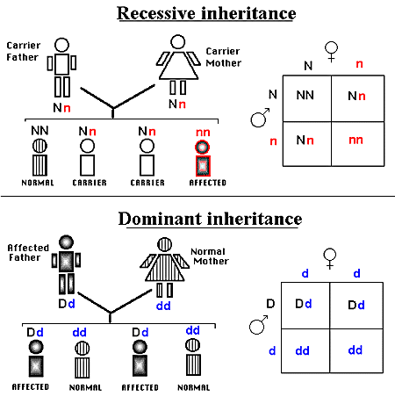

How are new alleles created?
- Mutations
  - Spontaneous – no known reason
  - Ultraviolet radiation
  - X – rays
  - Some chemicals
  - Even temperature
- The process is random and can occur anywhere along the chromosome
F. So, the gene pool is all the different alleles of each gene and all the genes that exist in a population.

G. This means that evolution is the change in the types of alleles of a gene over time, thus expanding the gene pool.
  - While the creation of new alleles is a random process, evolution is not a random process.
  - Evolution is a result of environmental factors.

II. What is the evidence supporting the theory of evolution?
  - Selective breeding
    - Domestic animal breeding – dogs, cats, cows, horses etc.
    - Domestic crops – Corn, tomatoes, rice etc.
  - Selective environmental pressure
    - Antibiotic resistance
    - Pesticide resistance
    - Over 500 fruitfly species in Hawaii developed from 2 species
    - Darwin’s finches
  - Fossil record
  - DNA record
III. Evolution is in response to environmental change (or absence of a species in a particular niche)
  - The movement of planet’s plates (Theory of Plate Tectonics) is an example of substantial environmental change that produced a wide array of species occupying similar niches and habitats.
  - Species response to environmental change in 3 different ways
    - Adaptation (by evolution) for:
      - Coping with abiotic factors – polar bear’s heavy fur, leaf drop in winter by deciduous plants
      - Obtaining food – a frog’s long tongue, broad plant leaves, different moth parts of insects
Escaping predation – thorns on plants, warning colors on insects, carapace on tortoise
d. Pollination – flower color, quantity of pollen or nectar, insect mouth parts
e. Finding/attracting mates – deer antlers, peacock tails, bright colors of male song birds
f. Seed dispersal – wings, hooks, fruit

2. Migration
  - A species will migrate if it can. The new environmental conditions must be conducive to survival.
3. Extinction

C. What determines if a species will be able to survive a change?
  - Rate and degree of environmental change
  - The genetic variability within the species’ gene pool
  - Biotic potential
  - Size of organism
  - Specialization to a given habitat and/or food supply
  - Geographic distribution.

