Beaumont Newhall, Eighteen Thirty-Nine: The Birth of Photography

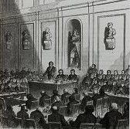
Figure 1.37. Artist unknown. Joint Meeting of the academies of Sciences and Fine Arts in the Institute of France, Paris, August 19, 1839. Engraving. Gernsheim collection, Humanities Research Center, University of Texas, Austin, Texas.
In practically every history of photography I’ve read,
it is written that [Paul] Delaroche, on first seeing daguerreotypes, exclaimed:
“From today, painting is dead!”
But in a letter to Arago he wrote:
“Monsieur Daguerre’s wonderful discovery
is an immense service rendered to art.”

Beaumont Newhall

An invention has recently been made public in Paris that seems more like some marvel of a fairy tale or delusion of necromancy than a practical reality ….

The Spectator, March 1839

The invention of photography in the mid-nineteenth century forever altered the world of art, more fundamentally so, one can argue, than the digital revolution of the late twentieth century. This essay by Beaumont Newhall is surely the most expressive and succinct version of the dramatic birth of photography ever told by an expert in the field. The author was one of photography’s first historians and exceedingly influential. He established the history of photography as an academic discipline and asserted an authoritative canon of art photography. Newhall’s 1937 exhibition and catalogue, Photography 1839-1937, for the Museum of Modern Art in New York, made a place for photography in the very citadel of high modern art. An accomplished writer, archivist, and noted data sleuth, Newhall secured recollections of the past and numerous primary documents for photographic history. This piece, a cameo introduction for the 1990 J. P. Getty exhibition catalogue, Photography: Discovery and Invention, is filled with famous facts, incidents, quotes, and images; one imagines Newhall simply reaching into his "favorites" file for them.
Although William Henry Fox Talbot’s discoveries in England are well presented, the essay focuses longest on the contemporaneous invention of the daguerreotype and the events leading up to "the great moment," in Newhall’s words, "when photography was, at long last, given to the world at the Académie des Sciences in the Palais de l’Institut de France on August 19, 1839." We are given to feel something of the thrill felt by scientists and artists at that official announcement, and the wild enthusiasm of the public, the "Daguerreotypomania," that followed.
This sketch colors in the historical background for the critical and documentary essays on photography by Peter Galassi, Walter Benjamin, Charles Baudelaire, and William Henry Fox Talbot in this chapter. Other texts in this volume deal with the photographic representation of modern life: the modern individual, the modern body, the modern city, the reaches of European tourism and empire, Orientalism, Primitivism, modern war, and the history of early film. Newhall prepares us for the shock of the new form and content by documenting the original reception and how incredibly far and fast photography spread. As you read, try to imagine any other art medium ever achieving such instant fame and popularity. What effect might that unprecedented democratic success have had on photography’s delayed acceptance as a fine art medium?

Our selection is from Photography: Discovery and Invention. Malibu, CA: J. Paul Getty publication, 1990.
pp.19-30

For Further Reading:

Hirsch, Robert. Seizing the Light: A History of Photography. Columbus, Ohio: McGraw-Hill, 1999.

Newhall, Beaumont. The History of Photography from 1839 to the Present. New York: Museum of Modern Art, 1982.

Rosenblum, Naomi. A World History of Photography, 3rd ed. New York: Abbeville Press, 1997.

To celebrate […] the birth of photography as a medium of picture making, I would like to refer to some contemporary accounts of what happened in 1839. I begin with a boast from Louis-Jacques-Mandé Daguerre (1787-1851) announcing his invention of the daguerreotype process. Daguerre was a popular artist in the world of entertainment in Paris. He produced with a partner, Charles-Marie Bouton, presentations of huge paintings, forty-six by seventy-two feet in size, of the most illusionistic character, which were shown in the Diorama, a theater without actors. [On Daguerre’s Diorama, see Viewpoint, “Ocular Gastronomy” in chapter three.] When Parisians first received a broadside circulated by Daguerre entitled, in bold letters, “The Daguerreotype,” they were amazed and puzzled. Translated, it reads:

THE DAGUERREOTYPE

The discovery l am announcing to the public is of that small number which, in principle, results, and potential influences on the arts, naturally takes its place with the most useful and extraordinary inventions.
It consists in the spontaneous reproduction of the images of nature received in the camera obscura —not with their colors, but with great delicacy of tonal gradations..
With this process, without any notion of drawing, without any knowledge of chemistry or physics, it will be possible to take, in a few minutes, the most detailed views of the most picturesque sites. .
The daguerreotype is not an instrument to be used to draw nature, but a chemical and physical process which gives her the ability to reproduce herself.

DAGUERRE,
Painter, Inventor, and
Director of the Diorama.

On January 15, 1839, an exhibition made up of about forty pictures showing the results of the daguerreotype will be opened with a subscription at the same time, the conditions of which will be announced then.

Can you imagine reading such a proud boast and wondering exactly what Daguerre was talking about and what the results looked like?
The inventor did not show any daguerreotypes to the public as planned, because events transpired differently than he had imagined they would. Some details were published in the Gazette de France on January 6, 1839, by a reporter named Gaucheraud, about whom I know nothing except that he did an excellent interview with Daguerre. Gaucheraud’s story repeated Daguerre’s announcement but added some facts: “M. Daguerre does not work on paper at all; he must have polished metal plates. We have seen on copper several views of the boulevards, the Pont Marie and its surroundings, and a lot of other places rendered with a truth which nature alone can give to her works.” Furthermore, Gaucheraud stated, “Arago, Biot, and Humboldt have verified the authenticity of this discovery, which excited their admiration, and M. Arago will make it known to the Académie des Sciences in a few days.” These three men were distinguished scientists. François Arago (1786 - 1853) was a physicist, an astronomer, and director of the Paris observatory. He was also perpetual secretary of the Académie des Sciences and a member of parliament, representing the department of Pyrenees-Orientales. Jean-Baptiste Biot (1774 - 1862) was a physicist. Alexander von Humboldt (1769 - 1859), a German, was a naturalist and explorer.
Arago, in addressing the Académie, spoke about Daguerre’s pictures that were shown to him and to its members, describing some of them as follows: “A view of the grand gallery that connects the Louvre to the Tuileries, a view of the Cité and the towers of Notre Dame, views of the Seine, and several of the bridges (Figure 1.38). All these pictures could be examined with a magnifying glass, without losing any precision — at least of those objects that remained immobile while their images were delineating themselves.” The amount of detail Daguerre was able to record is remarkable. A detail of a still life of fossils (Figure 1.39) he made in the Conservatoire des Arts et Métiers can be enlarged without losing sharpness.
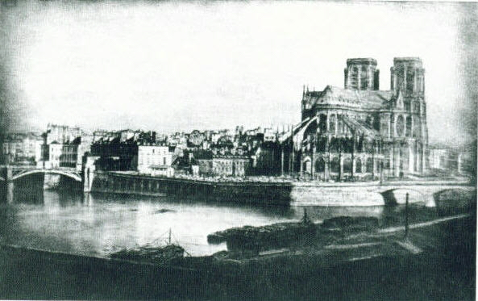
Figure 1.38. Louis-Jacque-Mandé Daguerre. The Cathedral of Notre dame from the Pont de la Tournelle, Paris, circa 1830. Daguerreotype. Gernsheim collection, Humanities Research Center, University of Texas, Austin, Texas.
It may seem a little strange to those who know Paris that these views are mirror images. All daguerreotypes are laterally reversed, unless the photographer put a mirror or prism over the lens. Curiously, this did not seem to bother people; contemporary accounts show little concern with the distortion. In later years it was pointed out that the only image one knows of oneself is what can be seen in a mirror. Therefore, a daguerreotype could be considered by the sitter to be an exact likeness.
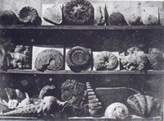
Figure 1.39. Louis-Jacque-Mandé Daguerre. Shells and Fossils, 1839. Daguerreotype. Conservatoire National des arts et Métiers, Paris.
Arago also stated to the Académie that Daguerre, “in investigating how he might be recompensed for his pains and expenses . . . recognized without hesitation that a patent would not do: once disclosed, his process would be available to everybody. Thus, it seems indispensable that the government should compensate Monsieur Daguerre directly and that France should nobly give to the whole world a discovery that could contribute so much to the arts and sciences.” Immediately, Arago began to discuss with the Chambre des Députés his plan to reward Daguerre and his partner, Isidore Niépce (1795 - 1868), with annuities for presenting the daguerreotype to the world. Niépce was the son of Daguerre’s late partner, Joseph-Nicéphore Niépce (1765 - 1833). In his announcement of the daguerreotype, the inventor gave full credit to the elder Niépce, who had carried out unsuccessful experiments in photography as early as 1826. On his death in 1833 his son replaced him as Daguerre’s partner.
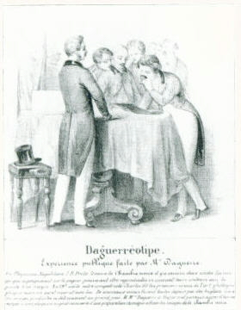
Figure 1.40. Public Demonstration by M. Daguerre, 1839. Lithograph. International Museum of Photography at George Eastman House, Rochester, New York
Almost at once the European public was curious about the daguerreotype. Remember that no one had yet seen examples except at the meeting of the Académie. The British periodical The Spectator, for example, wrote in March 1839:

An invention has recently been made public in Paris (Figure 1.40) that seems more like some marvel of a fairy tale or delusion of necromancy than a practical reality: it amounts to nothing less than making light produce permanent pictures, and engrave them at the same time, in the course of a few minutes. The thing seems incredible, and, but for indisputable evidence, we should not at first hearing believe it; it is, however, a fact: the process and its results have been witnessed by Monsieur Arago, who reported on its merits to the Académie des Sciences.

Interestingly enough, the scientist Arago consulted with the then-popular painter Paul Delaroche (1797 - 1856) about the artistic possibilities of the new invention. In practically every history of photography I’ve read, it is written that Delaroche, on first seeing daguerreotypes, exclaimed: “From today, painting is dead!” But in a letter to Arago he wrote:
M. Daguerre’s process completely satisfies art’s every need, as the results prove. It carries some of its basic qualities to such perfection that it will become for even the most skillful painters a subject for observation and study. The drawings obtained by this means are at once remarkable for the perfection of details and for the richness and harmony of the whole. Nature is reproduced in them not only with truth, but with art (Figure 1.41) .... Monsieur Daguerre’s wonderful discovery is an immense service rendered to art.
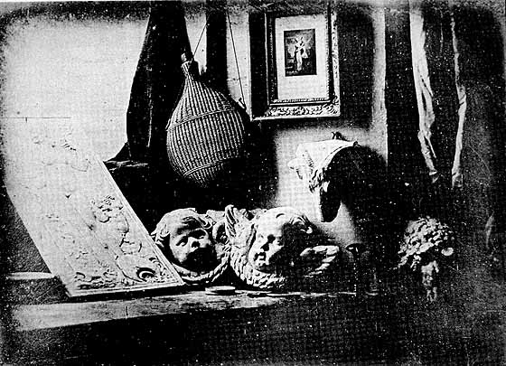
Figure 1.41. Louis-Jacque-Mandé Daguerre. Still Life, 1837. Daguerreotype. Société Françasie de Photographie, Paris.

The magazine L’Artiste reported:
The plate is exposed to light and at once, whatever may be the shadow projected on this plate — earth or sky, running water, the cathedral lost in the clouds, the stone, the paving, the imperceptible grain of sand that floats on the surface — all things, big and little, engrave themselves instantly within this kind of camera obscura (Figures 1.42, 1.43).
You can now say to the towers of Notre Dame: place yourselves there! And the towers will obey, brought home in their entirety, from the tremendous rock on which they are built to the
slender and light spires.
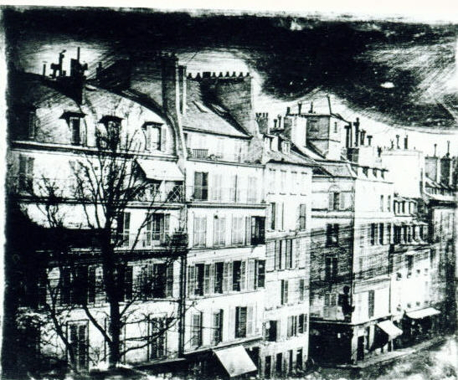
Figure 1.43. Louis-Jacque-Mandé Daguerre. Paris Buildings, 1830. Daguerreotype. Museum d’Histoire Naturelle, Perpignan.
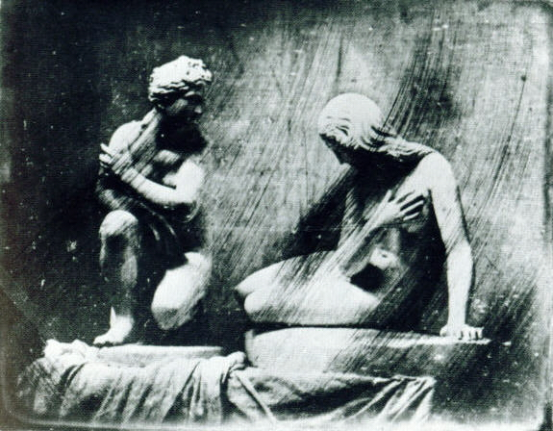
Figure 1.42. Louis-Jacque-Mandé Daguerre. Statues, 1830. Daguerreotype. Museum d’Historie Naturelle, Perpignan.

Samuel F. B. Morse (1791-1872), the American artist and inventor of the electric telegraph, was in Paris in 1839. He was fascinated with the news of Daguerre’s invention, for he had tried unsuccessfully himself to fix the images of the camera obscura. He wrote a letter to his brother in New York, who published it in his newspaper, The Observer:
A few days ago I addressed a note to Mr. D[aguerre] requesting, as a stranger, the favor to see his results, and inviting him in turn to see my Telegraph. I was politely invited to see them under these circumstances, for he had determined not to show them again, until the Chamber had passed definitely on a proposition for the Government to purchase the secret of his discovery, and make it public. The day before yesterday, the 7th [of April], I called on Mr. Daguerre, at his rooms in the Diorama, to see these admirable results.

They are produced on a metallic surface, the principal pieces about 7 inches by 5, and they resemble aquatint engravings, for they are in simple chiaroscuro, not in colors. But the exquisite minuteness of the delineation cannot be conceived. No painting or engraving ever approached it.

For example: in a view up the street (Figure 1.44), a distant sign could be perceived, and the eye could just discern that there were lines of letters upon it, but so minute as not to be read with the naked eye. By the assistance of a powerful lens, which magnified 60 times, applied to the delineation, every letter was clearly and distinctly legible, and so also were the walls of the building and the pavement of the street.
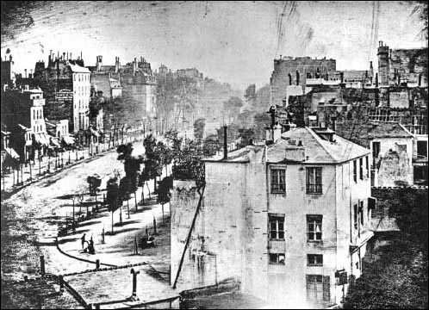
Figure 1.44. Louis-Jacque-Mandé Daguerre. Boulevard du Temple, 1839. Daguerreotype. Bayerisches National Museum, Munich.
Objects moving are not impressed. The boulevard, so constantly filled with a moving throng of pedestrians and carriages, was perfectly solitary, except an individual who was having his boots brushed. His feet were compelled, of course, to be stationary for some time, one being on the box of the bootblack, and the other on the ground. Consequently, his boots and legs are well defined, but he is without body or head, because these were in motion.

Now, we must move from Paris to London, or perhaps to the village of Lacock in Wiltshire, England, where the scientist William Henry Fox Talbot (1800 - 1877) lived. He recollected that when he learned about the daguerreotype, “I was placed in a very unusual dilemma (scarcely to be paralleled in the annals of science); for I was threatened with the loss of all my labour, in case M. Daguerre‘s process proved to be identical with mine, and in case he published it at Paris before I had time to do so in London.” Remember that Talbot had not seen — nobody had seen — any daguerreotypes except Arago, his colleagues in the Académie des Sciences, and Samuel F. B. Morse. Talbot did not know what all the fuss was about except from the exciting articles that kept appearing in the press.
Talbot had begun to work out a photographic system of his own in the 1830s. One of his first pictures, a tiny negative of a window in Lacock Abbey, his home in Wiltshire, still exists (Figure 1.45). He mounted it on a card with the note: “Latticed window (with the camera obscura). August 1835.” When first made, the squares of glass about 200 in number could be counted, with help of a lens.” The technique Talbot invented was completely different from Daguerre’s, though he did not know it. He thought Daguerre might be using the exact process he had invented.
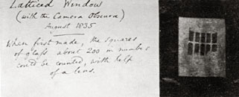
Figure 1.45. William Henry Fox Talbot. Latticed Window, 1835. Photogenic drawing. Science Museum, London.
Talbot was invited by his friend and fellow scientist Michael Faraday (1791 - 1867) to show some of his “photogenic drawings” — as Talbot called his first experiments — at the Royal Institution in London on January 25, 1839. Thus, he was the first to show photographs to the public. […] Most of Talbot’s earliest works were made without a camera by placing leaves, lace, or other small objects directly on paper made light sensitive by coating it with a solution of silver salts (Figures 1.46, 1.47). A month later Talbot published complete directions for using his invention. [See excerpt from Talbot’s The Pencil of Nature in this chapter.]
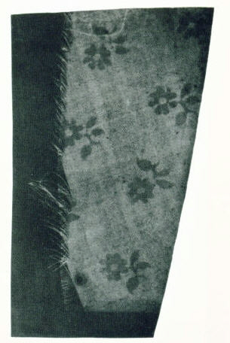
Figure 1.47. William Henry Fox Talbot. Linen, 1855. Photogenic drawing, 4 ½” x 1 ¾” (11.2 x 4.8 cm). J. Paul Getty Museum, Malibu, California.
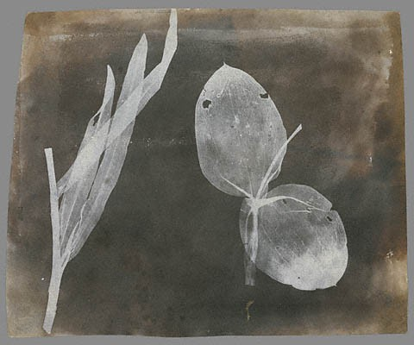
Figure 1.46. William Henry Fox Talbot. Leaves of Orchidea, April 1830. Photogenic drawing, 6 ¾” x 8 ¼” (17.2 x 20.9 cm). J. Paul Getty Museum, Malibu, California.

We now must return to Paris to learn about the negotiations by the government to purchase Daguerre’s secret. Arago made a speech to the Députés on July 3, describing Daguerre’s invention in a general way and pointing out its potential. His colleague in the Académie, Joseph-Louis Gay-Lussac (1778 - 1850), gave a similar talk to the Chambre des Pairs. Both chambers passed the bill awarding Daguerre and Isidore Niépce annuities in exchange for the public presentation of the daguerreotype technique. The bill was signed by the king.
The government awarded Daguerre six thousand francs per year for disclosing two inventions: the daguerreotype and the illusionistic Diorama paintings. Niépce received two thousand francs a year in recognition of his father’s research. What were six thousand francs worth? When I looked at a guide to Paris for 1848, 1 found that a good meal, including wine, cost two francs. And I figured out that if you got a similar meal, with wine, in any restaurant today for between five and ten dollars, you would be lucky. So I estimated that the sum of six thousand francs was indeed a livable salary, something on the order of fifteen thousand dollars today.
We now are approaching the great moment when photography was, at long last, given to the world at the Académie des Sciences in the Palais de l’Institut de France on August 19, 1839. The London Globe wrote, four days later:
It having been announced that the process employed by M. Daguerre for fixing images of objects by the camera obscura would be revealed on Monday, at the sitting of the Academy of Sciences, every part of the space reserved for visitors was filled as early as one o’clock, although it was known that the description of the process would not take place until three. Upwards of two hundred persons who could not obtain admittance remained in the courtyard of the palace of the Institute.

Daguerre did not speak, nor did his partner, the young Niépce. Arago made a learned scientific presentation that bewildered most of his listeners, according to reports about it. A German, Ludwig Pfau, who was present on this great day, wrote:

The crowd was like an electric battery, sending out a stream of sparks. Everyone was happy to see others in a happy mood. ... Gradually I managed to push through the crowd and attached myself to a group near the meeting-place, who seemed to be scientists. Here I felt myself at last closer to events, both spiritually and physically. After a long wait, a door opens in the background and the first of the audience to come out rush into the vestibule. “Silver iodide,” cries one. “Quicksilver!” shouts another, while a third maintains that hyposulphite of soda is the name of the secret substance. Everyone pricks his ears, but nobody understands anything. Dense circles form round single speakers, and the crowd surges forward in order to snatch bits of news here and there. At length our group too manages to catch hold of the coat-tails of one of the lucky audience and make him speak out. Thus the secret gradually unfolds itself, but for a long time still, the excited crowd mills to and fro under the arcades of the Institute, and on the Pont des Arts, before it can make up its mind to return to everyday things. . . . A few days later, you could see in all the squares of Paris three-legged dark boxes planted in front of churches and palaces.

At this particular meeting the whole secret was divulged in a general way. But Daguerre had worked out a very efficient merchandising scheme, arranging with Alphonse Giroux to make cameras long before the day of Arago’s speech. A stock of cameras and developing equipment was ready for sale. George Eastman House is fortunate to have one of these cameras, which bears on its side the seal of the maker, Giroux, and the signature of Daguerre himself (Figure 1.48). Daguerre already had written an instruction manual that was on sale only a few days after Arago’s presentation. What is almost unbelievable to me is the number of manuals that were printed and sold. In France there were eight editions; in England, three (Figure 1.49); in Germany, five; in Sweden, one; in Italy, two; and in Spain, two. Twenty-one editions in four months! — plus reproductions of the instructions in condensed form in newspapers and magazines.
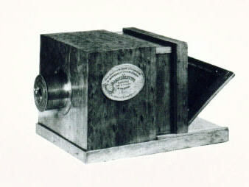
Figure 1.48. Daguerre’s camera. International Museum of Photography at George Eastman House, Rochester, New York.
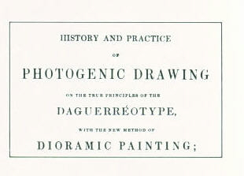
Figure 1.49. Louis-Jacque-Mandé Daguerre. History and Practice of Photogenic Drawing. (London, 1839), title page, (detail). Royal Photographic Society, Bath.
I would now like to move on to the end of this exciting period. Having finally learned what the daguerreotype was, the public knew how it was made. Imagine that in the two months between August 19 and the middle of October, such beautiful pictures could be made as that of the Propylaea in Athens, taken by Pierre-Gustave Joly de Lotbinière (1798 - 1865), a Canadian landholder who lived most of the time in Paris, learned the daguerreotype technique there, and made many views in the Mediterranean area. Engravings of some of his daguerreotypes were included in the series Excursions daguerréiennes, published in 1842 by Nicolas-Marie-Paymal Lerebours (1807-1873) (Figure 1.50). Another daguerreotypist, Frédéric Goupil-Fesquet (active 1839 traveled in Egypt with the French painter Horace Vernet (1789 -1863), who wrote to a friend, “We have been daguerreotyping like lions” (Figures 1.51, 1.52). Exactly how lions make daguerreotypes I do not know. While they were in Egypt, Vernet and Fesquet went up the Nile in a boat. To their surprise and delight they met Joly de Lotbinière on board. The two pioneer daguerreotypists worked together.
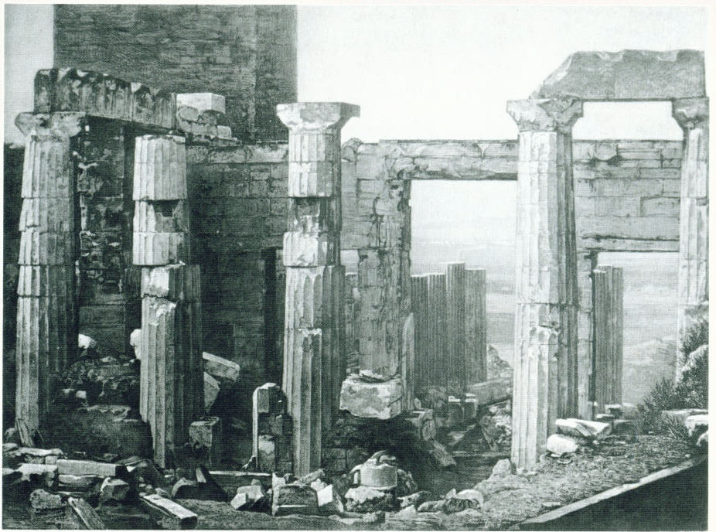
Figure 1.50. Pierre-Gustave Joly de Lotbinière. The Propylaea in Athens, 1839. Engraving from a daguerreotype. From Nicolas-Marie-Paymal Lerebours, Excursions daguerréiennes, vol.1 (Paris 1842). International Museum of Photography at George Eastman House, Rochester, New York.
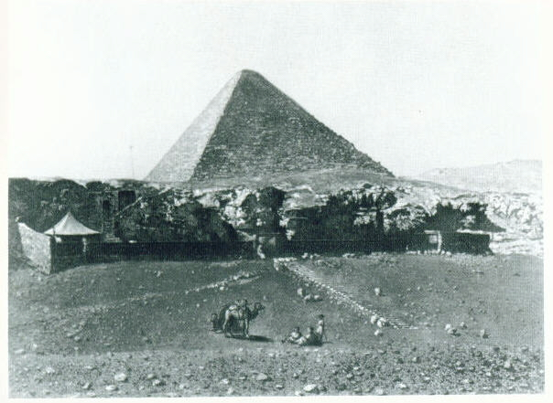
Figure 1.51. Frédéric Goupil-Fesquet. The Great Pyramid, Egypt, 1839. Engraving from a daguerreotype. From Lerebours, vol. 1 (1842).
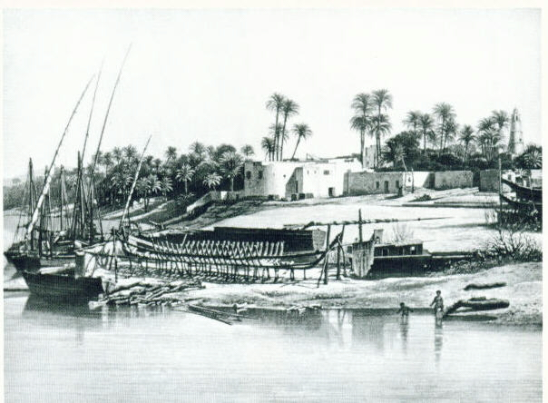
Figure 1.52. Frédéric Goupil-Fesquet. Luxor, 1839. Engraving from a daguerreotype. From Lerebours, vol. 1 (1842).

This is only a sketch of the process by which photography was established in 1839 as a practical picture-making medium. The technique was even caricatured. The lithograph entitled Daguerreotypomania, made as a gift for New Year’s Day, 1840, is full of allusions to the craze (Figure 1.53). The balloon has a camera instead of a basket. The train is made up of giant cameras instead of cars. The clock is a camera. A procession of daguerreotypers winds off toward the horizon. Some dance around the fuming box with which the plates were developed. In the corner a man sits immobilized in a kind of pillory, posing for his portrait. A fitting close to my sketch is a caricature made in 1840 by Honoré Daumier (1808—1879), showing a daguerreotype camera — complete with Giroux’s seal — on its tripod and the daguerreotypist timing the exposure with his watch (Figure 1.54). The title: Patience is the Virtue of Donkeys.
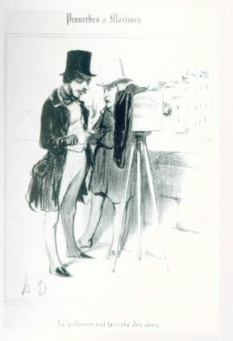
Figure 1.54. Honoré Daumier. Patience is the Virtue of Donkeys, 1840. Lithograph. International Museum of Photography at George Eastman House, Rochester, New York.
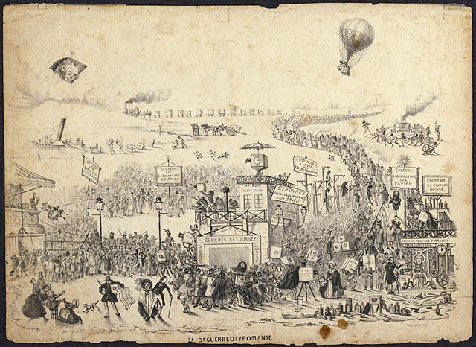
Figure 1.53. Maurisset. Daguerreotypomania, 1839. Lithograph. International Museum of Photography at George Eastman House, Rochester, New York.

Reproduced in Image 8 (1959), pp. 32-36.
Compte-rendu de I’Académie des Sciences 8 (1839), p. 5.
Ibid.
Reprinted in Museum of Foreign Literature, Science and Art (Philadelphia) (March1839), unpaginated.
Translated in Image 11 (1962), p. 26.
Translated in Magazine of Art (May 1951), p. 125.
Observer (New York), April 20, 1839.
Literary Gazette no. 1160 (April 11, 1839), p. 236.
Globe (London), August 23, 1839.
Ludwig Pfau, Kunst und Gewerbe (Stuttgart, 1877), pp. 115-117, translated in Helmut Gernsheim, Origins of Photography (New York, 1982), p. 45.

