Peter Galassi, Before Photography

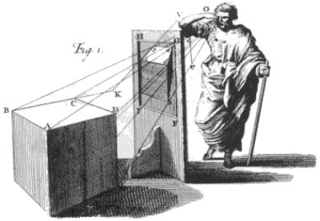
Figure 1.55. Artist uncknown. The Principle of Linear Perspective. Engraving, 10 x 8 ¾ in (25.4 x 22.23 cm). Brook Taylor, New Principles of Linear Perspective or, the Art of Designing on a Plane (London, 1811). Yale University Library, New Haven, Connecticut.

Photography was not a bastard left by science
on the doorstep of art, but
a legitimate child of the Western pictorial tradition.
Peter Galassi

Photographic media – traditional and digital photography, film, television, video, and the internet – dominate global art and communication today. And painting no longer enjoys anything like the preeminent position it held in mid-nineteenth century Europe. Ever since painter Paul Delaroche’s purported exclamation at the birth of photography – “From today, painting is dead!” – art critics have been predicting the end of painting. Indeed, the invention of photography coincides historically with the onset of the never-ending end and "crisis” of painting – the crisis that spurred the radical formal innovations of modern painting from Manet to Jackson Pollock. Although it is a mistake to believe that photography single-handedly caused the transformation from classical to modernist painting, from mimetic illusion to experimental modes of realism and abstraction, the historical coincidence of the birth of photography and the crisis of painting is far from innocent. From Daguerre and Talbot’s public reports of their discoveries in 1839, the histories of painting and photography have been inextricably tangled. Our job is to grasp the creative historical dynamics of the relationship along with the significance and scale of the nineteenth-century revolution in art technology.
According to Peter Galassi, we are looking at an evolution in art, not a revolution. In the following essay he discredits the notion that photography radically disrupted the history of painting. With well-spun logic he traces the pedigree of photography back to early Renaissance Italy and the discovery of linear perspective. Galassi is persuaded that photography is "a legitimate child of the Western pictorial tradition." While other historians of photography have looked for its origins in the biographies of individual inventors, advances of science and technology, social and political transformations, or the mid-nineteenth century Positivist preoccupation with realism, this essay looks instead at the longer mimetic tradition of the West, to "four-hundred-odd years of perspective’s hegemony over Western painting." In other words, for a tradition uniquely (of all the world’s aesthetic traditions) obsessed with visual mimesis – with seeing, comprehending, representing the world as it really is and exactly translating that three-dimensional reality onto a two-dimensional surface – photography, after all that, seems a predictable end.
Of great value for our study of modern art is Galassi’s historical analysis of vision in painting and of linear perspective as a symbolic form. The insight that vision is cultural and historical will help us see that style itself – regardless of medium – has meaning. We need such an awareness to go beyond modern subject matter to grasp exactly what it is that makes an artwork look "modern.”
Be sure that you can see for yourself the comparisons Galassi is making; don’t just take his word for it. What are the two polar conceptions of perspective in Western painting? What are the "normative procedures" of Renaissance and modern painting? How could they have led to the invention of photography? Why is the photographer unable to make a picture following Paolo Uccello’s early Renaissance procedure? Could a photographer follow Edgar Degas’ perspective system? Do today’s digital photographic processes change the terms of Galassi’s argument? Is the photograph “the epitome of realism”?

Our selection is from Peter Galassi, Before Photography: Painting and the Invention of Photography (New York: The Museum of Modern Art, 1981) pp 11-18.

For Further Reading:

Crary, Jonathan. Techniques of the Observer: On Vision and Modernity in the Nineteenth
Century (Cambridge, Massachusetts: MIT Press, 1990).

Hockney, David. Secret Knowledge: Rediscovering the Lost Techniques of the Old Masters (New York:
Penguin Putnam, 2001).

Jay, Martin. “Scopic Regimes of Modernity.” In Vision and Visuality. ed. Hal Foster (Seattle: Bay Press,
1988).

Panofsky, Erwin. Perspective as Symbolic Form. Translated by Christopher Wood (New York: Zone
Books, 1991).

Perhaps the most curious aspect of the race to invent photography is that it was not a race until it was over. With the exception of Daguerre and Niépce (who became partners), none of the four or five serious contestants was aware of the others. Despite this fact, the finish was remarkably close. Indeed, the identity of the winner and the date of the finish depend on which characteristic of the medium is chosen as salient. There are respectable arguments for Thomas Wedgwood in 1802, Nicéphore Niépce in 1826, William Henry Fox Talbot in 1835, and L.-J.-M. Daguerre in 1835 or 1839 (when the invention was publicly announced).
This apparent coincidence is all the more striking because, despite the technical character of the invention, we cannot point to any technical innovation as a catalyst. All of the inventors simply combined two scientific principles that had been known for quite some time. The first of these was optical. Light passing through a small aperture in one wall of a dark room (or “camera obscura”) projects an image on the opposite wall. The camera obscura had been a familiar tool of artists and scientists from the sixteenth century. From the eighteenth, it had been common in portable form, designed to project on paper or glass an image that the artist could trace. The second principle was chemical. In 1717, Johann Heinrich Schulze had shown that certain chemicals, especially silver halides, turn dark when exposed to light. The inventors of photography used such chemicals to render permanent the insubstantial image formed in the camera obscura.
“Considering that knowledge of the chemical as well as the optical principles of photography was fairly widespread following Schulze’s experiment – which found its way not only into serious scientific treatises but also into popular books of amusing parlour tricks – the circumstance that photography was not invented earlier remains the greatest mystery in its history.” For Helmut and Alison Gernsheim, who wrote these words, and for most other historians of photography, the mystery persists because its solution is considered to be primarily scientific. The bulk of writing on photography’s prehistory, even in works by art historians, has been technical. The increasing popularity of the camera obscura and the proliferation of other mechanical aids to drawing have been traced in detail. These developments are obviously relevant to the invention of photography. So too is the cumulative search for new methods of pictorial reproduction, which played, for example, a large role in the experiments of Wedgwood and Niépce. But these technical experiments and enthusiasms answer only one side of the question.
No one has proposed that the invention of photography was a mistake or an isolated flash of genius. Most modern studies of the individual inventors treat their careers as representative rather than idiosyncratic, and even the driest technical histories implicitly acknowledge that photography was a product of shared traditions and aspirations. The best writers have recognized that these traditions are social and artistic as well as scientific. Nevertheless, the problem in this form has received less attention than it deserves, perhaps because it cannot be solved by the analysis of a single biography or sequence of scientific or artistic influences.
There is little doubt that reference to the great social and political transformations of the late eighteenth and early nineteenth centuries is an important feature of any adequate solution. However, this aspect of the problem is difficult, since hindsight too readily concludes that the early uses of photography satisfied needs that existed before its invention. Perhaps it is more logical to suggest that the period spawned a great volume of speculative tinkering, whose spirit and products fostered as well as answered such needs.
The social context of the invention of photography is important. Here, however, I propose to concentrate on the narrower (although kindred) issue of photography’s relationship to the traditional arts. Previous studies of this issue have yielded many useful facts, but the principles under which the facts have been gathered and organized remain largely unexamined. The principles have changed little since Heinrich Schwarz’s representative article of 1949, “Art and Photography: Forerunners and Influences.” The article’s title reflects its divided conception. The first half traces the history of mechanical aids to post-Renaissance art, especially the camera obscura, whose increasing use, Schwarz argues, led to the invention of photography. Abruptly inverting his argument, Schwarz then lists nineteenth-century paintings derived directly from photographs.
The neat split in Schwarz’s method is symptomatic of the prevailing understanding of photography’s relationship to painting. Regarded essentially as a child of technical rather than aesthetic traditions, the medium is inevitably considered an outsider, which proceeded to disrupt the course of painting. The extreme corollary of this conception is the notion that photography adopted (or usurped) the representational function of painting, allowing (or forcing) painting to become abstract. This argument, now discredited, seems to have been launched around 1900 by painters, who used it to justify their rejection of nineteenth-century naturalism. The argument has its roots in the conviction — born in 1839 — that photography is the epitome of realism. Few today would accept this notion without qualification, yet it has remained indispensable to most writers who sense a need to supplement the scientific rationale for the invention of photography with an aesthetic one. Devotees of the camera obscura explain the machine’s growing popularity as a symptom of a new thirst for accurate description. Others point to the precision of Biedermeier painting or the spectacular illusion of Daguerre’s Diorama. The position is summarized in Beaumont Newhall’s words: “The fever for reality was running high.”
This formulation is not untrue, but it is vague and ahistorical. So often have Western artists earned the label “realist” and so various are their achievements that the label has meaning only in a historical framework. Such a framework, an admirable one, exists for the Realist movement of the mid-nineteenth century. However, the pre-photographic realism that Newhall and others refer to is a patchwork of disparate expressions, defined not by artistic tradition but by the very invention it is meant to explain. It is, in other words, a tautology, which in effect remands the interpretive burden to the scientific tradition. The object here is to show that photography was not a bastard left by science on the doorstep of art, but a legitimate child of the Western pictorial tradition.
The ultimate origins of photography – both technical and aesthetic – lie in the fifteenth-century invention of linear perspective. The technical side of this statement is simple: photography is nothing more than a means for automatically producing pictures in perfect perspective. The aesthetic side is more complex and is meaningful only in broader historical terms.
Renaissance perspective adopted vision as the sole basis for representation: every perspective picture represents its subject as it would be seen from a particular point of view at a particular moment. Measured against the accumulated options of prior pictorial art, this is a narrow conception. However, in the four-hundred-odd years of perspective’s hegemony over Western painting, artists managed to construe it in an extraordinary variety of ways. Quite apart from the issue of their subjects, the pictures of Paolo Uccello, Jan Vermeer, and Edgar Degas, for example, are very different in appearance. To a great extent these differences may be (and have been) understood in terms of the principle underlying each painter’s manipulation of the perspective system or, in other words, the way each conceived the role of vision in art. These conceptions, moreover, did not develop at random, but form a coherent history.
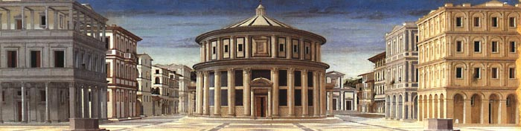
Figure 1.56. Piero della Francesca. An Ideal Townscape, c. 1470. Panel, 23 ½” x 78 ¾” (59.69 x 200.01 cm). Palazzo Ducale, Urbino, Italy.
Some familiar features of that history are illustrated in the comparison of the Ideal Townscape (Figure 1.56) from the circle of Piero della Francesca […] and Emanuel de Witte’s
Protestant Gothic Church (Figure 1.57) […]. The subject of each picture is a regular, manmade structure, symmetrical along an axis. The earlier painter adopted this as his axis of vision, so
that the picture, too, is symmetrical. It presents the ground plan of the architecture almost as clearly as a map. The relative sizes of the buildings are plainly shown and may be checked precisely by reference to the pavement, which is a logical guide to the whole space of the picture.
De Witte, by contrast, chose a point of view well off the axis of symmetry of the church; and his line of sight is not parallel to that axis but oblique, and arbitrary in regard to the structure. The frame also is differently conceived. The Italian view accommodates the entire piazza, but de Witte’s picture includes only a portion of the interior of the church. And, just as the point and axis of view are indifferent to the plan of the building, so this portion is a fragment unrelated to the rational form of the church. To this conception of a narrow slice of space, de Witte added that of a specific slice of time. Unlike the Italian painter, who imposed on his view the clarity of even light, de Witte accepted the momentary play of light and shade, which obscures the architectural logic.
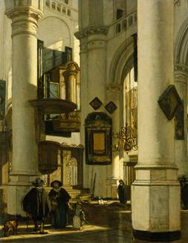
Figure 1.57. Emanuel de Witte. Protestant Gothic Church, 1669. Oil on panel 17” x 13 ½” (43.18 x 34.29 cm). Rijksmuseum, Amsterdam.
Both pictures are faithful to the rules of perspective. But the earlier work is formed in the service of its subject’s absolute order, while the later submits to the disruptive influence of an ostensibly arbitrary viewpoint and moment in time. We stand outside the Italian view, admirers of the timeless perfection of the imaginary townscape; in de Witte’s picture we are participants in the contingent experience of everyday life.
The elaboration of such comparisons leads to a continuous historical analysis of vision in painting. The differences between the fifteenth-century Italian view and de Witte’s Church are representative of a transformation in the standard of pictorial authenticity. The old standard did not disappear, but it became conservative, marked as a retrospective form. Also divergent from the norm was the vanguard, formed by pictures whose new visual syntax did not enter the mainstream until much later. Such a picture is Pieter Jansz Saenredam’s The Grote Kerk, Haarlem (Figure 1.58) […], where the conception of light is less radical than de Witte’s but the structure is more so. The frame abruptly truncates the near pillars, which loom enormously in comparison to their counterparts beyond, hiding crucial features of the interior space. The narrow band of pavement is almost powerless to explain the striking juxtaposition of near and far pillars in the middle of the picture. Not until the late nineteenth century was such a willfully fragmentary and internally discontinuous view the common option of every painter. […]
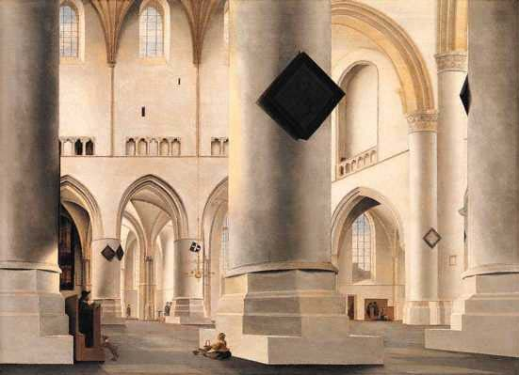
Figure 1.58. Pieter Jansz Saenredam. The Grote Kerk, Haarlem, 1636-37. Oil on panel, 23 ½” x 32 ¼” (59.5 x 81.7 cm). The Trustees of the National Gallery, London.
Ever since Leon Battista Alberti published On Painting in 1435, a perspective picture has been defined as a plane intersecting the pyramid of vision. […] At the apex of the pyramid is the eye. The pyramid’s base is the perimeter of the picture. The picture is the projection upon the intersecting plane of everything that lies within the scope of the pyramid, extending to infinity. The various ingenious objections notwithstanding, Alberti’s definition provides that if perfectly produced and viewed with one eye from the apex of the imaginary pyramid, a perspective picture will be like a window through which its subject is seen.
Given this definition, any perspective picture is implicitly the product of three fundamental choices. (1) The artist must choose the arrangement of the subject or (what amounts to the same thing) choose the moment at which to represent an existing subject; (2) he
must choose the point of view; (3) he must choose the scope of the view or, in other words, establish the edges of the picture. These three choices determine the basic composition of the picture.
All possible functions of these three interdependent choices lie between two extreme, limiting cases. In one, the point of view and the frame — the visual pyramid — are established first, creating a measured stage. The Ideal Townscape of Piero’s circle presents just such a stage, on which the buildings are arranged for maximum visibility, and where the position and size of potential figures are easily determined by reference to the preexisting grid. The grid is the key to the reciprocal relationship of two and three dimensions and allows the painter to compose from the former into the latter. Thus Uccello, in his Hunt (Figure 1.59) […], deployed the men, animals, and trees simultaneously on the surface of the picture and in space, so that there is no gap or obstruction in either.
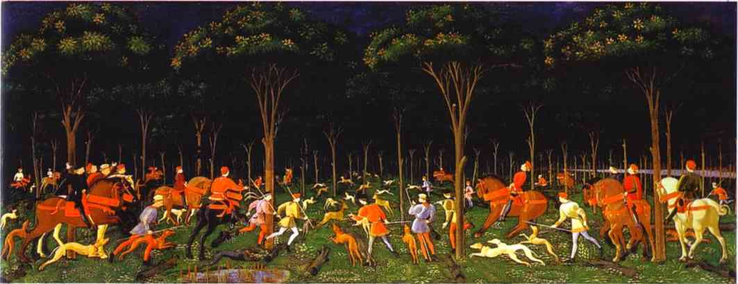
Figure 1.59. Paolo Uccello. The Hunt in the Forest, c. 1460. Tempera on wood panel, 25 ½” x 65” (64.77 x 165.1 cm). Ashmolean Museum, Oxford.
In the opposite conception of the perspective system, the world is accepted first as an uninterrupted field of potential pictures. From his chosen point of view, the artist scans this field with the pyramid of vision, forming his picture by choosing where and when to stop. De Witte’s and Saenredam’s pictures are obviously closer to this conception. So too is Degas’s The Racing Field (Figure 1.60) […], where point of view and frame rob the figures and animals of their physical integrity, compressing them into an unfamiliar pattern.
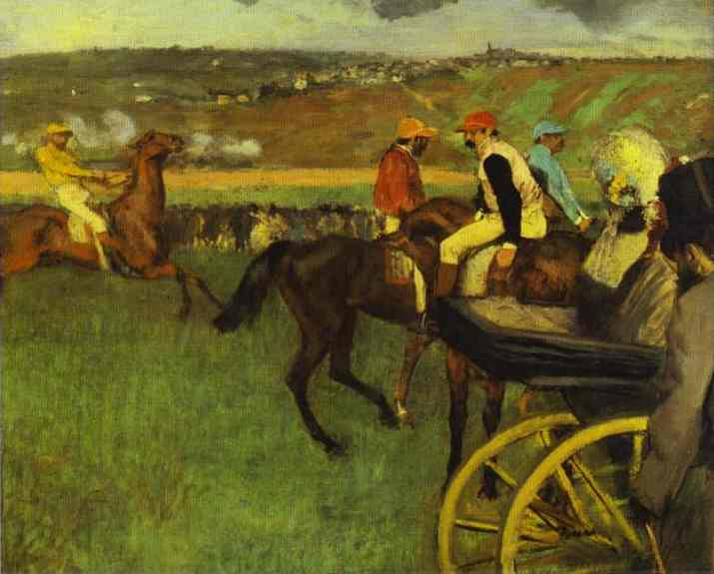
Figure 1.60. Edgar Degas. The Racing Field: Amateur Jockeys near a Carriage, c. 1877-80. Oil on canvas, 26” x 31 ¾” (66.04 x 80.65 cm). Musée du Louvre, Paris.
Degas of course composed his picture as carefully as Uccello, but his intuitive procedure was different. Uccello conceived of the visual pyramid as a static, neutral container, within which he organized the elements of his picture. In Degas’s work the visual pyramid plays an active, decisive role. We attribute the obstructions to the painter’s viewpoint and the asymmetry to the frame, which excludes as well as includes. Where Uccello’s painting seems comprehensive, Degas’s seems fragmentary, concentrating in a single visual aspect the vital spirit of the entire scene.
Uccello worked from pieces to a whole: he synthesized. Degas worked from a whole to an aspect: he analyzed.
These polar conceptions of perspective have a historical sense. Gradually, over a period of centuries, Uccello’s procedure of logical construction gave way to Degas’s strategy of selective description. In theory, there must have been a point at which pictorial experiment, diverging from the Renaissance norm, reached a critical stage, a sufficient density, to form a new norm. However, since artistic tradition develops along multiple fronts at different rates, and because the artist’s procedure is rarely his subject, this point is difficult to locate. It is not easy to name a date when the world expanded beyond the control of the studio artist, who then unhinged the visual pyramid, wielding it at large in pursuit of his subject.
Nevertheless, the invention of photography poses precisely this historical question. For the photographer, try as he might, could not follow Uccello’s procedure. The camera was a tool of perfect perspective, but the photographer was powerless to compose his picture. He could only, in the popular phrase, take it. Even in the studio the photographer began not with the comfortable plane of his picture but with the intractably three-dimensional stuff of the world.
Noting formal characteristics – obstructions and croppings – that readily arise from this unavoidable condition of photography, many art historians tacitly attribute to the invention of the medium the function of a crucial watershed. They explain, for example, some new features of Degas’s art in terms of the disruptive influence of photography, ignoring the long tradition from which his artistic procedure is derived. In fact it is not Degas’s work that needs explaining but the invention of photography.
Simply on a practical basis, photography would have been unsuited to the Renaissance art of composition. Uccello might have used the camera to make studies of bits and pieces for his pictures; but it is likely that such studies would have displeased him, as they did a much later artist, Edward Hopper: “I once got a little camera to use for details of architecture and so forth but the photo was always so different from the perspective the eye gives, I gave it up.”
The Renaissance system of perspective harnessed vision as a rational basis of picture-making. Initially, however, perspective was conceived only as a tool for the construction of three dimensions out of two. Not until much later was this conception replaced – as the common, intuitive standard – by its opposite: the derivation of a frankly flat picture from a given three-dimensional world. Photography, which is capable of serving only the latter artistic sense, was born of this fundamental transformation in pictorial strategy. The invention of photography must then coincide with or succeed the accumulation of pictorial experiment that marks the critical period of transformation from the normative procedure of Uccello’s era to that of Degas’s.

Biedermeier refers to bourgeois life and art in Germanic cities like Copenhagen, Berlin, Vienna and Prague in the mid-nineteenth century. Better known for domestic furniture and interior designs, the paintings, of typical middle-class subjects (family portraits, genre scenes, landscapes, and still lifes), were generally small, narrative, and highly detailed in style.
Helmut and Alison Gernsheim, The History of Photography from the Camera Obscura to the Beginning of the Modern Era (New York: McGraw-Hill, 1969), p. 13.
Heinrich Schwarz, “Art and Photography: Forerunners and Influences,” Magazine of Art, vol. 42, no 7 (Nov 1949). pp. 252-57.
Beaumont Newhall, The History of Photography from 1839 to the Present Day, 4th ed. Rev. (New York: The Museum of Modern Art, 1964), p. 12.
Quoted in Brian O’Doherty, “Portrait: Edward Hopper,” Art in America, vol. 52, no 6 (Dec. 1964), p. 77.

