Charles Baudelaire, On Photography, from The Salon of 1859

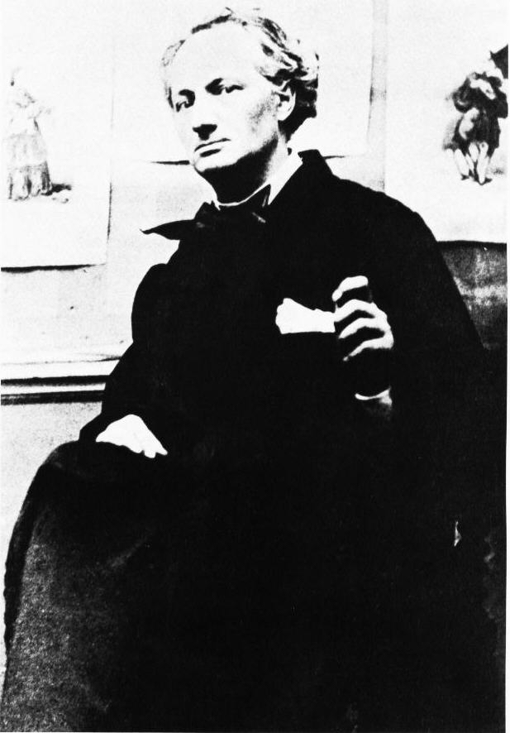
Figure 1.72. Nadar. Charles Baudelaire, 1855. Bibliothèque Nationale, Paris.

A madness, an extraordinary fanaticism took possession
of all these new sun-worshippers.

Baudelaire

Charles Baudelaire, father of modern art criticism, was deeply ambivalent about modernity. Some of his concerns about the creative situation for the artist in a mechanically progressive age are displayed in this commentary on photography from the Salon review of 1859, the year most Baudelaire scholars consider his most brilliant and productive. In the twelve years between the 1846 review and this one, the poet’s contempt for the values of the middle-class establishment and the egalitarian “mob” had deepened. After a brief, disillusioning engagement at the barricades in 1848, the 1851 Bonapartist coup d’état, and the coronation of Napoleon III the next year, whatever hope he might have held for the politics of his era vanished. His alienated modernism gained further assurance in early 1852 from his discovery of Edgar Allan Poe (1809-1849), the American poète maudit whose vision Baudelaire recognized as his own. Poe’s influence can be detected in the 1857 Flowers of Evil, a collection of poems that was immediately banned by the censors of Napoleon III. After a famous trial, six of the poems were judged an offense against public morality, and Baudelaire’s break with establishment culture was complete.
In 1846 Baudelaire had declared his admiration for the beauty of modern dress and manners and sought the painter who would capture it. In 1860 he expanded on these views in an article published in 1863, The Painter of Modern Life. Yet this 1859 commentary on photography, despite the absolute modernity of the medium, expresses scorn for its ubiquity and overwhelming popularity. Apparently putting aside his search for the artist who will represent modern life and his close ties to realists Courbet, Manet, Daumier, and the photographer Nadar, Baudelaire here asserts that “It is useless and tedious to represent what exists, because nothing that exists satisfies me…. I prefer the monsters of my fantasy to what is positively trivial.” Baudelaire’s poem, Correspondences (c.1852-6) [see chapter 12] likewise reduces the Realist aesthetic to irrelevance. Nature becomes an immaterial “forest of symbols,” a poet’s dictionary of subjective associations, metaphorical forms rather than concrete phenomena. The anti-materialist perspective of Correspondences and this commentary on photography will have a formative influence on Symbolist poets and artists in the decades after Baudelaire’s death. Its cultural prestige will reach far into the 20th century to give critical support to nearly every modernist movement from Fauvism and Cubism through Abstract Expressionism.
As you read, note the reasons Baudelaire gives for his attitude toward photography. What does he think of its many admirers, especially the painters? Is he still addressing the bourgeois viewer as he did in the 1845-6 Salon reviews? Who is his intended audience? How do Baudelaire’s observations about the social value of photography compare with the hopes W.H.F. Talbot expresses in the 1841 Pencil of Nature and Walter Benjamin’s views in the 1936 “Work of Art in the Age of Mechanical Reproduction”?

Baudelaire’s Salon of 1859 was first published in the Révue Française, Paris, June 10-July 20, 1859. This selection is from Charles Baudelaire, The Mirror of Art. Jonathan Mayne editor and translator. London: Phaidon Press Limited, 1955.

[…] During this lamentable period, a new industry arose which contributed not a little to confirm stupidity in its faith and to ruin whatever might remain of the divine in the French mind. The idolatrous mob demanded an ideal worthy of itself and appropriate to its nature – that is perfectly understood. In matters of painting and sculpture, the present-day Credo of the sophisticated, above all in France (and I do not think that anyone at all would dare to state the contrary), is this: “I believe in Nature, and I believe only in Nature (there are good reasons for that). I believe that Art is, and cannot be other than, the exact reproduction of Nature (a timid and dissident sect would wish to exclude the more repellent objects of nature, such as skeletons or chamber-pots). Thus an industry that could give us a result identical to Nature would be the absolute of Art.” A revengeful God has given ear to the prayers of this multitude. Daguerre was his Messiah. And now the faithful says to himself: “Since photography gives us every guarantee of exactitude that we could desire (they really believe that, the mad fools!), then photography and Art are the same thing:’ From that moment our squalid society rushed, Narcissus to a man, to gaze at its trivial image on a scrap of metal. A madness, an extraordinary fanaticism took possession of all these new sun-worshippers. Strange abominations took form. By bringing together a group of male and female clowns, got up like butchers and laundry-maids in a carnival, and by begging these heroes to be so kind as to hold their chance grimaces for the time necessary for the performance, the operator flattered himself that he was reproducing tragic or elegant scenes from ancient history. Some democratic writer ought to have seen here a cheap method of disseminating a loathing for history and for painting among the people, thus committing a double sacrilege and insulting at one and the same time the divine art of painting and the noble art of the actor. A little later a thousand hungry eyes were bending over the peepholes of the stereoscope, as though they were the attic-windows of the infinite. The love of pornography, which is no less deep-rooted in the natural heart of man than the love of himself, was not to let slip so fine an opportunity of self-satisfaction. And do not imagine that it was only children on their way back from school who took pleasure in these follies; the world was infatuated with them. I was once present when some friends were discretely concealing some such pictures from a beautiful woman, a woman of high society, not of mine—they were taking upon themselves some feeling of delicacy in her presence; but “No,” she replied. “Give them to me! Nothing is too strong for me.” I swear that I heard that; but who will believe me? “You can see that they are great ladies,” said Alexandre Dumas. “There are some still greater!“ said Cazotte.
As the photographic industry was the refuge of every would-be painter, every painter too ill-endowed or too lazy to complete his studies, this universal infatuation bore not only the mark of a blindness, an imbecility, but had also the air of a vengeance. I do not believe, or at least I do not wish to believe, in the absolute success of such a brutish conspiracy, in which, as in all others, one finds both fools and knaves; but I am convinced that the ill-applied developments of photography, like all other purely material developments of progress, have contributed much to the impoverishment of the French artistic genius, which is already so scarce. In vain may our modern Fatuity roar, belch forth all the rumbling wind of its rotund stomach, spew out all the undigested sophisms with which recent philosophy has stuffed it from top to bottom; it is nonetheless obvious that this industry, by invading the territories of art, has become art’s most mortal enemy, and that the confusion of their several functions prevents any of them from being properly fulfilled. Poetry and progress are like two ambitious men who hate one another with an instinctive hatred, and when they meet upon the same road, one of them has to give place. If photography is allowed to supplement art in some of its functions, it will soon have supplanted or corrupted it altogether, thanks to the stupidity of the multitude which is its natural ally. It is time, then, for it to return to its true duty, which is to be the servant of the sciences and arts— but the very humble servant, like printing or shorthand, which have neither created nor supplemented literature. Let it hasten to enrich the tourist’s album and restore to his eye the precision which his memory may lack; let it adorn the naturalist’s library, and enlarge microscopic animals; let it even provide information to corroborate the astronomer’s hypotheses; in short, let it be the secretary and clerk of whoever needs an absolute factual exactitude in his profession—up to that point nothing could be better. Let it rescue from oblivion those tumbling ruins, those books, prints and manuscripts which time is devouring, precious things whose form is dissolving and which demand a place in the archives of our memory—— it will be thanked and applauded. But if it be allowed to encroach upon the domain of the impalpable and the imaginary, upon anything whose value depends solely upon the addition of something of a man’s soul, then it will be so much the worse for us!
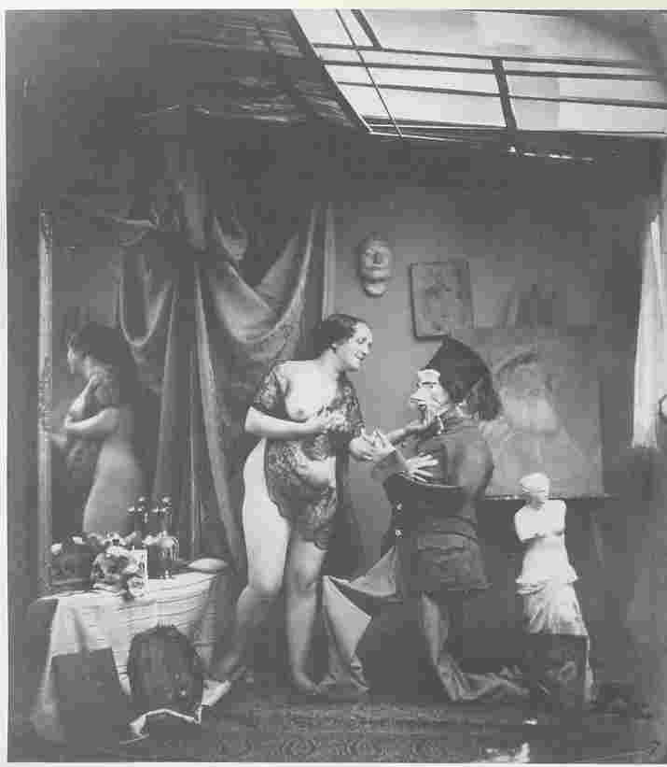
Figure 1.73. Bruno Braquehais. Academic Study - No. 7, 1854. Reproduced in Elizabeth Anne McCauley. Industrial Madness: Commercial Photography in Paris, 1848-1871. New Haven: Yale U.P, 1994. Bibliothèque Nationale, Paris.
I know very well that some people will retort, “The disease which you have just been diagnosing is a disease of imbeciles. What man worthy of the name of artist, and what true connoisseur, has ever confused art with industry?” I know it; and yet I will ask them in my turn if they believe in the contagion of good and evil, in the action of the mass on individuals, and in the involuntary, forced obedience of the individual to the mass. It is an incontestable, an irresistible law that the artist should act upon the public, and that the public should react upon the artist; and besides, those terrible witnesses, the facts, are easy to study; the disaster is verifiable. Each day art further diminishes its self-respect by bowing down before external reality; each day the painter becomes more and more given to painting not what he dreams but what he sees. Nevertheless it is a happiness to dream, and it used to be a glory to express what one dreamt. But I ask you! does the painter still know this happiness?
Could you find an honest observer to declare that the invasion of photography and the great industrial madness of our times have no part at all in this deplorable result? Are we to suppose that a people whose eyes are growing used to considering the results of a material science as though they were the products of the beautiful, will not in the course of time have singularly diminished its faculties of judging and of feeling what are among the most ethereal and immaterial aspects of creation?

