The Photographic Comportment of Bernd and Hilla Becher
To gather meaning from Blake Stimson’s essay on the photographic series’ made by German photographers Hilla and Bernd Becher, it is first necessary to understand the author’s definition of comportment as a stance, or a way of placing oneself in the world. After this, we can position the Bechers’ work alongside the work of others from that period, and by comparison know just where the Bechers’ comportment is situated. The Bechers’ first project came at the time when photographer/curator Edward Steichen exhibited his 1955 Family of Man at the Museum of Modern Art New York- a grandiose vision based on a running theme of human unity and worldwide kinship. Equally determined, was photographer Robert Frank’s project The Americans, in which the artist compiled a sequence of images from over 800 rolls of film that he shot while traveling across the United States. In the manner of Jack Kerouac’s characters from On the Road (1957), Frank crisscrossed the country to experience American culture and to critique it with the lens of his camera.
Against these two projects from the 1950’s, that like the Bechers’ also worked as a succession of images rather than the idea of a single photograph, The Family of Man and The Americans seem laden with obvious meaning. When viewing the Bechers’ works however, one does not instantaneously identify some strong social or politically overt statement. Instead, the Bechers’ photographs seem to make a return to earlier industrial aesthetics, and seem to work off the newer concept of a series itself- which then becomes a mode for comparison. It is especially important to identify the differences between the words subjectivity and objectivity, and to know which of these two define the Bechers’ work. It also important to understand the Bechers’ German heritage, to understand where the photographic team finds their influences, and to know the ways in which the work of Hilla and Bernd Becher will go on to directly influence photography students like Thomas Ruff, or indirectly influence artists like Andy Warhol who revolutionized the art world by working conceptually.
Rebecca Crowther
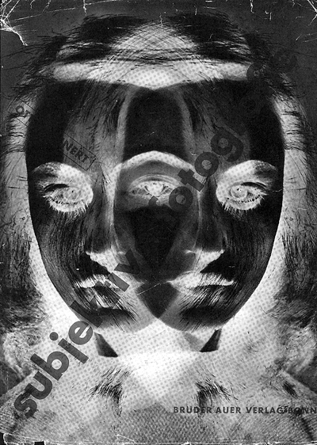
_________________________________________________________________________________
Otto Steinert, exhibition catalogue cover for the exhibition “Subjektive fotographie,” 1952.
Bernd and Hilla Becher first began their still-ongoing project of systematically photographing industrial structures-water towers, blast furnaces, gas tanks, mine heads, grain elevators, and the like-in the late 1950s.¹ The seemingly objective and scientific character of their project was in part a polemical return to the "straight" aesthetics and social themes of the 1920s and 1930s in response to the postpolitical and postindustrial subjectivist photographic aesthetics that arose in the early postwar period. This latter position was epitomized in Germany by the entrepreneurial, beauty-in-the-eye-of-the-beholder humanism of Otto Steinert's subjektive fotografie-“ ‘Subjective photography,’” wrote Steinert in his founding manifesto, "means humanized, individualized photography"-and globally by the one-world/one-culture humanism of The Family of Man.² While many photographers followed Robert Frank's critical rejoinder and depicted the seamier, chauvinistic underbelly of the syrupy universalisms advocated for by Steichen and Steinert, the Bechers seemed simply to reject it and return to an older, prewar paradigm. That they were responding critically does not mean, however, that the Bechers were not working at the same crossroads between man and machine, human nature and human progress, that had differently concerned Steichen, Steinert, and Frank (and many others at the time). "The idea," they said once, "is to make families of objects," or, on another occasion, "to create families of motifs"-objects or motifs, that is, they continued, that "become humanized and destroy one another, as in Nature where the older is devoured by the newer.”3 Their brute oedipal definition of the family form aside, this method of composition, of arranging pictures, is not so different from the relations established between Steichen's motifs lovers, childbirth, mothers and children, children playing, disturbed children, fathers and sons, and so on-or, for that matter, is it all that different from the narrative relations established between the constituent parts of Frank's book The Americans, shooting from the hip as he did, fleeing from one roadside encounter to another, from one flag or political rally or civic parade or scene of squalor or expression of anomie to another and another and another. For each of these enterprises, the movement itself from image to image to image aimed to be the story more so than did the sum of the collected parts, regardless of whether it is the movement of the photographer himself or herself, or the camera, or the movement of our own eye as it skips from one photograph to the next. Like their predecessors, the Bechers have been concerned from the beginning with what Kevin Lynch called in 1960 a "pattern of ... sequential experiences," that is, with a process that connects one image to the next and the next and the next ("as in Nature," the Bechers said), rather than using photography to exercise the analytical powers of isolation, definition, and classification (beyond, that is, their minimalist typological schemata of water towers versus mine heads, round buildings versus square) or even detailed description and cognitive understanding. This is just to state the obvious. The Becher photographs are "not illustrations," as one observer puts it flatly, but instead do their work as photography "by means of the network of photographs." That is, what the images viewed together provide, the same reviewer continued, is "an anatomy lesson," an anatomy of the relations between constituent parts.4
Putting this idea of network or system or series or sequence in more historical terms, a more critical observer describes their project thus: "The Bechers are interested in the character implicit in a facade, just the way [August] Sander was in the character implicit in a face," but then adds as an afterthought, indicating the crossroads we have already begun to consider here, "I cannot help regarding these pictures as macabre monuments to human self-distortion in the name of social reason-all-too-human structures that are ridiculously social."5 It is only in viewing these structures in the serial form given by the Bechers that both the" all-too-human" character that we might see in the regional or architectural or other distinguishable particularity of each, and the "ridiculously social" conformity of those particularities to the Bechers' own archival schema, is revealed. Working objectivity against subjectivity, one comportment against the other and then back again, the Bechers' project finds the motor of its epic continuity in an elastic liminal bearing that bounds between a cool, mechanical, quasi-disembodied objectivity, on the one hand, and, as we shall see, a hot, subjective comportment that speaks of its own history and desire in its bearing toward the world, on the other.
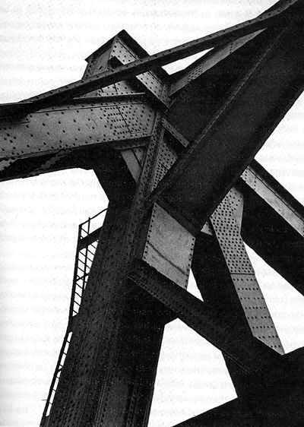
Still, their project did draw its critical vitality from two prewar influences, and both would seem to locate their ambition opposite to the postwar subjectivism of Steichen and Frank-that is, strictly on the side of what was once called the New Objectivity. The first of these prewar influences was the systematic, pseudoscientific studies of Karl Blossfeldt, Albert Renger-Patzsch, and particularly August Sander whose life project of making sociological portraits of Germans from all classes and occupations provided the methodological and affective structure for the Bechers' own typological procedure and a logical alternative to the affective charge given in both the sentimental identification and scornful disidentification adopted by their humanist predecessors. The second major influence, the source for the distinctive subject matter they chose to apply Sander's system to, was the industrial iconography popular with many photographers and artists in the 1920s and 1930s. They might have had in mind one of the many well-known photographs by Renger-Patzsch, such as his Intersecting Braces of a Truss Bridge from 1928, for example, but it could have just as well been photography by Charles Sheeler or Margaret Bourke-White or Laszlo Moholy-Nagy or many, many others equally and less reknowned. Just to recall a key influence from a history that is well understood by any student of the Bechers, scientific method, industrial subject matter, and the mechanical advantage of photography-to varying degrees among their machine age forebears from around the industrialized world and across the political spectrum-all drew on and supported a challenge to the perceived anachronism of aestheticism and subjectivism and promised a new place and new importance for artists in the modern world. That ambition was developed in many places-for example, by Rodchenko in 1928 when he insisted that "every modern cultured man must make war against art as against opium.6
Albert Renger-Patszch, Intersecting Braces of a Truss Bridge in Duisburg-Hochfeldt, 1928

Not all members of the once-labeled "engineer generation" were as antipathetic to the older ideals as Rodchenko (Renger-Patzsch, for one, sought something more like reconciliation between modern life and art and set himself against such modernist polemics particularly as they were developed in Germany by Moholy-Nagy), but all did share in the claim for photography's machine age advantage, responsibility, and entitlement.7All agreed that representation needed to be mechanical if it was to be modern; all agreed that art needed to somehow sober, objective, sachlich, at a remove from any simple expressiveness unto itself and at a remove from any claim that the art object might be a bearer of value in and of itself.
More broadly still, of course, this tension between art as an autonomous and self-contained value, on the one hand, and modern life, on the other; has regularly given definition and distinction to the social role played by photography throughout its history. From the beginning, photography was not only a passive product or sign or symptom of modernity but also worked actively as an engine of modernization. Beginning already with its official, state-sponsored birth in 1839, both civic duty and marketplace, opportunity alike were pinned to its capacity for bringing vision as an idea; and visual representation as a material resource into the workaday world of the masses, for bringing visual imagination up to speed with the ever, accelerating, ever-expanding industrial revolution and thereby modernizing the archaic, pseudoreligious, would-be aristocratic presumption of in its new, modernist role as herald of the private life of the bourgeois subject.
This mantle trumpeted by the machine age photographers and regularly assumed for photography generally is carried forward in the Bechers' work, albeit complexly. While their career has been almost exclusively a function of the international art market and art publishing industry and the German art education system, their photographic studies regularly have been characterized as "industrial archeology" or "a contribution to the social history of industrial work" and are routinely assumed to support such extra-artistic ambitions and accomplishments. These assumptions are misleading however: their photographs offer little social-historical or archeological interpretation, and they do not detail the particulars of design, operation and social function that might be useful for such areas of study.8 They have been completely upfront about this. "Things which can be interesting for technical historians," they have said, for example, "are not visually interesting for us."9 Indeed, they often go to great lengths to ensure the absence of the sort of detail that would be of interest to technical historians, of social historians or historians of any sort really. "We want to offer the audience a point of view, or rather a grammar, to understand and compare; the different structures," is how they describe their ambition. "Through photography, we try to arrange these shapes and render them comparable. To do so, the objects must be isolated from their context and freed from all association."10 When they have tried collaborating with historians, for example, it has not worked out at all. "They wanted to write a text, and garnish their text with our photos," complained Bernd about their experimentation with such a role in the late 1960s. "They couldn't imagine that photographs could stand on their own. They wanted to give it a scientific basis," objected Hilla. ''It was quite dreadful," continued Bernd. ''It was a bad experience," Hilla agreed. "Working with them, we felt for the first time that we weren't free." ll
They do employ a method, like much historical or archeological analysis, that is strict in its consistency and pure in its sense of purpose but that purpose avoids "context" and "association" by design and thus has little to offer understanding in the manner traditionally given by such extra-artistic, analytically minded aims that are the province of historians and archeologists. Their more properly artistic characterizations of the structures they photograph-" anonymous sculptures," as they termed it in 1969, for example, and "basic forms" or Grundformen, in 1999-suggest a more useful understanding of their project by drawing us away from the simpler, more transparent notion of representation assumed in such archeological and social historical characterizations and throwing us into the murkier waters of formal analysis and aesthetic experience.
The Bechers have emerged as a leading influence in postwar art history, not only for their own work and its interweaving with other artistic developments such as minimalism and conceptual art, but also, particularly in the past decade, for the extension of their project by a string of extraordinarily successful students.¹² Indeed, the "point of view" or "grammar" the Bechers developed has gained a significant measure of dominance within contemporary art practice as a whole. My effort here is to read that "grammar" as embodied expression, as a form of comportment or bearing toward the world, and as a sign or symptom of a social relation, that is, as a sign or condition or component part of a social form. The distinctive orientation and determination of that photographic body language or photographic comportment, which in the Becher scholarship is sometimes said to be found midway "between distance and proximity," has taken on imposing proportions in the epic continuity of their own work and in the stilled grandeur seemingly discovered anew by their students again and again and again in settings ranging from the magisterial all the way down the food chain of aesthetic discrimination to the banal. Indeed, comporting oneself to see the world in this way-to see it grandly regardless of whether what is being viewed is itself grand-may be said to be their legacy. "Standing before the photographs of museums and churches and mobs of tourists, we can become absorbed by the chaos of culture," one critic testifies, for example, standing in the face of a vastness of detail recorded with all that Germanic deep focus, concentrated precision, and meticulous craftsmanship. "We turn inward," the same critic continues sensitively, "breathing slowly.” 13
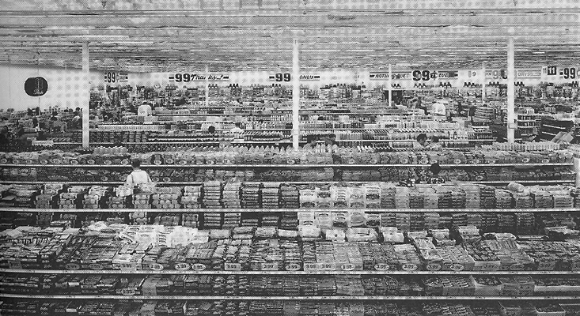
Considering the strong debt of this way of looking at the world, to various artistic developments of the 1920s and 1930s, its powerfully disciplined elaboration as a form by the Bechers themselves beginning in the 1950s and 1960s, and its art world success in the work of their students in the 1980s and 1990s, I will be asking how it has been able to, "at a stroke," in the words of one philosopher of comportment, "incorporate the past into the present and weld that present to a future.”14 Such an inquiry, it can be said, is the task of the historian generally: "not to moralize about remembering and forgetting" -this is Anson Rabinbach writing about the question of postwar Germans' coming to terms with their Nazi past in order to consider historical method more broadly-but instead "to identify the ways that certain metaphoric pasts can be cathected to contemporary events."15
Andrea Gursky, 99 Cent, 1999. © 2005 Artists Rights Society (ARS), New York
The Bechers have taken up a specific past-the heroic age of industrial modernity-and rearticulated it with a new and different force in the present. They have, as Rabinbach puts it, cathected a politically and morally charged myth of the past to contemporary events. Framing this larger question about the place of the past in the present more narrowly around photography, we can ask how the Bechers have conveyed photography's heroic Enlightenment promise of rigor and transparency and progress, its grand bid to "make war against art as against opium," as Rodchenko put it, into the present. One answer to this question that we need to consider in order to get at the characteristic bearing in their work and the legacy of that bearing in the work of their students is whether the Enlightenment promise long assumed to be the distinctive charter of photography has been somehow inverted or returned to its homeland category of art, that is, to the same category it had originally taken as its oedipal foil. In order to flesh out the details of this bearing or comportment, I will be working between three separate attitudes that each can be said to be driving the Becher project. First, I consider their commitment to their project and position; second, I consider the delight or simple pleasure given in their visual record of the objects photographed; and, third, I evaluate the claim to enlightenment or appeal to a universal standard given in the rigorous systematicity of their undertaking. Each of these attitudes or perspectives is given its own section in what follows, but the goal in the end is to bring all three together into a common understanding of the conviction or pleasure or truth that endows their comportment with its forceful sense of purpose, a sense of purpose that, judging from their success, seems to continue to be powerfully compelling for their own project and for the work of their successful students.
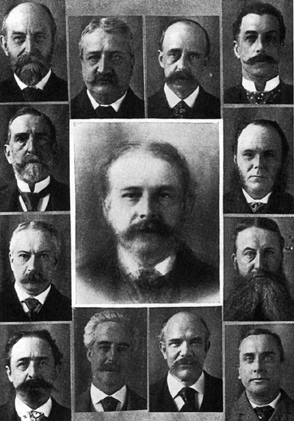
The most obvious feature of the Bechers' project is its disciplined commitment to a singular vision-a commitment that has been consistent over nearly half a century's duration, consistent across many different countries and regions, and consistent from each to the next of many thousands of photographs. As one critic has put it, the pattern of "rhythms and repetitions" established between the individual pictures (and, we might add, between individual series as well) is "very much the idea of work."16 Such, the artists have admitted, is their goal-to produce a more or less perfect chain of different forms and shapes." Indeed, something this "perfect chain" or pattern of serial rhythms and repetitions is initial impression given to the beholder when facing a Becher installation or book for the first time or when moving from one to the next of any their ten or fifteen books-from Water Towers to Framework Houses to Tanks to Industrial Landscapes, for example-or in and between any of the numerable exhibition catalogues.¹⁷
Follower of Sir Francis Galton, composite photograph of twelve Boston physicians, from McClure’s Magazine, 1894.
Their system is based on a rigorous set of procedural rules: a standardized format and ratio of figure to ground; a uniformly level, full-frontal view; near-identical flat lighting conditions or the approximation of such conditions in the photographic processing; a consistent lack of human presence; a consistent use of the restricted chromatic spectrum offered by black and white photography rather than the broad range given by color, precise uniformity in print quality, sizing, framing, and presentation; and a shared function for all the structures photographed for a given series. There is another obvious rule too, although one their project might be said to systematically ignore: their industrial history is exclusively and resolutely a history of the West. We need make only the most rudimentary comparisons to see that theirs is a project about modernization, not globalization, and so does not detail, or even allude to, the geopolitical ambitions and conflicts that drive the process.¹⁸ They do not, for example, group the images by geographical or historical categories, which would bring a more detailed historical consciousness to bear on the material at hand, nor do they depict or generally otherwise consider the workers and others involved with the structures they represent, and they do not arrange the pictures in a manner that would chronicle the development of their project. The term they generally use to describe their method is typological, and they freely state that it has "much to do with the 19th century," that is, they say, with "the encyclopedic approach" used, for example, in botany or zoology or, we might add, various psychophysiological approaches used in medicine and criminology.19 Indeed, we might say more broadly, their system is based precisely on the nineteenth-century principle of the archive-on its "dry compartmentalization," as Allan Sekula has described it-that so concerned Michel Foucault and the waves of Foucauldians that followed him.
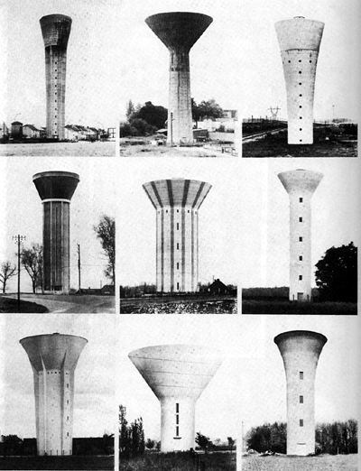
While an individual Becher photograph seen on its own without attribution could be mistaken easily as the sort of transparent illustration used in trade journals or annual reports, for example, or in books on the history or design of industrial architecture, the same photograph seen in its intended setting alongside tens or hundreds of nearly identical others could not support any similar instrumental goal. While it is true that it is "only through their participation in a system of presentation, under the model of the archive, that the single images gain a significance which is larger than their particular instances," as one observer puts it, the kind of significance given by this systematization is different.20 Unlike similar approaches used in botany or zoology, for example, the cumulative effect of the typological method as it is applied in the Bechers' life project does not provide greater knowledge of the processes or history of their subject. Instead, the use of rhythm and repetition endows the buildings they photograph with the "anonymity" or abstract form they seek (by divorcing meaning from original purpose and everyday social function) rather than with scientific specificity and, in turn, allows us to read them ahistorically and extrasocially and appreciate them as autonomous aesthetic objects or "sculpture."
Bernd and Hilla Becher, Water Towers from Bernhard und Hilla Becher: Typologien industrieller Bauten 1963-1975. 1977.
This distinctive method of cultivating aesthetic response is consistent with the 1920s and 1930s project of aesthetic appropriation of scientific or systemic method, but it is also different. Perhaps the most significant measure of difference between the Bechers and their forebears is artistic ambition. At those moments when it was most full of itself, the "New Vision" (as it was called in the preeminent artistic slogan of the day) was to render intelligible and help propagate a new social order based on mass production, mass politics, and mass media. This mission offered artists a sense of social significance that the profession had not enjoyed since its days in the court. Suddenly, as one memoirist has recounted in a conventional piece of critical wisdom from the period, "the artist was deprived not of his social acceptance but of his isolation. This social isolation had been a by-product of the Industrial Revolution, as typical and pernicious as slums, mechanization and unemployment.... Montmartre, Schwabing, Bloomsbury, and Greenwich Village were expressions as typical of nineteenth century mentality as Wall Street, Lloyds of London, La Bourse, and Das kaiserliche Berlin."21 At its grandest, artists of the industrializing world in the 1920s and 1930s believed that by taking up photography as a medium, industry as a theme, and science as a method, they were abandoning the bohemian ghettos and would, once again, occupy positions at the center of social life by working as designers and propagandists for the emerging political class.
What gave artists renewed confidence and ambition was a new understanding of patronage that had been made possible by the revolutions of the 1910s. Instead of decorating the private mansions of individual bankers or businessmen, artists were hired by revolutionary governments in Russia and Mexico and patronized by communist parties in much of the rest of the industrialized world to make art that spoke about and addressed itself to the working masses. This vision took root in the 1920s with artists fancying themselves as Taylorist engineers or planners and was gradually retooled by the 1930s for duties on the other side of the labor-management divide as artists came to see themselves in the figure of the industrial worker. This new sense of significance and anticipation of an emerging audience and market quickly impressed itself on most of the developing movements of the period regardless of whether the political conditions existed to actually support such ambition. At the heart of this transformed self-consciousness was the assumption that the world was being remade through mass production and mass politics and artists, as the engineers and laborers of visual form, were to be key players developing the mass culture that would drive both fronts of modernization.
A rich sense of this anticipated social role was given in a series of statements by the Russian-born, Berlin-trained, New York-based, precisionist turned-social realist Louis Lozowick on the changing status of the artist in the Soviet Union. “To say that art has been encouraged in the Soviet Union is to make a true but tame statement about the actual situation,” he reported in 1936 to his peers at the First American Artists' Congress in New York. “Of course art has been encouraged," he continued. "Artists are considered part of the vast army of workers, physical and mental and as such an indispensable factor in the socialist reconstruction of the country. Full members in trade unions, the artists carry insurance against sickness, accident and unemployment. They are consulted on every issue that vitally affects the country. When we read, for example, of such vast projects as the ten year plan for the complete rebuilding of Moscow, the most gigantic scheme of city planning in history, we are not surprised to find artists actively cooperating."²²
Still today the Bechers' work (and its legacy in the art of their success students) makes reference to this phantasm from the prewar past. Unlike their artist-cum-engineer-cum-worker predecessors, however, the Bechers’ sensibility relies on melancholy rather than visionary innovation or allegiance with the revolutionary class to make its point. Tied to the loss of an idealized past, their work gains its emotional power, its expressive force as art, from the extent to which it conveys that sense of loss to beholder. Their photographs present us with a transformed image of avant-garde ambitions of the 1920s and 1930s. In their view, the industrial structures that served as monuments to the "gigantic schemes” of collective life, monuments to technological, social, and political modernization, have aged and are now empty of all but memory of the ambition they once housed. Likewise, their postwar rehashing of the “ New Vision" is now drained of all but memory of the heroic affect that we along with artists' sense of their own "indispensable" contribution. Bechers have stated their position outright: "We don't agree with the depiction of buildings in the 20s and 30s. Things were seen either from above
or below which tended to monumentalize the object. This was exploited in terms of a socialistic view-a fresh view of the world, a new man, a new beginning. "23
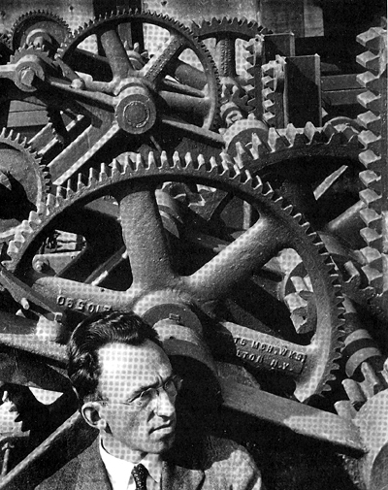
This postwar critique of the New Vision and related artistic ambitions, the prewar past is generally consistent across an entire generation of artists and intellectuals whose historically distinct form of criticality continues to serve as a foundation for the range of critical perspectives available to us today. We do not have to go far for such testimony. Witness, for example, Michel Foucault in one of his most-cited essays. We “know from experience," he writes, "that the claim to escape from the system of contemporary reality so as to produce the overall programs of another society', of another way of thinking, another culture, another vision of the world, has led only to the return of the most dangerous traditions ... to the programs for a new man that the worst political systems have repeated throughout the twentieth century.”24 The Bechers, like many of their contemporaries, have made an obsession of this disagreement with the past. By returning to those views again and again and again for nearly half a century with even greater sobriety, even greater assiduousness, even greater industry than the Neue Sachlichkeit that inspired them, by shooting the grand icons of the machine age "straight-on" so they do not, they have claimed, "hide or exaggerate or depict anything in an untrue fashion," by committing themselves to an ethic of representation free of bogus political elevation or degradation, they realize one leg of their generation's postmodern affect.²⁵ In so doing, the Bechers' commitment sits wedged between a passionate, trance-like fascination with the great progressive democratic ambitions of modernism and an equally ardent renunciation.
Ralph Steiner, Louis Lozowick before Erie Canal Lock Gears, 1929.
Such is the Bechers' burden, their ethic: an ideological commitment to a form of representation that is somehow free of ideology, free of a "socialistic view" or the view of any other doctrine or ism. But such commitment is really only one part of what is given by their strong sense of order, by the "rhythms and repetitions" that form their project, and so now we turn to the second part: the unmistakable delight taken in the play of form.
The promise of the aesthetic as a realm of experience separate from the instrumental thinking of daily life has served many different purposes over the years since it was first elaborated by the Enlightenment philosophers. It has given rise, for example, to the ideal of a public sphere of proto-political discourse independent of undue influence from church, state, and, later, the marketplace. Where art was "claimed as a serviceable topic of discussion through which a [newly] publicly-oriented subjectivity communicated with itself."26 So too, the aesthetic has long given rise to the contrary ideal of a bohemian preserve where a delicately cultivated, aristocratic balance of taste and tastelessness, convention and transgression, sentiment and suspicion suffers the brute indifference and smug naiveté of its bourgeois audience.
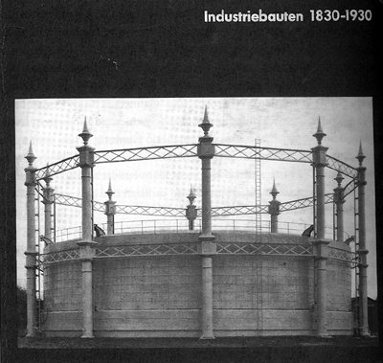
The Bechers' transformation of the iconography and methodology of social ambition from the 1920s and 1930s into "anonymous sculptures" relies just as much as their forebears on this counterpoint between aesthetic and instrumental worldviews, but they do so oppositely. Theirs is no war against the opiate of the elite, as Rodchenko had advocated. They have made themselves and their audience into connoisseurs of an industrial past, providing us all with opportunity for unexpected visual delectation, with opportunity to delight in the play of fine distinctions and subtle variations between the appearances of many different structures that all perform the same instrumental function. 27 They offer their audience, as one viewer has testified, for example, the opportunity to delight in differences in composition, rhythm and formal solutions where an ordinarily distracted eye would see only indifference and standardization." "I love Bernd and Hilla Becher's work," this enthusiast writes; it is "genuinely great art, the kind that has no need to have its name protected by being placed in a museum, because it already belongs to our collective memory.”28 In the words of another viewer, the Bechers' work is said to allow us "to regard a single line of rivets as equally significant a marking as a full-blown mannerist conceit.”29 In so doing, they revitalize the old aestheticist claims about taste and tastelessness by exercising those claims on the turf of instrumental reason, that is, by making art out of industry.
Bernd and Hilla Becher, cover Industriebauten, 1830-1930, 1967
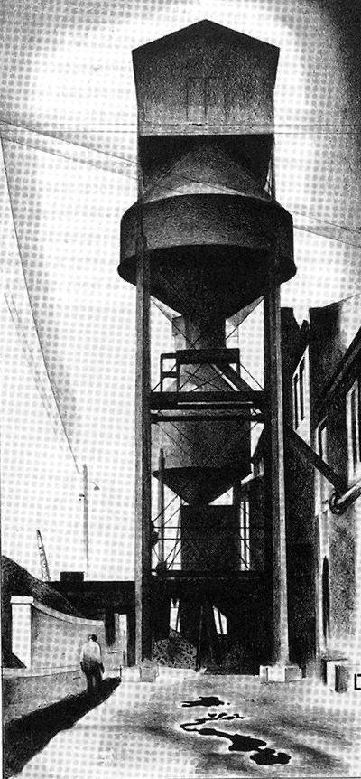
One interpretation of their contribution, one that has deep roots in modernist critical theory, might argue that such connoisseurship represents nothing more than the aestheticization of politics, nothing more than the transformation of a publicly oriented sensibility into a rarefied product aimed at an elite market that ambivalently and obsessively draws succor from an earlier, more political moment for its legitimation. "Their work is a fraud," a certain school of critic might once have alleged, "a mere neo-avant-garde." Andreas Huyssen, for example, has made a broader statement that might be torn from its original circumstance and retrofitted to this concern, particularly if we grant the Bechers nothing more than their disaffected pastiche of the past. "The obsessive attempts to give utopia a bad name," he writes, "remain fundamentally ideological and locked in a discursive battle with residual and emerging utopian thinking in the here and now."30 A more open-handed interpretation, however, might see that same act of aestheticization as in its own way liberating, as both cathartic and invigorating, as an attempt to serve equally two pressing and contradictory concerns: to both remember and let go of a failed political program and failed attempt to upgrade artists' social status in the name of the possibility for other, more viable investments. As such, the unexpected finery afforded by the Bechers, the part of their work that declares itself to be art in the most conventional decorative or ornamental sense, the systemic delight in the play of form, might well be valued (even, perhaps, by that group one critic has labeled "the last partisans of the avant-garde") as something more than mere decadence or self-indulgence or anti-utopianism: that is, as a form of esotericism, a refuge from political cynicism for an age in which such refuge is unavailable.³¹
Louis Lozowick, Tanks #3, Smithsonian American Art Museum.
This question about the place of the aesthetic in the Bechers' work can also be phrased in more general terms: How is it that we move beyond the critical negation of failed political attachments from the past? How can old commitments-the old "socialistic views," for example-be rendered sympathetic beyond their inadequacy, heroic beyond their failing, forward looking beyond their obsolescence, cherished beyond not being believed? 32 The issue here is one of political memory, of a "talking cure" for false consciousness, of how the political past is negotiated within our sense of the present and how that settlement inhabits the realm of the aesthetic. In the light of such a question, the Bechers' mastery of their craft and the obsessiveness of their fascination-their tight, standardized formal rigor and their fixed commitment to a grueling, lifelong study-might be prized precisely for the way the aesthetic appeal of its form can serve to dislodge an earlier political ideal from its place under the weight of protracted repression and anxiety in the present in order to be reseated in a position of simpler, less freighted distinction in the past. The distinguishing beauty of their work thus would not be found in the way it shares our period's still-vital critical distance from the old utopianisms, the old "programs for a new man" and the like-at least not on its own-but instead in its seemingly indefatigable preservationist impulse, in its attempt to hold on to and find delight in the great beleaguered promise of the modernist past over and above the critique of that past that is still vital in the present.
It is the fantasy life of this work, its capacity to take delight in an opening in the past that leads forward into the future, its way in which "certain metaphoric pasts can be cathected to contemporary events," as Anson Rabinbach termed it, then, that might be said to have sustained it and driven its rhythm and repetition onward, maintaining its commitment to producing nearly the same picture over and over and over again for almost half a century. Bernd Becher was clear about his fascination in a 1969 interview. "These things are so full of fantasy there is absolutely no sense in trying to paint them; I realized that no artist could have made them better," he said. "This is purely economic architecture. They throw it up, they use it, they misuse it, they throw it away.”33 A term the artists return to periodically is nomadic architecture. The structures are "not like the pyramids," they have said; they are not "for eternity.”34 Their vision is of an architecture free of the burden of culture, free of the burden of identity, free of the burden of eternity. "An Italian gasometer does not look Italian and a Chinese blast furnace does not look Chinese," they have said, and it is this form of looking that is so appealing; it is this form of looking, this comportment, that delights.³⁵

The strongest reference for identity thinking for anyone growing up in Germany during the war would be the construction of Germanness and its others, and this was as formative for the Bechers as for any others of their generation. "The industrial world is completely divorced from" such identity thinking, from Nazism, Bernd has said. "It has absolutely nothing to do with ideology. It corresponds more to the pragmatic English way of thinking." As the artists note, their nineteenth-century approach itself, like the structures they photograph, is drawn from "the soul of industrial thought." Method and subject matter, form and content, serve as reciprocal homologous support for each other. Just as with industry, so photography in their hands is assumed to be "by its very nature free of ideology."36 This sense of freedom, this delight in the industrial as an alternative to ideology, is the engine sustaining their distinctive photographic comportment.
Ed Ruscha, one of a dozen or so blank page spreads from Nine Swimming Pools and a Broken Glass, 1968. Artist’s Book.
All the end-of-ideology claims that developed in the 1950s like the Bechers' were born of similar assumptions. Each arose with a theory of ideology based on the principle of identity-as in Nazi ideology, for example, or communist ideology-and any cultural development that weakened or diluted identity was understood to do so as well to the ideology that sustained that identity. As Raymond Aron put it the same year the Bechers embarked on their project, for example, ideology was supposed to draw its authority from "the longing for a purpose, for communion with the people, for something controlled by an idea or a will."37 This identity-thesis was embraced across a wide political spectrum from Aron leftward, and in many respects it continues to form our own moment now. But it is important for our purposes to recall how this model of ideology was different from that first developed by Marx, which, after all, was the model that subtended the ambitions of the engineer generation and that, in principle, was returned to in the postwar critical rejoinder of the Bechers.
What the modernists of the 1920s and 1930s had wanted was a kind of materialist foothold that would sustain the progressive development of identity-in social planning, in the machine, in their productivism itselfand could hold its own against the vagaries of taste in a world increasingly dominated by consumerism. Such consumerism was a big part of the modernity of artists like Rodchenko, Moholy-Nagy, Renger, and others, of course, but as a group they had no aspiration for an anti-aesthetic per se (as would later be the case with pop art and other developments in the 1960s, for example), no aspiration to abandon the claims of science, no aspiration for negation that rested on its own laurels. In the Marxian schema that they had inherited, the very moment that ideology in its identity-based sense is said to be negated is itself the turning point into ideology proper or the moment when, as the Communist Manifesto put it famously, "all that is solid melts into air, all that is holy is profaned," and identity is given over to process, social relations are given over to relations between things, and politics is given over to economics. "All fixed, fast- frozen relations, with their train of ancient and venerable prejudices and opinions are swept away," the manifesto continues, "all new-formed ones become antiquated before they can ossify."38
This type of ideology is given not by propagandists and ideologists-in an important sense, there can be no such thing as a capitalist Goebbels-but is always given instead right in the technology. "Modern Industry never views or treats the existing form of production process as the definitive one," Marx wrote. That is, it can never be established as doctrine. As such, he continued, it is "revolutionary" and opposed to all earlier modes of production. "By means of machinery, chemical processes and other methods, it is continually transforming not only in the technical basis of production, but also the functions of the worker and the social combinations of the labor process," Marx continued; it "incessantly throws masses of capital and of workers from one branch of production to another."39 This movement is the "nomadic" quality of modern industry that the Bechers rely on to make their point-it is this, they say, that is "like nature"-and their ambitious project speaks equally to Marx's account of industry as progressive social change as it does to his account of it as bearer of false consciousness, alienation, and exploitation.⁴⁰
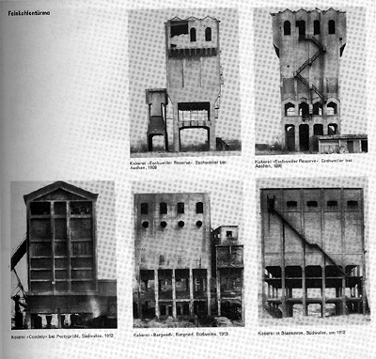
The Bechers work this boundary between promise and threat differently, however: their project provides a systematic manner of viewing the world that wagers its own system of value, and thereby its distinctive form of autonomy, against its architectural subject. Where the architecture promises pure instrumentality, they provide a purity of aesthetic form. As such, while their work makes its own claim to be free of ideology, its own claim to being apolitical, it does so differently than does the industry they photograph. Their method as artists is to pit one modern form against another, to pit the nomadism of aesthetic delight against the nomadism of industry, to pit the (idealistic, German) soul of aesthetic experience against the (pragmatic, English) "soul of industrial thought." In so doing they have produced a full-blown nineteenth-century archive exactly in the manner that Foucault would describe. It is an archive not of bodies but of machines, however, not of the formal, physiognomic variations of deviance but of industriousness, not of those discarded by modernity but of that modernity has shed of itself. 41 The delight offered by their art-in its machinic rhythms and repetitions, in the play of form across the registers of its objectivity and systematicity-is therefore realized only against the revolutionary promise of the modern industry it depicts. It is a view of industrial history as if it were nature, as if it were an organic process unto itself, as if it were a slide show or a picture book flipping from one image to the next and the next and the next. The structures "come and go almost like nature," they have said. "This was interesting for us.”42
Bernd and Hilla Becher, page spread from Industriebauten, 1830-1930, 1967.
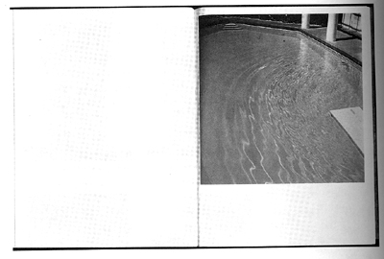
Art and industry thus stand opposed in the Bechers' work in a manner different from, even contrary to, their machine age forebears. Put schematically, their project is one of aestheticizing industry rather than industrializing art. This, it might be said, is the other leg of postmodernism in their work-the way in which it engages in the play of signification with diminished concern for its attachment to some properly material reality. This is also the way in which their work plays with and transforms the Neue Sachlichkeit legacy of documentary photography with its "socialistic view," its core critical materialist mandate of author-as-producer reportage. "The paradox," insisted Daniel Bell in 1960, is that the end-of-ideology generation-the Bechers' generation, the generation of the 1950s, that is, the last generation that still openly subscribed to some vestige of the Enlightenment project-"wants to live a 'heroic' life but finds the image" of such heroism "truly 'quixotic.' "43
Ed Ruscha, spread from Nine Swimming Pools and a Broken Glass, 1968.
But this turn away from modernism's politicized vision of industry, from its heroism that was not yet quixotic, is in no way the whole story. Art and industry also rely on a common foundation in the Bechers' work, and it is this that can be said to be its continued embrace of modernism, its faith in the power of representation to reveal and comprehend the hidden material conditions of the world it addresses, its faith in the project of Enlightenment. Although the Bechers' work distances itself from most of the affective attachments of the engineer-cum-worker ideal of their forebears, it does share with that ideal (in a manner that is fully modern) faith in the more abstract aim of system. Their work cares little for the mimicking of the consumer world and the consumer's vision that emerged as a program side-by-side with theirs in the various pre-pop and pop movements of the 1950s and early 1960s. In this way, their serial form, their comportment between distance and proximity, is very different from that of many of their contemporaries such as Andy Warhol, Ed Ruscha, and Gerhard Richter, with whom they are often compared. Like these others, theirs is a cool vision, detached from maudlin sentiments of all kinds, political or otherwise, but, unlike them, that detachment is not founded on irony, and the pleasure taken in their project is not the consumer's pleasure of expenditure without return, of process without aim. Indeed, it might be said, if there is one thing the Becher project is more than anything else, one thing that distinguishes it from the core critical motif of their pop-culturalist contemporaries, it is the apparent earnestness with which it embraces systematicity, the way in which it holds onto modernism's seriousness of purpose and concentration of aim even as it abandons the purpose or aim itself.
What then has this residual modernist ideal of systematicity meant for the Bechers and their audiences, and what might it mean for us now? What, in the end, is the value of their archive? What is the value of their old-fashioned artist-cum-engineer modernism? Certainly it has taken on the form and weight of the ethical principle of commitment, as argued above. Certainly, too, it has provided occasion for aesthetic experience or delight. But these standards on their own are abstract forms and empty of historical content, empty of any claim for why such an ethic or such an aesthetic might appeal or serve its constituency and its time. The historical promise of systemic form had been clear enough for their machine age forebears: it was to carry the new vision, the society planned by artists. It was to be scientific management raised to the level of social engineering through its visual forms. Its promise, in short, was that it would produce, as the Bechers have said disapprovingly, "a socialistic view-a fresh view of the world, a new man, a new beginning."
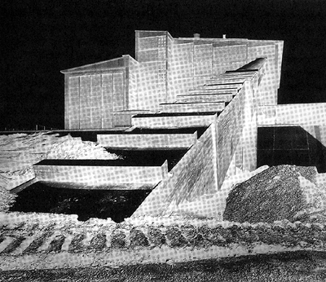
From our latter-day perspective, it is important to remember that this critique is really a product of the generation of the Bechers and Foucault and did not emerge immediately after the war but instead arose only in the 1950s. In the earlier postwar period, the old prewar project for a new man was actually revitalized and given a new mission, if only for a moment. Against the fluctuating political passions aroused by the emerging anticommunist bunker culture of the late 1940s and early 1950s, many public intellectuals came to approach the question of political subjectivity with a renewed sense of urgency and purpose. Much-discussed statements by public intellectuals like Norman Cousins and Albert Einstein set the tone in the United States and paralleled the more immediately pressing self-scrutiny in Germany institutionalized in the reeducation program and developed in a more philosophical manner by intellectuals such as Karl Jaspers. "Brainwork is not all this requires,” Jaspers wrote in his lecture "The Question of German Guilt." "The intellect must put the heart to work, arouse it to an inner activity which in turn carries the brainwork."44 The concept of heartwork permeated the discussion across the postwar world. "Our poisoned hearts must be cured," is how Camus put it, we must "remake our political mentality.”45
Otto Steinert, Kraftwerk Bexbach, 1953.
Photographers once again assumed a special role for this reconstruction, this production of a new, new vision and new, new man. Such was the mission adopted programmatically by Edward Steichen for The Family of Man, for example, and it was the mandate assumed by Otto Steinert for his Subjektive Fotografie. "As the most widely-spread vehicle of expression up to the present day," he wrote, "photography is called upon to mold the visual consciousness of our age. And as the pictorial technique most generally comprehensible and most easily accessible to lay hands on, it is particularly fitted to promote the mutual understanding of the nations.”46 Like Steichen's aim to illustrate common human experience in an iconography of joy and suffering, loss and gain, so Steinert sought a discursive means to represent human commonality by invoking a subjectivized experience of vision, even when industry was the subject at hand.
In a significant sense, the search for a "visual consciousness of our age" promoted by Steichen and Steinert, like the he artwork called for by Cousins, Einstein, Jaspers, and Camus, was similar to that of the war consciousness that it promised to move beyond, at least structurally. In both cases-in the wartime German Volk, for example, and in the postwar Family of Man- the primary ideological goal was to produce a powerful and passionate sense of belonging, to produce the affective experience of nation. The structure of the social bond in both cases thus was based on the principle of identity or passionate attachment to a shared sense of self, even if the later attachment was to be built around shared guilt. It was a social form generated through ideological means of the first, identity-driven variety discussed above rather than by the second, Marxian account. The structural correspondence of wartime and postwar approaches to political subjectivity was an insight not lost on the Bechers' generation and one that motivated their rejection of the one-world, hearts-of-men model.
There are, of course, other possible levers for generating a "visual consciousness of our age" than that of the passionate attachments of one-world nationalism, like that of Steichen, or the passionate indulgences of a one-world subjectivism, of the experience of interiority itself as the medium of commonality, like that of Otto Steinert. On the idealistic end of the spectrum, for example, there is the old philosopher's dream of collectively generated enlightenment or communicative reason developed through the search for shared interest and the principle of common human reason. More soberly, perhaps, and far closer to our own experience now, there is the capitalist's dreamworld of individual interest, or a fluid collective economy of individual wagers, risks, investments, losses, and gains brought into commerce through the market logic of exchange. However, the Bechers' own practice and the model of sociality it promises is not vested in either of these systems. Neither collectivist nor individualist, they work the principle of systematicity with equal passion, equal commitment and delight, to their own alternative "rhythms and repetitions," that is, to their own distinctive aesthetic ends.
Through this differential setting of form against content, aesthetic against instrumental aims, the Bechers return us to the original Enlightenment promise of the aesthetic-one lost on any simple account of the delight given in their work that would see it as unexpected beauty without philosophy, as delight without reason. That promise, in Kant's formula, is the development of "the faculty for judging an object ... without any interest."⁴⁷ Judgment, in the Bechers' work, assumes the abstract form of a concept that allows aesthetic response to take place in a manner similar to cognition but through which, as Kant says, "no thing is actually cognized."⁴⁸ The experience of their work is thus realized as satisfaction (or dissatisfaction) in the object without any specific individual aim or instrumental purpose being satisfied (or frustrated), without any notion of individual interest or collective will. The experience produced, the delight that conveys satisfaction, thus is generalized and endowed with the presumption of universality or, in Kant's terms, "common sense." ⁴⁹
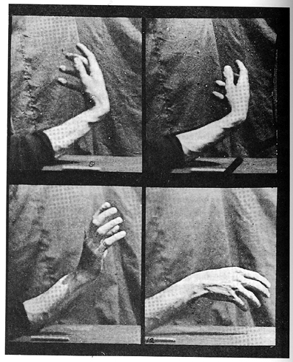
It is this experience of universality that the Bechers' project courts and posits as its systemic aim; it is this experience that serves as an alternative "visual consciousness of our age" different from the collective passions of political identification, partisan or otherwise, and different from the common individual interests of the consumer. The key to their system, to the particular form of social value they produce, lies in the fact that the objects they photograph are "anonymous." The Bechers give us modern industry in a manner that disavows its social, political, historical, and economic value and, in so doing, makes it available anew via an alternative category-aesthetic value or value "without any interest." This is a particular form of delight, philosophically distinct from other sorts of visual pleasure, and it conjures up a particular comportment, one that carries both the promise and the burden of social consequence. By creating the circumstances for such experience using aging industrial structures still resonant with the memory of all their great modern ambitions, the Bechers create a powerful sense of that disavowal of instrumental value, that purposiveness without purpose, as Kant named it, as loss, as the experience of no interest where interest was once housed, of no passion where passion once resided. In so doing, they give us a fully elaborated neo-Kantian judgment made melancholy, a fully developed archive structured around an absent ideal, and the great promise of Enlightenment is recovered in all of its original glory but now on the foundation of its own lost materialist soul. They incorporate "the past into the present and weld that present to a future," and they do so "at a stroke," as Merleau-Ponty put it, that is, in and through their bearing toward the world, through their standpoint midway between distance and proximity, through their gaze that looks neither up nor down but instead "straight-on” so that it does not "hide or exaggerate or depict anything in an untrue fashion." The final question-the one that only we can evaluate-concerns the ongoing vitality of this comportment now, the present truth of this myth of the past that it asks us to cathect as the basis of our future.
Eadweard Muybridge, Movement of the Hand; Beating Time, ca. 1884-1887, detail of frames 5, 6, 11, 12. George Eastman House, Rochester, N.Y.
Like being and anguish in the previous two chapters, the comportment of the Bechers' photographs is an embodied relationship to the world, a mode of being in, or, perhaps better, a mode of being with the world more than it is a mode of representing it. In this way, comportment itself becomes an ethical or critical position in the Bechers' work just as photographic being or the experience of "photography itself" did for The Family of Man and as photographic anguish or the experience of producing oneself as a solitary observer, "turning away after the click of the still-camera shutter," did for Frank. If the experience of The Family of Man was one of losing oneself, losing one's identity in the mix of what Frank characterized with both longing and contempt as "human mayonnaise," the experience of losing oneself in a depersonalized human generality, and if the experience that Frank himself cultivated was one of escaping from the burden of particularity by other means, that is by leaving town, by fleeing from identity, from typecast particularity into an anguished and desocialized distinction, into an introverted and friendless particularity, then the experience given by the Bechers was more subtle and more complex. Theirs was one of measured, calculated relations with the world around them, not of merging into it or fleeing from it, and so the affective and aesthetic charge of their work is always tempered, nuanced, qualified, and guarded. The tension that drives their work is a matter of simultaneously holding onto a commitment and indulging in a visual delight without allowing either the ethical impulse or the desire to get the upper hand. To put this another way, their work is driven by both its impulse to commonality and systematicity and its impulse to difference as the beholder moves from one picture to the next and the next and the next, delighting in the differences made available by the systemic arrangement along the way. It was this tension between the general and the particular, between commitment and delight, that has kept their camera "straight-on," as they have said, never fatiguing from its resolve or aim, staying true to its original comportment over the course of nearly fifty years.
The Bechers' comportment thus might be understood, finally, in three ways, only two of which we have considered so far. In the first instance already considered, it is a simple and consistent pattern of behavior in the sense of personal bearing or carriage or demeanor or deportment, in the sense of the angle of their camera, their distance from the subject they photograph and a host of other easily describable formal properties that register their embodied relation to the world. Such a formal analysis also opens itself up readily to the second conventional understanding of comportment: that is, as behavior or bearing or carriage in its proper sense, in the sense of good or appropriate or measured behavior or conduct, in the sense of the cultivated manners and staid conventions of bourgeois propriety. The thrill or delight or appeal of the Becher project was, after all, born out of conformity to a precise set of rules of conduct.
Bernd and Hilla Becher, page spread from Industriebauten, 1830-1930, 1967.
Proper comportment in this sense has always been a vehicle for social grace, a means for ease of movement in and through the world. Such ease is achieved by the measured self-containment and proper distance of good manners, by the propriety and predictability that becomes available only by closely attending to and assimilating a standardized set of rules of behavior, by rigorously maintaining the proper level of emotional engagement (between distance and proximity) from the world.
In this way, the Becher undertaking is very different from both The Americans and The Family of Man, neither of which allowed any measure of such distance or propriety and both of which gush within their own affective registers without reserve. Yet all three also shared a common cause, and this will speak to the third quality of comportment in the Bechers' work, the one we have not really addressed properly yet: in all three projects, photography was asked to represent its own place or bearing or identity in the world separate from other forms or expressions of sociality, to produce the experience of what Steichen called "photography itself." By comporting itself as photography qua photography-by opening out from one discrete view to the next and the next and the next without any one view displacing the other, that is, by its strong adherence to the serial form of the photographic essay-the Becher project, like The Family of Man and The Americans had each done differently before it, realized its own identity, its own version of photography as nation. All three projects did this consciously and expressly against the old forms of sociality realized in the rituals, customs, and procedures of citizenship or economic exchange or religious devotion, that is, against the threat of renewing the old nationalisms that had enabled the atrocities of World War II.
Like any identity or any nationalism, this was a form of abstraction. The Bechers' work bears the discomfort of living in a historical moment rife with contradiction and threat and comports that discomfort into an independent social form, an alternative mode of collective self-knowing, to that provided by the old political subjectivities given in other abstractions-the figures of the citizen, for example, or the consumer. Like the strong sequencing of photographs in The Family of Man and The Americans, they layout a "pattern of sequential experiences," as Kevin Lynch termed it, a way of moving through and interacting with the world with balance, poise, and equanimity. This investment in comportment was different from the investments of The Family of Man and The Americans, but all three projects shared the vision of photography as a medium of sociality, as a modeling agent for social form. In each instance, a new form of political subjectivity was given expression, a new dream of nation rendered, and it was done so only in the play between pictures.
The Bechers' and the other projects studied here have not generally been understood in terms of this dream of a new man even though such a dream has often been assumed to be housed in photographic form, if generally by other means than those studied here. This assumption was essential in myriad ways to the heady prewar days of the "New Vision," but it was also in evidence in the photographic theory for the period studied here. For example, this was an enduring, if somehow overwrought, theme developed at length by theorist and promoter Karl Pawek when he characterized the "new photographic style today" in 1959 as follows: "The old camera" of the prewar era "was not inside the space of the world it recorded, it was always positioned outside that world, somewhere in the infinite. The modern camera," the camera that emerged after the war, "has its place right among the subjects it photographs." What he had in mind was something much more like Steinert's project than that of the Bechers, or more like The Family of Man, but his analysis and its affinity with the Becher comportment is clear. "There is no variation in levels between the modern camera and our world," he insisted, putting a fine point on what he had in mind: the modern camera did not look up to monuments of modernity or down onto a rational social plan but instead positioned itself on the ground, in the flux of social experience as a participant observer.⁵⁰ Indeed, he would say later (while introducing his 1964 exhibition that raised the question that Steichen's project had presumed to answer, "World exhibition of photography on the theme What is man?"), both the problem addressed by photography and its opportunity alike arose precisely at the subject-object split or split between participant and observer: "In modern photography objective and subjective elements are mingled in such a way that the objective elements do not exclude the subjective, and the subjective elements do not place the objective in question.”51
This was photography's historically specific contribution, insisted Pawek, as it is "no easy problem to understand for our contemporary mentality which tends to turn either towards a one-sided theory of immanence or towards an equally one-sided empiricism." Photography's role was ultimately to be philosophical: "The radical split of reality into Descartes' res extensa and res cogitans, in the external world as in thought, is transcended anew on the terrain of modern photography. This is one of the points where photography is revealed to be the instrument of a new epoch. It is for these reasons too that photography is such an exciting affair, because its own 'conditions' are identical to those of a new epoch in intellectual history.”52 That new epoch described by Pawek, we can see in retrospect, was the epoch first and foremost of phenomenology as a leading intellectual-historical development-both in the sense of an origin point in time, the moment of Merleau-Ponty's pivot (rather than Husserl's withdrawal from time, the epoche), and in the sense of a historical period-and it is the epoch that has concerned us here.⁵³ Photography's conditions were "identical" with its contemporary intellectual history because it was enacting a relationship to the world that philosophy was attempting to describe.
The question to conclude with, thus, is the one we began with: the manner in which serial photography inscribes a point of view or a grammar constitutive of political subjectivity, the manner in which it creates the lived experience of social form. To put this another way, we can ask whether the movements of body and machine required to take a picture can become conventionalized and therefore shift from being not only the instrumental movement necessary to perform an operation to something that takes on the cultural expressiveness and conventionality of comportment. Photography as a technology poses a special case generally with two related properties in this regard. The first property is the function of the camera as "one of the organs of [man's] activity, which he annexes to his own bodily organs," as Marx described it for technology generally, or an "extension of man" in Marshall McLuhan's terminology or, more narrowly, a "camera-stylo" in Alexandre Astruc's auteurist manifesto. 54 Each of these accounts assumes that a new, embodied form of expressiveness is made possible with the mechanical extension of the human apparatus. The camera moves about the world pointing its lens this way and that in a kind of dance that is itself expressive of feeling and meaning and that expression is indexed or inscribed in photographs and film. The new vision enabled by photographic technology, thus, is a pas de deux between subject and object-or a pas de trois between photographer-subject, photographed object, and beholding audience-a dance that is defined only in the interaction of elements, not by the identity of anyone of the elements themselves.
The second property that must be considered in concert with the first is the status of the photograph as a unitary representative of a slice of space-time and its implicit and often explicit reference to all other photographs as equivalent units. This parceling of the world that Bergson and others rejected so vociferously, and that film did so much to cover over, carried its own distinct meaning and promise by allowing each individual image or frame to be perceived as a building block for a larger aggregate form.
This second property can be brought together with the first by considering that aggregation as itself a form of inscribed movement or gesture, as elements brought together within a larger dance or embodied performance of the camera. Such, of course, is very similar to frames brought together in a film or notes brought together in a musical composition, but we can also distinguish the different possibilities available to still photography conceived of and responded to as an aggregate form. In particular, we can point to the ways that the movement of the camera lens is performed, indexed, and returned to the beholder as a process of distancing from the self, of becoming other to oneself, that is, of becoming identified with what used to be called the "image world" or with photography as such. This is achieved first and foremost because serial photography holds onto the separation of frames and does not allow each to be displaced by the next in an overarching, overdetermining narrative (or just temporal) schema. The experience of these hard partitions is the moment of abstraction differentiated as photographic being and photographic anxiety above in Chapters 1 and 2, and here described as the boundary and point of tension between distance and proximity, between particularity and generality, in the Bechers' photographic comportment.
To return again to our foundational example, we can look to Muybridge's sequencing and the pas de trois that takes place between the movement of the photographer (or movement from camera to camera to camera in a camera bank), the movement of the photographed subject, and the movement of the beholder from one frame to the next and the next and the next. There are many things for the beholder to identify with a sequence like this-the movement of the hand beating time, for example, or the vantage point of both camera and eye at tabletop height. But we might focus most closely on the staccato rhythm of the movements between frames that is emphasized by the (human or machine) gesture of depressing the shutter release button over and over again, the sound of the shutter releasing and the consequent framing of individual images. Experiencing photography's decisive moment in this way is at once an experience of a discrete view and that same discrete view opening out to another and another and another in a series that is, at least potentially, without end.
This balance or tension between the particular and the general, between the systematic rigors of representation and the play of delight indulging in the differences of form is the governing characteristic of the photographic comportment considered here. Like a salute or a hand held to heart for a national anthem or hands held together in prayer, the comportment given by the camera's movement through space is a medium capable of expressing cultural coding, and with that, it is a medium for realizing a social bond. The bodily movement of the photographer, particularly when considered in relation to the movement of the photographed subject, on the one hand, and the photograph's beholder, on the other, is itself a form that has a history and means different things at different times.
"In modern times," wrote Hegel, the individual finds the abstract form of knowledge "ready-made." The scientific, rationalistic view of the world pervades modern understanding and in so being the experience of knowledge is codified as abstraction rather than revelation. Thus, "the task nowadays" for understanding in response to such ready-made and abstract forms of understanding, especially including identity, the "fixed thought" which "the ‘I’ itself is" (or, for our purposes, the self-understanding given by nation), "consists not so much in purging the individual of an immediate, sensuous mode of apprehension, and making him into a substance that is an object of thought and that thinks, but rather in just the opposite, in freeing determinate thoughts from their fixity.” 55 This was the great modernist aim that gave rise to the Becher comportment, just as it did for Frank's Americans and The Family of Man: to free determinate thoughts from their fixity, as Hegel termed it, or to free embodiment from self-consciousness and voluntarism. The goal for Hegel and the tradition that followed, however, was never to evade such determination altogether. The question was only how or where to find the right balance.
This is the point where all three projects studied here can be distinguished from their postmodern followers. None would say with Gerhard Richter, for example, that "I do not pursue any particular intentions, system or direction. I do not have a programme, a style, a course to follow ... I like things indeterminate and boundless, and I like persistent uncertainty."56 Instead each held firm to the promise of a system or program even as they experienced the world as boundless, as marked by persistent uncertainty. It is this peculiar rigor, this commitment to contradiction, to negation as a way of being in the world that never languished in its own criticality, that opened their undertaking to the distinct period promise first named by Merleau-Ponty "the pivot of the world."

1. For a useful account of the early development of their project, see Virginia Ann Heckert, "A Photographic Archive of Industrial Architecture: The Work of Bernd and Hilla Becher" (master's thesis, University of California, Santa Barbara, 1987), pp. 9-12.
2. Steinert, subjective fotografie, 1952, quoted in Manfred Schmalriede, "'Subjektive Fotografie' and Its Relation to the Twenties," in Subjektive fotografie: Images of the 50's (Essen: Museum Folkwang, 1984), p. 22.
3. Bernd Becher in conversation with Jean-Fran~ois Chevrier, James Lingwood, and Thomas Struth, in Another Objectivity: June 10-July 17,1988, Institute of Contemporary Arts, London (London: Institute of Contemporary Arts, 1988), p. 57. Bernd and Hilla Becher quoted in an exhibition statement for "Distance and Proximity (Germany), Bernd & Hilla Becher/Andreas Gursky/Candida Hofer/Axel Hutte/Simone Nieweg/Thomas Ruff/Jorg Sasse/Tomas Struth/Petra Wunderlich," <http://www . photosynkyria.gr/98/ex/ex 48_en.html>.
4. R. H. Fuchs, "Bernd and Hilla Becher," in Bernd und Hilla Becher (Eindhoven: Van Abbemuseum, 1981), n. p.
5. Donald Kuspit, review, Artforum 28 (April 1990): 170.
6. Alexander Rodchenko, "Against the Synthetic Portrait, for the Snapshot," in Christopher Phillips, ed. Photography in the Modern Era: European Documents and Critical Writings, 1913-1940 (New York: Metropolitan Museum of Art, 1989), p. 241.
7. Werner Graeff, "Es kommt der neue Ingenier," G 1 (1923): n.p.
8. Asked why their work exists in an art context rather than being made available in public archives for research purposes, they responded, "We did offer it to the government but they weren't interested. The work is about visual considerations, therefore it was only natural to show it in art galleries." See Angela Grauerholz and Anne Ramsden, "Photographing Industrial Architecture: An Interview with Hilla and Bernd Becher," Parachute 22 (1981): 18.
9. Bernd Becher in Another Objectivity, p. 61.
10. Liliane Touraine. "Bernd and Hilla Becher: The Function Doesn't Make the Form," Artefactum (April-May 1989): 9.

11. Bernd and Hilla Becher interviewed in Ulf Erdmann Ziegler, "The Bechers' Industrial Lexicon," Art in America Oune 2002): 98.
12. For example, Thomas Ruff, Thomas Struth, and Andreas Gursky, now sometimes collectively known as "Struffsky."
13. Michael Kimmelman, "Where Truth Dare Not Meet Your Gaze," New York Times, February 7, 2003.
14. Maurice Merleau-Ponty, The Phenomenology of Perception (New York: Humanities, 1962), p. 392.
15. Anson Rabinbach, "Response to Karen Brecht, 'In the Aftermath of Nazi Germany: Alexander Mitscherlich and Psychoanalysis-Legend and Legacy,' " American Imago 52 (1995): 322-323.
- Robert A Sobieszek, "Two Books of Ultra-Topography," Image 14 (1971): 12.
- Bernd and Hilla Becher, "Anonymous Sculpture," Art and Artists 5 (1970): 56.
18. Here is how they dealt with this issue in an interview: "Q: If you got a tip-off now about a certain industry in Korea, would you get in a plane and go photograph there?" "B: It's not a case of photographing everything in the world, but of proving that there is a form of architecture that consists in essence of apparatus, that has nothing to do with design, and nothing to do with architecture either." "H: The question can also be answered by restricting oneself-if one must restrict oneselfprimarily to the early industrialized countries, so that the whole historical span can be seen. Certain things are found in England, because that goes back the furthest, and in Belgium, France and Germany, up to a certain point even Italy." "B: And the USA." "H: Of course, there especially one finds things that are highly interestingfor example, the grain elevators. You can't do without them. But you don't necessarily have to have grain elevators in Korea." Bernd and Hilla Becher interviewed in Ziegler, "The Bechers' Industrial Lexicon," p. 140.
19. Ziegler, "Industrial Lexicon," p. 97.
20. Gregorio Magnani, "Ordering Procedures: Photography in Recent German Art," Arts Magazine 64 (March 1990): 81-82.
21. Sibyl Moholy-Nagy, Moholy-Nagy: Experiment in Totality, 2nd ed. (Cambridge, Mass.: MIT Press, 1969 [1950]), p. 2.
22. Louis Lozowick, "Status of the Artist in the U.S.S.R.," in Artists against War and Fascism: Papers of the First American Artists' Congress (New Brunswick, N.J.: Rutgers University Press, 1986), pp. 162-163.
23. Grauerholz, "Photographing Industrial Architecture," p. 18.
24. Michel Foucault, "What Is Enlightenment?" in Paul Rabinow, ed., The Foucault Reader (New York: Pantheon, 1984), p. 46.
25. Grauerholz "Photographing Industrial Architecture," p. 18.
26. Jiirgen Habermas, The Structural Transfonnation of the Public Sphere: An Inquiry into a Category of Bourgeois Society (Cambridge, Mass.: MIT Press, 1989), pp. 29, 33-34 (translation modified).
27. For an extended analysis using this character of the Bechers' work to argue for the redemption of "the name of art" in the wake of the anti-aestheticism and politicization of functionalism, see Thierry de Duve, Basic Fonns (New York: te Neues, 1999).
28. de Duve, Basic Fonns, pp. 15, 9.
29. Luc Sante, The New Republic, July 3, 1995, p. 29.
30. Andreas Huyssen, Twilight Memories: Marking Time in a Culture of Amnesia (New York: Routledge, 1995), p. 86.
31. Thierry de Duve, Kant after Duchamp (Cambridge, Mass.: MIT Press, 1996), p. 455.
32. Among other attempts to take up this enterprise, see Andrew Hemingway, Artists on the Left: American Artists and the Communist Movement, 1926-1956 (New Haven, Conn.: Yale University Press, 2002).
33. "Beauty in the Awful," Time, September 5, 1969, p. 69.
34. Glenn Zorpette, "Dynamic Duos: How Artist Teams Work," Art News (Summer 1994): 166.
35. Lynda Morris, Bernd and Hilla Becher (London: Arts Council of Great Britain, 1974), n.p.
36. Ziegler, "Industrial Lexicon," p. 143.
37. Raymond Aron, The Opium of the Intellectuals (New York: Doubleday, 1957), p. 46.
38. Karl Marx and Frederick Engels, The Communist Manifesto (London: Verso, 1998), p.38.
39. Karl Marx, Capital: A Critique of Political Economy (New York: Penquin, 1992), 1: 617.
40. Another Objectivity, pp. 60-61.
41. As with modern industry, we know best from Foucault that modern thought has realized its social power by being similarly nomadic. Earlier, premodern modes were essentially conservative, while modern "systems of dispersion" or discourses and the epistemological architecture they produce-archives-are inherently revolutionary by being based on "neither a configuration, nor a form" (that is, on neither structural nor mimetic representation of the object of study), but instead on a process or "a group of rules that are immanent in a practice." Foucault, Archaeology of Knowledge (New York: Pantheon Books, 1982), pp. 37, 46. Foucault's three introductory examples of this modern form of knowledge-as-system were sexuality, "penality," and art (p. 41). The Becher archive is just such a discourse in its "densest and most complex," self-instituting form. "History, Discourse, Discontinuity," Salmagundi no. 20 (Summer-Fall 1972), p. 241. That is, it is what Foucault called an "art with its own normativity," a procedure of discursive organization that develops its own autonomous standards of valorization separate from the objects it organizes and maintains its value as a group of rules immanent in a practice rather than as a configuration or form. Foucault, Archaeology of Knowledge (New York: Pantheon, 1982), p. 41.
- Hilla Becher in Another Objectivity, p. 57.
43. Daniel Bell, The End ofIdeology: On the Exhaustion of Political Ideas in the Fifties (Cambridge, Mass.: Harvard University Press, 1988 [1960]), p. 301.
44. Karl]aspers, The Question of German Guilt (New York: Dial Press, 1947), p. 16.
45. Albert Camus, "Defense of Intelligence," in Resistance Rebellion and Death (New York: Knopf, 1961), p. 61.
46. Otto Steinert, Subjektive Fotografie; ein Bildband modemer europaischer Fotografie (Bonn: Bruder Auer, 1952), p. 5.
47. Immanuel Kant, Critique of the Power ofludgment (New York: Cambridge, 2000), p.96.
- Ibid., p. 57.
- Ibid., pp. 122-123.
50. Karl Pawek, "Do We Have a New Photographic Style Today?" in Wolf Strache, ed., The German Photographic Annual: 1959 (New York: American Book Publishing, 1959), p. 19. See also <http://www.uturn.org/Essays/SUBPHOTOpdf.pdf>.
51. Karl Pawek, "The Language of Photography: The Methods of This Exhibition," in World Exhibition of Photography on the Theme What Is Man? 555 Photos by 264 Photographers from 36 Countries (Hamburg: Gruner & Jahr, 1964), n.p.
52. Ibid.
53. Pawek as a theorist is a good limit case for this question about political subjectivity that has served as the driving concern throughout this book.
54. Alexandre Astruc, "The Birth of a New Avant-Garde: La Camera-Stylo," in Peter Graham, ed., The New Wave (New York: Doubleday, 1968). Marshall McLuhan, Understanding Media: The Extensions of Man (New York: Continuum, 1962).

55. Hegel, Phenomenology of Spirit (New York: Oxford University Press, 1979), pp. 19-20.
56. Brandon Taylor, Avant-Garde and After: Rethinking Art Now (New York: Abrams, 1995), p. 40.

