Rosalind Krauss, “The Photographic Conditions of Surrealism” 1981

Surrealism is considered the last of the modern European art movements. However, unlike Realism, Impressionism, and other art movements, Surrealism was notably heterogeneous, with artists employing many media and styles. Unable to define Surrealism as a stylistic unity, art history defines it instead as a body of shared concepts and attitudes. Here Krauss will argue for a unifying concept. She also argues for the supremacy of Surrealist photography over Surrealist painting and sculpture. This essay is difficult reading but worth it. Read it slowly and several times over to be sure you can grasp the valuable insights it offers into the nature of photography and its unique contribution to the history of representation. I have drawn questions from the essay that I hope will help you study. For the quiz, be able to answer any of the following questions and know the meaning of the underlined words.
Study questions:
- According to the author, what are the Bauhaus and surrealist aesthetic positions on photography and how do they conflict?
- How does Krauss compare the character of the frame in Florence Henri’s self-portrait and Man Ray’s Monument to Sade?
- Why is style a “vexing question” for Surrealist artwork?
- What does Krauss propose unifies the entire Surrealist movement instead of style?
- Who was André Breton?
- Why did Breton consider vision more important than hearing?
- What is Surrealist “automatic writing”?
- Why has perception been considered superior to representation in the Western tradition (prior to dada and surrealism)?
- What was Breton’s attitude toward photography? Why did he illustrate his books with photographs?
- What is “convulsive beauty”? How is it related to Surrealist representation?
- How are the photographs in Breton’s books oneiric?
- How do they function as signs and emblems – semiologically?
- What 8 surrealistic photographic forms did the author identify?
- What is photomontage?
- How did German Dada photomontage artists like Hannah Hoch use juxtaposition or syntax in their works?
- How does spacing in a Dada photomontage destroy the “simultaneous present” characteristic of a photograph?
- Why did surrealist photographers seldom use photomontage?
- What is the surrealist strategy of doubling and what does it signify?
- How is doubling different from repetition?
- How does a photograph have a special relation to reality wholly different from painting and sculpture? What are “trace” and “index”?
- How is convulsive beauty achieved in a photograph?
- How did the surrealist found object or found verbal fragment achieve convulsive beauty?
- How and why is the frame (cropping, edge) in photography the “most inherently photographic” sign?
- According to Krauss, what idea about nature unites all surrealist production?
- According to Moholy-Nagy, what was the New Vision?
- How does the camera function as a prosthetic?
- Rewrite the author’s last paragraph into a thesis statement of one sentence.

The Photographic Conditions of Surrealism Rosalind E. Krauss
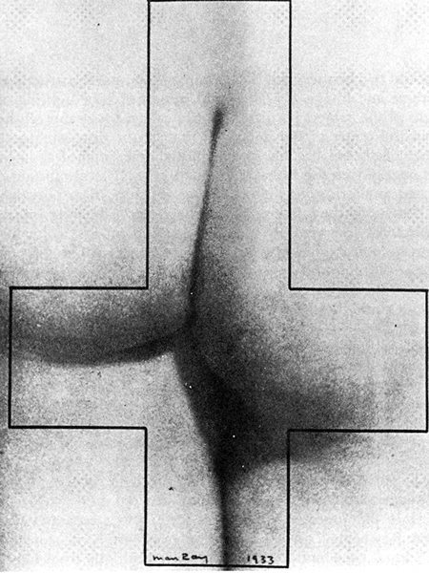
I open my subject with a comparison. On the one hand, there is Man Ray’s Monument to de Sade, a photograph made in 1933 for the magazine Le Surréalisme au service de la révolution. On the other, there is a self-portrait by Florence Henri, given wide exposure by its appearance in the 1929 Foto-Auge, a publication that catalogued the European avant-garde’s position with regard to photography. This comparison involves, then, a slight adulteration of my subject-surrealism-by introducing an image deeply associated with the Bauhaus. For Florence Henri had been a student of Moholy-Nagy, though at the time of Foto-Auge, she had returned to Paris. Of course the purity of Foto-Auge’s statement had already been adulterated by the presence within its covers of certain surrealist associates, like Man Ray, Maurice Tabard, and E. T. L. Mesens. But by and large Foto-Auge is dominated by German material and can be conceived of as organizing a Bauhaus view of photography, a view that we now think of as structured by the Vorkors’s obsession with form.
Man Ray. Monument to de Sade. 1933.
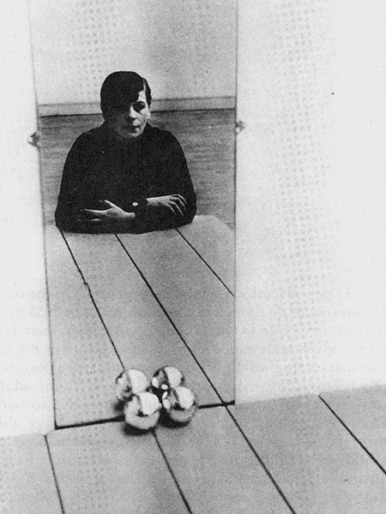
Indeed, one way of eavesdropping on a Bauhaus-derived experience of this photograph is to read its analysis from the introduction to a recent reprint portfolio of Henri’s work. Remarking that she is known almost exclusively through this self-portrait, the writer continues,
Florence Henri. Self Portrait. 1928.
Its concentration and structure are so perfect that its quintessence is at once apparent. The forceful impression it produces derives principally from the subject’s intense gaze at her own reflection…. Her gaze passes dispassionately through the mirror and is returned-parallel to the lines made by the joints in the table.... The balls-normally symbols of movement-here strengthen the impression of stillness and undisturbed contemplation .They have been assigned a position at the vertex of the picture their exact position at the same time lends stability to the structure and provides the dominant element of the human reflection with the necessary contrast.
In light of the writer's determination to straightjacket this image within the limits of an abstracting, mechanically formalist discourse, the strategy behind a juxtaposition of Man Ray's photograph with Florence Henri's becomes apparent. Because the comparison forces attention away from the contents of the Henri-whether those contents are conceived of as psychological (the "intense gaze" and its dispassionate stare) or as formal (the establishment of stillness through structural stability, etc.). And being turned from the photograph's contents, one's attention is relocated on the container-on what could be called the character of the frame as sign or emblem. For the Henri and the Man Ray share the same recourse to the definition of a photographic subject through the act of framing it, even as they share the same enframing shape.
In both cases one is treated to the capture of the photographic subject by the frame, and in both, this capture has a sexual import. In the Man Ray the act of rotation, which transmutes the sign of the cross into the figure of the phallus, juxtaposes an emblem of the Sadean act of sacrilege with an image of the object of its sexual pleasure. And two further aspects of this image bespeak the structural reciprocity between frame and image, container and contained. The lighting of the buttocks and thighs of the subject is such that physical density drains off the body as it moves from the center of the image, so that by the time one's gaze approaches the margins, flesh has become so generalized and flattened as to be assimilated to printed page. Given this threat of dissipation of physical substance, the frame is experienced as shoring up the collapsing structure of corporeality and guaranteeing its density by the rather conceptual gesture of drawing limits. This sense of the structural intervention of frame inside contents is further deepened by the morphological consonance-what we could call the visual rhyming-between shape of frame and shape of figure: for the linear intersections set up by the clefts and folds in the photographed anatomy mimic the master shape of the frame. Never could the object of violation have been depicted as more willing.
In Florence Henri's self-portrait there is a similar play between flatness and fullness, as there is a parallel sense of the phallic frame as both maker and captor of the sitter's image. Within the spell of this comparison, the chromed balls function to project the experience of phallicism into the center of the image, setting up (as in the Man Ray) a system of reiteration and echo; and this seems far more imperatively their role than that of promoting the formal values of stillness and balance.
It can, of course, be objected that this comparison is tendentious. That it is a false analogy. That it suggests some kind of relationship between these two artists that cannot be there since they operate from across the rift that separates two aesthetic positions: Man Ray being a surrealist and Florence Henri being committed to an ideology of formal rigor and abstraction received initially from Leger and then from the Bauhaus. It can be argued that if there is a kind of phallicism in Henri's portrait, it is there inadvertently; she could not really have intended it.
As art history becomes increasingly positivist, it holds more and more to the view that "intention is some internal, prior mental event causally connected with outward effects, which remain the evidence for its having occurred," and thus, to say that works of art are intentional objects is to say that each bit of them is separately intended. But, sharing neither this positivism nor this view of consciousness, I have no scruples in using the comparative method to wrest this image from the protective hold of Miss Henri's "intention" and to open it, by analogy, to a whole range of production that was taking place at the same time and in the same locale.
Yet with these two images I do not mean to introduce an exercise in comparative iconography. As I said, the area of interest is far less in the contents of these photographs than it is in their frame. Which is to say that if there is any question of phallicism here, it is to be found within the whole photographic
enterprise of framing and thereby capturing a subject. Its conditions can be generalized way beyond the specifics of sexual imagery to a structural logic that subsumes this particular image and accounts for a wide number of decisions made by photographers of this time, both with regard to subject and to form. The name that an entirely different field of critical theory gives to this structural logic is "the economy of the supplement." And what I intend to reveal in the relatedness of photographic practice in France and Germany in the 1920s and '30s is a shared conception of photography as defined by the supplement.
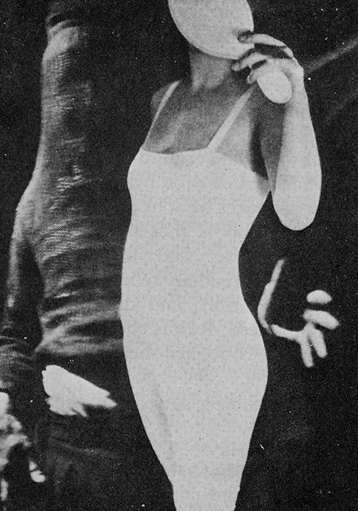
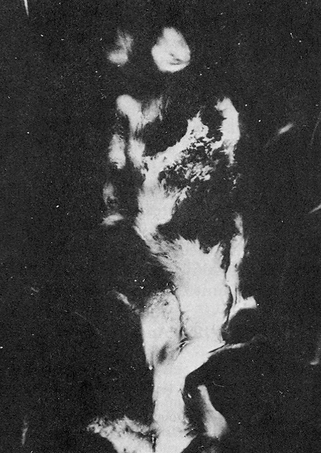
But I am getting ahead of my argument. My reason at the outset for introducing my subject by means of comparison is that I wish to invoke the comparative method as such, the comparative method as it was introduced into art-historical practice in order to focus on a wholly different object than that of intention. The comparative method was fashioned to net the illusive historical beast called style, a prey which, because it was transpersonal, was understood as being quite beyond the claims of either individual authorship or intention. This is why Wolfllin believed the lair of style to be the decorative arts rather than the domain of masterpieces, why he looked for it- Morelli-fashion -in those areas that would be the product of inattention, a lack of specific "design" -going so far as to claim that the "whole development of world views" was to be found in the history of the relationship of gables.
Maurice Tabard.Hand and Woman. 1929.
Raoul Ubac. La Nébulese.1939.
Now it is precisely style that continues to be a vexing problem for anyone dealing with surrealist art. Commenting on the formal heterogeneity of a movement that could encompass the abstract liquifaction of Miró, on the one hand, and the dry realism of Magritte or Dali on the other, William Rubin addresses this problem of style, declaring that "we cannot formulate a definition of Surrealist painting comparable in clarity with the meanings of Impressionism and Cubism." Yet as a scholar who has to think his way into and around the mass of material that is said to be surrealist, Rubin feels in need of what he calls an "intrinsic definition of Surrealist painting." And so he produces what he claims to be "the first such definition ever proposed." His definition is that there are two poles of surrealist endeavor-the automatist/abstract and the academic/illusionist-the two poles corresponding to "the Freudian twin props of Surrealist theory, namely automatism [or free association] and dreams." Although these two pictorial modes look very unlike indeed, Rubin continues, they can be united around the concept of the irrationally conceived metaphoric image.
Now, in 1925 André Breton began to examine the subject surrealism and painting, and from the outset he characterized his material in terms of the very twin poles-automatism and dream-and the subject matter of Rubin's later definition. If forty years afterward Rubin was so unhappy with Breton's attempt at a synthetic statement that he had to claim to have produced the first such definition ever, it is undoubtedly because Rubin, like everyone else, has been unconvinced that Breton's was a definition in the first place. If one wishes to produce a synthesis between A and B, it is not enough simply to say, "A plus B." A synthesis is rather different from a list. And it has long been apparent that a catalogue of subject matter held in common is neither necessary nor sufficient to produce the kind of coherence one is referring to by the notion of style.
If Rubin's nondefinition is a mirror-image of Breton's earlier one, this relationship is important, because it locates Breton's own theory as a source for the problem confronting all subsequent discussions. But Breton, as the most central spokesman for surrealism, is an obstacle one must surmount; one cannot avoid him, if the issue is to deal with the movement comprehensively-as one must if a synthetic notion like style is involved.
The same failure to think the formal heterogeneity of Miró and Magritte into something like stylistic unity plagues every effort of Breton as theoretician of the movement. Attempting to define surrealism, Breton produces instead a series of contradictions which, like the one between the linearity of Magritte and the colorism of Miró, strike one as being irreducible.
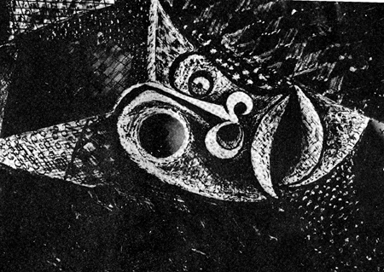
Thus, Breton introduces "Surrealism and Painting" with a declaration of the absolute value of vision among the sensory modes. Rejecting the late nineteenth-century dictum that all art should aspire to the condition of music, an idea very much alive among twentieth-century abstract artists, Breton insists that "visual images attain what music never can," and he bids this great medium farewell with the words, "so may night continue to descend upon the orchestra." His hymn of praise to vision had begun, "The eye exists in its savage state. The marvels of the earth ... have as their sole witness the wild eye that traces all its colors back to the rainbow." And by this statement he is contrasting the immediacy
Brassaï. Temptation of St.Anthony. 1935.
of vision-its perceptual automatism, as it were-to the premeditated, reflective gait of thought. The savageness of vision is good, pure, uncontaminated by ratiocination; the calculations of reason (which Breton never fails to call "bourgeois reason") are controlling, degenerate, bad.
Besides being untainted by reason, vision's primacy results from the way its objects are present to it, through an immediacy and transparency that compels belief. Indeed, Breton often presents surrealism-as-a-whole as defined by visuality. In the First Manifesto he locates the very invention of psychic automatism within the experience of hypnogogic images-that is, of half-waking, half-dreaming, visual experience.
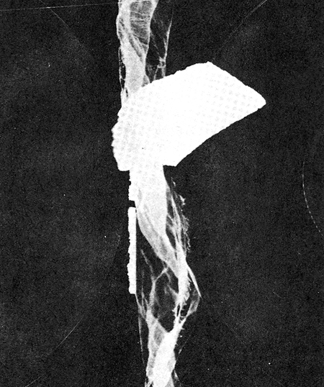
But as we know, the privileged place of vision in surrealism is immediately challenged by a medium given a greater privilege: namely, writing. Psychic automatism is itself a written form, a "scribbling on paper," a textual production. And when it is transferred to the domain of visual practice, as in the work of André Masson, automatism is no less understood as a kind of writing. Breton describes Masson's automatic drawings as being essentially cursive, scriptorial, the result of "this hand, enamoured of its own movement and of that alone." "Indeed," Breton writes, "the essential discovery of surrealism is that, without preconceived intention, the pen that flows in order to write and the pencil that runs in order to draw spin an infinitely precious substance." So, in the very essay that had begun by extolling the visual and insisting on the impossibility of imagining a "picture as being other than a window," Breton proceeds definitively to choose writing over vision, expressing his distaste for the "other road available to Surrealism," namely, "the stabilizing of dream images in the kind of still-life deception known as trompe l'oeil (and the very word 'deception' betrays the weakness of the process)."
Man Ray. Untitled (rayograph). 1923.
Now this distinction between writing and vision is one of the many antinomies that Breton speaks of wanting surrealism to dissolve in the higher synthesis of a surreality which will, in this case, "resolve the dualism of perception and representation." It is an old antinomy within Western culture, and one which does not simply hold these two things to be opposite forms of experience, but places one higher than the other. Perception is better, truer, because it is immediate to experience, while representation must always remain suspect because it is never anything but a copy, a re-creation in another form, a set of signs for experience. Perception gives directly onto the real, while representation is set at an unbridgeable distance from it, making reality present only in the form of substitutes, that is, through the proxies of signs. Because of its distance from the real, representation can thus be suspected of fraud.
In preferring the products of a cursive automatism to those of visual, imagistic depiction, Breton appears to be reversing the classical preference of vision to writing, of immediacy to dissociation. For in Breton's definition, it is the pictorial image that is suspect, a "deception," while the cursive one is true.
Yet in some ways this apparent reversal does not really overthrow the traditional Platonic dislike of representation, because the visual imagery Breton suspects is a picture and thus the representation of a dream rather than the dream itself. Breton, therefore, continues Western culture's fear of representation as an invitation to deceit. And the truth of the cursive flow of automatist writing or drawing is less a representation of something than it is a manifestation or recording: like the lines traced on paper by the seismograph or the cardiograph. What this cursive web makes present by making visible is a direct experience of what Breton calls "rhythmic unity," which he goes on to characterize as "the absence of contradiction, the relaxation of emotional tensions due to repression, a lack of the sense of time, and the replacement of external reality by a psychic reality obeying the pleasure principle alone." Thus the unity produced by the web of automatic drawing is akin to what Freud called the oceanic feeling-the infantile, libidinal domain of pleasure not yet constrained by civilization and its discontents. "Automatism," Breton declares, "leads us in a straight line to this region," and the region he has in mind is the unconscious. With this directness, automatism makes the unconscious, the oceanic feeling, present. Automatism may be writing, but it is not, like the rest of the written signs of Western culture, representation. It is a kind of presence, the direct presence of the artist's inner self. This sense of automatism as a manifestation of the innermost self, and thus not representation at all, is also contained within Breton's description of automatic writing as "spoken thought." Thought is not a representation but is that which is utterly transparent to the mind, immediate to experience, untainted by the distance and exteriority of signs.
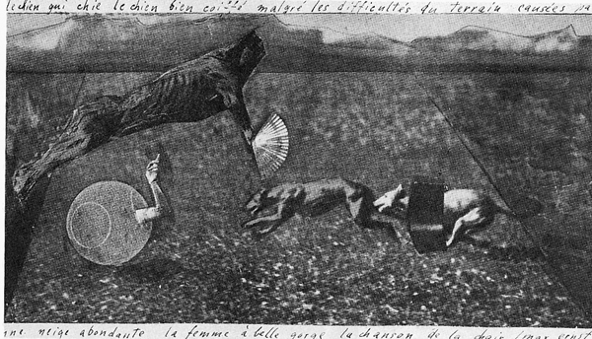
But this commitment to automatism and writing as a special modality of presence, and a consequent dislike of representation as a cheat, is not consistent in Breton, who contradicts himself on this matter as he contradicts himself on almost every point in surrealist theory. In many places we find Breton declaring, "It makes no difference whether there remains a perceptible difference between beings which are evoked and beings which are present, since I dismiss such differences out of hand at every moment of my life." And as we will see, the welcome Breton accords to representation, to signs, is very great indeed, for representation is the very core of his definition of Convulsive Beauty, and Convulsive Beauty is another term for the Marvelous, which is the great talismanic concept at the heart of surrealism itself.
Max Ernst. 1922.
The contradictions about the priorities of vision and representation, presence and sign, are typical of the confusions within surrealist theory. And these contradictions are focused all the more clearly if one reflects on Breton's position on photography. Given his aversion to "the real forms of real objects," and his insistence on another order of experience, we would expect Breton to despise photography. As the quintessentially realist medium, photography would have to be rejected by the poet who insisted that "for a total revision of real values, the plastic work of art will either refer to a purely internal model or will cease to exist. "
But in fact Breton has a curious tolerance for photography. Of the first two artists that he claimed for surrealism proper-Max Ernst and Man Ray-one of them was a photographer. And if we imagine that he accepted Man Ray on the basis of the presumed anti-realism of the rayographs, this is in fact not so. Breton protested against characterizing the rayographs as abstract or making any distinction between Man Ray's cameraless photography and that produced with a normal lens. But even more than his support for specific photographers, Breton's placement of photography at the very heart of surrealist publication is startling. In 1925 he had asked, "…and when will all the books that are worth anything stop being illustrated with drawings and appear only with photographs?"
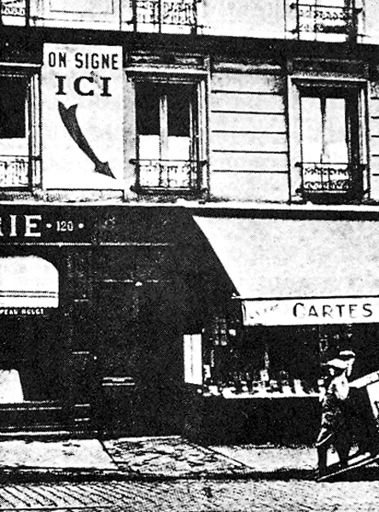
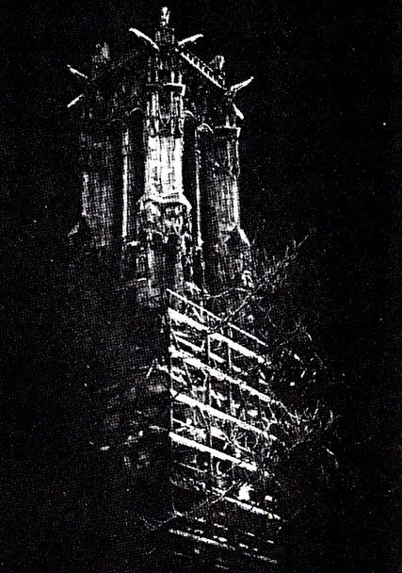
This was not an idle question, for Breton's next three major works were indeed "illustrated" with photographs. Nadja (1928) bore images almost exclusively by Boiffard; Les Vases communicants (1932) has a few film stills and photographic documents; and the illustrative material for L'Amour fou (1937) was divided for the most part between Man Ray and Brassaï. Within the high oneiric atmosphere of these books, the presence of the photographs strikes one as extremely eccentric-an appendage to the text that is as mysterious in its motivation as the images themselves are banal. In writing about surrealism Walter Benjamin focuses on the curious presence of these "illustrations."
J.A. Boiffard. Illustration for André Breton, Nadja,1928

Brassaï. Illustration for André Breton, L’Amour fou,1937.
In such passages photography intervenes in a very strange way. It makes the streets, gates, squares of the city into illustrations of a trashy novel, draws off the banal obviousness of this ancient architecture to inject it with the most pristine intensity towards the events described, to which, as in old chambermaids' books, word-for-word quotations with page numbers refer.
But photography's presumed eccentricity to surrealist thought and practice must itself be reconsidered. For it was not injected into the very heart of the surrealist text only in the work of Breton; it was the major visual resource of the surrealist periodicals. The founding publication of the movement, La Révolution surrealiste, bore no visual relation to the vanguardist typographic extravaganzas of the Dada broadsheets. Rather, at the instigation of Pierre Naville, it was modeled specifically on the scientific magazine La Nature. Conceived almost exclusively as the publication of documents, the first issues of La Revolution surréaliste carried two types of verbal testimony: specimens of automatic writing and records of dreams. Sober columns of test carrying this data are juxtaposed with visual material, most of it Man Ray's photographs, all of it having the documentary impact of illustrative evidence.
Naville's hostility to the traditional fine arts was well known, and the third issue of the journal carried his declaration: "I have no tastes except distaste. Masters, master-crooks, smear your canvases. Everyone knows there is no surrealist painting. Neither the marks of a pencil abandoned to the accident of gesture, nor the image retracing the forms of the dream.... “But spectacles, he insists, are acceptable.” Memory and the pleasure of the eyes," Naville writes, "that is the whole aesthetic." The list of things conducive to this visual pleasure includes streets, kiosks, automobiles, cinema, and photographs.
One of the effects of the extraordinary 1978 Hayward Gallery exhibition, Dada and Surrealism Reviewed, was to begin to force attention away from the pictorial and sculptural production that surrounds surrealism and onto the periodicals, demonstrating the way that journals formed the armature of these movements. Witnessing the parade of surrealist magazines-La Révolution surréaliste, Le Surréalisme au service de la révolution, Documents, Minotaure, Marie, The International Surrealist Bulletin, VVV, Le Surréalisme, même, and many others-one becomes convinced that they more than anything else are the true objects produced by surrealism. And with this conviction comes an inescapable association to the most important statement yet made about the vocation of photography: Benjamin's "The Work of Art in the Age of Mechanical Reproduction," and from there to one of the phenomena that Benjamin speaks of in the course of sketching the new terrain of art-after-photography, namely, the illustrated magazine, which is to say, photograph plus text.
At the very moment when Benjamin was making his analysis, the surrealists were quite independently putting it into practice. And that they were doing so is something that traditional art history, with its eye focused on works of fine art, has tended to miss.
If we add these two things together: namely the primacy the surrealists themselves gave to the illustrative photograph, and the failure of stylistic concepts derived from the formal, pictorial code-distinctions like linear/painterly or representational/abstract-to forge any kind of unity from the apparent diversity of surrealist production, the failure to arrive, that is, at what Rubin called an intrinsic definition of surrealism, we might be led to the possibility that it is within the photographic rather than the pictorial code that such a definition is to be found-that is, that issues of surrealist heterogeneity will be resolved around the semiological functions of photography rather than the formal properties operating the traditional art-historical classifications of style. What is at stake, then, is the relocation of photography from its eccentric position relative to surrealism to one that is absolutely central-definitive, one might say.
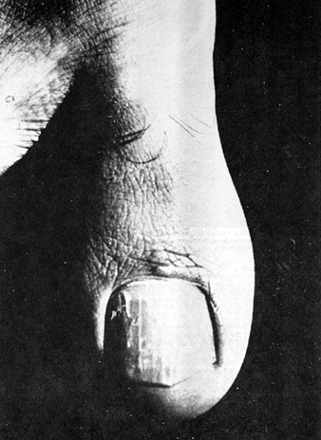
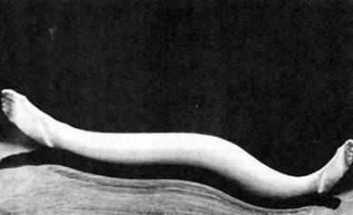
Now, it may be objected that in turning to photography for a principle of unification, one is simply replacing one set of problems with another. For the same visual heterogeneity reigns within the domain of surrealist photography as within its painting and sculpture. Quickly examining the range of surrealist photographic forms, we can think of I) the absolutely banal images Boiffard created for Breton's Nadja; 2) the less banal but still straight photographs made by Boiffard for Documents in 1929, such as the ones made for Georges Bataille's essay on the big toe; 3) still "straight," but raising certain questions about the status of photographic evidence, the documentations of sculptural objects that have no existence apart from the photograph, which were immediately dismantled after being recorded (examples are by Hans Bellmer and Man Ray); moving, then, into the great range of processes used to manipulate the image; 4) the frequent use of negative printing; 5) the recourse to multiple exposure or sandwich printing to produce montage effects; 6) various kinds of manipulations with mirrors, as in the Kertész Distortion series; 7) the two processes made famous by Man Ray, namely solarization and the cameraless image of the rayograph-the latter having a rather obvious appeal to surrealist sensibilities because of the cursive, graphic quality of the images against their flattened, abstracted ground and because of the psychological status these ghosts of objects seem to have attained-Ribemont-Dessaignes calling them "these objects of dreams," Man Ray himself locating them more within the domain of memory by their effect of "recalling the event more or less clearly, like the undisturbed ashes of an object consumed by flames"; 8) the technique Raoul Ubac called brúlage, in which the emulsion is burned (which literalizes Man Ray's evocative description of the rayograph), the process having arisen from an attempt to assimilate photography fully into the domain of automatic practice, just as the series of graphic manipulations that Brassaï made in the mid-1930s attempted to open photographic information to a direct relationship with a kind of automatist, drawn image.
J.-A. Boiffard. Illustration for Georges Bataille, Le Gros Orteil”, Documents, no.6, 1929.
André Kertész. Distortion.1933.
Long as this list is, there is one form still missing from it, namely, photomontage. This form, pioneered by Dada, was rarely employed by surrealist photographers, though it was attractive to certain of the surrealist poets, who made photomontages themselves. One important example is André Breton's 1938 self- portrait entitled Automatic Writing.
Breton's self-portrait, fabricated from various photographic elements, is not only an example of photomontage-a process distinct from combination printing insofar as the term refers, for the most part, to the cutting up and reassembling of already printed material-but it is also an instance of construction en abyme. It is the microscope as representative of a lensed instrument that places within the field of the representation another representation that reduplicates an aspect of the first, namely the photographic process by which the parts were originally made. And if Breton does this, it is to set up the intellectual rhyme between psychic automatism as a process of mechanical recording and the automatism associated with the camera-"that blind instrument," as Breton says. His own association of these two mechanical means of registration occurs as early as 1920, when he declared that "automatic writing, which appeared at the end of the 19th century, is a true photography of thought."
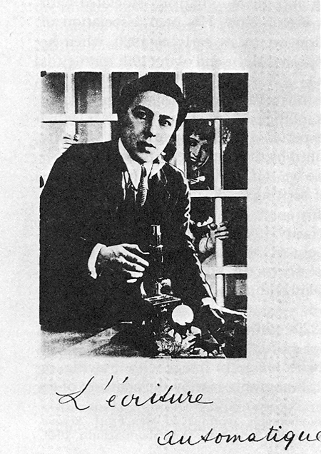
But if an icon of the lens's automatism is placed inside this image entitled Écriture-Automatique, what, we might ask, of the concept of writing itself? Is that not entirely foreign to the purely visual experience of photography-a visuality itself symbolized as heightened and intensified by the presence of the microscope? Faced with this image and its caption, are we not confronted with yet another instance of the constant juxtaposition of writing and vision, a juxtaposition that leads nowhere but to theoretical confusion? It is my intention to show that this time it leads not to confusion but to clarity, to exactly the kind of dialectical synthesis of opposites that Breton had set out as the program for surrealism. For what I wish to claim is that the notion of écriture is pictured inside this work through the very fabric of the image's making, that is, through the medium of montage.
André Breton. L’Écriture -automatique. 1938.
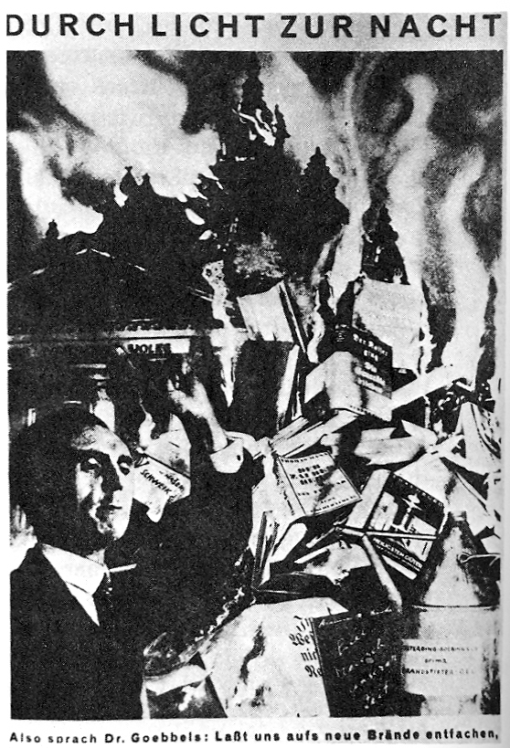
Throughout the avant-garde in the 1920s, photomontage was understood as a means of infiltrating the mere picture of reality with its meaning. This was achieved through juxtaposition: of image with image, or image with drawing, or image with text. John Heartfield said, "A photograph can, by the addition of an unimportant spot of color, become a photomontage, a work of art of a special kind." And what kind this was to be is explained by Tretyakov when he wrote, "If the photograph, under the influence of the text (or caption), expresses not simply the fact which it shows, but also the social tendency expressed by the fact, then this is already a photomontage." Aragon seconded this insistence on a sense of reality bearing its own interpretation when he described Heartfield's work, "As he was playing with the fire of appearance, reality took fire around him .... The scraps of photographs that he formerly manoeuvred for the pleasure of stupefaction, under his fingers began to signify."
John Heartfield. Durch Licht zur Nacht. May 10, 1933.
This insistence on signification as a political act, on a revision of photography away from the surfaces of the real, was preached by Bertolt Brecht, who said, "A photograph of the Krupp works or GEC yields almost nothing about these institutions .... Therefore something has actively to be constructed, something artificial, something set-up." This was a position that was uncongenial to the proto-surrealist Max Ernst, who dismissed the Berlin dadaists with the words, "C'est vraiment allemand. Les intellectuels allemands ne peuvent pas faire ni caca ni pipi sans des ideologies." But photomontage was nonetheless the medium of the Fatagagas and remained an abiding principal in Ernst's later work; and when Aragon wrote about the effect of the separate elements in Ernst's montages he compared them to "words." By this he refers not only to the transparency of each signifying element (by contrast with the opacity of the pieces of cubist collages), but also to the experience of each element as a separate unit which, like a word, is conditioned by its placement within the syntagmatic chain of the sentence, is controlled by the condition of syntax.
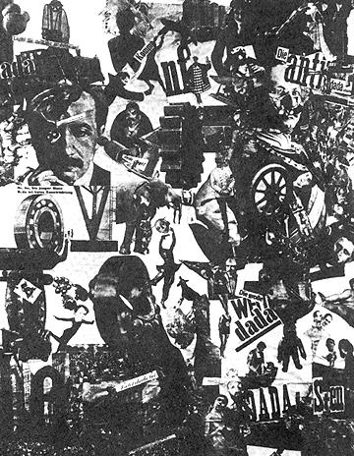
Whether we think of syntax as temporal-as the pure succession of one word after another within the unreeling of the spoken sentence; or whether we think of it as spatial-as the serial progression of separate units on the printed page; syntax in either dimension reduces to the basic exteriority of one unit to another. Traditional linguistics contemplates this pure exteriority as that fissure or gap or blank that exists between signs, separating them one from the other, just as it also thinks of the units of the sign itself as riven into two parts-one irremediably outside or exterior to the other. The two parts are signified and signifier-the first the meaning of the sign, a meaning transparent to thought held within consciousness; the second, the mark or sound that is the sign's material vehicle. "The order of the signified," Derrida writes, stating the position of traditional linguistics, "is never contemporary, is at best the subtly discrepant inverse or parallel-discrepant by the time of a breath-from the order of the signifier." For Derrida, of course, spacing is not an exteriority that signals the outside boundaries of meaning: one signified's end before another's onset. Rather, spacing is radicalized as the precondition for meaning as such, and the outsideness of spacing is revealed as already constituting the condition of the "inside." This movement, in which spacing "invaginates" presence, will be shown to illuminate the distinction between surrealist photography and its dada predecessor.
Hannah Hoch, Cut With The Kitchen Knife, 1919
In dada montage the experience of blanks or spacing is very strong, for between the silhouettes of the photographed forms the white page announces itself as the medium that both combines and separates them. The white page is not the opaque surface of cubist collage, asserting the formal and material unity of the visual support; the white page is rather the fluid matrix within which each representation of reality is secured in isolation, held within a condition of exteriority, of syntax, of spacing.
The photographic image, thus "spaced," is deprived of one of the most powerful of photography's many illusions. It is robbed of a sense of presence. Photography's vaunted capture of a moment in time is the seizure and freezing of presence. It is the image of simultaneity, of the way that everything within a given space at a given moment is present to everything else; it is a declaration of the seamless integrity of the real. The photograph carries on one continuous surface the trace or imprint of all that vision captures in one glance. The photographic image is not only a trophy of this reality, but a document of its unity as that-which-was-present-at-one-time. But spacing destroys simultaneous presence: for it shows things sequentially, either one after another or external to one another occupying separate cells. It is spacing that makes it clear-as it was to Heartfield, Tretyakov, Brecht, Aragon-that we are not looking at reality, but at the world infested by interpretation or signification, which is to say, reality distended by the gaps or blanks which are the formal preconditions of the sign.
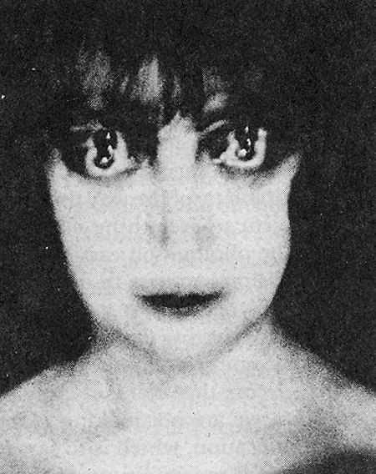
Now, as I said, the surrealist photographers rarely used photomontage. Their interest was in the seamless unity of the print, with no intrusions of the white page. By preserving the body of the print intact, they could make it read photographically, that is to say, in direct contact with reality. But without exception the surrealist photographers infiltrated the body of this print, this single page, with spacing. Sometimes they mimicked photomontage by means of combination printing. But that is the least interesting of their strategies, because it does not create, forcefully enough, an experience of the real itself as sign, the real fractured by spacing. The cloisonné of the solarized print is to a greater extent testimony to this kind of cleavage in reality. As are the momentarily unintelligible gaps created by negative printing. But more important than anything else is the strategy of doubling. For it is doubling that produces the formal rhythm of spacing-the two-step that banishes the unitary condition of the moment, that creates within the moment an experience of fission. For it is doubling that elicits the notion that to an original has been added its copy. The double is the simulacrum, the second, the representative of the original. It comes after the first, and in this following, it can only exist as figure, or image. But in being seen in conjunction with the original, the double destroys the pure singularity of the first. Through duplication, it opens the original to the effect of difference, of deferral, of one-thing-after-another, or within another: of multiples burgeoning within the same.
Man Ray. La Marquise Casati. 1922.
This sense of deferral, of opening reality to the "interval of a breath," we have been calling (following Derrida) spacing. But doubling does something else besides the transmutation of presence into succession. It marks the first in the chain as a signifying element: it transmutes raw matter into the conventionalized form of the signifier. Levi-Strauss describes the importance of pure phonemic doubling in the onset of linguistic experience in infancy-the child's dawning knowledge of signs.
Even at the babbling stage the phoneme group /pa/ can be heard. But the difference between /pa/ and /papa/ does not reside simply in reduplication: /pa/ is a noise, /papa/ is a word. The reduplication indicates intent on the part of the speaker; it endows the second syllable with a function different from that which would have been performed by the first separately, or in the form of a potentially limitless series of identical sounds /papapapa/ produced by mere babbling. Therefore the second /pa/ is not a repetition of the first, nor has it the same signification. It is a sign that, like itself, the first /pa/ too was a sign, and that as a pair they fall into the category of signifiers, not of things signified. Repetition is thus the indicator that the "wild sounds" of babbling have been made deliberate, intentional; and that what they intend is meaning. Doubling is in this sense the "signifier of signification."
From the perspective of formed language, the phonemes /pa/ or /ma/ seem less like wild sounds and more like verbal elements in potentia. But if we think of the infant's production of gutturals and glottal stops, and other sounds that do not form a part of spoken English, we have a stronger sense of this babbling as the raw material of sonic reality. Thus /pa/ moving to /papa/ seems less disconnected from the case of photographic doubling, where the material of the image is the world in front of the camera.
As I said above, surrealist photography exploits the special connection to reality with which all photography is endowed. For photography is an imprint or transfer off the real; it is a photochemically processed trace causally connected to that thing in the world to which it refers in a manner parallel to that of fingerprints or footprints or the rings of water that cold glasses leave on tables. The photograph is thus generically distinct from painting or sculpture or drawing. On the family tree of images it is closer to palm prints, death masks, the Shroud of Turin, or the tracks of gulls on beaches. For technically and semiologically speaking, drawings and paintings are icons, while photographs are indexes.
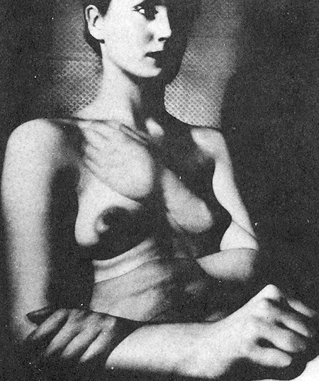
Given this special status with regard to the real, being, that is, a kind of deposit of the real itself, the manipulations wrought by the surrealist photographers-the spacings and doublings-are intended to register the spacings and doublings of that very reality of which this photograph is merely the faithful trace. In this way the photographic medium is exploited to produce a paradox: the paradox of reality constituted as sign-or presence transformed into absence, into representation, into spacing, into writing.
Bill Brandt. Perspectives of Nudes.
Now this is the move that lies at the very heart of surrealist thinking, for it is precisely this experience of reality as representation that constitutes the notion of the Marvelous or of Convulsive Beauty-the key concepts of surrealism. Towards the beginning of L'Amour tou there is a section that Breton had published on its own under the title "Beauty Will Be Convulsive ....” In this manifesto Breton characterizes Convulsive Beauty in terms of three basic types of example. The first falls under the general case of mimicry-or those instances in nature when one thing imitates another-the most familiar, perhaps, being those markings on the wings of moths that imitate eyes. Breton is enormously attracted to mimicry, as were all the surrealists, Documents having, for example, published Blossfeldt's photographs of plant life imitating the volutes and flutings of classical architecture. In "Beauty Will Be Convulsive" the instances of mimicry Breton uses are the coral imitations of plants on the Great Barrier Reef and 'The Imperial Mantle," from a grotto near Montpellier, where a wall of quartz offers the spectacle of natural carving, producing the image of drapery "which forever defies that of statuary." Mimicry is thus an instance of the natural production of signs, of one thing in nature contorting itself into a representation of another.
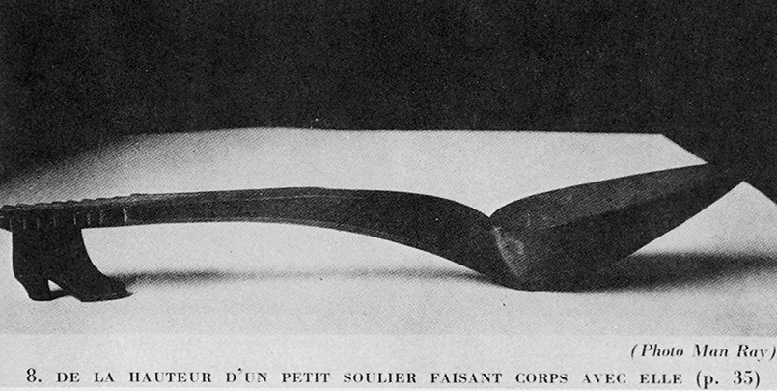
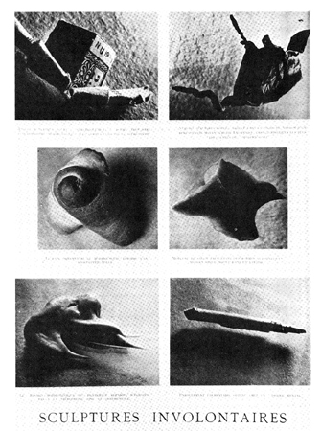
Breton's second example is "the expiration of movement" -the experience of something that should be in motion but has been stopped, derailed, or, as Duchamp would have said, "delayed." In this regard Breton writes, "I am sorry not to be able to reproduce, among the illustrations to this text, a photograph of a very handsome locomotive after it had been abandoned for many years to the delirium of a virgin forest." That Breton should have wanted to show a photograph of this object is compelling because the very idea of stop-motion is intrinsically photographic. The convulsiveness, then, the arousal in front of the object, is to a perception of it detached from the continuum of its natural existence, a detachment which deprives the locomotive of some part of its physical self and turns it into a sign of the reality it no longer possesses. The still photograph of this stilled train would thus be a representation of an object already constituted as a representation.
Man Ray. Illustration for André Breton, L’Amour fou, 1937.
Brassaï. Photographs for Sculptures Involuntaires. Published in Minotaure (1933).
Breton's third example consists of the found-object or found verbal fragment-both instances of objective chance-where an emissary from the external world carries a message informing the recipient of his own desire. The found-object is a sign of that desire. The particular object Breton uses at the opening of L'Amour fou is a perfect demonstration of Convulsive Beauty's condition as sign. The object is a slipper-spoon that Breton found in a flea market, and which he recognized as a fulfillment of the wish spoken by the automatic phrase that had begun running through his mind some months before-the phrase cendrier Cendrillon, or Cinderella ashtray. The flea-market object became something that signified for him as he began to see it as an extraordinary mise-en-abyme: a chain of reduplications to infinity in which the spoon and handle of the object was seen as the front and last of a shoe of which the little carved slipper was the heel. Then that slipper was imagined as having for its heel another slipper, and so on to infinity. Breton read the natural writing of this chain of reduplicated slippers as signifying his own desire for love and thus as the sign that begins the quest of L'Amour fou.
If we are to generalize the aesthetic of surrealism, the concept of Convulsive Beauty is at the core of that aesthetic: reducing to an experience of reality transformed into representation. Surreality is, we could say, nature convulsed into a kind of writing. The special access that photography has to this experience is its privileged connection to the real. The manipulations then available to photography-what we have been calling doubling and spacing-appear to document these convulsions. The photographs are not interpretations of reality, decoding it, as in Heartfield's photomontages. They are presentations of that very reality as configured, or coded, or written. The experience of nature as sign, or nature as representation, comes "naturally" then to photography. It extends, as well, to that domain most inherently photographic, which is that of the framing edge of the image experienced as cut or cropped. But I would add, though there is no space here to expand on it, that what unites all surrealist production is precisely this experience of nature as representation, physical matter as writing. This is of course not a morphological coherence, but a semiological one.
No account of surrealist photography would be complete if it could not incorporate the unmanipulated images that figure in the movement's publications-works like the Boiffard big toes, or the "Involuntary Sculptures" photographed by Brassaï for Salvador Dali, or the straight image of a hatted figure by Man Ray made for Minotaure. Because it is this type that is closest to the movement's heart. But the theoretical apparatus by which to assimilate this genre of photograph has already been developed. And that is the concept of spacing.
Inside the image, spacing can be generated by the cloisonné of solarization or the use of found frames to interrupt or displace segments of reality. But at the very boundary of the image the camera frame which crops or cuts the represented element out of reality-at-large can be seen as another example of spacing. Spacing is the indication of a break in the simultaneous experience of the real, a rupture that issues into sequence. Photographic cropping is always experienced as a rupture in the continuous fabric of reality. But surrealist photography puts enormous pressure on that frame to make it itself read as a sign-an empty sign it is true, but an integer in the calculus of meaning: a signifier of signification.
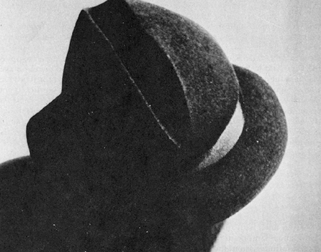
The frame announces that between the part of reality that was cut away and this part there is a difference; and that this segment which the frame frames is an example of nature-as-representation, nature-as-sign. As it signals that experience of reality the camera frame also controls it, configures it. This it does by point-of view, as in the Man Ray example, or by focal length, as in the extreme close-ups of the Dali. And in both these instances what the camera frames and thereby makes visible is the automatic writing of the world: the constant, uninterrupted production of signs. Dali's images are of those nasty pieces of paper like bus tickets and theater stubs that we roll into little columns in our pockets, or those pieces of eraser that we unconsciously knead-these are what his camera produces through the enlargements that he publishes as involuntary sculpture. Man Ray's photograph is one of several to accompany an essay by Tristan Tzara about the unconscious production of sexual imagery throughout all aspects of culture-this particular one being the design of hats.
Man Ray. Illustration for Tzara, “D’un Certain Automatisme Gout,” Minotaure (1933).
The frame announces the camera's ability to find and isolate what we could call the world's constant writing of erotic symbols, its ceaseless automatism. In this capacity the frame can itself be glorified, represented, as in the photograph by Man Ray that I introduced at the outset. Or it can simply be there, silently operating as spacing, as in Brassaï's seizure of automatic production in his series on graffiti.
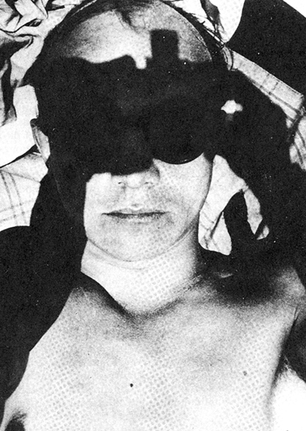
And now, with this experience of the frame, we arrive at the supplement. Throughout Europe in the twenties and thirties, camera-seeing was exalted as a special form of vision: the New Vision, Moholy-Nagy called it. From the Inkhuk to the Bauhaus to the ateliers of Montparnasse, the New Vision was understood in the same way. As Moholy explained it, human eyesight was, simply, defective, weak, impotent. "Helmholtz," Moholy explained, "used to tell his pupils that if an optician were to succeed in making a human eye and brought it to him for his approval, he would be bound to say: 'This is a clumsy piece of work.''' But the invention of the camera has made up for this deficiency so that now "we may say that we see the world with different eyes."
Umbo. Self Portrait. C.1930
These, of course, are camera-eyes. They see faster, sharper, at stranger angles, closer-to, microscopically, with a transposition of tonalities, with the penetration of X-ray, and with access to the multiplication of images that makes possible the writing of association and memory. Camera-seeing is thus an extraordinary extension of normal vision, one that supplements the deficiencies of the naked eye. The camera covers and arms this nakedness; it acts as a kind of prosthesis, enlarging the capacity of the human body.
But in increasing the ways in which the world can be present to vision, the camera mediates that presence, gets between the viewer and the world, shapes reality according to its terms. Thus what supplements and enlarges human vision also supplants the viewer himself; the camera is the aid who comes to usurp.
The experience of the camera as prosthesis and the image of it figuring in the field of the photograph is everywhere to be found in the New VisionIn Umbo's self-portrait the camera is represented by a cast shadow whose relationship to the photographer's eyes involves the interesting paradox of all supplementary devices, where the very thing that extends, displaces as well. In this image the camera that literally expands Umbo's vision, allowing him to see himself, also masks his eyes, nearly extinguishing them in shadow.
Florence Henri's self-portrait functions in similar ways. There the camera's frame is revealed as that which masters or dominates the subject, and the phallic shape she constructs for its symbol is continuous with the form that most of world culture has used for the expression of supremacy. The supplement is thus experienced emblematically, through the internalized representation of the camera frame as an image of mastery: camera-seeing essentialized as a superior power of focus and selection from within the inchoate sprawl of the real.
Throughout Europe in the 1920s there was the experience of something supplemental added to reality. That this was coherently experienced and actively configured in the photography made with the supplementary instrument accounts for the incredible coherence of European photography of this period-not, as is sometimes suggested, its diffraction into different sects. But it is my thesis that what the surrealists in particular added to that reality was the vision of it as representation or sign. Reality was both extended and replaced or supplanted by that master supplement which is writing: the paradoxical writing of the photograph.

Florence Henri Portfolio, Cologne, Galerie Wilde, 1974, introduction by Klaus-Jürgen Senbach.
Stanley Cavell, Must We Mean What We Say?, New York, Scribners, 1969, pp.226, 236.
The seminal text is Jacques Derrida, Of Grammatology, Baltimore, John Hopkins, 1974.
The references throughout this paragraph are to Rubin’s attempt, at the time of the Museum of Modern Art exhibition Dada, Surrealism, and Their Heritage, of which he was curator, to produce a concise synthetic statement which would serve as a theory of a Surrealist style. See William Rubin, “Toward a Critical Framework,” Artforum, vol. V., no. 1 (September 1966), 36.
Andre Breton, "Le Surrealisme et la peinture," La Revolution surrealiste, vol. I (July 1925), 26-30. The complete series of essays was collected in Breton, Surrealism and Painting, trans. Simon Watson Taylor, New York, Harper &: Row, Icon edition, 1972. Further references are to this translation.
Breton, Surrealism and Painting, p.68.
Ibid., p.70.
André Breton, “Océanie” (1948), reprinted in Breton, La Clé des champs, Paris, Sagitttaire, 1953, 1973 edition, p. 278.
Thus, Breton insists that “any form of expression in which automatism does not at least advance undercover runs a grave risk of moving out of the surrealist orbit” (Surrealism and Painting , p.68)
Ibid.
Ibid.
In Breton’s words, “The emotional intensity stored up within the poet or a painter at a given moment… (Surrealism and Painting, p.68).
Ibid.
Ibid. Breton goes on to express his distaste for what he calls photography’s positivist values, asserting that “in the final analysis it is not the faithful image that we aim to retain of something” (p. 32).
The protest was against the attitudes like that of Ribemont-Dessaignes, who in introducing a 1924 Man Ray exhibition, honored “these abstract photographs with a new universe”.
This question had begun, “The photographic print…is permeated with an emotive value that makes it a supremely precious article of exchange” (Surrealism and Painting, p. 32)
Walter Benjamin “Surrealism: The Last Snapshot of European Intelligentsia,” in Reflections, New York, Harcourt Brace Jovanovich, 1978, p.183.
19. Pierre Naville, "Beaux-Arts," La Revolution surrealiste, vol. I (April 1925), 27. It was in deference to Naville and others that, when later in the year Breton launched his support of the enterprise of the fine arts, he had nevertheless to begin by referring to "that lamentable expedient which is painting."
Man Ray, Exhibition Rayographs 1921-1928, Stügart, L.G.A., 1963.
In a text introducing Ernst’s Fatagaga photomontages, reprinted in Max Ernst, Beyond Painting and Other Writings by the Artist and His Friends, New York, Wittenborn Schultz, 1948, p.177.
John Heartfield, Photomontages of the Nazi Period, New York, Universe Books, 1977, p.26.
Ibid.
Louis Aragon, “John Heartfield et la beauté révolutionnaire” (1935), reprinted in Aragon, Les Collages , Paris,Hermann, 1965, pp.78-79.
In Walter Benjamin, “A Short History of Photography,” Screen, vol. 13, no.1 (Spring 1972), 24.
Cited in Dawn Ades. Photomontage, New York, Pantheon, 1976, p.19.
Lois Aragon, “La Peinture au défi,“ in Les Collages, p.44.
Derrida. Of Grammatology. P.18.
Claude Lévi –Strauss, The Raw and The Cooked, New York, Harper and Row,1970, pp.339-340.
Ibid. See Craig Owens, "Photography en abyme," October, no. 5 (Summer 1978), 73-88, for another use of this passage in the analysis of photography.
Louis Aragon's 1925 definition of the Marvelous reads, "Le merveilleux, c'est la contradiction qui apparait dans Ie reel" ("Idees," La Revolution sUTTealiste, vol. I [April 1925] 30).
Andre Breton, L'AmouT lou, Paris, Gallimard, 1937, p. 13.
Ibid., pp.35-41.
Laszlo Moholy-Nagy, Vision in Motion, Chicago, 1947, p. 206.
See my “Jump over the Bauhaus,” October, no.15 (Winter 1980), 103-110.

