Modern & Contemporary Art 1C:
Rococo to the Present

Spring 2017

Tuesday/Thursday 4:30-5:45 pm
Mendocino Hall 1005
Instructor: Elaine O'Brien Ph.D.
Office: Kadema 190
Office Hours: TTH 3-4pm, TH 12-1pm,
and by appointment
eobrien@csus.edu
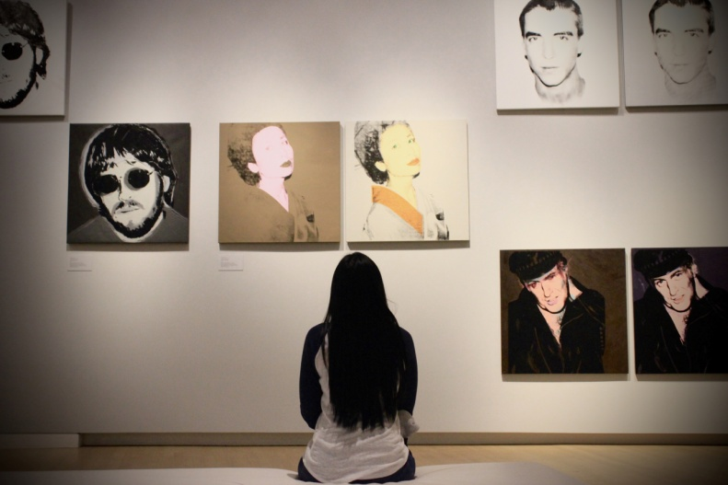
http://www.csus.edu/indiv/o/obriene/
Art 1C student with Andy Warhol portraits at the Crocker Art Museum, Sacramento

Course Description :

This course introduces the history of art and architecture from the middle of the 18th century to the present. We begin with the European Rococo, a period and style that marks the dissolution of the age of absolute monarchy and the beginning of the modern era. In the contexts of the revolutionary changes that marked modernity, we study Neo-Classicism, Romanticism and the rise of the avant-garde, Realism, Impressionism, and the new 19th century art media of photography and film. Symbolism, Fauvism, Cubism, Surrealism, Dada, and many canonical artworks of the 20th century through Pop and Minimal art of the 1960s are introduced. Postmodern art: conceptual art, performance, Neo-Expressionism, video, and new media from the 1970s to the 1990s mark the major cultural turn that characterizes art today. The course concludes with exemplary works of global contemporary art made in the 21st century.

Heads up: This course contains content that you might find disturbing. Do not take it if you are upset by art that challenges norms, including, societal, religious, and sexual norms.

Note: Note: This course satisfies General Education requirements for AREA C: The Arts and Humanities. It is recommended for freshman or sophomore years. There are no prerequisites, but it is recommended that Art 1A and/or Art 1B be taken before Art 1C.

Catalog description: A 3-unit lecture based survey of the history of world art from the late 18th century to the present, from the European Rococo, Enlightenment, age of science and revolution, through Neo-Classicism, Romanticism and the rise of the international avant-garde, Realism, Impression, Symbolism, photography and film. In the 20th century, Fauvism, Cubism, the Bauhaus, Expressionism, Pop, Minimal art, Postmodernism, conceptualism, performance, video and new media are considered from global perspectives and artistic production. Part of the art history foundation sequence. It is recommended that ART 1A and/or ART 1B be taken before ART 1C.

Required text:
Kleiner, Fred. Gardner's Art through the Ages, Book E, Backpack Edition: Modern Europe and America, 14th Edition.

Learning Objectives: This course offers you an opportunity to:
- Gain knowledge about many great works of modern and contemporary art
- Develop an understanding of how art is tied to historical contexts
- Develop analytical, research, and critical thinking skills as well as the vocabulary to write and talk about works of visual culture situated in time and place
- Develop critical thinking skills by asking questions such as why an artwork is historically significant while other works are not
- Develop an understanding of the role of the artist in society
- Develop an appreciation for multiple interpretations of artworks and overcome the mistaken notion that there is one “right” interpretation
- Develop confidence to evaluate artworks and a sense of the value of art to life in general outside the academic environment and the bachelor’s degree requirement
- Gain some of the worldliness needed for our era of globalization
- Make the enjoyment of visual art, especially the art of your own time, a normal part of your life

GE Area C Learning Outcomes for C1 (Arts):
The learning objectives associated with C1 should focus on artistic processes and how works of art reflect the cultural contexts in which they were produced. Specifically, students completing the C1 requirements should be able to:
- Think conceptually and critically about medium, performance or presentation, and production for at least one art form.
- Demonstrate knowledge of artistic production, aesthetic properties, and the way creative work is shaped by artistic and cultural forces.
- Have an acquaintance with a broad understanding of artistic forms, genres, and cultural sources.
- Be able to develop and defend informed judgments about creative work.
- Demonstrate knowledge of the conventions of at least one of the disciplines in the arts.

To help you achieve learning objectives:
- Tips for Successful Students: http://homepage.usask.ca/~clv022/success.htm
- Dartmouth College Academic Skills website: http://www.dartmouth.edu/~acskills/success/index.html
- Note: College courses require around nine hours per week of study outside of class (time for reading, writing, and test preparation). Click here and scroll down to standard study time requirements and time management tips.
- CSUS Student Tech Center: http://www.csus.edu/stc Free classes and one-on-one help
- For free, one-on-one help with writing in any class, visit the University Reading and Writing Center in Calaveras 128. The Reading and Writing Center can help you at any stage in your reading and writing processes: coming up with a topic, developing and organizing a draft, understanding difficult texts, or developing strategies to become a better editor. To make an appointment or a series of appointments, visit the Reading and Writing Center in CLV 128. We also offer tutoring for one unit of academic credit through ENGL121. For current Reading and Writing Center hours and more information, visit the website at www.csus.edu/writingcenter.

Course Requirements and Grade Basis:

- 5 quizzes (10 points each) 50
- Crocker Art Museum Report 10
- Annotated bibliography 20
- Take-home final 20
Total 100 points

Course Attendance and Other Art 1C Policies
- Attendance is taken almost every time from quizzes and ungraded in-class response papers.
  - Three unexcused absences reduce your grade by one letter grade; each subsequent absence reduces your grade by a whole letter. Five unexcused absences result in automatic failure. Chronic lateness or leaving early (more than three times) can reduce your grade by one letter.
    - Illness and family/childcare emergencies are excused with a written note from your health-care practitioner, or the student health clinic. Scheduled appointments, transportation problems, and job demands are not excused. I often excuse students who explain the reason for their absence to me in person during my office hours or by appointment. Please do not hesitate to come to see me about family emergencies or any situation that will keep you from class. We can probably work something out that’s fair to you and the other students.
    - Always feel free to email me, but an email alone cannot excuse an absence.
- Cell phones and all electronic devices must be turned off and out of sight during class. I will ask you to leave the class and count you as absent.
- Large-screen laptops only for note taking are permitted only in the first row. I will ask you to move to the first row or close your laptop and put it away.
- Please do not sit in the back row of the lecture room or the back area. I will ask you to move forward.
- No sleeping in class. Sleepers lower overall class energy and morale. If you are sleeping, I might ask you to leave class and count you as absent.
- No eating or drinking please. I will ask you to put it away.

- NOTE: Remarkably good attitude is noted on the roster as “good attitude.” Remarkably bad attitude is noted on the roster as “bad attitude.” Attitude is huge.

- Note: For personal questions that require my full attention, such as your progress in class, or situations that are affecting your performance, see me during my office hours or by appointment (not before class), and always feel free to email me.
- A smart idea: Exchange contact information with two students in class. Your student colleagues can answer many questions if you miss or are late for class and need notes or if you just need to confirm your understanding of ideas and information.

University Policy on Dropping a Course
Drop courses through the second week of the semester through the Student Center. You don’t need signatures, but you must drop online. There is no such thing as an automatic drop. Instructors have the authority to drop students, but they are not required to do so. Even if your instructor asks you to leave the class, the drop must be entered on My Sac State. Failure to drop a course according to University policy is likely to result in the assignment of a failing grade of “WU” or “F” in that course. If you are uncertain which classes you are enrolled in, log onto My Sac State and check your Student Center or check with the Student Services Counter, LSN Hall, first floor

50%: Quizzes: Six (timed) 15-25 minute quizzes are on the schedule. One (a missed or lowest-score) quiz is dropped. Your quiz average is derived from five out of the six quiz scores.
Quiz rescheduling and format changes are announced in class.

Quiz format:
- Identification of one or two artworks from the lectures since the previous quiz. Identify 1) full name and nationality of artist, 2) title of artwork, and 3) date (within a quarter century until 1900; for art made in the 20th and 21st centuries, know the date within the decade), 4) period or movement, 5) medium, and 6) three or more historically significant points about the artwork.
- I might ask you to identify an unknown artwork by an artist we studied. Go to Google image search and look at all the artworks you can find by each artist until you can recognize their style.
- Usually, but not always, there will also be a short essay question on history and ideas emphasized in the week’s lectures and in the corresponding textbook chapter.

- Quiz scoring is on a scale from 1-10 points based on how much mastery of the material is demonstrated.
- Quiz points will be totaled and averaged at the end of the semester. Your lowest score or missed quiz is dropped. Your top five quiz scores are averaged and count for 50% of your course grade.
    - Keep your quizzes for possible discrepancies at the end of the semester.
    - No makeup quizzes will be given, but one quiz (missed or lowest score) is subtracted from the total.

Suggestions for how to study for an art history quiz:
- Form a study group or get a study partner.
- Review the description of the quizzes on the syllabus.
- Go to the Art 1C PowerPoint lectures on the course website.
- Make flashcards – one for every artwork that was shown in lecture.
- On the front of the card draw a thumbnail sketch of the artwork. Put no written information on the front of the card.
- On the back, write down information about that artwork focusing on why the artwork is historically significant. Include information from both Art through the Ages and class lectures about this work and related works. Include titles of artworks and names of related artists.
- For essay questions, think about what you would ask about this work if you were the professor. It will always be something I emphasized in lecture. Use your notes to review the points emphasized in lecture.

10%: Crocker Art Museum response: Due May 2
NOTE: You may choose instead to visit the new UC Davis Shrem Museum or a Bay Area modern and contemporary art museum, like SFMoMA. 10 extra credit points. Follow the guidelines below.
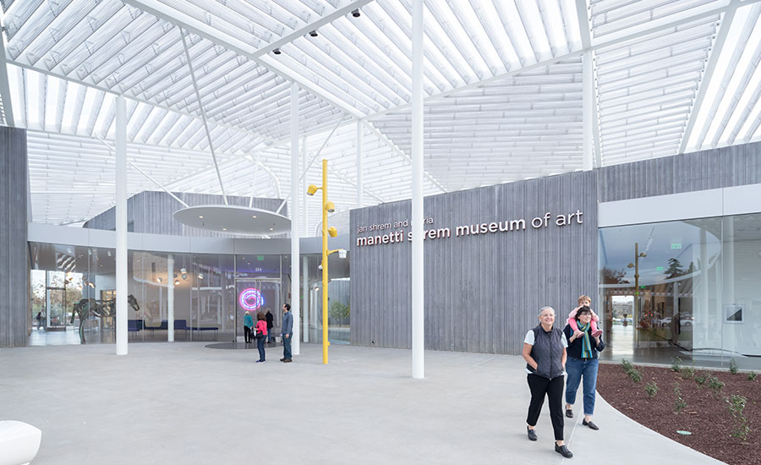
    - Watch this 3-minute video before you go: http://youtu.be/drrBd1bCiW0?list=PLdGqz6dgvIzZlgSGtCMrwxPJVEoPkYwiT
The new Shrem museum, UC Davis, is always free

Visit the Crocker Art Museum on O Street: https://crockerartmuseum.org/visit
    - Check the website before you go for open days and hours, exhibitions on view, the cost to students (bring your ID), parking and other information you need. Third Sundays are free.
    - Pick up a map at the front desk and ask where to find art made after 1960.
    - You must chose a work made after 1960. No credit for pre-1960 artwork.
    - Have someone else take a picture of you with the artwork. Include the entire artwork if possible. Selfies won’t work and are not accepted because they’re too close. If you go alone, ask a stranger in the gallery or the museum guard to take it for you.
      - The Shrem museum at UC Davis is free but does not allow photography of artworks. You can do a 15-minute sketch of the artwork plus a photo of you in the gallery.
    - Email me the photo of you in the Crocker as a JPEG attachment: eobrien@csus.edu
    - In the body of the email or as an attachment, put 1) all the ID information from the wall sign (full name of artist, title, date, medium) and 2) one or two well-written, thoughtful paragraphs (around 150 words) a) describing the artwork and b) explaining why it’s your favorite contemporary work in the museum.
- The museum assignment is graded on a scale of 1-10 based on the quality of the photograph and how thoughtful, complete, and well written your response is.
- Late submissions are marked down 1 point (out of 10 total).
- Early submissions are welcomed and earn 1 bonus point.
- No car? Click here for map and directions for taking the bus from campus to the Crocker.

20%: Annotated Bibliography: (Due April 25)
Chicago style (12 font, double space) NOTE: Late papers are marked down one point per class.
An annotated bibliography is the same as a standard bibliography, but each entry includes a short description of
1) the author’s expertise
2) the content of the book or article
3) author’s point of view
- Each of the three entries in the annotated bibliography should be 120 words, 12 font, double space.
- For Chicago Style annotated bibliography format, click here.
For each of the entries:
1) Write a one or two sentence description of the expertise of the author about the artwork you selected. (Select art historians only.)
2) Write a concise one-paragraph c. 50-word summary of the book or article’s content.
- Write the author’s thesis/argument/point of view about the artwork and artist (around 50 words)

- To begin, select one work of art that interests you the most in the Art 1C textbook. Do not wait for me to lecture on that artwork. Choose any artwork in the entire book. Consider selecting a work you do not know about and perhaps one you think is ugly, disturbing, or ridiculous. Such a choice might be more interesting and a better opportunity to learn why specialists consider an artwork historically significant.

- The authors must be art historians who specialize on the artist, art movement, or era of the work you select (do an online search to find the authors’ expertise). The most important part of your grade is the quality (trustworthiness) of your sources.

- 2) Using the university library’s OneSearch – “Advanced Search” as well as “Database & Article Searching” (use the search subject “ART”) - find two peer-reviewed articles and one book about the artist and your selected artwork. Choose sources that give the most information on your artwork/artist. If you aren’t sure what a peer-reviewed article is, read this: http://lib.calpoly.edu/research/guides/articles.html If you can’t find two peer-reviewed articles about the artwork, email me immediately. I will help you.

20%: Take home final (Due May 11) (12-font, single space): Select 10 works of art that you believe are the most historically significant in the entire course. Choose artworks shown in lecture only. Identify each one completely, as on quizzes [1) full name and nationality of artist, 2) title of artwork, 3) date 4) period/movement, and 5) medium). Explain in 75-100 words (for each) why that work of art is one of the ten most historically significant artworks we have studied. Include a brief explanation of the historical situation of the artist and how the artwork is his or her response to that situation. Images are not required.

*NOTE: PLAGIARIZED Bibliographies AND TAKE HOME FINALS EARN AN AUTOMATIC F.
It’s easy to avoid plagiarism. Simply cite (in your footnotes and bibliography) all quotations and paraphrases. Here is the CSUS definition of plagiarism: At Sacramento State plagiarism is the use of distinctive ideas or works belonging to another person without providing adequate acknowledgement of that person’s contribution. Regardless of the means of appropriation, incorporation of another’s work into one’s own requires adequate identification and acknowledgement. Plagiarism is doubly unethical because it deprives the author of rightful credit and gives credit to someone who has not earned it. Acknowledgement is not necessary [only] when the material used is common knowledge.

Extra Credit:
- Extra credit opportunities are activities that will increase your understanding of art and visual culture. These include attending artist lectures, writing gallery and museum reports, and writing reports on videos of art documentaries available online (see me to check quality) in the library Media Center. You can think up your own extra credit activity. See me if you’re not sure if your idea qualifies.
- Extra credit points are recorded next to your name in the grade book.
- NOTE: Extra credit points are not averaged into quiz or other scores for required assignments, but they can make a difference at the end of the semester. If your grade is on the border between grades – between a B+ and an A, for example - extra credit points can move you to the higher grade. They can also make up for an unexcused absence, but you must discuss that intention with me first. The last day to turn in extra credit is May 9.
________________________________________________________________________________________________________________
Schedule:
- The schedule is subject to changes announced in lecture.
- Lectures are available on the course website just before class and will remain there throughout the semester.

January 24: Introduction
Homework:
Read: “Why Have There Been No Great Women Artists?”an article written by American art historian Linda Nochlin in 1970.
- Read this: What is a thesis statement?
- *Print out the Nochlin essay; underline her thesis statement and three supporting points (facts that prove her thesis is credible). Bring your marked hard copy of the article to class for discussion.

Keep in mind that this is a historical essay. Do not read it as if it were written today. In 1970, when Nochlin wrote it, there were very few women artists living or dead represented in art history textbooks. Today there are many. Why is that?
- What caused the dramatic change in the demographics of who makes art after 1970?

NOTE: On the first quiz, February 7, I will ask you to write a paraphrase of Linda Nochlin’s thesis statement in one or two sentences.

January 26: Discuss Nochlin essay
View video in class: WAR: Women, Art, Revolution (2011) Take notes. Write down facts (Who? What? When? Where? Why?) that are presented in the video and support or contradict Nochlin ’s thesis. *Remember that Nochlin’s essay was written in 1970 and the WAR video was made in 2011. WAR looks back historically on the feminist revolution in art that Nochlin led for art history.

January 31: Rococo
Read: Chapter 26: Rococo to Neoclassicism

February 2: Neoclassicism

February 7: Quiz 1 – Two questions will be asked:
1) One of the following:
a) Describe in detail “Course Attendance and Other Policies” [see syllabus pp. 2-3]
OR
b) Describe in detail the Points of View annotated bibliography requirements
2) Write a paraphrase of Linda Nochlin’s thesis (her answer to the question the title asks) and two facts presented in the video WAR that support Nochlin’s argument.

February 9 : Library research instruction // Neoclassicism
Read: Chapter 27: Romanticism, Realism, Photography

February 14 : Romanticism

February 16: Quiz 2 / Romanticism

February 21: Realism
Read: Chapter 28: Impressionism, Post-Impressionism, Symbolism

February 23: Realism and Photography

February 28: Impressionism

March 2: Post-Impressionism
Read: Chapter 29: Modernism in Europe and America: 1900-1945

March 7: Post-Impressionism

March 9: Quiz 3 / Symbolism and Fauvism
March 14: Expressionism

March 16: Dada

March 21 & 23: Spring Break - No Class

March 28: Dada and Cubism

March 30: Cubism

April 4: Quiz 4 / Cubism
April 6: Surrealism
April 11: Abstract Expressionism
April 13: sixties and seventies

April 18: sixties and seventies

April 20: eighties and nineties

April 25: Annotated bibliography due
Read: Chapter 31: Contemporary Art Worldwide

April 27: Quiz 5

May 2: Crocker Art Museum Assignment due
May 4:

May 6:
Take home final due May 11. See syllabus page 7 for description of the take home final.

May 11: Quiz 6 / Take home final due. Our last class will be an in-class discussion of your take-home finals as a review of the course. Be prepared to defend your top ten choices to the class. Attendance at this class is required and part of your take-home final grade.

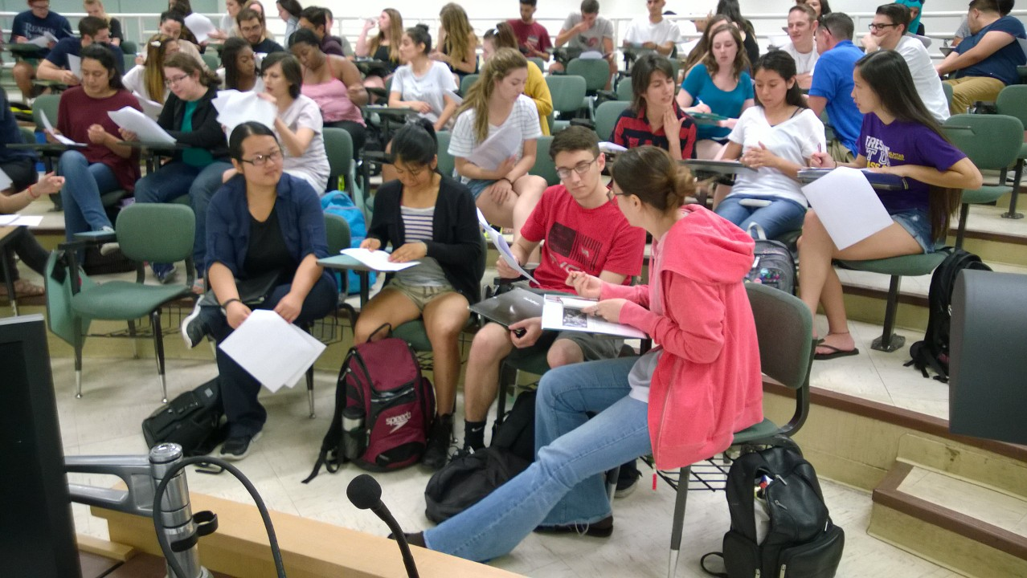
Final class: Art 1C students collaboratively select the top ten

