
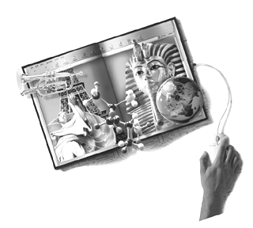
Unit Plan Template
Note: Type in the gray areas.

Unit Author
First and Last Name
Author's E-mail Address
Course Name(s)
Course Number(s)
Course Section(s)
School City, State, Zip
Instructor Name(s):

Unit Overview
Unit Plan Title
Curriculum-Framing Questions
Essential Question
Unit Questions
Unit Summary

Subject Area(s): (List all subjects that apply)

Grade Level (Click boxes of all grade levels that apply)
K-2  6-8  ESL  Gifted and Talented | 3-5  9-12  Resource  Other:

Student Objectives/Learning Outcomes
Targeted State Frameworks/Content Standards/Benchmarks
Procedures
Approximate Time Needed (Example: 45 minutes, 4 hours, 1 year, etc.)
Prerequisite Skills

Materials and Resources Required For Unit

Technology – Hardware (Click boxes of all equipment needed.)

Camera  Computer(s)  Digital Camera  DVD Player  Internet Connection | Laser Disk  Printer  Projection System  Scanner  Television | VCR  Video Camera  Video Conferencing Equip.  Other:
Technology – Software (Click boxes of all software needed.)
Database/Spreadsheet  Desktop Publishing  E-mail Software  Encyclopedia on CD-ROM | Image Processing  Internet Web Browser  Multimedia | Web Page Development  Word Processing  Other:

Printed Materials
Supplies
Internet Resources
Others
Accommodations for Differentiated Instruction
Resource Student
Gifted Student
Student Assessment

