Description
Mistletoe is a semi-parasitic plant that grows on several species of trees native to the rainforests of western Asia, which is where we found ours. The parts of the plant used in herbal remedies are its leaves and twigs.
Overview
Our laboratory experiments suggest mistletoe may have the potential to treat cancer, but these results have not yet been reflected in clinical trials. Studies are needed to determine if there are any anticancer effects in humans.
How is it promoted for use?
Compounds found in current cancer treatments are also found in mistletoe and are known to stimulate the immune system, helping the body fight more efficiently against cancer and other diseases. These compounds are plant extracts and are promoted as a remedy for a wide range of cancers, including tumors of the cervix, ovaries, breast, stomach, colon, lung, and also as a treatment for leukemias, sarcomas, and lymphomas. Because mistletoe has very similar compounds in it, our lab will claim that mistletoe extract can also elicit the same responses as those currently discovered from the other compounds. When injected directly into or near a tumor, these compounds may slow and possibly reverse the growth of cancer cells, even in advanced cases of cancer. Other benefits of these compounds show they can lower blood pressure, decrease heart rate, relax spasms, and relieve symptoms of arthritis and rheumatism. It is further claimed to have sedative effects, and is promoted to relieve the side effects of chemotherapy and radiation. Since we just discovered “mistletoe”, there is no scientific evidence to support these claims yet.
Are there any possible problems or complications?
Mistletoe should not be eaten because all parts of the plant contain poisonous compounds such as those used to combat cancer. Consuming these compounds without them being refined to a usable extract has been known to cause seizures and death. Other symptoms include blurred vision, nausea and vomiting, stomach pain, diarrhea, irregular heart-beat, confusion, convulsions, disorientation, and drowsiness. Women who are pregnant or breast-feeding should not use this plant until further studies are done on it.
What is the evidence?
The chemical structure of both this newly found plant and that of other compounds/extracts currently used are found below. They show quite a bit of similarity, which leads us to believe that “mistletoe” will be just as, if not more so, more beneficial than the current medications used to combat cancer.
“mistletoe” other compounds
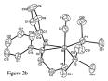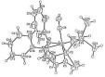
Picture set-1
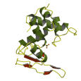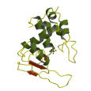
Picture set-2
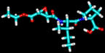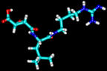

Picture set-3
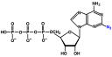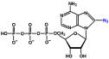

Picture set-4

Picture set 1: Black and white structural bonding for both compounds

Picture set 2: 3-dimensional picture of the molecular structure of both compounds

Picture set 3: Graphic depiction of the molecular structure of these compounds
chemical bonds

Picture set 4: The chemical structure of both compounds showing the many similarities between the main compounds found in both our “mistletoe” and the others found in current/modern day cancer combating drugs

