Optional Extra Credit Assignment Instructions

- Answer the following Questions, Exercises, and Problems based on Chapter 15 (Financial Statement Analysis) of the Garrison text (Chapter 15 in either 11th, 12th or 13th edition will suffice).
- The criteria used to allocate points to this assignment are:
  - Completion
  - Neatness, clear labeling, and demonstration of effort
- Based on my strict discretion:
  - 20 points will be earned if both criteria are fully met.
  - 10 points will be earned if the criteria are substantially (but not fully) met.
  - 0 points will be earned if the criteria are not substantially met.
- Points earned will be added only to the numerator (not the denominator) of your total point percentage in the course. Mathematically, this is to your advantage (as opposed to also adding the 20 points possible to your denominator).
- A hard copy of this assignment is due and should be submitted to my office (TAH 2098) on or before the date of your final exam.
- There is no penalty for not doing this assignment. It is completely optional.
- All answers must originate from the individual student. No copying, collaboration, answer borrowing, or consulting with others is allowed.

Now go to Pages 2-10 of this document →

Questions
15-1Distinguish between horizontal and vertical analysis of financial statement data.
15-2What is the basic purpose for examining trends in a company's financial ratios and other data? What other kinds of comparisons might an analyst make?
15-3Assume that two companies in the same industry have equal earnings. Why might these companies have different price-earnings ratios? If a company has a price-earnings ratio of 20 and reports earnings per share for the current year of $4, at what price would you expect to find the stock selling on the market?
15-4Would you expect a company in a rapidly growing technological industry to have a high or low dividend payout ratio?
15-5What is meant by the dividend yield on a common stock investment?
15-6What is meant by the term financial leverage?
15-7The president of a plastics company was quoted in a business journal as stating, “We haven't had a dollar of interest-paying debt in over 10 years. Not many companies can say that.” As a stockholder in this company, how would you feel about its policy of not taking on debt?
15-8If a stock's market value exceeds its book value, then the stock is overpriced. Do you agree? Explain.
15-9A company seeking a line of credit at a bank was turned down. Among other things, the bank stated that the company's 2 to 1 current ratio was not adequate. Give reasons why a 2 to 1 current ratio might not be adequate.

EXERCISE 15-1 Common-Size Income Statement
A comparative income statement is given below for Ryder Company:
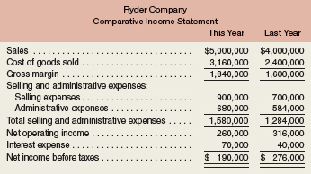
The president is concerned that net income is down even though sales have increased during the year. The president is also concerned that administrative expenses have increased because the company made a concerted effort to cut waste out of the organization.
Required:
1. |  | Express each year's income statement in common-size percentages. Carry computations to one decimal place.
2. |  | Comment briefly on the changes between the two years.

EXERCISE 15-2 Financial Ratios for Common Stockholders
Comparative financial statements for Heritage Antiquing Services for the fiscal year ending December 31 appear on the following page. The company did not issue any new common or preferred stock during the year. A total of 600 thousand shares of common stock were outstanding. The interest rate on the bond payable was 14%, the income tax rate was 40%, and the dividend per share of common stock was $0.75. The market value of the company's common stock at the end of the year was $26. All of the company's sales are on account.
p. 701
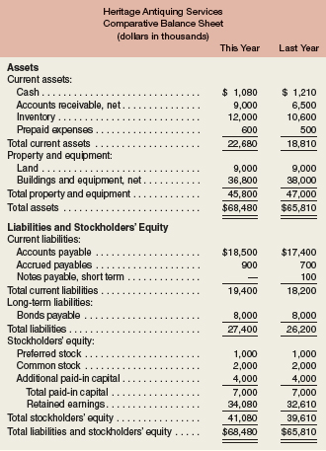
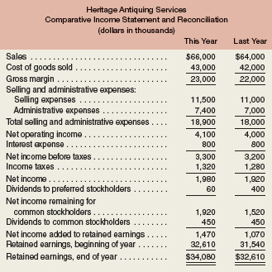
Required:
Compute the following financial ratios for common stockholders for this year:
1. |  | Gross margin percentage.
2. |  | Earnings per share of common stock.
3. |  | Price-earnings ratio.
4. |  | Dividend payout ratio.
5. |  | Dividend yield ratio.
6. |  | Return on total assets.
7. |  | Return on common stockholders' equity.
8. |  | Book value per share.

EXERCISE 15-3 Financial Ratios for Short-Term Creditors
Refer to the data in Exercise 15-2 for Heritage Antiquing Services.
Required:
Compute the following financial data for short-term creditors for this year:
1. |  | Working capital.
2. |  | Current ratio.
3. |  | Acid-test ratio.
4. |  | Accounts receivable turnover.
5. |  | Average collection period.
6. |  | Inventory turnover.
7. |  | Average sale period.

EXERCISE 15-4 Financial Ratios for Long-Term Creditors
Refer to the data in Exercise 15-2 for Heritage Antiquing Services.
Required:
Compute the following financial ratios for long-term creditors for this year:
1. |  | Times interest earned ratio.
2. |  | Debt-to-equity ratio.

PROBLEM 15-16 Comprehensive Ratio Analysis
You have just been hired as a loan officer at Fairfield State Bank. Your supervisor has given you a file containing a request from Hedrick Company, a manufacturer of auto components, for a $1,000,000 five-year loan. Financial statement data on the company for the last two years are given below:
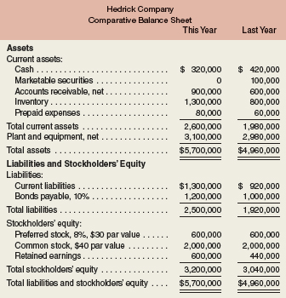
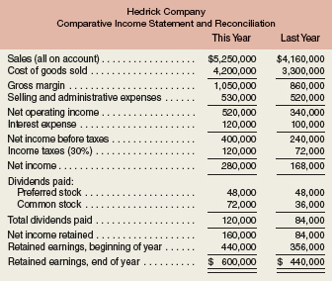
Marva Rossen, who just two years ago was appointed president of Hedrick Company, admits that the company has been “inconsistent” in its performance over the past several years. But Rossen argues that the company has its costs under control and is now experiencing strong sales growth, as evidenced by the more than 25% increase in sales over the last year. Rossen also argues that investors have recognized the improving situation at Hedrick Company, as shown by the jump in the price of its common stock from $20 per share last year to $36 per share this year. Rossen believes that with strong leadership and with the modernized equipment that the $1,000,000 loan will enable the company to buy, profits will be even stronger in the future.
Anxious to impress your supervisor, you decide to generate all the information you can about the company. You determine that the following ratios are typical of companies in Hedrick's industry:
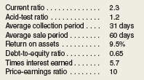
Required:
1. |  | You decide first to assess the rate of return that the company is generating. Compute the following for both this year and last year:
  a. |  | The return on total assets. (Total assets at the beginning of last year were $4,320,000.)
  b. |  | The return on common stockholders' equity. (Stockholders' equity at the beginning of last year totaled $3,016,000. There has been no change in preferred or common stock over the last two years.)
  c. |  | Is the company's financial leverage positive or negative? Explain
2. |  | You decide next to assess the well-being of the common stockholders. For both this year and last year, compute:
  a. |  | The earnings per share.
  b. |  | The dividend yield ratio for common stock.
  c. |  | The dividend payout ratio for common stock.
  d. |  | The price-earnings ratio. How do investors regard Hedrick Company as compared to other companies in the industry? Explain.
  e. |  | The book value per share of common stock. Does the difference between market value per share and book value per share suggest that the stock at its current price is a bargain? Explain.
  f. |  | The gross margin percentage.
3. |  | You decide, finally, to assess creditor ratios to determine both short-term and long-term debt paying ability. For both this year and last year, compute:
  a. |  | Working capital.
  b. |  | The current ratio.
  c. |  | The acid-test ratio.
  d. |  | The average collection period. (The accounts receivable at the beginning of last year totaled $520,000.)
  e. |  | The average sale period. (The inventory at the beginning of last year totaled $640,000.)
  f. |  | The debt-to-equity ratio.
  g. |  | The times interest earned.
4. |  | Make a recommendation to your supervisor as to whether the loan should be approved.

