Optional Extra Credit Assignment Instructions

- Answer the following Questions (1-10), Exercises (30,39,43), and Problems (49,52) based on Chapter 6 (Fundamental of Product and Service Costing) of the Lanen 5e text.
- The criteria used to allocate points to this assignment are:
  - Completion
  - Thoroughness (MUST SHOW ALL YOUR WORK)
  - Neatness, clear labeling, and demonstration of effort
- Based on my strict discretion:
  - 20 points will be earned if both criteria are fully met.
  - 0 points will be earned if the criteria are not fully met.
- Points earned will be added only to the numerator (not the denominator) of your total point percentage in the course. Mathematically, this is to your advantage (as opposed to also adding the 20 points possible to your denominator).
- A hard copy of this assignment is due and should be submitted in class on the date of your final exam.
- There is no penalty for not doing this assignment. It is completely optional.
- All answers must originate from the individual student. No copying, collaboration, answer borrowing, or consulting with others is allowed.

Now go to Pages 2-7 of this document

REVIEW QUESTIONS

6-1.How are product costing and cost allocation related?

6-2.What are the three criteria for the design of cost management systems?

6-3.Why are cost flow diagrams useful in describing product costing systems?

6-4.What are the characteristics of the following three costing systems: (a) job costing, (b) process costing, and (c) operation costing?

6-5.How are job order, process, and operation costing the same? How are they different?

6-6.Describe the predetermined overhead rate. What is the role of the predetermined overhead rate in product costing?

6-7.Ideally, what does an allocation base reflect between the overhead cost and the activity (production of a product, for example)?

6-8.What is two-stage cost allocation?

6-9.What is continuous flow processing? Give at least three examples of products that might use continuous flow processing.

6-10.What is each component of the basic cost flow model? Describe each component.

6-30. Basic Product Costing
(LO 6-3)
Sara's Sodas produces a popular soft drink. Operating data for January follow:
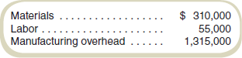
Sara's Sodas produced 4 million liters of the beverage in January.
Required
Compute the cost per liter of beverage produced in January.

6-39. Predetermined Overhead Rates
(LO 6-4)
Tiger Furnishings produces two models of cabinets for home theater components, the Basic and the Dominator. Data on operations and costs for March follow:
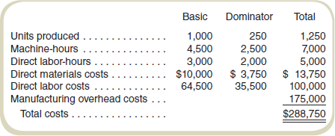
Required
Compute the predetermined overhead rate assuming that Tiger Furnishings uses direct labor-hoursto allocate overhead costs.

6-43. Operations Costing
(LO 6-6)
Howrley-David, Inc., manufactures two models of motorcycles: the Fatboy and the Screamer. Both models are assembled in the same plant and require the same assembling operations. The difference between the models is the cost of materials. The following data are available for August:
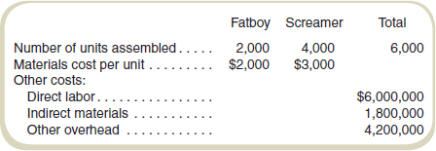
Required
Howrley-David uses operations costing and assigns conversion costs based on the number of units assembled. Compute the cost of each model assembled in August.

6-49. Two-Stage Allocation and Product Costing
(LO 6-5)
Donovan & Parents produces soccer shorts and jerseys for youth leagues. Most of the production is done by machine. Data on operations and costs for March follow:
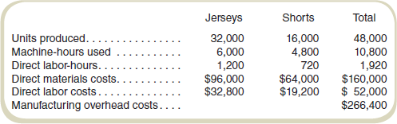
Management asks the firm's cost accountant to compute product costs. The accountant first assigns overhead costs to two pools: overhead related to direct materials and overhead related to machine-hours. The analysis of overhead accounts by the cost accountant follows:
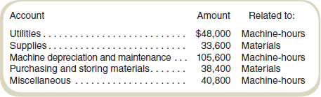
Required
- Compute the predetermined overhead rates assuming that Donovan uses machine-hours to allocate machine-related overhead costs and materials costs to allocate materials-relatedoverhead costs.
- Compute the total costs of production and the cost per unit for each of the two products for March.

6-52. Operation Costing
(LO 6-6)
DiDonato Supplies manufactures two versions of presentation remotes: Basic and Laser. Both models go through the same assembly process and are produced in the same plant. The difference between the models is in the additional parts for the laser model as well as the cost of the parts themselves. The following data are available for the year just ended:
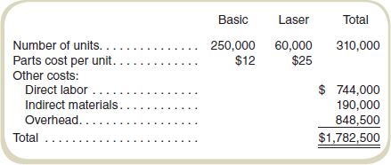
Required
DiDonato uses operations costing and assigns conversion costs based on the number of units assembled. Compute the cost per unit of the Basic and Laser models for the year just ended.

