Bio 181: Internet-based exercise: Week 4

Invitrogen Gateway cloning system

We are in the process of cloning a novel plasmid, carrying two antibiotic resistance genes, from two separate plasmids, by restriction digestion followed by sticky-end ligation.

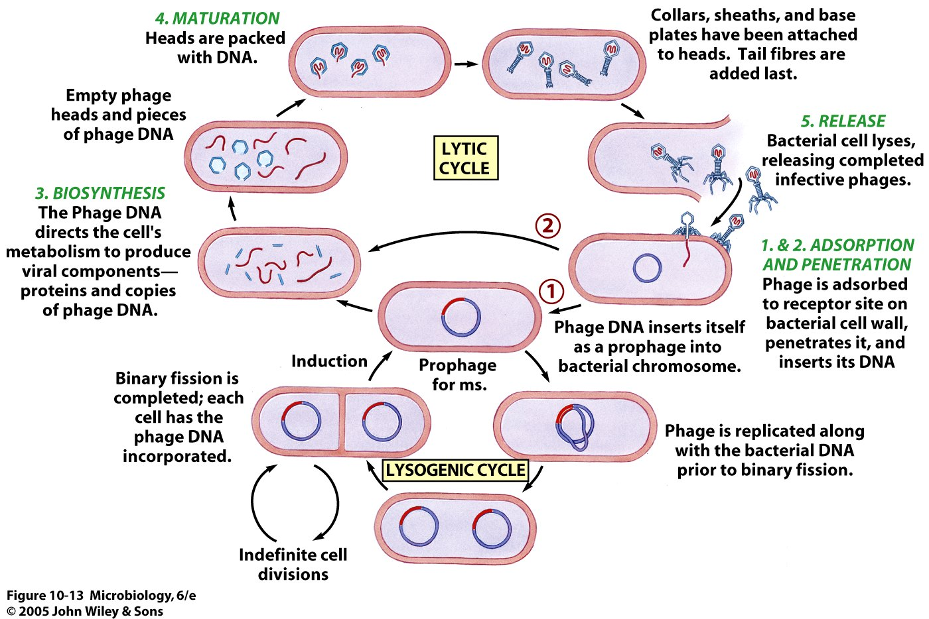
The plasmids we are working with (and the plasmid we create) are all suitable vectors for recombinant DNA work in bacteria. The plasmid will be replicated and maintained in bacterial cells, and the antibiotic resistance genes will be expressed in bacteria. However, different vectors may be needed for different applications. In particular, if you have a gene that you want expressed into protein, you may need that expression to occur in eukaryotic cells which are capable of various post-translational modifications. Or, you may want your gene cloned into a special plasmid that regulates expression, or carries a different selectable marker.

MANY vectors exist for many cloning applications. In this week’s exercise, you will learn about a system developed by Invitrogen that allows you to clone your gene once into one vector (the “entry vector”), and then easily transfer that gene into any of a range of different vectors for your specific needs. This “subcloning” is normally done by taking the first plasmid clone, restriction digesting out the gene of interest, and ligating it once again into a different vector. The Invitrogen “Gateway” technology offers a faster, simpler approach.

As background, first recall that temperate viruses, such as bacteriophage lambda, have a lysogenic phase in their life cycle. Sometimes, instead of multiplying rapidly and then lysing their host, lysogenic viruses will integrate their genome by recombination directly into the host cell’s chromosome. There, the virus remains dormant until some signal triggers the viral DNA to pop out again (a reversal of the original recombination event, called excision); and a lytic cycle then commences.
Invitrogen has made this natural process the basis of their system for excising cloned genes from one vector, and inserting them into another. Below, read the excerpts I have pasted from the internet; then visit the two websites, and answer the questions.

Source: http://www.biomedcentral.com/1471-2199/7/46

From Gateway to MultiSite Gateway in one recombination event
Enrico Magnani, Linnea Bartling and Sarah Hake BMC Molecular Biology 2006, 7:46doi:10.1186/1471-2199-7-46

Background

Recombinase-based cloning technologies are becoming increasingly popular because of their easy use and high efficiency. These tools exploit bacterial or viral site-specific recombinases like the bacteriophage P1 Cre, the Saccharomyces cerevisiae FLP or the bacteriophage lambda integrase. These enzymes catalyze a reciprocal double-stranded DNA exchange between two specific DNA sites.
Gateway (Invitrogen) is one of the most popular recombination cloning technologies. It is based on the Escherichia coli bacteriophage lambda integrase/att system. Two sets of reactions are employed in this technology: LR and BP recombinations (Fig 1). The BP reaction is catalyzed by the BP Clonase enzyme mix (Invitrogen), which recombines attB sites with attP sites. The LR Clonase mix (Invitrogen) is responsible for recombination of attL sites with attR sites. Any DNA fragment of interest can be PCR amplified with primers containing attB sites and cloned into a donor vector carrying attP sites in the presence of the BP Clonase mix. The recombination of attB with attP sites leads to the formation of attL and attR sites. The reaction creates an entry clone bearing the insert of interest flanked by attL sites and a byproduct flanked by attR sites (Fig 1A). The insert can then be mobilized into any destination vector having attR sites via an LR reaction (Fig 1B). The resulting construct can be easily selected using a combination of a positive (antibiotic resistance) and a negative (the cytotoxic ccdB gene) selection which does not allow the growth of E. coli transformed with either the initial vectors or the by-product. The vast number of Gateway destination vectors designed for many different biological analyses and the large collections of entry clones carrying entire genome open reading frames make this technology highly attractive.
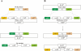Figure 1. Gateway BP and LR reactions. (A) BP recombination of a PCR product "X" flanked by attB sites with a Gateway donor vector [3]. (B) LR recombination of an entry clone bearing a DNA fragment "X" with a Gateway destination vector [3].

Gateway® Technology
The Gateway® Technology is a universal cloning method that takes advantage of
the site-specific recombination properties of bacteriophage lambda to provide
a rapid and highly efficient way to move DNA sequences into multiple vector
systems. The Gateway® Technology is schematically represented below.

attB1-gene-attB2 × attP1-ccdB-attP2 attL1-gene-attL2 × attR1-ccdB-attR2
(expression clone) (pDONR™) (entry clone) (destination vector)

The attB × attP reaction is mediated by Gateway® BP Clonase™ II enzyme mix; the
attL × attR reaction is mediated by Gateway® LR Clonase™ II enzyme mix. ccdB is the
F plasmid-encoded gene that inhibits growth of E. coli and “gene” represents
any DNA segment of interest (e.g. PCR product, cDNA, genomic DNA).
Description
Gateway® BP Clonase™ II enzyme mix is a proprietary enzyme and buffer
formulation containing the bacteriophage lambda recombination protein
Integrase (Int), the E. coli-encoded protein Integration Host Factor (IHF), and
reaction buffer provided in a single mix for convenient reaction set up. Gateway®
BP Clonase™ II enzyme mix catalyzes in vitro recombination between an attB PCR
product (or attB-containing expression clone) and an attP-containing donor
vector to generate an attL-containing entry clone.

Now visit:

http://www.geneart.com/fileadmin/user_upload/pdfs/Gateway.pdf (pages 2 and 3 only)

http://www.invitrogen.com/downloads/gateway-the-basics-seminar.html (important: use the Pause button and View Notes)

1. The oldest technique for cutting DNA out of a plasmid is to use restriction endonucleases. State one reason why the Gateway system might be better.

2. In the Gateway system, it isn’t restriction endonucleases that excise the gene from the plasmid. What kind of enzymes / from what source do the cutting and pasting?

3. In nature, where would you find the attB site? The attP site?

4. attB and attP recombine to form what sites?

5. attL and attR recombine to form what sites?

6. Using Gateway, once your desired gene is in an “entry” vector, it can be moved into any other Gateway vector in a one step reaction by recombination using the LR Clonase enzyme mix. The recombination is a mutual exchange, however, producing the desired clone and a “junk” plasmid. How do you select for bacteria transformed with the desired clone? (HINT: positive selection for transformed bacteria; negative selection for those transformed with the wrong clone.)

