Bio 181 Internet-based exercise: Week 7
DUE: Wednesday, Nov. 14th
UDG cloning of PCR products
In class, we are using the TOPO-TA method to directly clone a PCR product (produced by RT-PCR of total RNA using Taq polymerase, which adds 3’A overhangs to DNA).
Other clever methods exist, including UDG cloning.
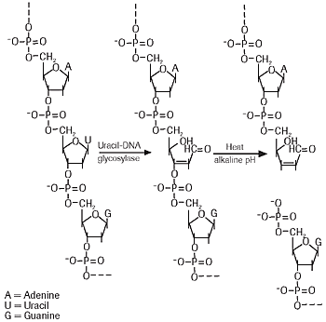

Uracil in DNA can arise as a result of misincorporation of dUMP residues by DNA polymerase, or by deamination of cytosine.
Uracil-DNA glycosylase (UDG) is a DNA repair enzyme that excises uracil residues from DNA by cleaving the N-glycosylic bond, leaving “abasic” residues (the base has been removed from the sugar).
As shown, these abasic residues then leave the DNA susceptible to cleavage (to allow excision of the bad base).

Visit:
http://www.neb.com/nebecomm/techBulletinFiles/techbulletinE5500.pdf

Read and ponder the cloning strategy described in New England Biolab’s USER system.
Answer briefly, in your own words to show me you understand.
{Directly quoting the text only shows you can read.}

1. USER Friendly cloning involves sticky end ligation of PCR product into the vector. Any PCR product, regardless of its sequence, can be cloned into the USER vector. How do you make the sticky ends on the PCR product compatible (complementary to) the sticky ends on the vector?

2. Restriction enzymes are NOT used to make the sticky ends on the PCR product. How are the sticky ends (single-strand overhangs) made?

3. The vector is provided already linearized. Why doesn’t the vector reclose on itself (without insert)?

4. Is DNA ligase used in this protocol?

5. This method is prone to nonspecific amplification; therefore some kind of hot start PCR should be used. Why is nonspecific amplification potentially a problem? (answer is NOT in the text)

