Reframing, recontextualizing and the social reconstruction of higher education in California, USA
Mark Stoner, Professor, Department of Communication Studies, California State University, Sacramento, California, USA.
Abstract: In 2009, The Chancellor of the California State University (CSU), Charles Reed, hired Sir Michael Barber to work with the presidents of the 23 campuses “aimed at setting a goal for closing the achievement gap and increasing graduation rates from their institutions, and for CSU as a system” “Deliverology,” renamed, the “Graduation Initiative” was immediately implemented. Given the effect of Barber’s presentation as pedagogic discourse in policy and practice, it merits close examination; further, systemic commentaries on and elaborations of Barber’s “deliverology” as policy enacted within the economic, political context of higher education in California also merit attention.
Starting with Bernstein concepts of framing and recontextualization, Branham and Pearce’s notion of “contextual reconstruction” and Brown’s definition of ideology, this presentation will make visible the rhetorical means by which the discourse of the CSU controls and recreates the meaning of higher education for those within and without the system. The value of the study lies in exposing the patterns of discourse as it reframes and recontextualizes higher education, thus reshaping its meaning, value and processes for the state of California.
The California State University (CSU) system, formed in 1960 and once commonly referred to as the People’s University, was for many years tuition free to all qualified student citizens of the state (Gerth, 2010, p.100). The mission of the CSU is undergraduate teaching. In the last twenty years, the state’s financial commitment to the universities (both the California State University system and the University of California system) has significantly diminished and has done so dramatically since 2008, shifting income sources directly to student fees. Within the legislature, a focus on “productivity” and “accountability” spurred efforts by the CSU administration to “prove” the value of the system.
To do so, in 2009, CSU Chancellor Charles Reed, hired Sir Michael Barber to work with the presidents of the 23 campuses for the purpose of “setting a goal for closing the achievement gap and increasing graduation rates from their institutions, and for CSU as a system” (Reed 2009). Barber conducted a two-day workshop for the CSU administration and trustees grounded in his management approach called “Deliverology” (Barber, Moffit, & Kihn 2011). The process was quickly renamed within the system as the “Graduation Initiative” and immediately implemented.
Given the effect of Barber’s presentation as pedagogic discourse regarding policy and practice, it merits close examination; further, systemic commentaries on and elaborations of Barber’s “deliverology” as policy enacted within the economic, political context of higher education in California also merit attention. Barber’s presentation repositions managerial practices and policies from railroad, hospital and educational management in the UK to higher education in California. Such recontextualizing of deliverology, from a Bernsteinian perspective, serves as a form of pedagogical discourse (Bernstein 2000). Given Barber’s audience and the occasion of his presentation, it marks a clearly intentional moment in expanding the official recontextualizing field (ORF) Bernstein posits (p. 33). Further, such discourse, as Barber’s presentation and official commentaries reveal, constructs control mechanisms that serve to legitimate very limited forms of discourse surrounding the complex problems of social justice and equality; of access to and success in higher education. Bernstein notes that, “No discourse ever moves without ideology at play” (p.32). His modal statement invites investigation. Bernstein describes pedagogic discourse as constructed “by a recontextualizing principle which selectively appropriates, relocates, refocuses and relates other discourses to constitute its own order” (p. 33). This is essentially the definition of rhetorical invention (Jasinski). Bernstein (2000) recognizes the human beings’ role in the creative process noting, “The recontextualizing principle creates recontextualizing fields, it creates agents with recontextualizing functions. …Formally, we move from a recontextualizing principle to a recontextualizing field with agents with practicing ideologies” (p. 33). Consequently, I intend to examine the discourse of “deliverology” and its policy offspring, the Graduation Initiative, from a critical, rhetorical perspective in order to answer some relevant questions originally posed by Basil Bernstein about the language and pedagogic devices. Bernstein (2000) raises the question: “is the language device in itself neutral, is the system of rules that constitute this device neutral with respect to the meaning potential and therefore neutral in respect to what comes out of it?” (p. 27). He stated prior to his question that “…the rules of the language device are not ideologically free, but the rules reflect emphases on the meaning potential created by dominant groups. Thus, from this point of view, the relative stability of the rules may well have their origin in the concerns of dominant groups. …. It raises the point that the [language or pedagogic] device is not neutral, and that the device itself may have some intrinsic regulatory function” (p.27).
I will discuss how Barber’s recontextualization of deliverology, in the context of the California State University system as the Graduation Initiative, structures an ORF of considerable sophistication, charging administrative/bureaucratic agents with repeating and enacting the ORF, but is not ideological and consequently, will fail to achieve meaningful and positively effective relationships of power within the university. While its administrative/bureaucratic agents will maintain the Graduation Initiative project as long as the leadership demands, I suspect, its nature prevents it from articulating satisfactory power relationships among all relevant power shares (public, legislature, administration, students, faculty and staff) and will stutter at the level of mere “accounting force.”
Ideology as a concept lacks a singular definition. Given the nature of the pedagogical device as rhetoric, a rhetorically grounded definition will serve as the anchor for the analysis of Barber’s presentation to the CSU. Further, rhetorical theory attending specifically to the relationship between text/discourse and context will augment the analysis and help clarify the shortcoming of Bernstein’s conclusion that while the language device is not neutral (it certainly may be persuasive), it is not necessarily ideological. And that which is not ideological will be less effective in shaping meaning and the commitment of people to such communication projects.
Brown (1978) argues that ideology is not “false consciousness” as is it often portrayed, but functions as an account for experience. Scientific theory, for example, provides an overarching scheme by which people connect ideas and experience to construct a rational explanation for the world, and is therefore ideology. He defines ideology as a communication process which serves as “symbolic construction of the world in whose superordinate ‘name’ human beings can comprehensively order their experience and subsume their specific activities” (p. 126). Implicit in the definition are the qualities of ideology as communication, as a product of human symbolic interaction, as a source of categories that when “comprehensively ordered” provide meaning for people and their experiences and rules for categorizing. The relational effect of ideologizing—articulating relationships between objects and people—makes it central to understanding experience. For Brown, what distinguishes ideology from other forms of rhetoric or communication is the dimension of ultimacy. Discourse that can “comprehensively subsume human experience” (p. 126) may be the result of pedagogic discourse, but it may not. I part with Bernstein’s totalizing conclusion on this point and present Barber’s pedagogic discourse (2009) as a case that fails to construct or account for significant relationships among people and consequently fails to engender via the ORF a sense of commitment and meaning relative to the policy project of increasing graduation rates among students and faculty. It fails to reach the level of ideology.
Recall that Bernstein (2000) defines pedagogic discourse as a “principle for delocating a discourse, for relocating it, for refocusing it, according to its own principle” (p. 32). It is in effect a recontextualizing principle and since it deploys the same symbolic media as rhetoric, I will apply relevant rhetorical theory to connect Bernstein’s and Brown’s analyses of the language device as ideology.
Starting from a premise consistent with Bernstein, Branham and Pearce observe the reflexive nature of text and context, noting that, “Every communicative act is a text that derives meaning from the context of expectations and constraints in which it is experienced. At the same time, contexts are defined, invoked and altered by texts” (p. 19). They continue, “In practice … contexts tend to be relatively stable, because people and societies work to construct and enforce a re-creation of shared experiences” (p. 19). It is this stability (which was asserted similarly by Bernstein (2000) regarding the constitutive rules of the pedagogic device) that facilitates meaning-making and ideologizing over time avoiding chaos (and meaninglessness) while permitting necessary adaptations of explanations and maintenance of identity relative to changing conditions in the world of experience. Branham and Pearce posit four patterns of discursive response to re/contextualizing exigencies. (In Bernstein’s theory, exigencies would often correspond to learning events; in the case under analysis here, the CEO’s need for means to “prove” the value of the CSU served as rhetorical exigence and Barber’s relocation/recontextualization of deliverology was a rhetorical response to the exigence from within the ORF.) The four patterns of contextual reconstruction are: conformity to expectations of the context; non-participation wherein communicators are unwilling to “relocate their knowledge”; desecration which is marked by creation of texts that are unexpected, provocative, purposely disruptive and confusing and reconstruction of context via “simultaneous relation to multiple contexts” (Branham & Pearce 1985, p. 29). They contextualize reconstruction this way: “In any period of intellectual change, advocates of new ideas must address audiences whose vision reflects the soon-to-be-outmoded universe of discourse, and the arguments must partake of that universe sufficiently to provoke understanding and change” (p. 29). Their characterization of rhetorical action essentially describes the discursive core of good pedagogy. The patterns of response are useful, but not as provocative as their conceptualization of text-context relations which serve to tie together Bernstein’s concept of the pedagogical device and Brown’s conception of ideology. I will use them to make my case that Barber’s discourse (and the programmatic residue being the Graduation Initiative) misses the essential element of “interpersonal categorizing” (Brown 1978) and how that loss makes Barber’s pedagogical discourse non-ideological and not compelling. That conclusion also points to a need for modification of Bernstein’s ideas to accommodate this pedagogical phenomenon.
Branham and Pearce posit three forms of text-context relations: “charmed loops, in which texts and contexts are mutually entailing; subversive loops, in which texts and contexts are mutually invalidating; and strange loops, in which texts and contexts are mutually transformative” (p. 23). Given the case of Barber’s relocation of deliverology to the CSU, none of these forms is properly descriptive. A forth possibility, however, is suggested by Branham and Pearce’s insight that contextual reconstruction by relocating texts requires some reflexive interaction explaining (or assuming) the relevant features of the text to the context. Barber’s presentation attempts this but the loop connects relocated (and therefore “new” for some audiences) text and its new context, but does not have any relationship to the original context and therefore no impact on it.
The effect of Barber’s approach is a closed loop, a reflexive, reconstructive loop that is built not for purposes of explanation but for control (Figure 1.). It is reflexive in that deliverology springs from and reinforces neoliberal values; it is reconstructive in that Barber’s presentation reconstructs and refocuses administrator’s attention on outcomes over process; education as process ceases to be a concern; production of graduates becomes the main concern.
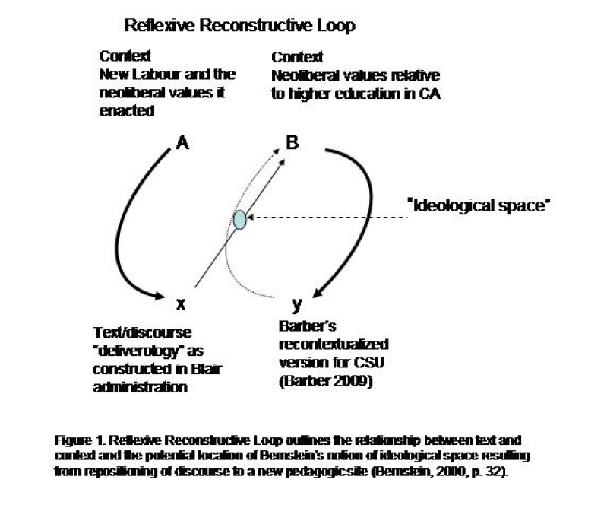
Brown argued that “transformation of experience into symbols fulfills the uniquely human propensity for categorizing all experience” (p.127). Abstractions (significant symbols) name categories, categories of categories and so on, so that people can articulate relationships and locations of power in order to construct their identities within a social web. Ideologizing is the broad communication project that makes human experience human by connecting contexts.
I argue that deliverology as the “graduation initiative” fails to connect contexts and thus fails to properly occupy the ideological space Bernstein argued was the product of pedagogic discourse. Barber’s PowerPoint presentation as pedagogical discourse, constructs a structure of surveillance and summary, and in so doing fails to articulate meaningful categories of experience and relationship. There is nothing in the discourse to explain past or present conditions; no vision of new possibilities of relationship are offered. The interdependence of major power shares—particularly students and faculty—are not recognized; the social, negotiational dimensions of the language device are missing; the “agents of record” are only top administrators in the CSU. Rather than work with all relevant entities, the agents of record are charged with surveillance of the staffs of delivery units and collection of regular progress reports. Power is not negotiated, shared among all parties who have a role in the education process and who finally interpret the meaning of “graduation” (e.g. some never intend to graduate). Power is not a communication medium to facilitate circulation and relocation of relevant discourses, but a blunt instrument deployed to keep staff in line (being “accountable” in this competitive, neoliberal, capitalist model is a euphemism for “vulnerable and controllable”).
In sum, my presentation attempts to establish two main insights. The first is how deliverololgy has been recontextualized for purpose of reframing the attention of CSU administration and the role of education within ongoing cultural struggle in California to impose neoliberal values, policies and their attendant processes on the largest system of higher education the United States. The second and more important one for our panel’s concern is that the pedagogical discourse fails to function ideologically and, I think, will ultimately fail the people who make up the CSU as an educational system. The closed discursive loop as presently constructed will become a “deviance amplifying” (Brown) cycle leading to greater and greater calls for “measurable” data; for calls to standardize teaching to produce such data and ultimately for the failure of the CSU as an educational system.

References
Barber, M. (2009). Raising Overall Achievement and Closing Gaps: Delivering the Access to Excellence. http://graduate.csuprojects.org/uploads/lK/y2/lKy2ZIOJunEl-FqKEGkrSw/CSU-EDI-Deck----10.28.09----FINAL.PDF
Barber, M., Moffit, A. & Kihn, P. (2011). Deliverology 101: A Field Guide for Educational Leaders. Thousand Oaks, CA: Corwin Press.
Brown, W. R. (1978) Ideology as communication process. Quarterly Journal of Speech, 64, 123-140.
Bernstein, B. (2000). Pedagogy, Symbolic Control and Identity: Theory, Research, Critique, Revised Edition. Lanham, MD: Rowman & Littlefield.
Branham, R. J. & Pearce, W. B. (1985). Between text and context: Toward a rhetoric of contextual reconstruction. Quarterly Journal of Speech, 71 19-36.
California State University Launches Bold Graduation Initiative to Increase Number of Students Earning Degrees (2010). Retrived from http://www.calstate.edu/PA/News/2010/release/3graduation-initiative.shtml
Gerth, D. R. (2010). The People’s University: A History of the California State University. Berkeley, CA: Berkeley Public Policy Press.
Jasinski, J. (2008). "Invention and Rhetoric." The International Encyclopedia of Communication. Donsbach, W. (ed). Blackwell Publishing, 2008. Blackwell Reference Online. 28 June 2012 DOI: 10.1111/b.9781405131995.2008.x
Reed, C. (2009). Chancellor’s Report to the Board of Trustees, November 18, 2009. Retreived from: http://www.calfac.org/sites/main/files/file-attachments/reed_report_1109.jpg
Toulmin, S. (1969). The Uses of Argument. Cambridge: Cambridge UP.

California’s other system of higher education, the prestigious University of California (UC), is primarily focused on research and graduate education.
By way of illustration, listed below are the fees for two representative campuses that serve the state capitol region: California State University, Sacramento and University of California, Davis: CSUS student fees 2008 $3854; 2011 $6572; 170% increase in 3 years (avg. increase of $900/yr) UCD student fees 2008 $28,545; 2011 $35,958.91; 136% increase in 3 years (avg. increase of $2471/yr)
[Barber] … served the UK government as Head of the Prime Minister’s Delivery Unit (from 2001-2005) and as Chief Adviser to the Secretary of State for Education on School Standards (from 1997-2001). Before joining government he was a professor at the Institute of Education at the University of London.
http://www.calstate.edu/executive/reparchive/091118.shtml
Barber’s presentation can be reviewed at http://www.csus.edu/indiv/s/stonerm/BarberDeliverologyPPTtoCSU.pdf
See Toulmin, p. 18 ff for a discussion of modal terms.
An example of a classic case of text reconstructing context in American history is Lincoln’s Gettysburg address. Lincoln very explicitly noted that he and the audience were not at the battlefield to hallow it with their words, but to be changed (“hallowed”) themselves by the experience. Deliverology as presented by Barber has no reference (other than by example) to UK government, though it does reference itself within the new context as the means by which it is to be implemented. Mark Stoner, 2012

