Helpful Hints for assembling your ecosystem project:
- Distilled Water v. Tap Water
Distilled water and tap water have different pH. Distilled water is more acidic and has a pH of about 5. Tap water, after being left out for 24 hours, is more neutral and has a pH of about 7. When conducting this project either distilled water or tap water will work. Both the Tetra and Red Platy fish will be able to adjust and survive in either water. However, when kids change the water they have to make sure to keep the pH constant because the fish do not like it when their environment keeps changing.

Distilled Water Tap Water
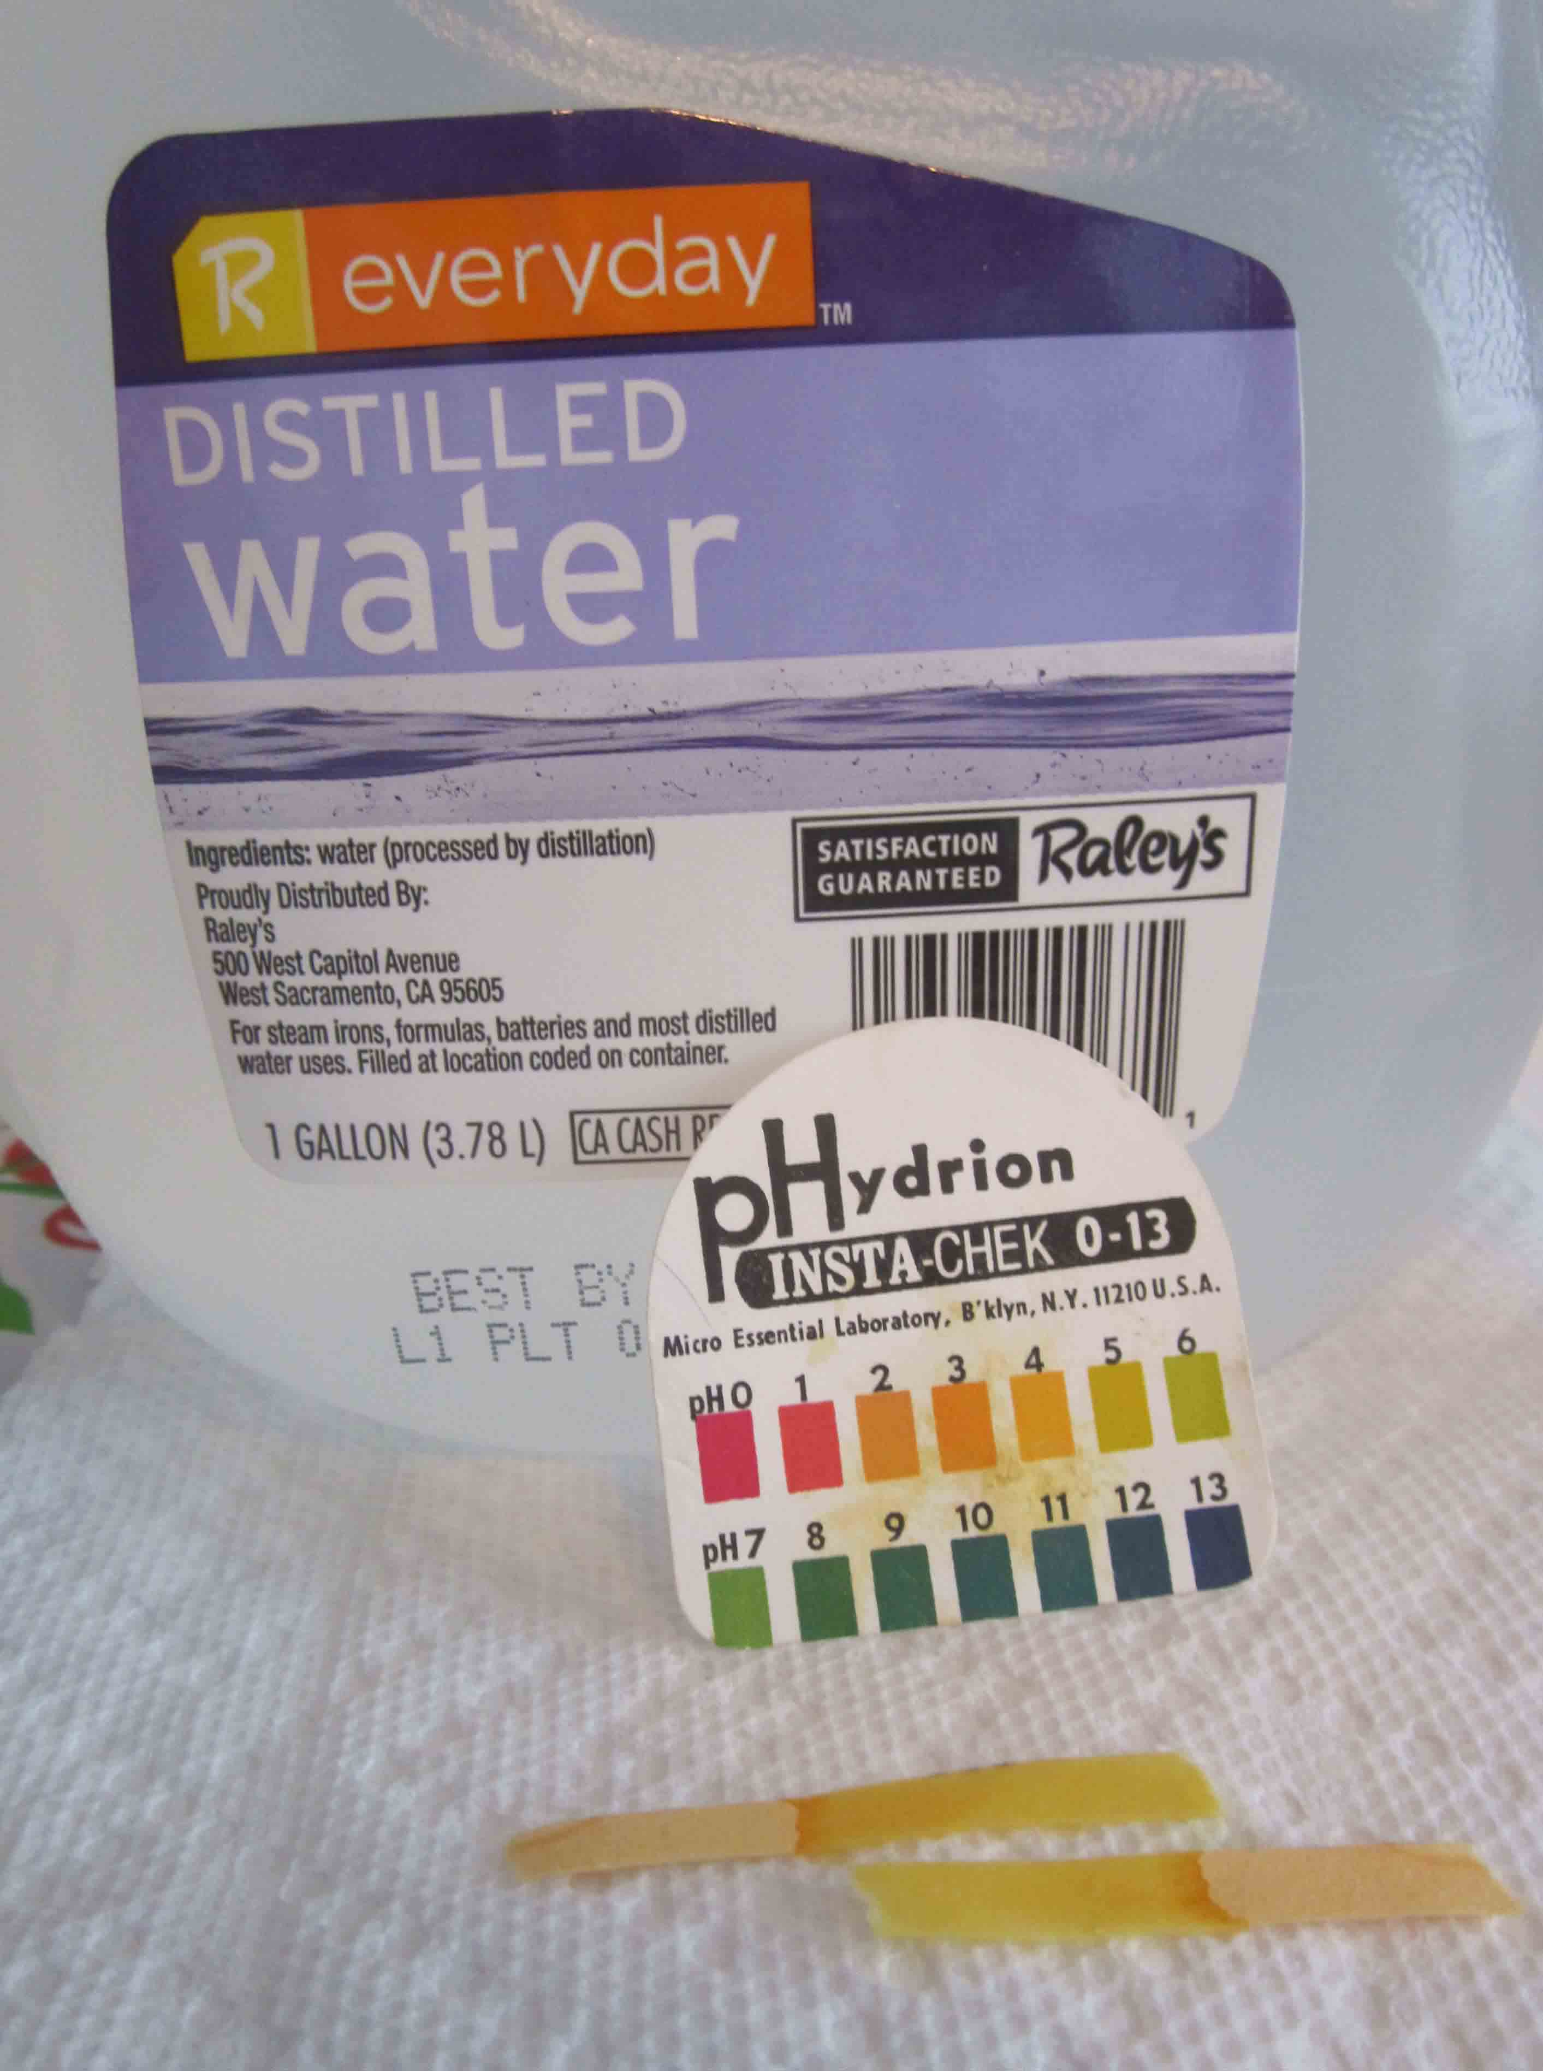
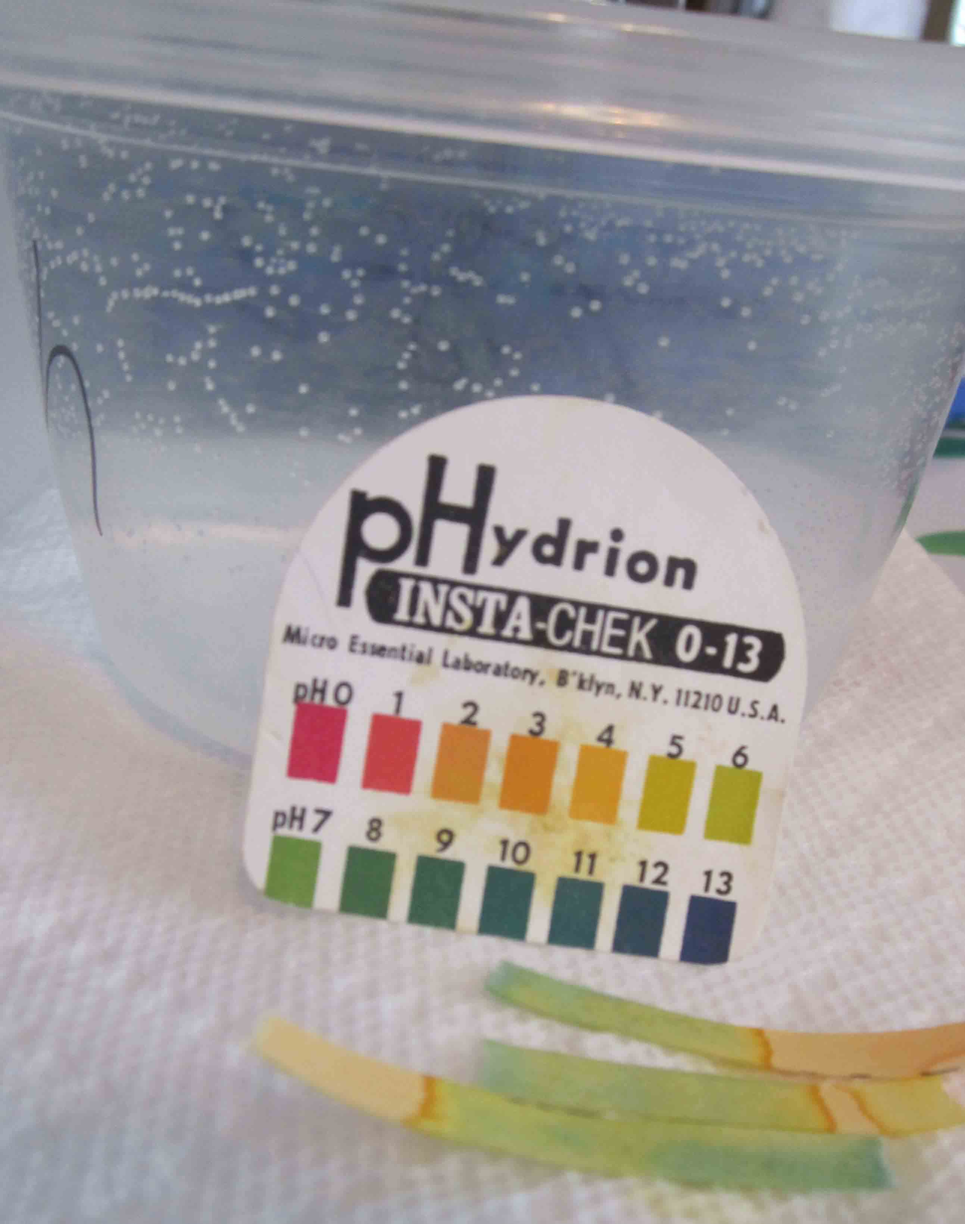
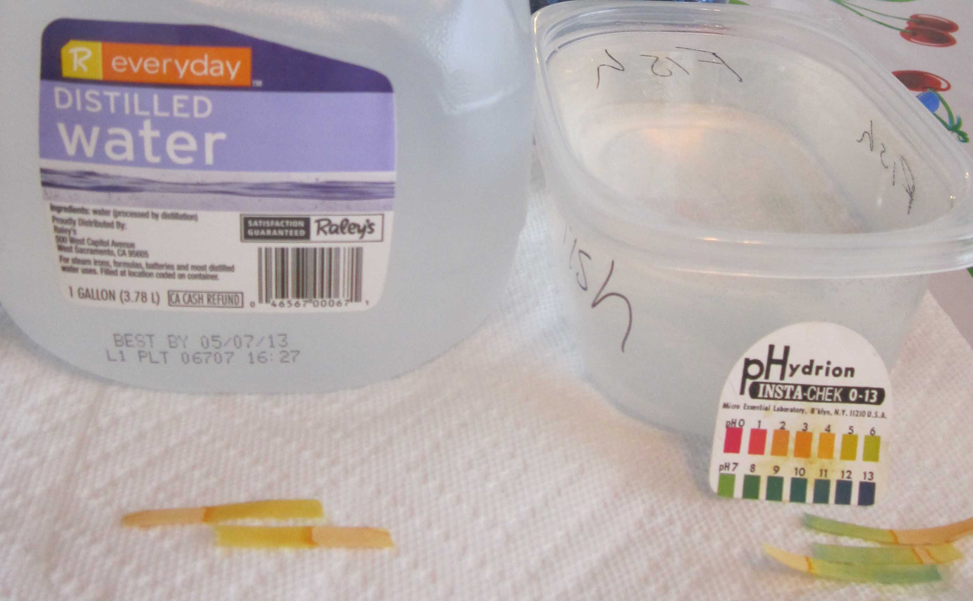

- Cost of Project (for 30 kids):
Item | Source | Cost per Item | Total cost
Two 2-Liter Bottles | Recycle | $0.00 | $0.00
Large push pins | Staples | $3.29 | 1 x $3.29 =  $3.29
Gravel | PETCO | $15.99 | 1 x $15.99 =  $15.99
Plant (Elodea) | PETCO | $2.99 | 30 x $2.99 =  $89.70
Fish (Tetra) | Capitol Aquarium | $2.88 | 30 x $2.88 =  $86.40
Fish (Red Platy) | Capitol Aquarium | $1.65 | 30 x $1.65 =  $49.50
Shrimp (Ghost Shrimp) | Capitol Aquarium | $0.25 | 30 x $0.25=  $7.50
Total (with Tetra):$202.88
Total (with Red Platy):$165.98

- Example Donation Letter Attached

