Quick Facts About Your Ecosystem  Plant: Elodea is a waterweed that acts as a food source for the fish. The Elodea creates oxygen for the ecosystem, but can also be a dangerous weed if it is not native to the environment.  Fish: Red Moon Platy are fish that feed off of elodea and like to live in an environment where the plants are loosely arranged. These fish should be kept in water that is between 70 and 75 degrees.  Shrimp: Ghost Shrimp are decomposers that eat the small particles of food in the tank and help keep the tank clean.  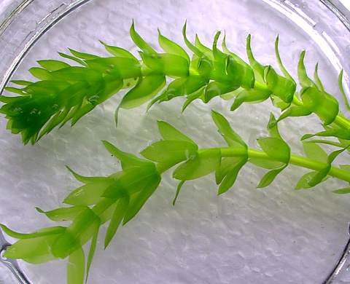  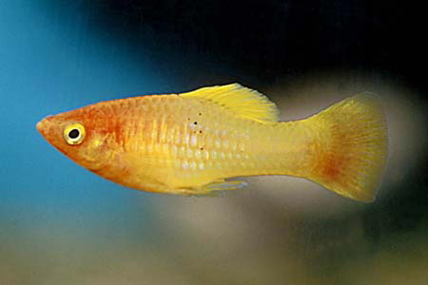  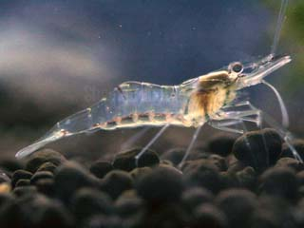  Water: when changing the water in your ecosystem make sure to use tap water and leave it out for a day, to dechlorinate the water, before putting your fish in.  CAUTION: Do not leave your ecosystem in direct sunlight. Do not release elodea, fish, or shrimp into the environment.  Plant, fish, shrimp are all from Capitol Aquarium. | Quick Facts About Your Ecosystem  Plant: Elodea is a waterweed that acts as a food source for the fish. The Elodea creates oxygen for the ecosystem, but can also be a dangerous weed if it is not native to the environment.  Fish: Red Moon Platy are fish that feed off of elodea and like to live in an environment where the plants are loosely arranged. These fish should be kept in water that is between 70 and 75 degrees.  Shrimp: Ghost Shrimp are decomposers that eat the small particles of food in the tank and help keep the tank clean.  Water: when changing the water in your ecosystem make sure to use tap water and leave it out for a day, to dechlorinate the water, before putting your fish in.  CAUTION: Do not leave your ecosystem in direct sunlight. Do not release elodea, fish, or shrimp into the environment.  Plant, fish, shrimp are all from Capitol Aquarium.
Quick Facts About Your Ecosystem  Plant: Elodea is a waterweed that acts as a food source for the fish. The Elodea creates oxygen for the ecosystem, but can also be a dangerous weed if it is not native to the environment.  Fish: Red Moon Platy are fish that feed off of elodea and like to live in an environment where the plants are loosely arranged. These fish should be kept in water that is between 70 and 75 degrees.  Shrimp: Ghost Shrimp are decomposers that eat the small particles of food in the tank and help keep the tank clean.  Water: when changing the water in your ecosystem make sure to use tap water and leave it out for a day, to dechlorinate the water, before putting your fish in.  CAUTION: Do not leave your ecosystem in direct sunlight. Do not release elodea, fish, or shrimp into the environment.  Plant, fish, shrimp are all from Capitol Aquarium. | Quick Facts About Your Ecosystem  Plant: Elodea is a waterweed that acts as a food source for the fish. The Elodea creates oxygen for the ecosystem, but can also be a dangerous weed if it is not native to the environment.  Fish: Red Moon Platy are fish that feed off of elodea and like to live in an environment where the plants are loosely arranged. These fish should be kept in water that is between 70 and 75 degrees.  Shrimp: Ghost Shrimp are decomposers that eat the small particles of food in the tank and help keep the tank clean.  Water: when changing the water in your ecosystem make sure to use tap water and leave it out for a day, to dechlorinate the water, before putting your fish in.  CAUTION: Do not leave your ecosystem in direct sunlight. Do not release elodea, fish, or shrimp into the environment.  Plant, fish, shrimp are all from Capitol Aquarium.

