Creating an Ecosystem.
Student project for 4th graders from Sheila Whitney, Arlene Hein Elementary
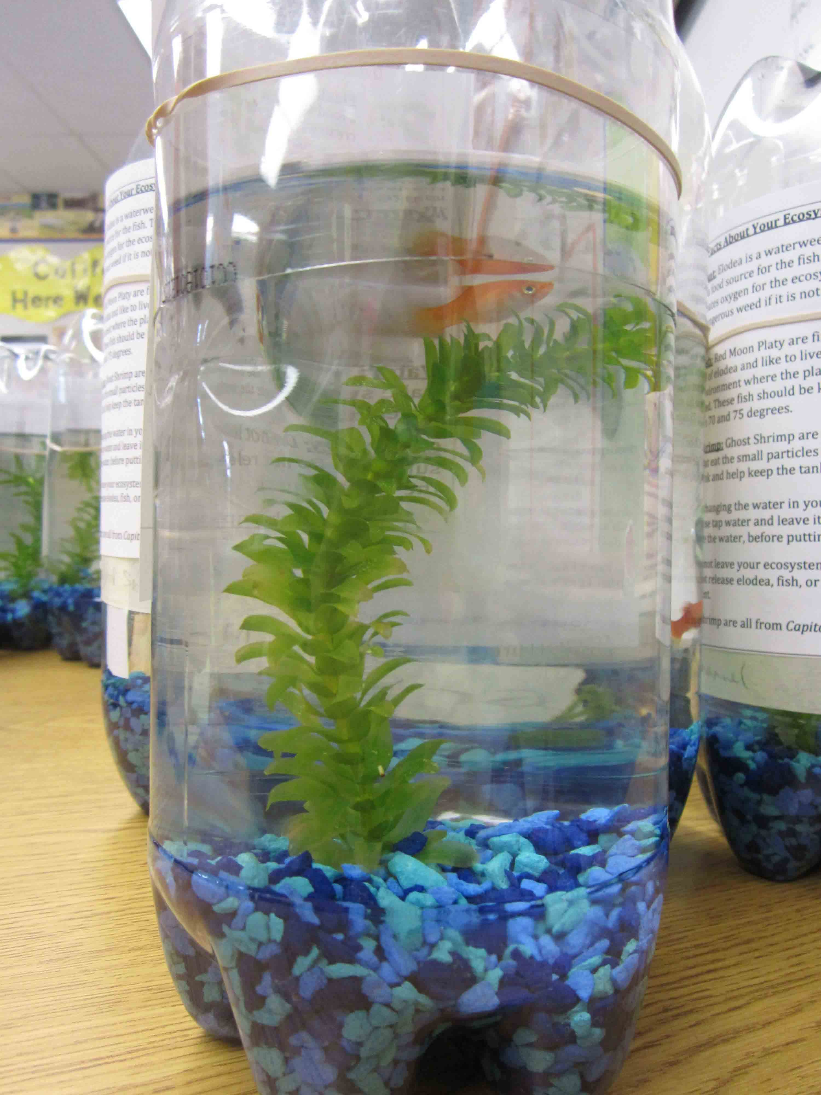
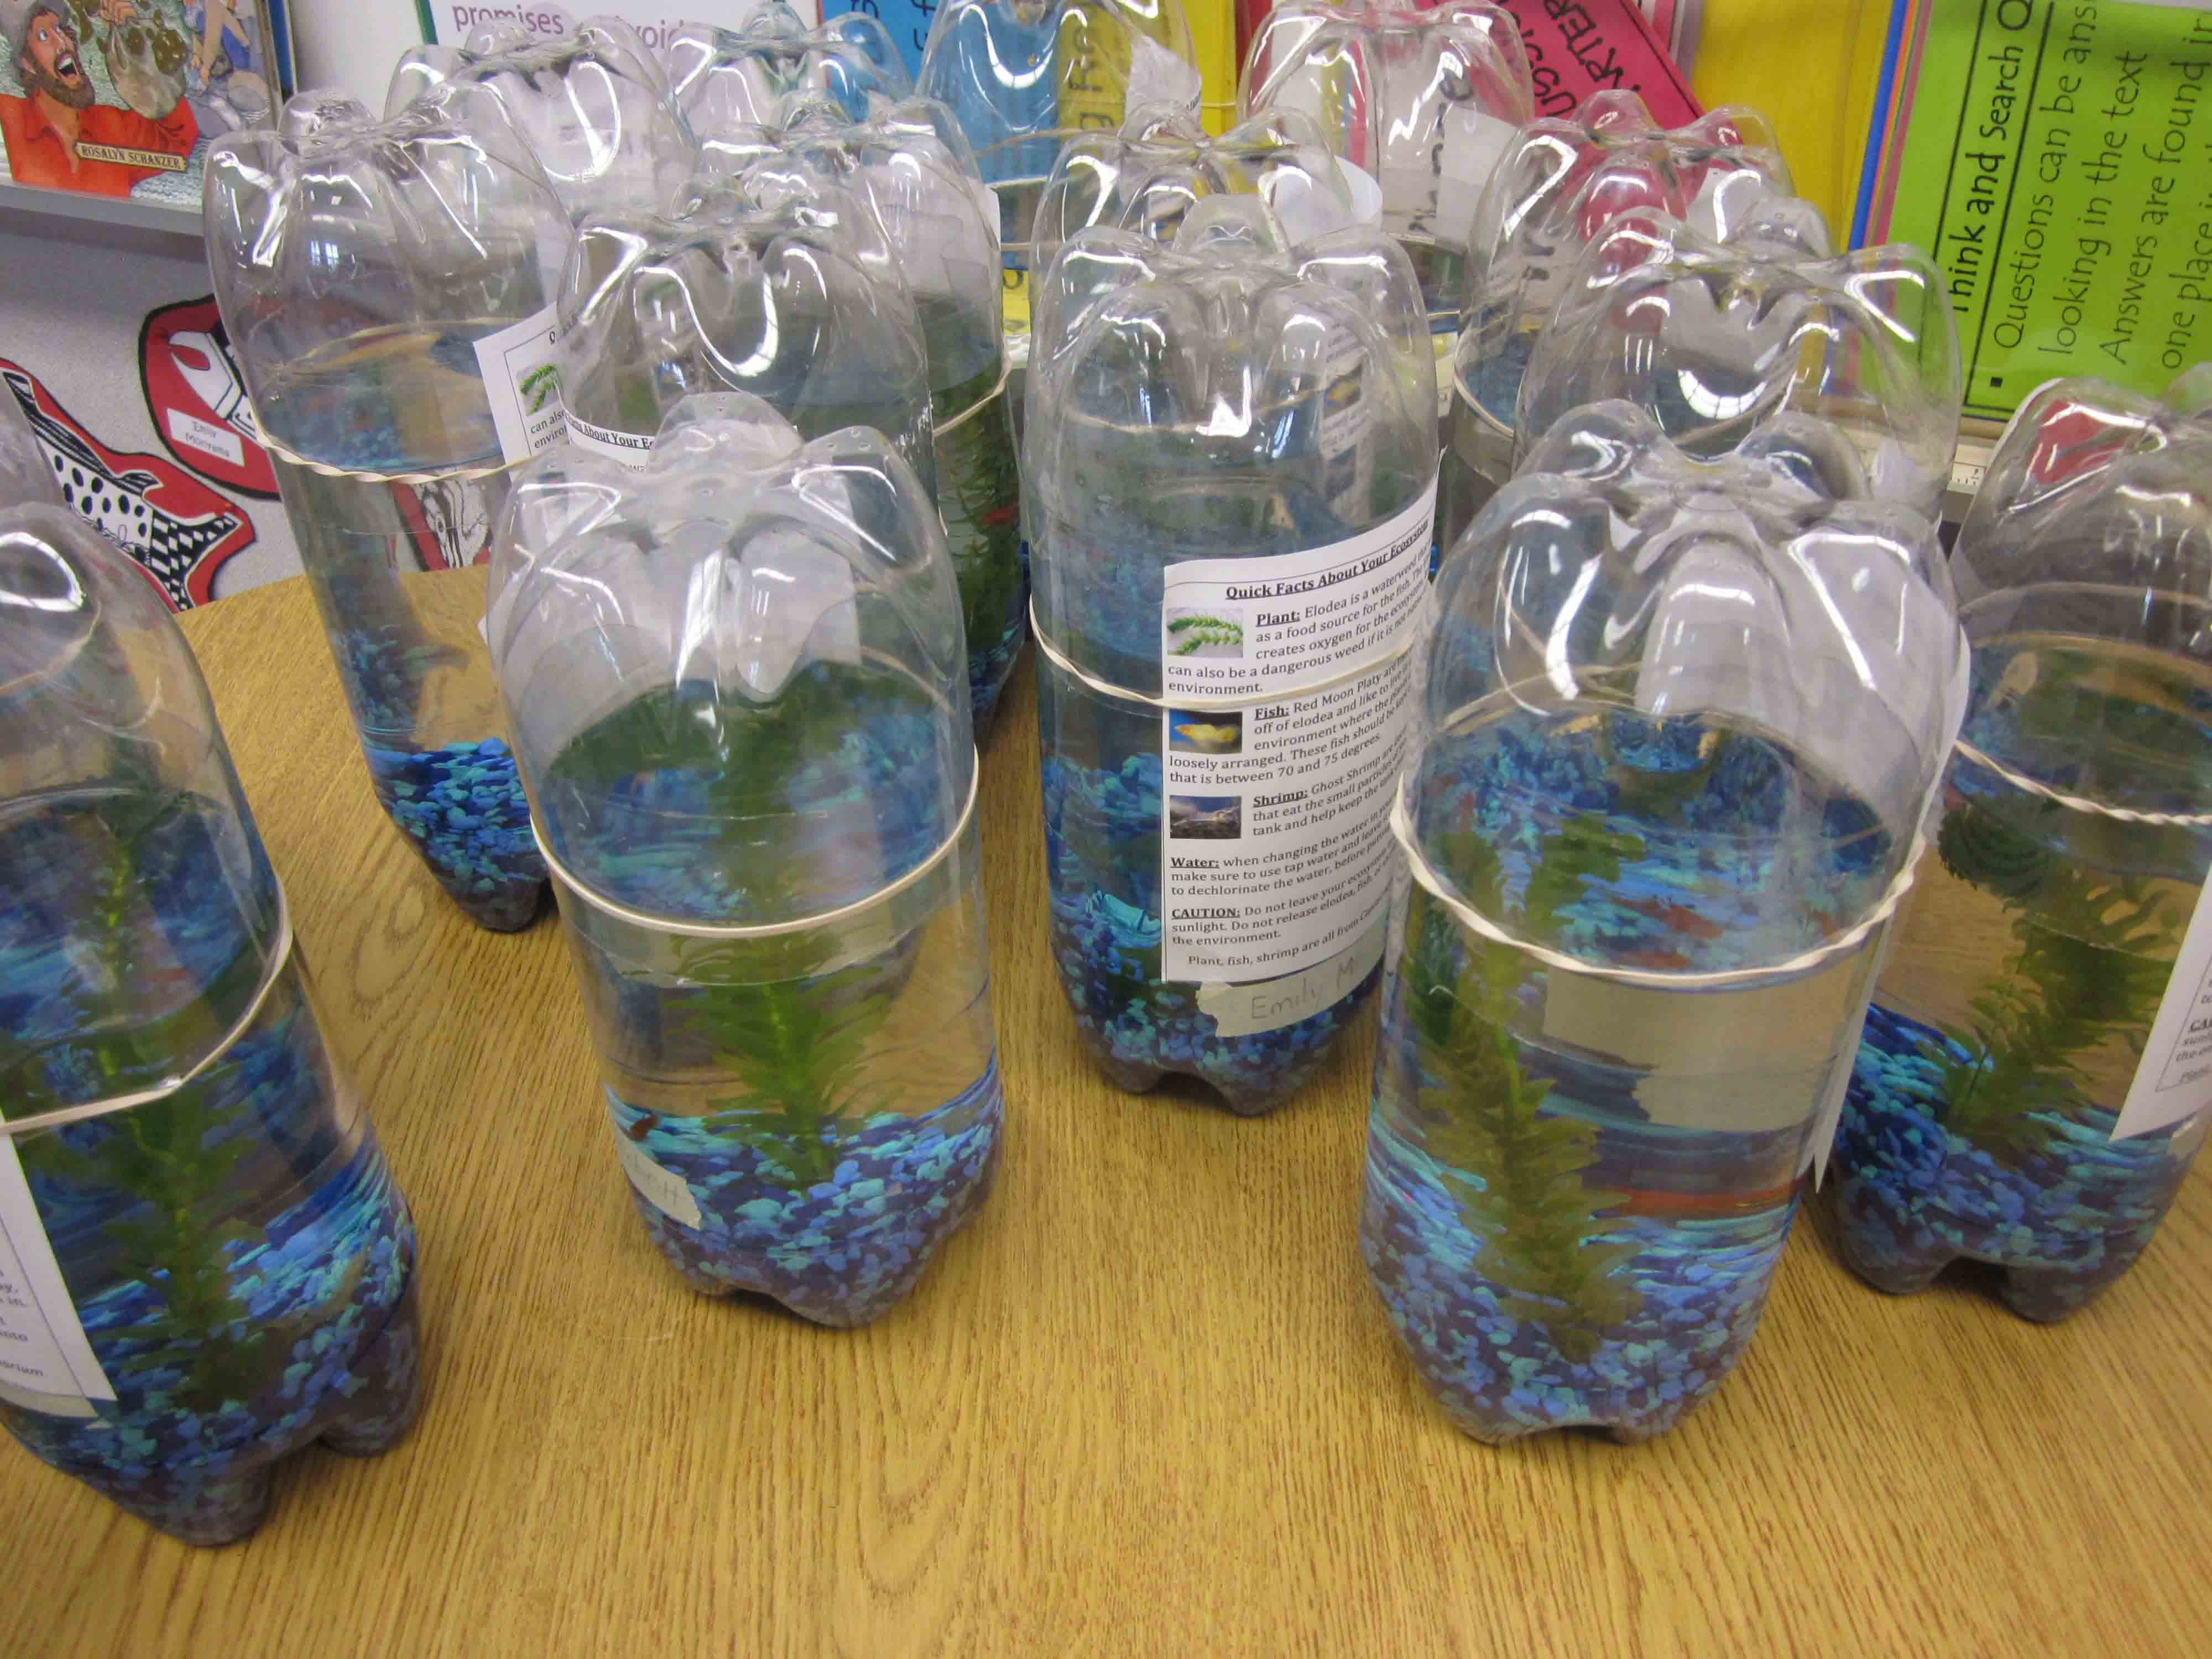

A. Supply List
- 2 2-Liter bottles  - Push pins  - Exactoknife  - Scissors  - Ruler  - Dry Erase marker  - Gravel  - Plant (Elodea)  - Fish (Tetra or Red Platy)  -Shrimp (Ghost Shrimp) | 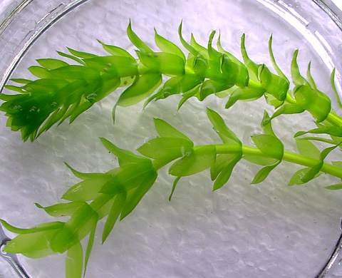  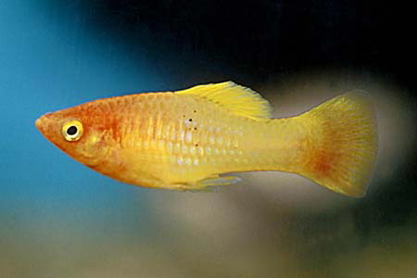  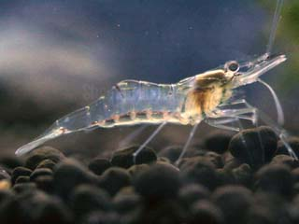  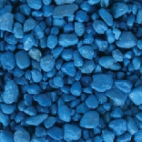  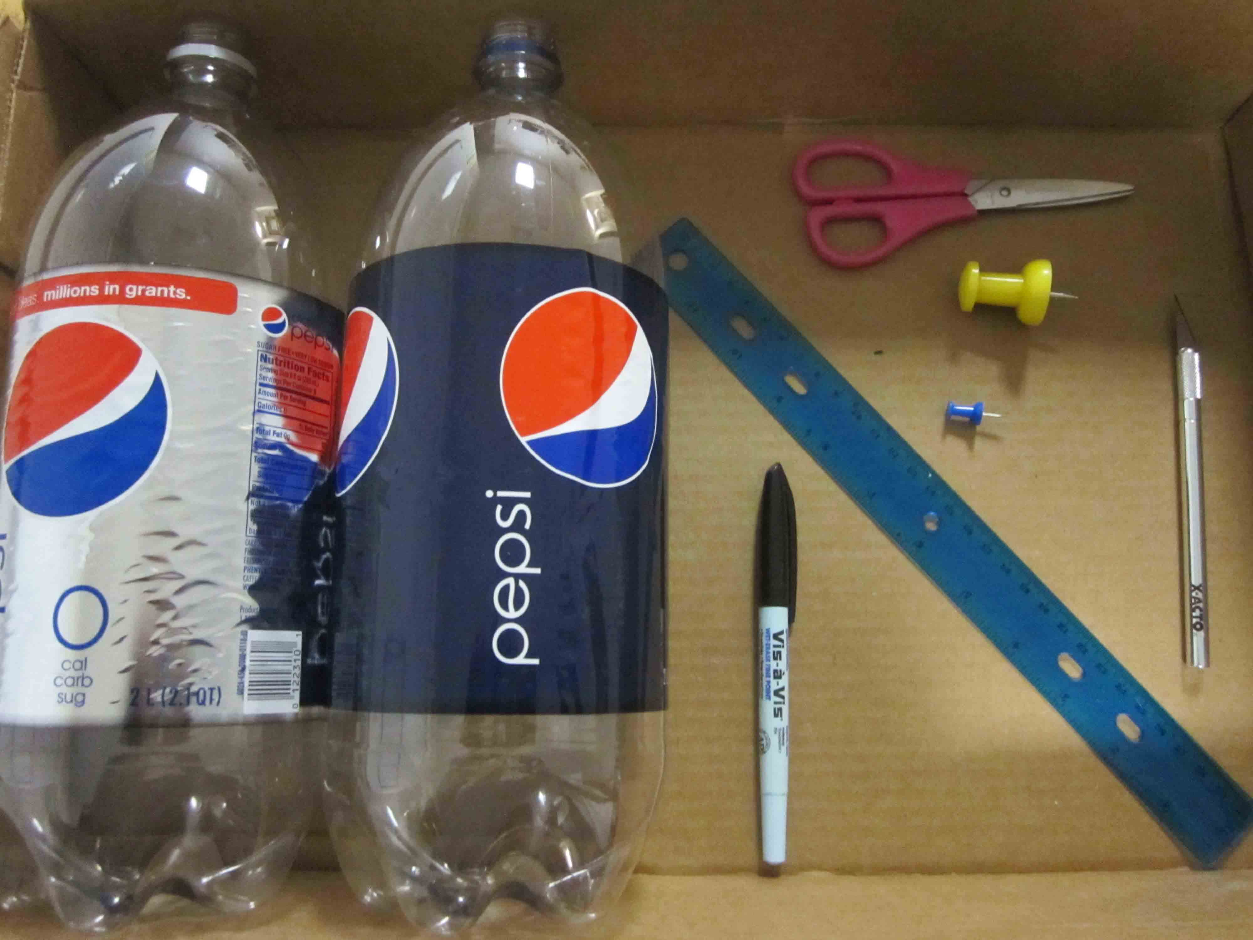

B. Step by step directions:
1. Start by washing out the 2 2-liter soda bottles and removing the labels. Do NOT use soap to wash out the bottles.  *If planning on using tap water, leave out 2L of tap water per ecosystem in an open container to dechlorinate for at least for 24 hours. | 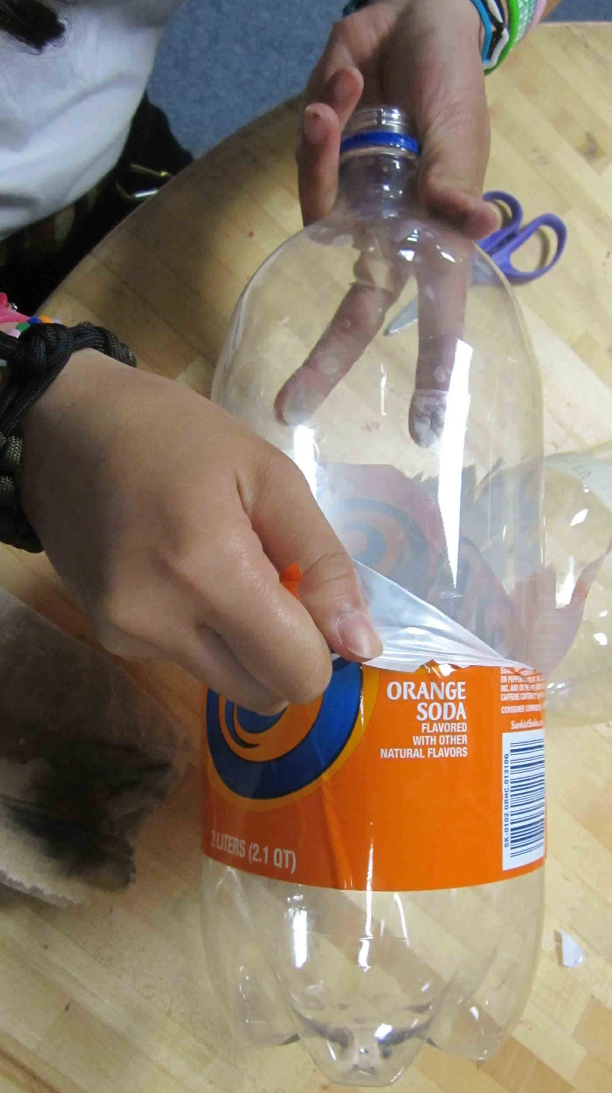

2. Using the ruler, measure 8-inches from the bottom of the bottle and make a mark using the dry erase marker. Do this all around the bottle so it is clear where to cut. Then do the same thing for the second bottle but this time measure 4-inches from the bottom. The 4-inch cut bottle will be the lid of the ecosystem. | 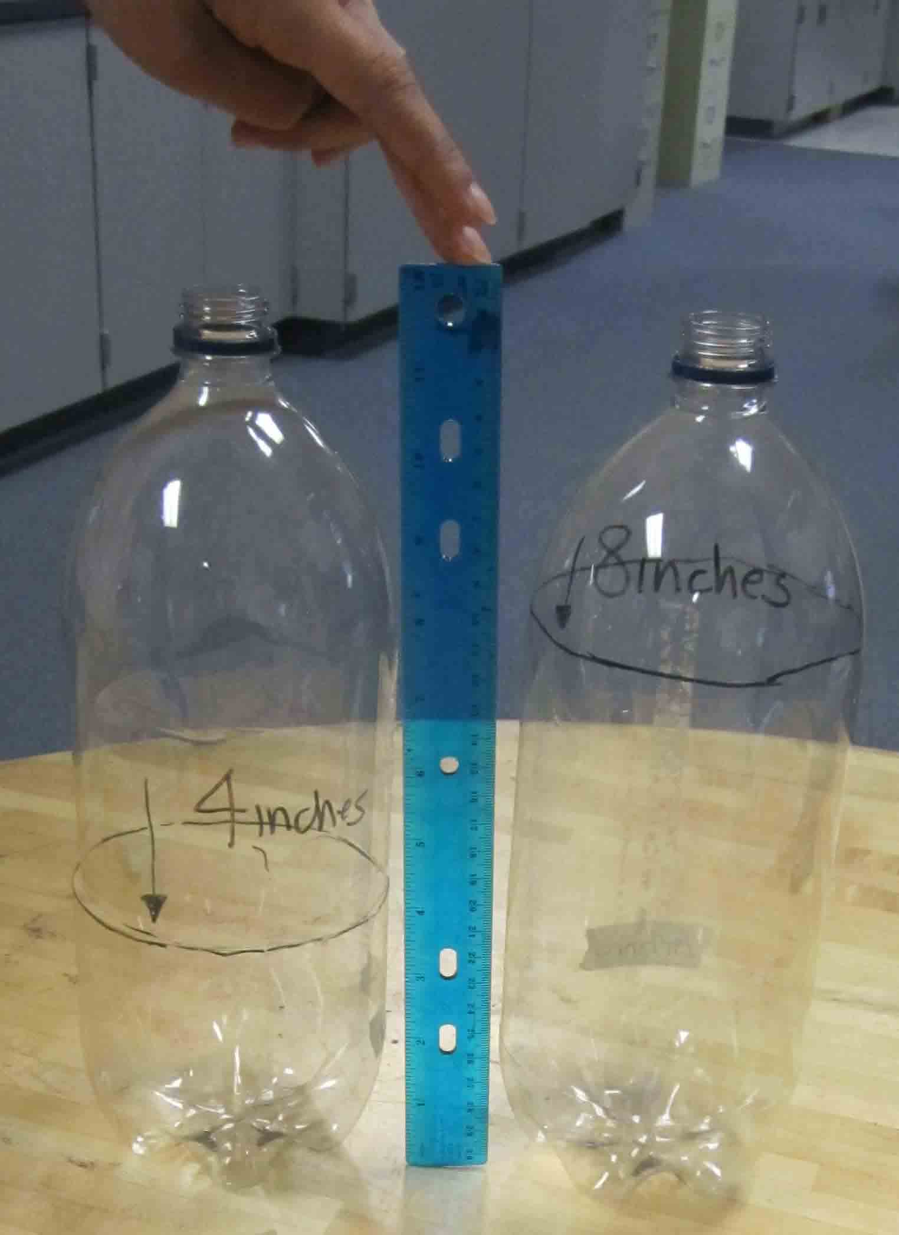

3. Carefully, use the exact-o-knife to poke a hole in the bottles, on the lines you just marked. Then use the scissors to finish cutting around the rest of the bottles. Only use the exact-o-knife to poke the hole because if you use it to cut the entire bottle it will become dull. | 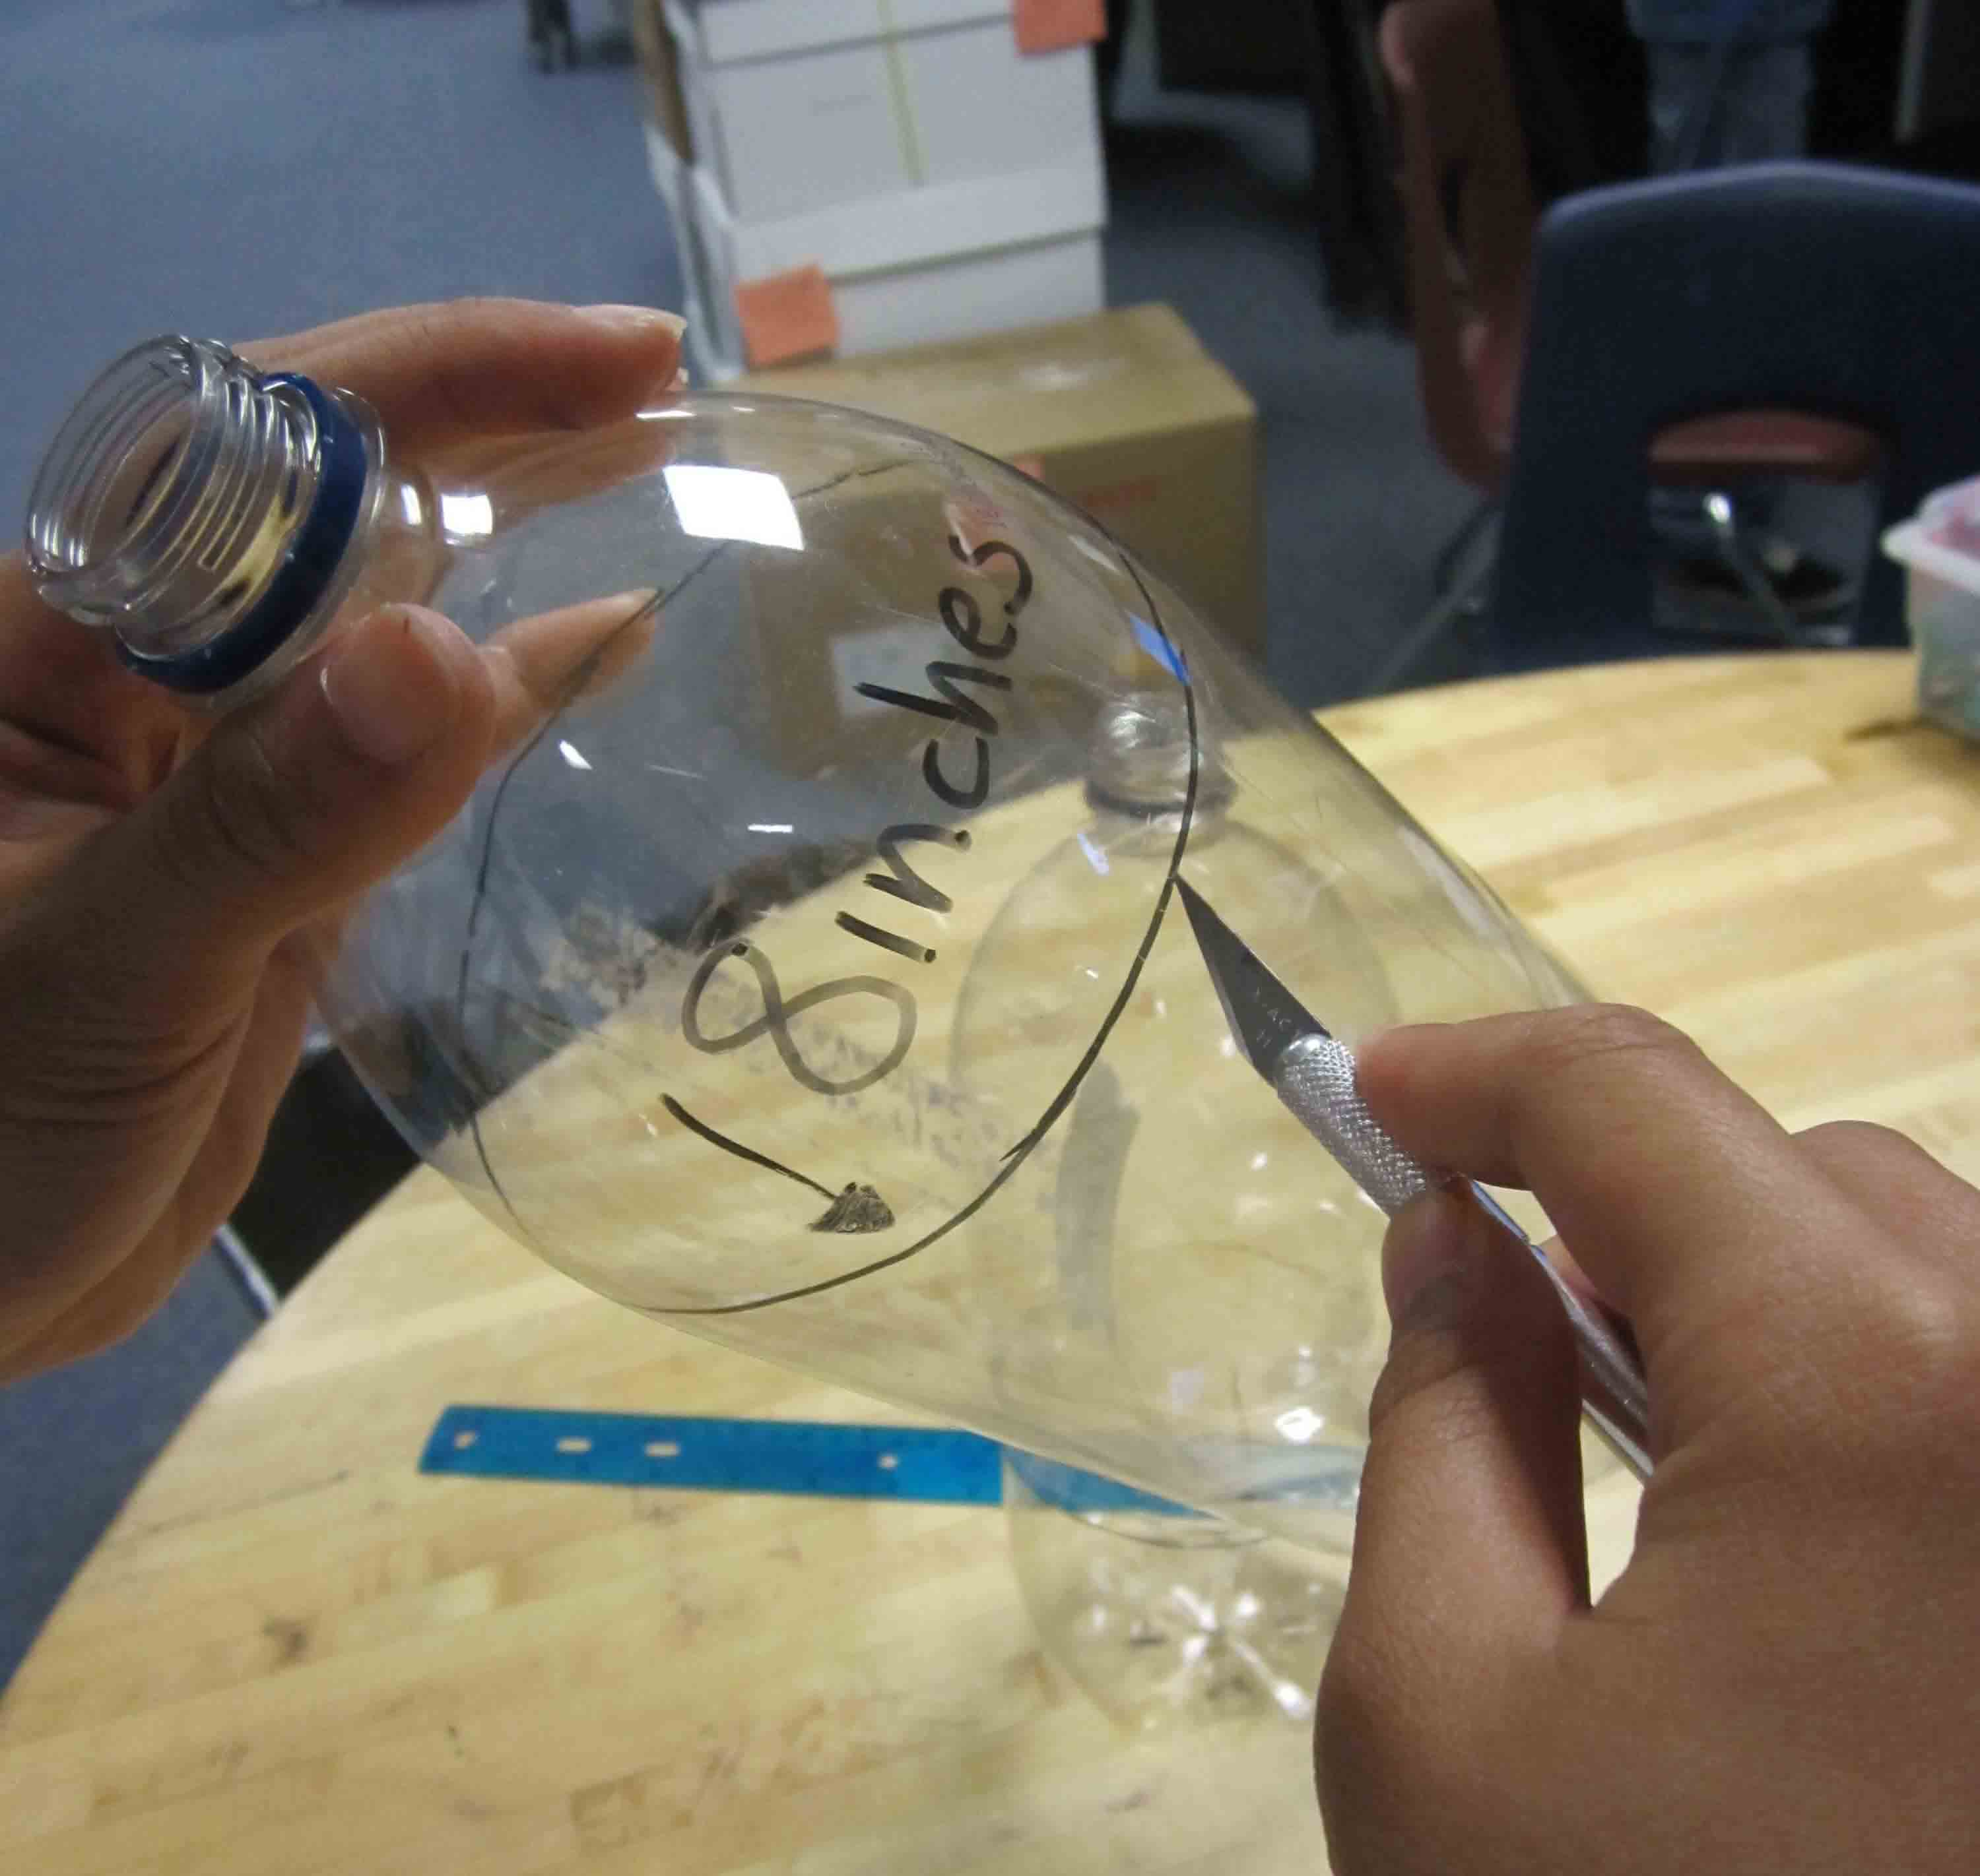  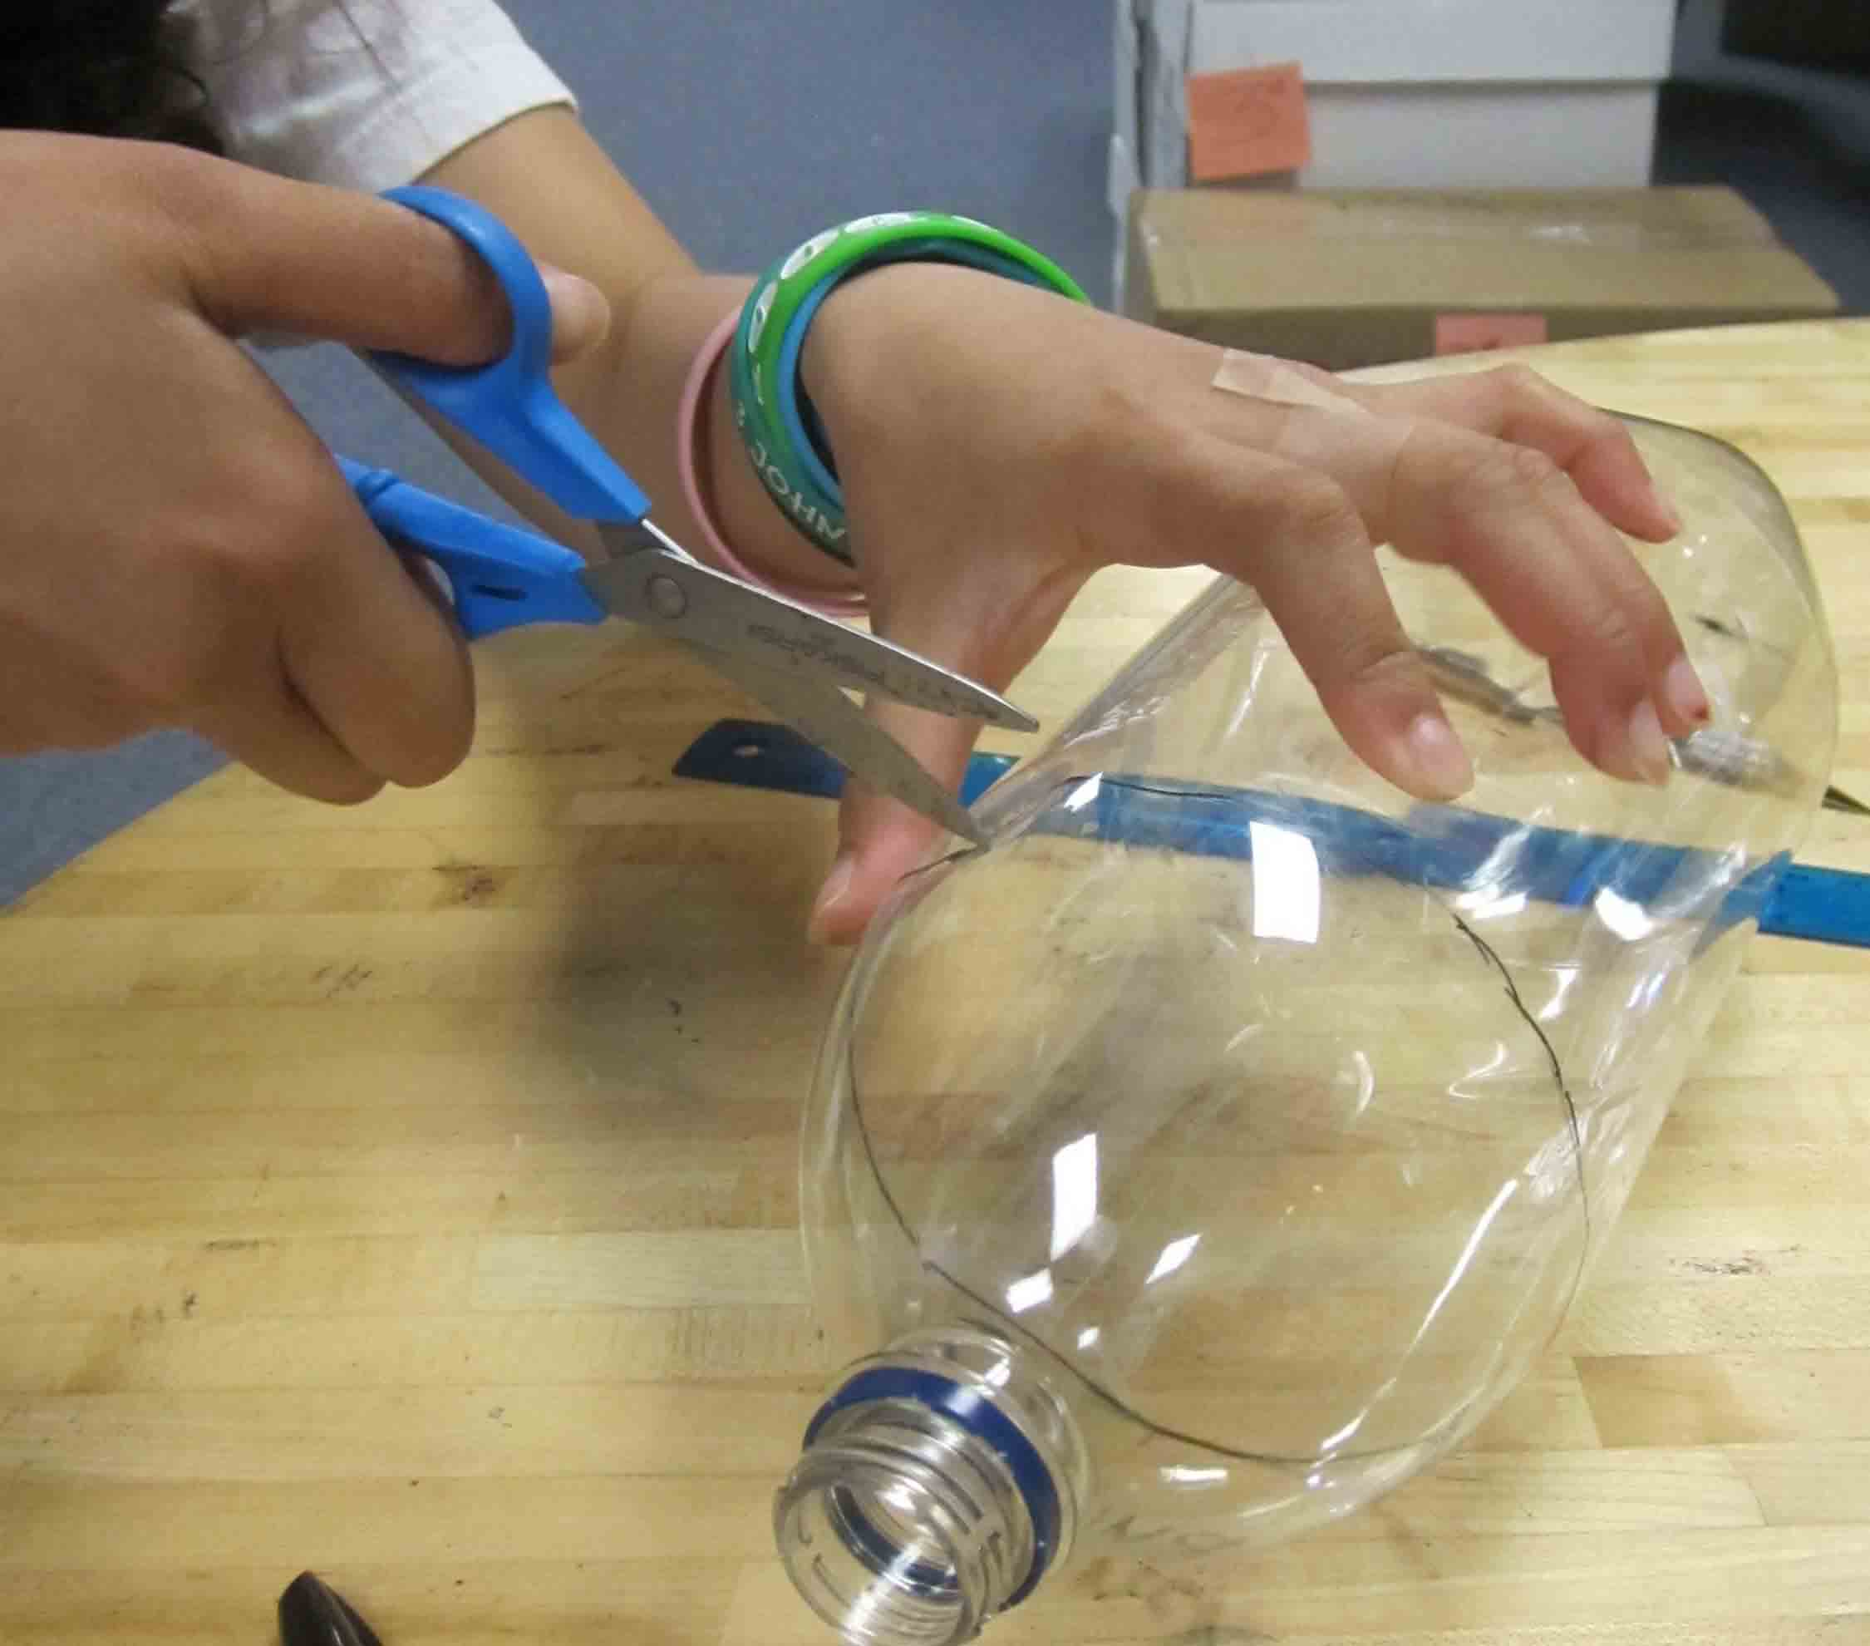

4. Then, using the pushpins poke about 3-4 air holes on each mound on the top of the lid of your ecosystem (the 4-inch cut bottle). It is important to poke the holes in the lid and not the bottom because you will be pouring water in the bottom half of your ecosystem. | 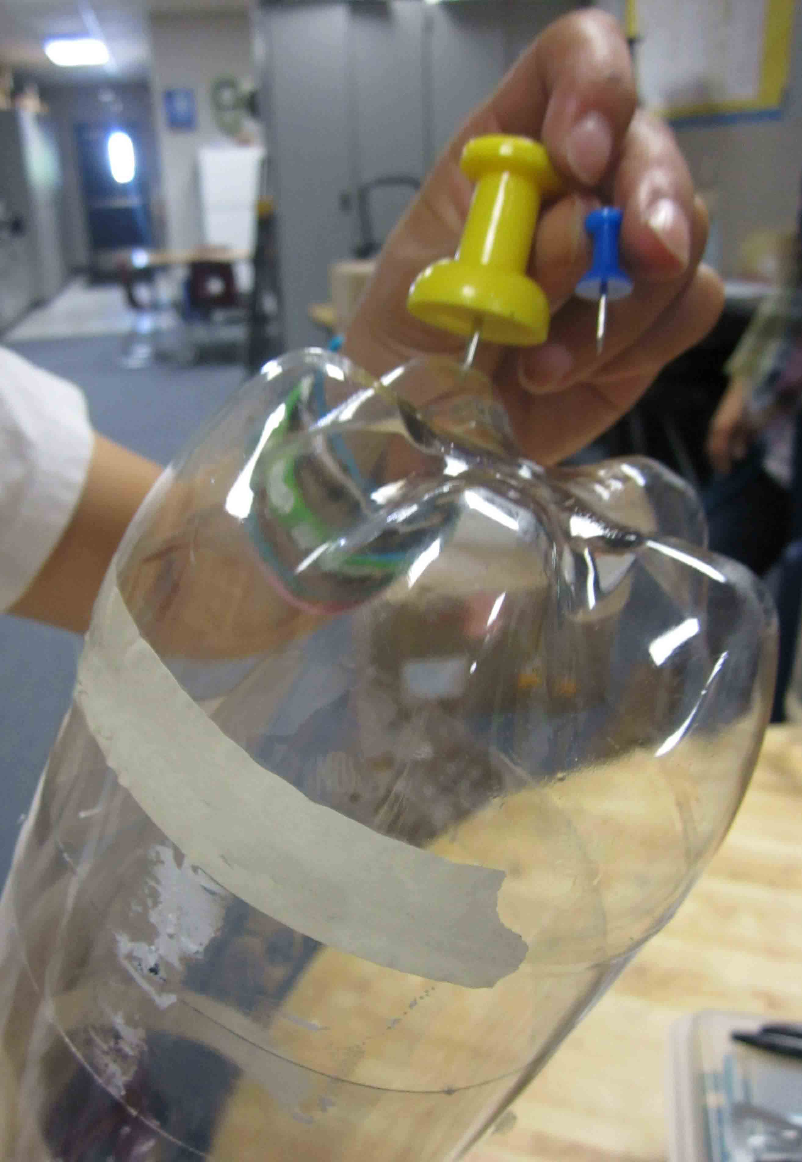

5. Fill the 8-inch cut bottle with about 2½-3 inches of gravel. Use enough gravel to hold down the elodea plant. | 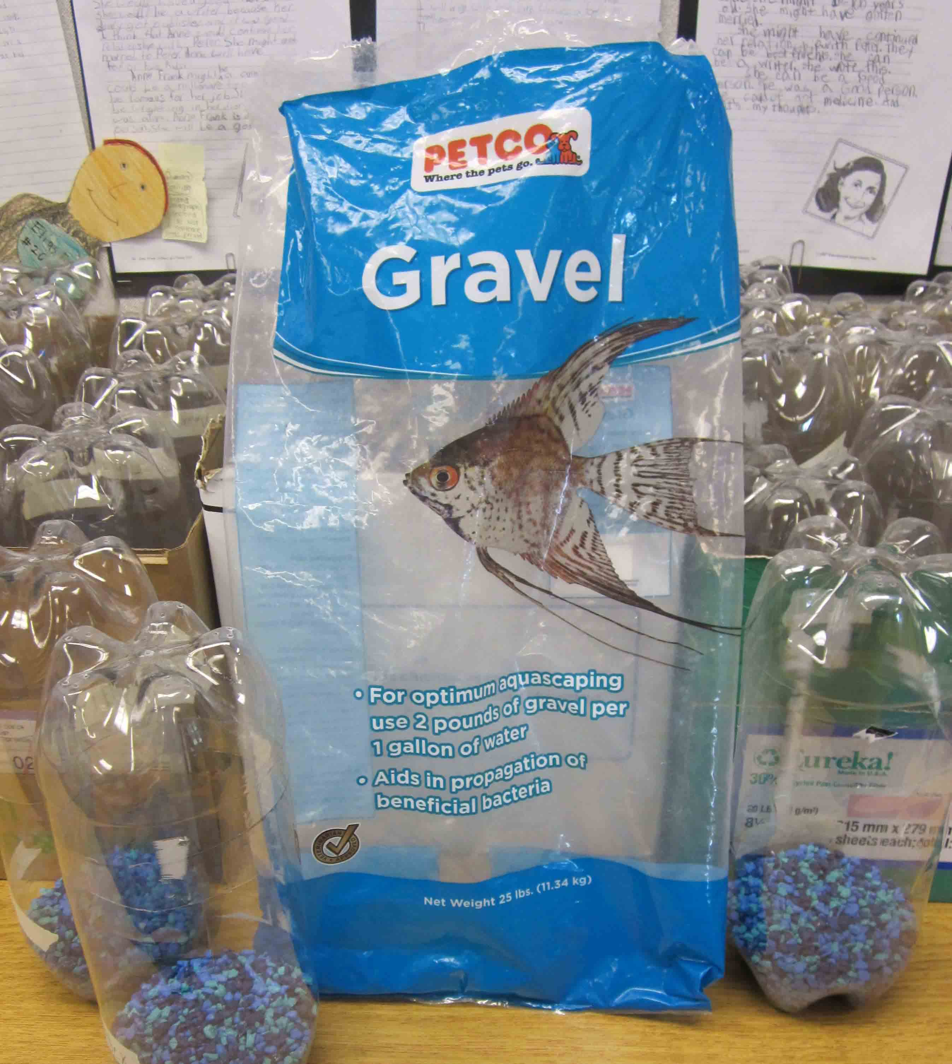

6. Anchor the elodea plant into the gravel. Make sure it is secure enough so that it will not come out when you pour in the water. | 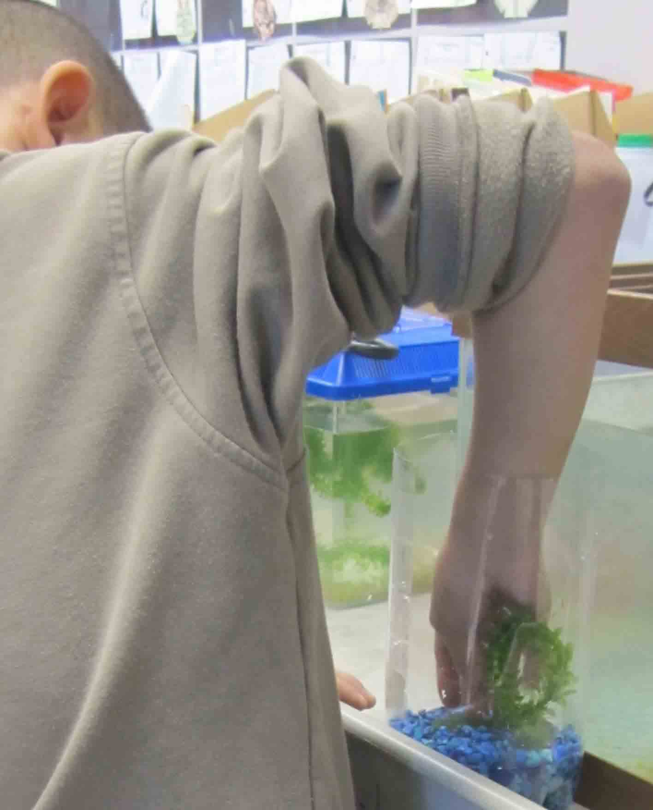

7. Pour in the water (Tap water must be left out for at least 24 hours). And put in the fish and shrimp. | 