Web BMI Application Version 1.0 – Lab instructions

Note: We may have to perform some additional steps in our lab because we have both .NET 1.1 and .NET 2.0 frameworks and we may encounter some security permission issues

- Create a new folder named C:\WebBMILab
- Copy the BMI.jpg, BMICalculator.vb files from my web site to the folder in step 1
- Go to Admin Tools in your Control Panel and select the Internet Information Services application
- In the IIS application, select the Default Web Site (left panel) and then select Action/New/Virtual Directory (see below)
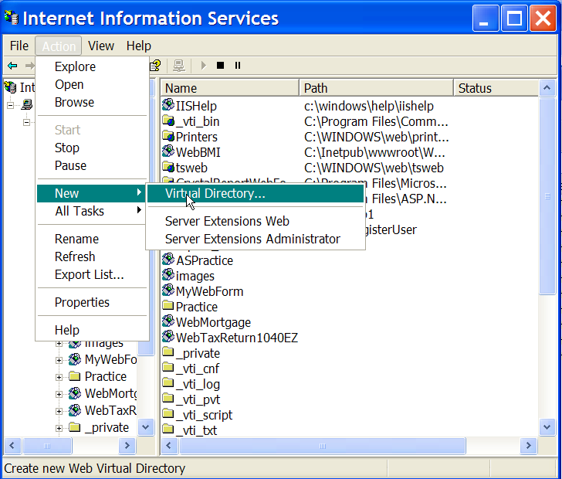
- In the wizard, type the directory alias WebBMILab1 (see below)
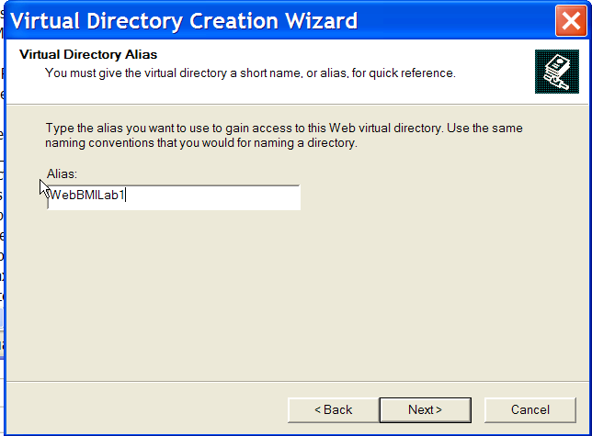
- Browse or type the path to the directory (see below)
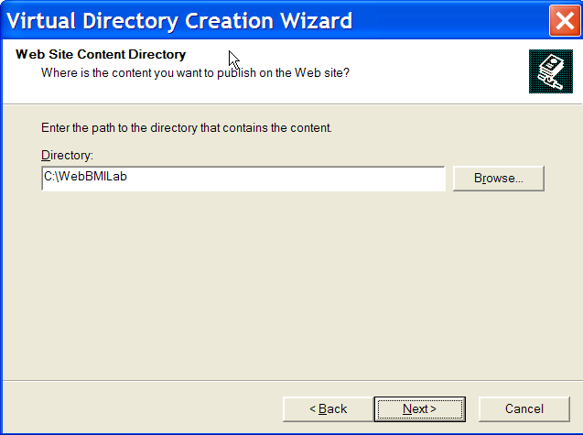
- Finish the wizard steps
- Start VS 2003 and create a new ASP.NET Web Application Project
- The location of the project is the new virtual directory you created and click the OK button (see below)
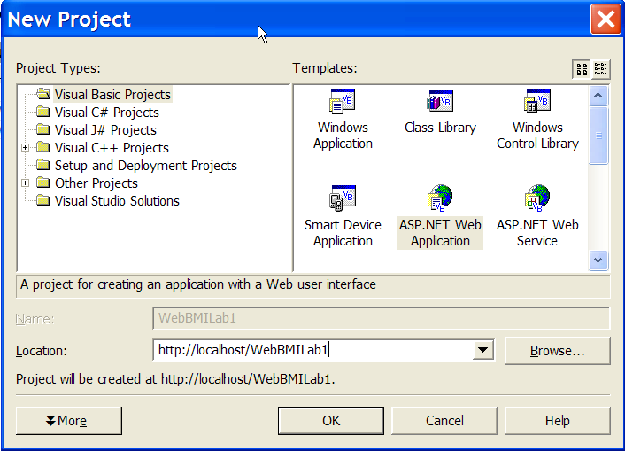
- In VS 2003, create the interface shown below (all web form components)
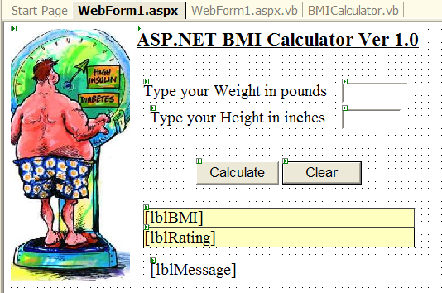
- Write the following code for the Calculate button
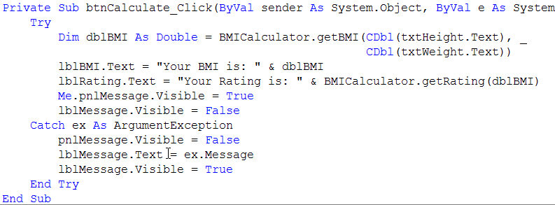
- Write the following code for the Clear button
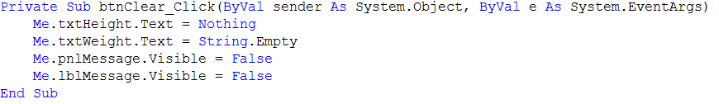
- Press F5 to start debugging
- Run this application outside VS 2003 using your browser. It should look like this:
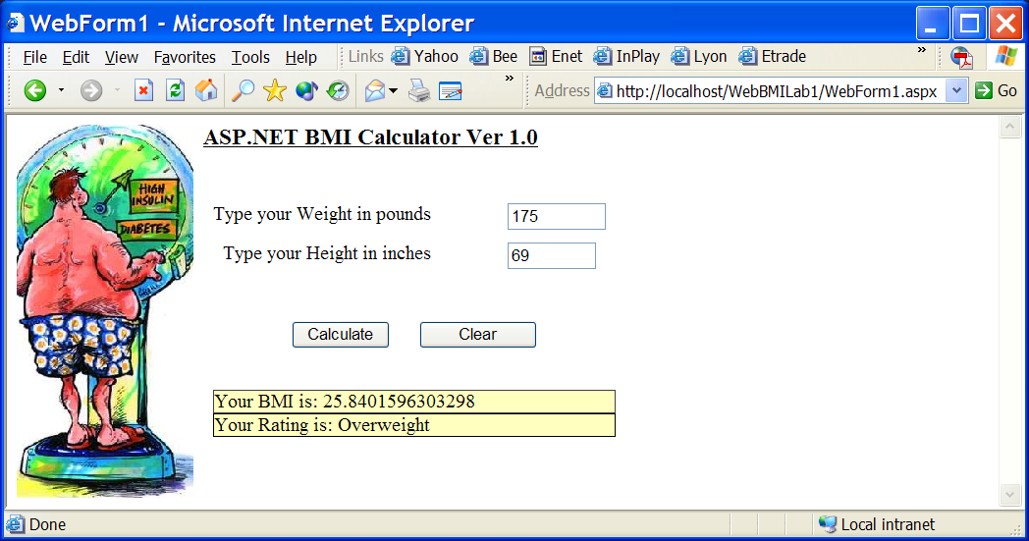

-- End of this exercise

