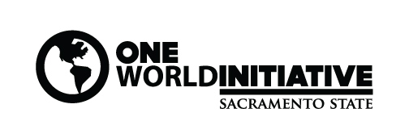

Student Symposium: GLOBAL PERSPECTIVES ON JUSTICE
Thursday, April 16, 2020 1:15-2:30 Pacific Suite, University Union

Posters and other formats including visual and performing arts, TED talk-style presentations, papers, and other modes of expression and exploration are encouraged. Individuals and groups engaging with the theme, “Global Perspectives on Justice,” from within a particular disciplinary mode or with an interdisciplinary approach are welcome—as are works in progress.

Proposal for Student Presentation (Deadline Wed. April 1st, 5pm)
Email completed proposal form and abstract to oneworld@csus.edu

Student (s) information:

Name (s):
Email:
Phone:
Major:

Academic standing (check box below):
Freshman Sophomore Junior □ Senior Graduate
Faculty advisor (recommended):
Faculty advisor contact information:

Presentation information:
Please indicate which format (s) you would prefer:

Poster or Table top (in this format you discuss your work as visitors walk through the exhibits)

Oral presentation or performance (in this format you present for an audience) Approximate length of presentation? ___________________

Title:

Medium (e.g. poster, paper, performance, artwork, installation etc.):

Special Requirements (e.g. audio-visual, power outlet, etc.):

Do you have any time constraints we should consider in building the schedule of presentations?
For example “I have class at 1:45” _______________________________________

Abstract/Summary (100 words maximum): On a separate page provide a summary of your proposed presentation. Please note, summaries may published on the One World website so they should be concise and well written.

